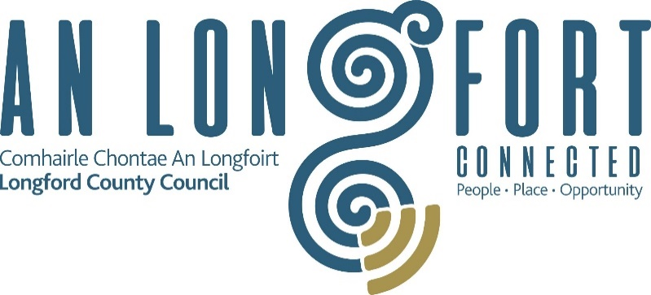

Data Subject Request Form
PART 1 – Type of Request
What would you like to do with your Personal Data?
I hereby wish to exercise my rights under the Data Protection Act 1988-2018 and request the right to:
☐ Access to my personal data
☐ Rectification of my personal data
☐ Erasure of my personal data
☐ Restriction of processing of my personal data
☐ Stop the processing of my personal data
☐ Transfer my Data to another organisation (Data Portability)
☐ Complain to the Data Protection Commissioner
PART 2 – Verification
Verification of your identity is required to accurately process your request
I enclose copy:

Passport ☐ Driving Licence ☐ Other ☐
(note that any copies of identity received will be destroyed upon confirmation of identity)
PART 3 – Details of Request
(Please provide as much information as possible to assist us in dealing with your request including the period during which the data was held)

PART 4
If you are requesting Access to your personal data, please confirm how you would like to receive the data
Email ☐ Post ☐ Collection ☐

Other ☐ (please specify) ________________________

PART 5 – Declaration by Requester
I Declare that, to the best of my knowledge, the information I have provided on this form is correct

Signature: _______________________________ Data: __________________________

Please return this completed form with identity verification to: The Data Protection & Information Compliance Officer, Longford County Council, Aras an Chontae,Great Water Street Longford,N39 NH56. OR By email to dpo@longfordcoco.ie

FOR OFFICE USE ONLY
As Data Protection & Information Compliance Officer, I hereby authorise ☐ refuse ☐ this Data Subject Request
Signed:

Date:
For further information on how Longford County Council process personal information can be found on our Privacy Statement on www.longfordcoco.ie under Data Protection

