County Longford Local Community Development Committee (LCDC)
Equality and Human Rights Statement

Adopted 6th April 2017

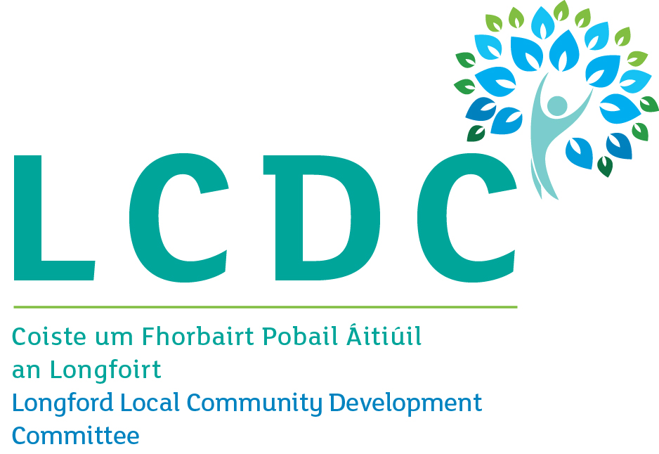

Background
County Longford Local Community Development Committee (LCDC) is an independent committee established by Longford County Council. Its primary role is to develop, co-ordinate and implement a coherent and integrated approach to local and community development. The primary work of the LCDC to date has been in advancing the community element of the Local Economic and Community Plan (LECP), the Rural Development Programme (LEADER), and the Social Inclusion Community Activation Programme (SICAP).
This equality and human rights statement reflects our shared commitment to equality and human rights. This encompasses the grounds covered in the equality legislation of gender, civil status, family status, age, disability, sexual orientation, race, religion and membership of the Traveller community, as well as socio-economic status.
This equality and human rights statement serves as a means to address our obligations under the Irish Human Rights Equality and Commission Act 2014 to have regard to the need to eliminate discrimination, promote equality of opportunity, and protect human rights in carrying out our functions.
Our Values
Our commitment to equality and human rights is motivated by a set of shared values:
Dignity
Autonomy
Democracy
Inclusion
Social justice
Values, Objectives and Issues
1. Dignity
Dignity is about valuing people and people valuing themselves. It involves respect, equal treatment, confidentiality, and the absence of any sense of being belittled.
County Longford LCDC seeks to enlist its partner and stakeholder organisations in taking action to sustain and further develop their capacity to value people and treat them with respect in their work.
We are, therefore, concerned with the following equality and human rights issues:
- Discrimination.
- Stereotypes.
- Lack of access for people with disabilities.
- Ensuring good standards in the treatment of service users.
- Lack of resources to provide for dignity.
2. Autonomy
Autonomy is about having choices and the freedom and capacity to make choices. It involves people making their own choices about their lives where possible.
County Longford LCDC seeks to enlist its partner and stakeholder organisations in taking action to sustain and further develop their capacity to support choices for people and choice making by people through their work, where possible.
We are, therefore, concerned with the following equality and human rights issues:
- Lack of choices for people, in particular due to the absence of infrastructure in rural areas.
- Lack of capacity among people to make choices, in particular due to inadequate income, limited education, lack of childcare, caring responsibilities, and lack of transport.
- Constrained choices for groups such as Travellers and migrants due to limited recognition of their different cultures.
- Limited autonomy for agencies in providing choices for people.

3. Democracy
Democracy is about participation in decision-making and accountability. It involves securing the engagement of all, ensuring the voice of marginalised groups is articulated and heard, and protecting people’s ability to voice opinions without fear.
County Longford LCDC seeks to encourage participation and engagement of all members of the community in an open, inclusive, and transparent way in its own planning processes and, through its evaluation processes, in the planning processes of others.
We are, therefore, concerned with the following equality and human rights issues:
- Limited participation in decision-making by some groups.
- Imbalance in representation of women and men and limited representation of the diversity of society in decision-making structures.
- Decision making processes that present barriers to the voice of marginalised groups or outsiders being heard.
- Lack of engagement in decision making processes by some groups and the lack of organisation, low level of information, limited knowledge of the processes, lack of resources, and limited interest that can underpin this.

4. Inclusion
Inclusion is about community, diversity, access and nobody being left out. It involves removing isolation and building a sense of belonging to a community, promoting respect for diversity, and enabling access for people in rural areas.
County Longford LCDC seeks to promote measures that advance participation in community, promote respect for and valuing of diversity, and increase access for people in rural areas.
We are, therefore, concerned with the following equality and human rights issues:
- Limited resources for community development.
- Lack of integration and ghettoisation of some people and groups.
- Failure to advance Universal Design in goods and services.
- Lack of flexibility in taking account of the practical implications of difference.
- Lack of facilities in rural areas.
- Lack of tailored focus on rural areas in policies and programmes.

5. Social Justice
Social justice is about the participation of all people in all areas of society, in particular marginalised groups. It involves a distribution of resources that is: just; meets assessed needs of the groups; and includes for positive action to address long-term disadvantage.
County Longford LCDC seeks to consistently assess the distribution of resources against criteria that is just, based on assessed needs, and involving positive action, both in its own plans and policies and in the plans of others that are overseen by the LCDC.
We are, therefore, concerned with the following equality and human rights issues:
- Poverty.
- Low levels of employment and precarious work.
- Low education status.
- Poor health status and access to appropriate healthcare.
- Homelessness.
- Poor built environment (Including public realm)
- Poor and uneven transport infrastructure.
- Inadequate domestic violence services.
- Imbalances between groups in the distribution of resources.
- Inaccurate and hostile perceptions held of marginalised groups and minorities and the benefits they get from the system.
- Failure to deal with anti-social behaviour.

This Statement
This equality and human rights statement will be:
Presented in draft form for consideration and adoption at a LCDC meeting.
Piloted as a reference point in the work of LCDC on the new SICAP programme.
Reviewed and finalised after this pilot with its ongoing use by the LCDC further identified.

This statement has been developed with LCDC members as the first part of an ongoing initiative by Longford County Council and Longford Community Resources clg. to support public sector bodies to better embed their concern for equality and human rights in their work. The initiative is funded by the Irish Human Rights and Equality Commission.

