Screening for Appropriate Assessment

of

Proposed Material Variation No. 1

to the

Longford County Development Plan
2015-2021

Planning Section
Longford County Council
April 2015
CONTENTS

Appropriate Assessment Screening Report for Proposed Variation No. 1 to Longford County Development Plan 2015 – 2021

- Introduction
  - Background
  - Legislative Context
  - Methodology
    - Stages of Appropriate Assessment
- Screening
  - Description of Proposed Variation
  - European Sites within 15km of the Plan Area
    - SACs and SPAs
  - Assessment Criteria
    - Other Plans and Programmes
    - Is the Variation Necessary to the Management of European Sites?
    - Elements of the Variation with potential to give rise to effects
- Conclusion

1 Introduction

1.1 Background

This report provides an Appropriate Assessment (AA) Screening of the proposed Variation No. 1 to Longford County Development Plan 2015 – 2021 as required for in the Planning and Development Act 2000 Section 13 (as amended) and in accordance with the relevant sections of the SEA Regulations 2004 and the EU Habitats Directive 92/43/EEC. The purpose of this report is to assess the likely effects of the proposed variation either alone or in combination with other projects or plans, on any Natura 2000 site and to consider whether these impacts are likely to be significant and thus require an appropriate assessment.

A Habitats Directive Assessment and associated SEA Environmental Report were previously prepared on the Longford County Development Plan. The assessment presented in this report considers the proposed Variation within the framework of the overall Plan taking account of the policies and objectives set out in the Plan.

1.2 Legislative Context

The Council Directive 92/43/EEC on the Conservation of Natural Habitats and of Wild Fauna and Flora, better known as “The Habitats Directive”, provides legal protection for habitats and species of European importance. Articles 3 to 9 provide the legislative means to protect habitats and species of Community interest through the establishment and conservation of an EU-wide network of sites known as Natura 2000. These are candidate Special Areas of Conservation (cSACs) designated under the Habitats Directive and Special Protection Areas (SPAs) designated under the Conservation of Wild Birds Directive (Directive 2009/17/EC – codified version of Directive 79/409/EEC as amended), hereafter referred to as European sites. Articles 6(3) and 6(4) of the Habitats Directive set out the decision-making tests for plans and projects likely to affect European sites. Article 6(3) establishes the requirement for Appropriate Assessment (AA):

“Any plan or project not directly connected with or necessary to the management of the [Natura 2000] site but likely to have a significant effect thereon, either individually or in combination with other plans or projects, shall be subjected to appropriate assessment of its implications for the site in view of the site’s conservation objectives. In light of the conclusions of the assessment of the implications for the site and subject to the provisions of paragraph 4, the competent national authorities shall agree to the plan or project only after having ascertained that it will not adversely affect the integrity of the site concerned and, if appropriate, after having obtained the opinion of the general public.

If, in spite of a negative assessment of the implications for the Natura 2000 site and in the absence of alternative solutions, a plan or project must nevertheless be carried out for imperative reasons of overriding public interest, including those of a social or economic nature, Member States shall take all compensatory measures necessary to ensure that the overall coherence of Natura 2000 is protected. It shall inform the Commission of the compensatory measures adopted.

Where the site concerned hosts a priority natural habitat type and/or a priority species the only considerations which may be raised are those relating to human health or public safety, to beneficial consequences of primary importance for the environment or, further to an opinion from the Commission, to other imperative reasons of overriding public interest.”

Article 6 is seen to reflect the overall aim of the Habitats Directive “promoting biodiversity by maintaining or restoring certain habitats and species at ‘favourable status’ within the context of Natura 200 sites” while taking into account economic, social, cultural and regional requirements as a means to achieving sustainable development.

These requirements are implemented in the Republic of Ireland by the European Communities (Birds and Natural Habitats) Regulations 2011. These new regulations consolidate the European Communities (Natural Habitats) Regulations 1997 to 2005 and the European Communities (Birds and Natural Habitats) (Control of Recreational Activities) Regulations 2010, as well as addressing transposition failures identified in the Court of Justice of the European Union judgments.

1.3 Methodology

The methodology followed in preparing this Appropriate Assessment (AA) Screening Statement is in accordance with the following guidance:
- Appropriate Assessment of Plans and Projects in Ireland. Guidance for Planning Authorities. (Department of the Environment, Heritage and Local Government, 2010)
- Assessment of plans and projects significantly affecting Natura 2000 sites: Methodological guidance on the provisions of Article 6(3) and (4) of the Habitats Directive 92/43/EEC, European Communities Environment DG, 2002.
- Managing Natura 2000 sites: The Provisions of Article 6 of the Habitats Directive 92/43/EEC European Commission, 2000

1.3.1 Stages of Appropriate Assessment

AA comprises up to four successive stages:

Stage One: Screening
This is the process which identifies the likely impacts upon a European site of a project or plan, either alone or in combination with other projects or plans, and considers whether it can be objectively concluded that these effects will not be significant. This stage of the screening process involves four steps, which fall under the following headings:
- Management of the site – involves determining whether or not the project or plan is directly connected with or necessary to the management of the site.
- Description of the project or plan – Describing the project or plan and the description and characterization of other projects or plans that in combination have the potential for having significant effects on the Natura 2000 site.
- Characteristics of the site – identifying the potential affects on Natura 2000 site(s)
- Assessment of Significance – assessing the significance of any effects on Natura 2000 site(s).

Stage Two: Appropriate Assessment
The consideration of the impact on the integrity of the European site of the project or plan, either alone or in combination with other projects or plans, with respect to the site’s structure and function and its conservation objectives. Additionally, where there are adverse impacts, an assessment of the potential mitigation of those impacts.

Stage Three: Assessment of Alternative Solutions
The process which examines alternative ways of achieving the objectives of the project or plan that avoid adverse impacts on the integrity of the European site.

Stage Four: Assessment where no alternative solutions exist and where adverse impacts remain
An assessment of compensatory measures where, in the light of an assessment of imperative reasons of overriding public interest (IROPI), it is deemed that the project or plan should proceed. The Habitats Directive promotes a hierarchy of avoidance, mitigation and compensatory measures. First, the plan should aim to avoid any impacts on European sites by identifying possible impacts early in the plan-making process and writing the plan in order to avoid such impacts. Second, mitigation measures should be applied, if necessary, during the AA process to the point where no adverse impacts on the site(s) remain. If the plan is still likely to result in impacts on European sites, and no further practicable mitigation is possible, then it must be rejected. If no alternative solutions are identified and the plan is required for imperative reasons of overriding public interest (IROPI test) under Article 6(4) of the Habitats Directive, then compensation measures are required for any remaining adverse effect.

In the case of this Appropriate Assessment, it is found that the proposed Variation to the Plan only requires Stage 1 assessment.

2 Stage 1 Screening

Screening determines whether Appropriate Assessment is necessary by examining:
- Whether a plan or project can be excluded from Appropriate Assessment requirements because it is directly connected with or necessary to the management of the site, and
- The potential effects of the project or plan, either along or in combination with other projects or plans, on a Natura 2000 site in view of its conservation objectives and considering whether these effects will be significant.

Screening involves the following:
1. A description of the plan or project, and local site or plan area characteristics;
2. Identification of relevant Natura 2000 sites and compilation of their qualifying interests and conservation objectives;
3. Assessment of likely effects – direct, indirect, or cumulative, undertaken on the basis of available information as a desk survey or field survey or primary research as necessary;
4. Screening statement with conclusions.

2.1 Description of the Proposed Variation

The Proposed Variation to the Longford County Development Plan 2015 – 2021 refers to a change in zoning contained within the Ballymahon Zoning Map located in Appendix 1 of the Longford County Development Plan 2015 - 2021. It refers to a piece of land 0.12 hectares in size, which is currently zoned for Recreation, Amenity and Green Spaces and it is proposed to amend it to Industrial/Commercial/Warehousing to facilitate an existing enterprise that has been in operation on the site for approximately 20 years. The site is bounded by the River Inny to the north east and the N55 to the south west and is located close to the junction of the N55 with the R392 within Ballymahon designated development envelope, as identified in the Longford County Development Plan 2015 – 2021. The site is currently in use, and has been for approximately 20 years, as a car sales operation and is only used for the storage and sale of cars. No repairs or maintenance to vehicles takes place on site. The proposed variation will allow the landowner to regularize the situation on the site and thereby improve the conditions on the site.

2.2 European Sites within 15 km of the location of the proposed variation

2.2.1 SACs and SPAs

This section of the screening process describes the European sites within a 15km zone of impact of the proposed zoning alteration. A distance of 15km is currently recommended in the DoE document Appropriate Assessment of Plans and Projects – Guidance for Planning Authorities and as a precautionary measure, to ensure that all potentially affected European sites are included in the screening process. The relevant European sites are listed in Table 2.1 together with their qualifying interests while their location in relation to area the subject of the proposed variation is illustrated in Figure 2.1. In order to determine the potential for impacts from the proposed variation, information on the qualifying features, known vulnerabilities and threats to site integrity pertaining to all potentially affected European sites was reviewed. This information was derived from a variety of sources, including:
• Ireland’s Article 17 Report to the European Commission “Status of EU Protected Habitats and Species in Ireland” (NPWS, 2008).
• Site Synopses.
• NATURA 2000 Standard Data Forms.
• Published Site Specific Conservation Objectives and supporting documents where available.

As the conservation objectives for the European sites focus on maintaining the favourable conservation status of the qualifying interests of each site, the screening process concentrated on assessing the potential implications of the proposed variation to the Longford County Development Plan against the qualifying interests of each site.

Table 2.1 European Sites (cSACs and SPAs) located within 15km of the location of the proposed variation

Site Name | Site Code | Qualifying features
Lough Ree cSAC | 000440 | Natural eutrophic lakes with Magnopotamion or Hydrocharition - type vegetation [3150]  Semi-natural dry grasslands and scrubland facies on calcareous substrates (Festuco-Brometalia) (* important orchid sites) [6210]  Degraded raised bogs still capable of natural regeneration [7120]  Alkaline fens [7230]  Limestone pavements [8240]  Old sessile oak woods with Ilex and Blechnum in the British Isles [91A0]  Bog woodland [91D0]  Lutra lutra (Otter) [1355]
Lough Ree SPA | 004064 | Little Grebe (Tachybaptus ruficollis) [A004]  Whooper Swan (Cygnus cygnus) [A038]  Wigeon (Anas penelope) [A050]  Teal (Anas crecca) [A052]  Mallard (Anas platyrhynchos) [A053]  Shoveler (Anas clypeata) [A056]  Tufted Duck (Aythya fuligula) [A061]  Common Scoter (Melanitta nigra) [A065]  Goldeneye (Bucephala clangula) [A067]  Coot (Fulica atra) [A125]  Golden Plover (Pluvialis apricaria) [A140]  Lapwing (Vanellus vanellus) [A142]  Common Tern (Sterna hirundo) [A193]  Wetland and Waterbirds [A999]
Ballymore Fen SAC | 002313 | Transition mires and quaking bogs

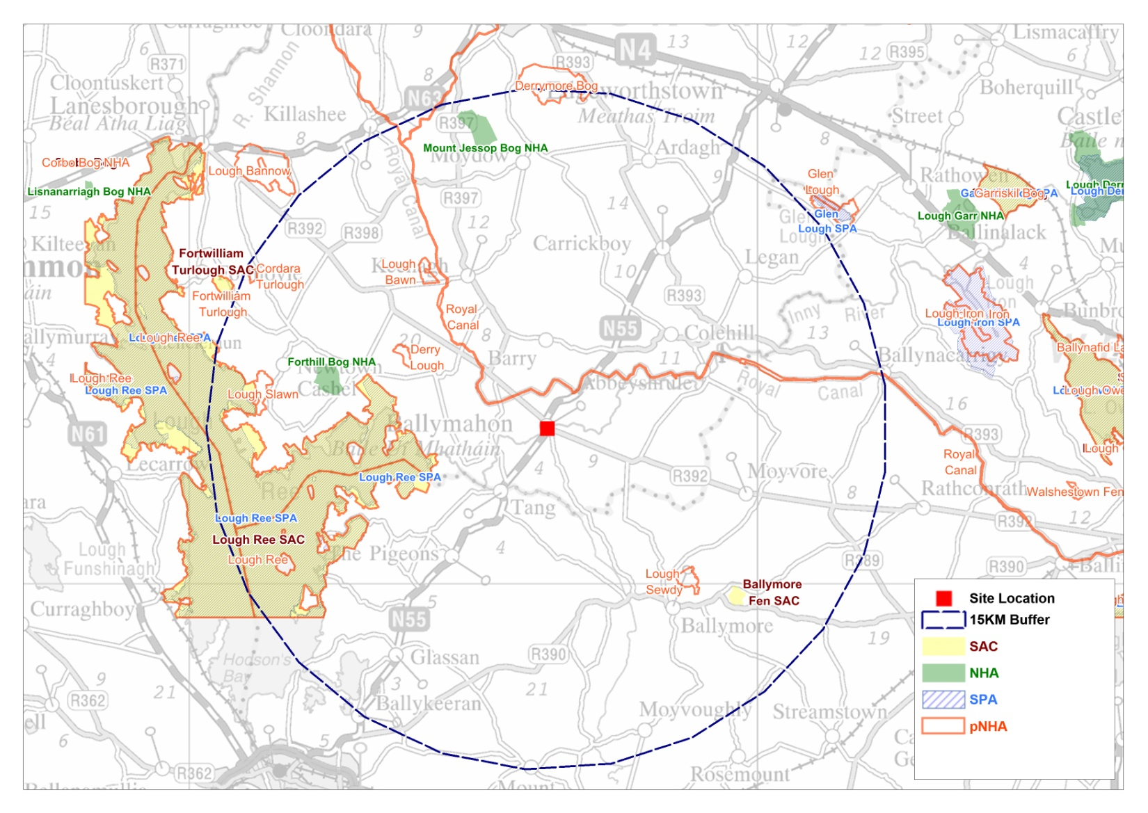
Figure 2.1 Distribution of European Sites located within 15km of the location of the proposed variation.

2.3 Assessment Criteria

2.3.1 Other Plans and Programmes

Numerous other higher level measures further mitigate potential impacts of the County Development Plan and this proposed variation, including EU Directives, national legislation and various guidelines. Principal among these are the following:

- The Habitats Directive (HD): The European Council Directive on the Conservation of natural habitats and of wild fauna and flora (92/43/EEC) (Habitats Directive)
- The Water Framework Directive (WFD): The Water Framework Directive 2000/60/EC
- The National Biodiversity Plan (NBP): UN Convention on Biological Diversity 1992 – National Biodiversity Plan 2002 is as a result of this.
- The Wildlife Act (WA): Wildlife Act 1976 and Wildlife (Amendment) Act 2000 (Wildlife Act)
- The Birds Directive (BD): The 1979 European Council Directive on the Conservation of Wild Birds (79/409/EEC) (Birds Directive)
- The Ramsar Convention (R): Convention on Wetlands of International Importance (Ramsar)
- The Bathing Water Directive (BW): Bathing Water Directive (76/160/EEC)
- The Urban Waste Water Treatment Directive (WW): (91/271/EEC) (amended by Directive 98/15/EEC)

2.3.2 Is the variation necessary for the management of the site

Determining whether or not the project or plan is directly connected with or necessary to the management of the site.

Under the Habitats Directive, plans or projects that are directly connected with or necessary to the nature conservation and management of a Natural 2000 site are exempt from the need for Stage 2 Appropriate Assessment. For this exemption to apply, management should be interpreted narrowly as nature conservation management in the sense of Article 6(1) of the Habitats Directive, for example the relationship between the proposed plan and the management of the Natura 2000 site should be shown to be direct and not a by-product of the plan, even of this might result in positive or beneficial effects for a site(s).

The proposed variation involves a change of zoning from Recreation/Amenity and Green Spaces to Industrial/Commercial/Warehousing to promote the economic development of Ballymahon and facilitate an existing business that has been in operation on the site for approximately 20 years, in order to regularize the situation on the ground and is not required for the nature conservation management of European sites. Therefore, the proposed variation is not considered by the Habitats Directive to be directly connected with or necessary to the management of European designated sites.

2.3.3 Elements of the proposed Variation with Potential to Give Rise to Effects

The proposed variation relates to a change of zoning of a portion of land. The proposed zoning is located 5.2km from the nearest point of the a European site and it is clear that the proposed variation will not cause any impacts on the conservation objectives of any Natura 2000 site in relation to the following factors:
- Size, scale, land take – the variation refers to 0.12ha of land already in use as a car sales operation, approximately 5.2km from the nearest Natura 2000 site and does not take any land from the Natura 2000 network.
- Distance from the Natura 2000 site or key features of the site – at the closest point the site is approximately 5.2km from the Natura 2000 site.
- Resource requirements (water abstraction etc) – none
- Emissions (disposal to land, water or air) – none
- Excavation/transportation requirements – none
- Duration of construction, operation, decommissioning, etc – no construction as site is already in operation, and will continue over the lifetime of the business
- Habitat area – n/a
- Disturbance to key species – none due to distance from Natura 2000 network
- Habitat or species fragmentation – none due to distance from Natura 2000 network
- Species density – the site is currently finished in gravel and accommodates a car sales operation so there is no significant species present on site
- Changes in key indicators of conservation value (water quality etc) – none
- Climate change – none
- Key relationships that define the structure/function of the sites – none.

The proposed variation will result in a change in zoning of an area of land approximately 0.12ha of land from its existing zoning as recreation/amenity and green spaces to industrial/commercial/warehousing. The site in question is located close to the banks of the River Inny and will allow for an existing car sales business which has been in operation at this location for a significant number of years to regularize the situation on the ground and to continue to operate at this location.

No potential for impacts on European sites to arise due to this proposed variation. Such an alteration would therefore not necessitate Stage 2 Appropriate Assessment.

3 Conclusion

This report presents an Appropriate Assessment Screening of the Proposed Variation to the Longford County Development Plan 2015 – 2021. The trigger for Stage Two Appropriate Assessment would be if the proposed variation were likely to have significant effects on a Natura 2000 site. This screening report evaluates the proposed variation (in the context of the Appropriate Assessment screening exercise already conducted for the ‘parent’ document, the Longford County Development Plan 2015 – 2021) to ascertain if the proposed variation warrants a Stage Two Appropriate Assessment.

This assessment finds that the proposed variation, by virtue of the location and scale of the area involved, shall not give rise to significant effects on the integrity of any Natura 2000 sites. Therefore, it is concluded that, should the proposed Variation be adopted, there is no potential for direct, indirect, or cumulative effects on the conservation objectives of relevant European sites (as listed in Table 2.1 above), and therefore there is no requirement to proceed to Stage II Appropriate Assessment.

