Expression of Interest for Inclusion in the
Outdoor Recreation Infrastructure Scheme 2023
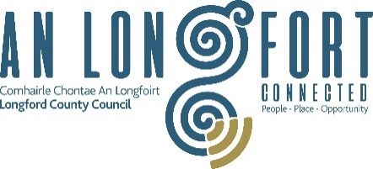
Please complete this Expression of Interest form
and return it to
Longford County Council Regeneration Department

Outdoor Recreation Infrastructure Scheme 2023

Location:

Amount of Funding Requested:

Applicant Group:

Applicant Contact Name:

Applicant Contact Address:

Applicant Telephone Number:

Applicant Mobile Number:

Applicant Email Address:

- Has funding for this project ever been sought from other sources? Yes No
(If "YES" yes please specify from what source and if funding was provided)

- Who are the specific project stakeholders/community partners in this project?
(Chamber of Commerce, Community group, etc.).

- Synopsis of Project:
- If seeking funding for projects of between €50,000 and €500,000, please detail how the proposed project addresses an identified need.

- What is the objective of the proposed project and how will the intended outcomes be measured? (Please identify any metrics or benchmarks that will be applied).

DECLARATION
I hereby confirm that I have read and understand this document. I request that consideration be given in support of the project as outlined above.

Signature __________________________________________________

Position __________________________________________________

Date __________________________________________________

