Lanesboro
Local Area
Plan
2004 - 2009

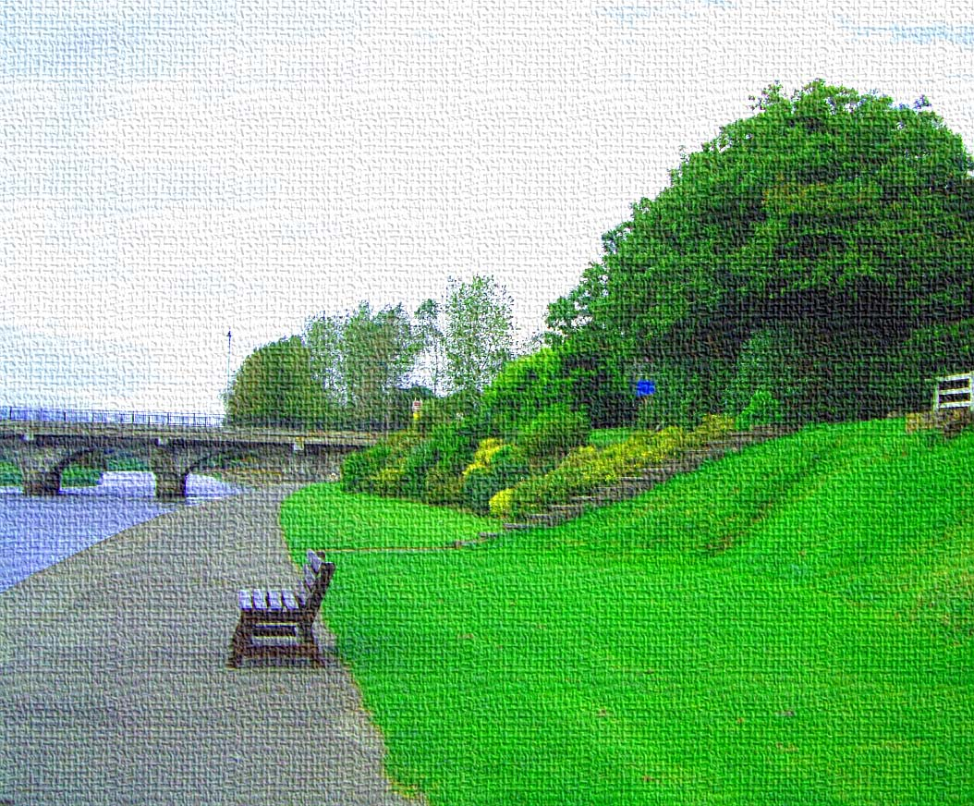

Prepared by:

The Planning Section,
Longford County Council

November 2004

Table of Contents
Introduction 2
Terms of Reference 2
Longford County Development Plan, 2003-2009 2
Legislative Context - Planning and Development Act, 2000 3
National and Regional Planning 3
Location and Context 4
Town Structure 4
Historical Context 5
Demographic Profile 6
Infrastructure 7
Roads 7
Public Transport 8
Sewerage 8
Water Supply 9
Energy 9
SWOT Analysis 10
Character 12
Landscape Setting 12
Morphology and Development 13
Community Groups/Organisations 13
Buildings and Structures 14
Residential 14
Commercial 15
Community 15
Public Realm 15
Paths 16
Open Space 16
Landscaping 16
Walkways 16
Development Pressure 16
Development Potential 17
Proposals 18
Design Principles 18
Local Character 18
Densities 18
Access and Circulation 18
Commercial Development 19
Services and Facilities 19
Amenities and Recreation 19
Open Spaces 19
Zonings 20
Commercial Core 20
Social/Community 20
Residential 20
Industrial/Commercial 20
Recreational 21
Protected Area/Passive Amenity 22
Potential Roadway/Access 22
Environmental Improvements 23
Likely Significant Effects on the Environment 24
Environmental Aims 24
Assessment of Objectives Against Environmental Aims 25

Introduction

Terms of Reference

This Local Area Plan has been prepared with reference to the legislation as outlined below and in accordance with the policy and objectives of the Longford County Development Plan, 2003 – 2009 and the Midland Regional Planning Guidelines.

Longford County Development Plan, 2003-2009
This Local Area plan (hereinafter referred to as LAP) has been prepared under Section 3 of the Longford County Development Plan, 2003 – 2009. Section 3.1.1. of the plan outlines the hierarchy of settlements in the County and states the following in relation to areas for which LAP are proposed, in addition to Granard, Ballymahon and Edgeworthstown:

- Newtownforbes, Drumlish, Lanesboro – Local growth centres. These settlements will continue to provide settlement centres for the population and local-level goods and services provision. The potential for tourism and amenity development, particularly at Lanesboro, is recognised and shall be promoted and encouraged where appropriate in the Local Area Plans which shall be prepared for these locations.

Section 3.1.3 of the County Development Plan contains the following rationale for the designation of these settlements and guidance on the content of the LAP documents:

These Local Area Plans shall be considered part of this Development Plan when they are made. The following, and where necessary, additional, zonings will be included where appropriate:

Residential, Commercial/Residential, Commercial, Industrial, Public Utility, Educational, Institutional, Recreational / Open Spaces, Churches / Burial Grounds, Agriculture.

The aim of this Local Area plan is to provide appropriate zonings to encourage and promote suitable development within the town and to address the following issues, in consultation and discussion with the relevant stakeholders:

- To implement and reinforce the settlement hierarchy as defined in the Longford County Development Plan, 2003 – 2009

- To define, enhance and strengthen the existing character of Lanesboro

- To guide development in order to promote a settlement that is an attractive place in which to live, work and visit

- To provide guidance and direction for those proposing to develop lands within the town

- To protect and enhance areas, structures and associations that contribute to the identity of the area and reinforce a “sense of place”

Legislative Context - Planning and Development Act, 2000
Provision has been made for the preparation of Local Area Plans under Section 18 (1) of the Act, which states the following:

“A planning authority may at any time, and for any particular area within its functional area, prepare a Local Area Plan in respect of that area”

Section 19 deals with the application and content of LAPs. 19(2) as amended by the Planning and Development (Amendment) Act, 2002, states that:

“A local area plan shall be consistent with the objectives of the development plan and shall consist of a written statement and a plan or plans which may include:

- Objectives for the zoning of land solely or primarily of particular areas for particular purposes
Or
- Such other objectives in such detail as may be determined by the planning authority for the proper planning and sustainable development of the area to which it applies, including detail on community facilities and amenities and on standards for the design of developments and structures.”

National and Regional Planning
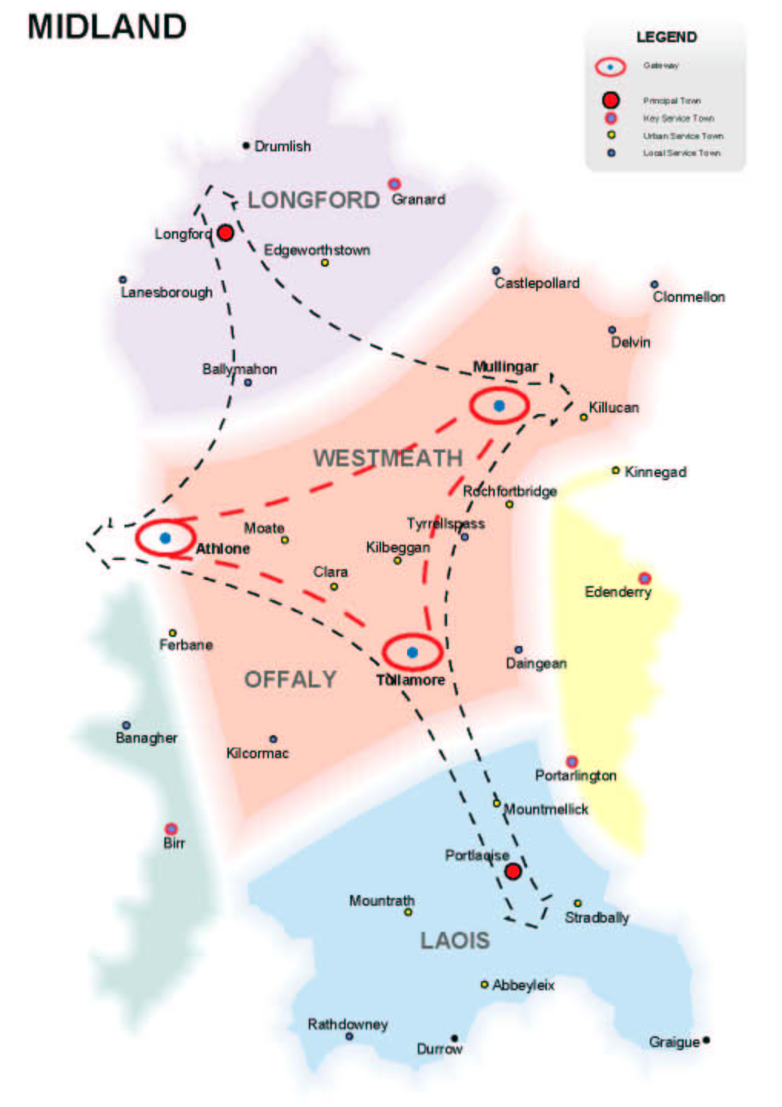
The National Spatial Strategy set out a framework for the planning and sustainable development of the Country in 2002. This strategy is translated to a regional level by the regional planning guidelines for the Midlands Region.

Lanesboro is designated as a Local Service Town in the RPGs. The following is how the guidelines envisage the role of Local Service Towns within the Region:

“These towns are described as being more remote from gateway and principal towns. They have attractive streetscapes, physical settings and heritage buildings that present a strong visual character. The guidelines envisage that these towns will be promoted in performing local level residential, retailing social and leisure facilities and providing appropriate local services to a wider rural hinterland.”

Location and Context

To Be Read In Conjunction with Fig.’s 1&2

Lanesboro is located on the eastern banks of the River Shannon at the northern end of Lough Ree. Approximately 10 miles southwest of Longford, the town is divided in two by the Shannon. The portion of the town on the western side of the River lies in County Roscommon and retains the old Irish name for the settlement of Ballyleague (Beal Atha Liag – ford of the stone). As this section lies outside of the functional boundary of Longford County Council it does not form part of the study area, however, consultation has taken place with Roscommon County Council in relation to the Plan.

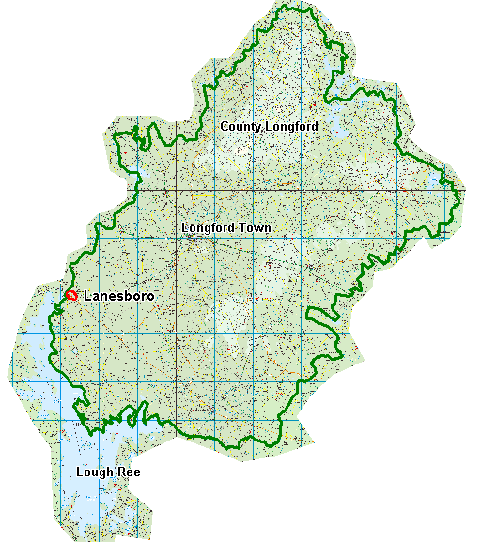

Not to scale

Fig. 1. Location Map

The N63 (National Secondary Route) from Longford to Roscommon passes through the main street of the Town, and the regional route from Lanesboro to Mullingar (R392) passes through in an east-west direction.

Town Structure
The core area of the town is laid out in a linear pattern, running in an east-west direction across the River Shannon. Beyond this street, structure is weak and takes the form of individual, mostly unrelated development.

The quality of the street enclosure along the Main axis varies considerably, as shown in Figure 2. In common with most towns of its era, the settlement backs onto the river and makes little attempt to relate to it. This has not been addressed in new developments on the Longford side of the River, while new developments at Ballyleague on the Roscommon side are now taking full advantage of the views and amenity open to this Lakeside location.

There are several opportunities available for the strengthening of the built fabric in Lanesboro, particularly in the following areas (to be read in conjunction with Fig. 2):

Area 1
Adjacent to the bridge, this area is very high profile as it represents the gateway to the entire County. The street line is poorly articulated with little active frontage, which should be addressed to create interest and an attractive atmosphere in close proximity to the River.

Area 2
Buildings in this area are set back from the main street-line, creating a wide and bare footpath area that is frequently used for parking. Plans are in place to upgrade the Hotel.

This is an open area in the built fabric, mainly used for on-street parking. While the surfacing of the area has been partly upgraded in recent years to brick paviors, individual parking spaces and entry and exit points remain undefined, leading to chaotic parking patterns, particularly during peak periods. Adjacent open yards and storage areas create a poor impression, which is particularly undesirable in this high profile location.

The large and unenclosed open space weakens the enclosure of the street, an effect that is heightened by the single-storey nature of the adjacent supermarket. This contrasts with the fine row of terraces to the west of the area and the buildings directly opposite, which are two to three storeys in height and form a uniform horizontal street line.

Area 3
This is perhaps the most high-profile section of the settlement, as it forms the initial impression of the town for the visitor. The broad nature of the footpaths is a requirement due to the difficult geometry of the junction and the implications this has for the safe movement of vehicular and pedestrian traffic, however, this leaves a bare and isolated impression of the area.

The single storey buildings at the western side of the Rathcline road weaken an otherwise strong sense of enclosure, and the profusion of signage lends a negative visual impression.

Area 4
The town structure begins to “fade” at this point, with the widening of building setbacks along the street. This area is particularly important as it forms the setting for the Church, a listed building occupying an elevated site, which should form a high profile and positive element within the streetscape.

The Green, a housing estate developed by Bord na Mona, is a good example of the architecture and urban design of the 1950’s, illustrating a strong emphasis on community and family friendly housing and layout.

Historical Context
An important bridging point on the Shannon, Lanesboro occupies the site of the Medieval borough of Áth Liag – the ford of the stone – and the site of successive bridges between the ancient provinces of Midhe and Connacht. The strategic importance of the settlement was recognised by the Anglo-Normans in the thirteenth century, from which it was occupied by Norman families such as the De Lacey’s, De Mariscos and Verduns. Athlone largely overtook this function, and there is little further historical mention of the area until the late seventeenth century, when Sir George Lane was granted the lands on the Longford side of the Shannon in the restoration.

There are two listed buildings within the town, St. Johns Church (Church of Ireland, 1856-61) and Lanesboro Parish Church (R.C., 1859). St. Johns lies to the north of the settlement, adjacent to the power station, which provides a surreal backdrop to the building and adjacent graveyard.

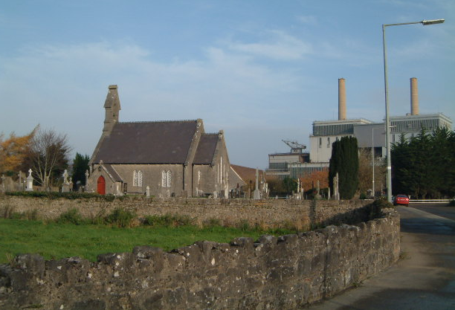
St. Johns Church of Ireland with Power Station in the background

The Catholic Church (Blessed Lady of the Rosary) occupies an elevated site to the west of the town, opposite the green area to the front of the Local Authority Housing Estate. In both cases, the street structure in the vicinity of these buildings is compromised, with little or no sense of enclosure, proportion or balance.

Demographic Profile
Lanesboro is contained within Rathcline DED, which has been taken as an indicator of the population of the town as this is the smallest area for which detailed population figures are available.

Year | Total | Males | Females | % Change
1991 | 1306 | 670 | 636 | ---
1996 | 1248 | 654 | 594 | -4.4%
2002 | 1268 | 654 | 614 | 1.6%

Sources: CSO census of Population, 1991, 1996 and 2002

The chart above illustrates the level of change over the last three census periods, with a decline in population over the period from 1991 to 1996, and a slight recovery from 1996 to 2002. It is interesting to note that the majority of the loss occurred in the female population, while the male population remained static over the last intercensile period.

Infrastructure

Roads
Lanesboro is served by the N63 and the R392, both of which pass through the main street of the town. When combined with chaotic parking practices, this can lead to congestion during peak periods. Geometry at the Main junction in the centre of the town is difficult, with limited available sightlines, again complicated by unrestricted parking. The impending commission Of the new power station will increase the level of heavy vehicular traffic within the settlement and is likely to exacerbate existing problems if left unchecked.

The following extracts from the programme of carriageway improvements as outlined in the County development Plan, 2003-2009, are relevant to the Lanesboro area:

Project | Design | Contract | Construction
N55 and N63 restoration/improvement | Report 2001 | NRA dependant | NRA dependant
Lanesboro industrial park construction | Ongoing | Ongoing | DOELG
R392 Ballymahon/Lanesboro improvement | Ongoing | DOELG | DOELG
R392 Ballymahon/Lanesboro realignment | Ongoing | DOELG | DOELG
Lanesboro amenity scheme restoration | Completed | DOELG | DOELG
COUNTY SIGNPOSTING PLAN | 2002 | 2003 | 2008
FOUR YEAR ROAD RESTORATION PLAN | Ongoing | 2002 | 2005

These improvements shall include, where appropriate, the implementation of accident reduction and traffic calming measures, public lighting installation and upgrading, strengthening and surfacing of carriageways and the improvement of signposting.

      - The Council will segregate, where possible, through the Urban and Village Renewal programme and the process of development control, vehicular and non-vehicular traffic in existing settlements and proposed new developments.

      - It is the policy of the Council to provide cycle ways where feasible and appropriate, between town centres and densely populated areas and along scenic routes in particular.

      - Routes of strategic importance within the County, as outlined below, shall be protected from further access creation:

  - N4 & N5
  - N55 & N60
  - Regional Routes – Longford/Athlone, Lanesboro/Mullingar, Longford/Arvagh

Proposed widening or intensification of use of existing accesses along these routes shall be assessed according to the relevant technical criteria.

      - The Council will continue to make representations to the National Roads Authority in order to secure the development of the following:

  - Longford Town by-pass
  - Edgeworthstown by-pass
  - Granard by-pass
  - Newtownforbes by-pass
  - Kilashee by-pass
  - The upgrading of all national routes

Applications for planning permission for developments proposed within any NRA study areas shall be forwarded to the NRA for evaluation and comment, which shall be taken into consideration in the assessment of the application.

Parking standards are also outlined in this section of the County Development Plan. These shall also be applied to developments carried out under this Local Area Plan (see Appendix).

Public Transport
Public transport services are limited to bus transport with the Longford-Galway service from Bus Eireann covering Kilashee and Lanesboro and operating once per day.

In addition to Bus Eireann, there are several private companies operating in the county, mainly servicing school runs.

Sewerage
Improvements to the capacity of sewerage works in the Lanesboro area are ongoing (as listed in the programme of works under Section 4.6 of the County Development Plan, 2003-2009) in order to offset the current deficiency in provision and protect the environmental quality of the Shannon and Lough Ree.

Works across the border in Ballyleague are underway and the potential for linking into this sewerage network are in the early stages of discussion. Sufficient sewerage capacity is essential for the balanced growth of Lanesboro and the protection of the environmental integrity of the area.

Water Supply
Work is ongoing in Lanesboro in connection with the upgrading of headwork’s and the local water supply network. No deficiencies are currently identified that would adversely affect the development potential of the town.

Energy
Energy provision within the settlement would appear to be meeting requirements. It is assumed that sufficient capacity exists for the scale of development likely to take place in the Lanesboro area over the period of this Local Area Plan.

The potential for the development of alternative energy sources with the decommissioning of the existing peat fired power station is an option should be given further consideration.

SWOT Analysis

To be read in conjunction with Fig. 2

Strengths
- Scenic location on River Shannon
- Reasonably intact town structure
- Proximity to historical monuments and sites and sites of natural heritage importance
- Power Station/employment
- Established community groups
- Angling tourist trade

Weaknesses
- Underdevelopment of tourism opportunities
- Inadequate sewerage treatment system
- Lack of services for town expansion
- Closure of power station in medium term
- Sections of weak urban structure along Main Street – gaps in horizontal street line
- Parking/through traffic conflict along Main Street
- Difficult junction between N63/R392/Rathcline road
- On periphery of County
- Falls between two administrative boundaries – little co-ordinated policy between adjacent Local Authorities and other agencies, e.g. National Roads Authority

Opportunities
- Development of water-based amenities and sports
- Development of historical based tourism and trips – proximity of Lough Ree, Inchcleraun Island, Saint’s Island etc.
- Potential for re-use of power station with renewable energy – tourist resource
- Development of walkways and educational routes through natural heritage areas
- Development of industrial park adjacent to power station
- Increased development, increased feasibility for service provision
- Preparation of Regional Guidelines – inter-regional co-operation
- Creation of focal points and urban spaces within the town
- Potential for development of Public open space
- Walking routes in close proximity to town centre
- Potential link from car-park to Rathcline Road – access for development to rear of the main street

Threats
- Unemployment
- Inappropriate development – damage to natural resources
- Decline of agriculture and peat-based industries
- Intensification of vehicular traffic through the town
- Continued lack of communication between community groups and adjacent Local Authorities
- Declining population

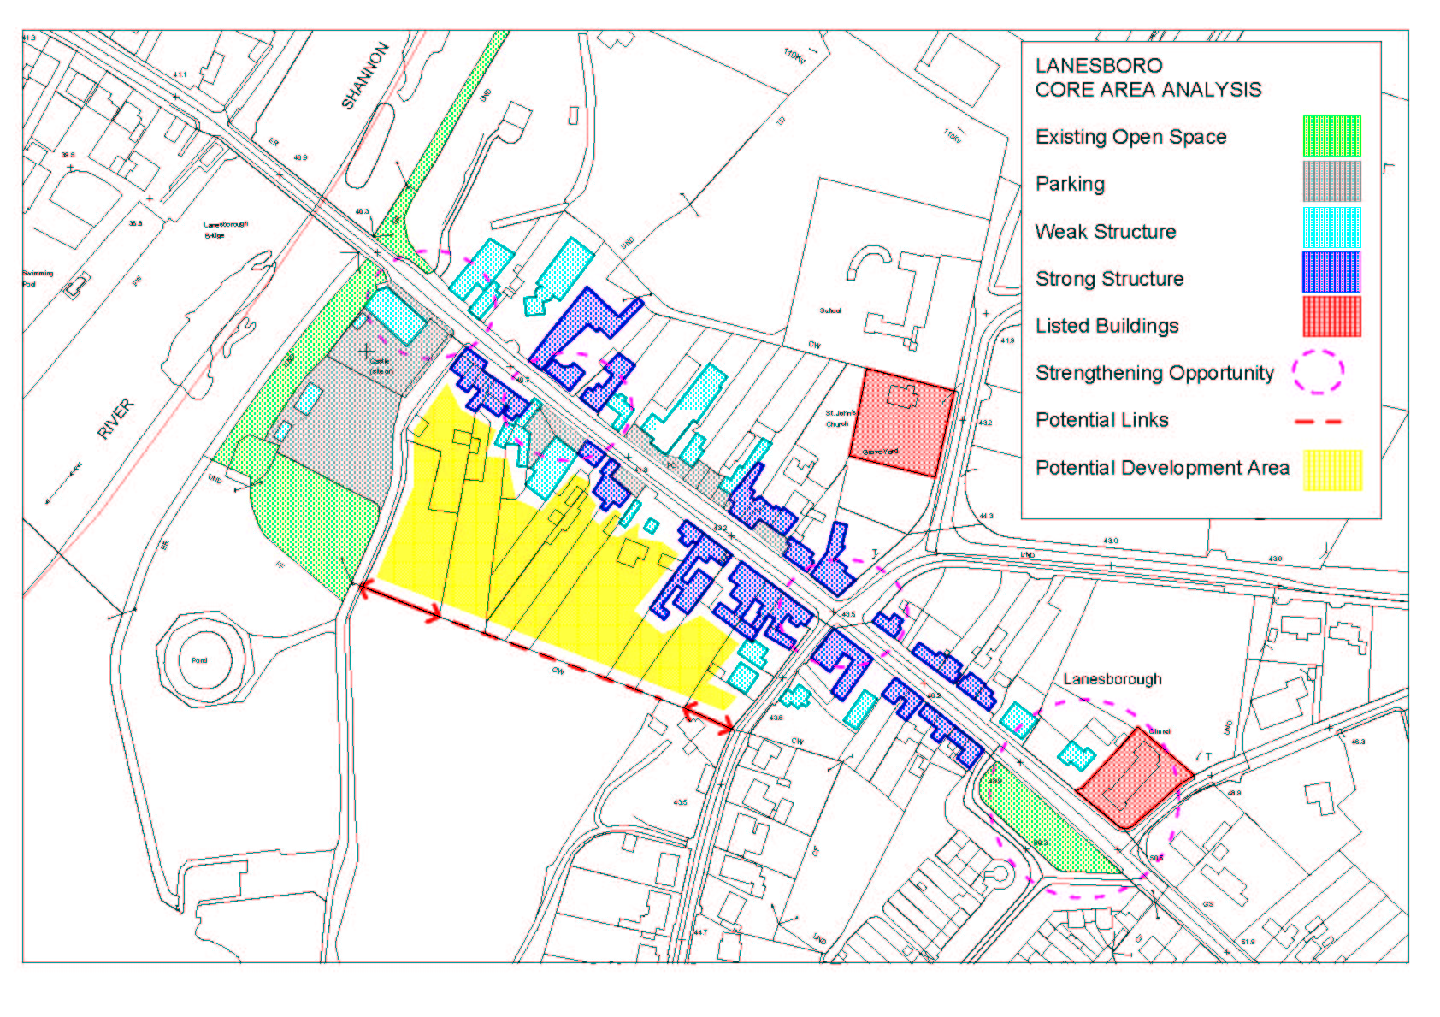
FIGURE 2
Area 1
Area 2
Area 3
Area 4

Character
Lanesboro has a unique character, derived from its position on the Shannon, the extensive community involvement in the development and maintenance of the town and the diverse mix of old and new that makes up its built form.

Landscape Setting
The town is located on the eastern bank of the river Shannon at the northern entrance to Lough Ree. Once a settlement of strategic importance, its role as the principal ford over the Shannon to the West was overtaken by Athlone in the middle ages.

The landscape setting is impressive, with views available to the south towards the islands in Lough Ree and picturesque views of the western bank, complete with moored pleasure craft and barges.

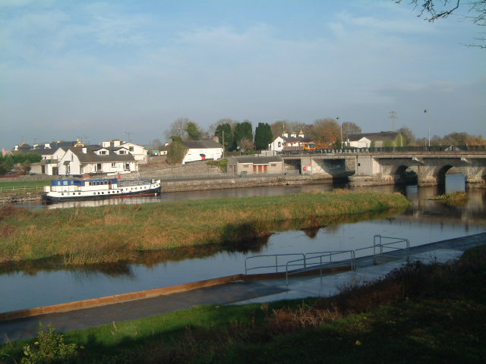
View across to western bank of the Shannon

Not yet developed to the extent of other settlements on the Shannon, Lanesboro retains an extensive area of amenity along its western extremity, consisting of riverside walks, open grassland park areas and wilderness areas designated under heritage legislation.

Extensive studies have been carried out on the Commons North area to the southwest of the town in terms of protection of natural heritage and the provision of passive amenity area for the town (see Appendix)

The power station exerts a substantial influence over the town in both physical and socio-economic terms. The visual effect of the station is currently even more pronounced as the new station is constructed and the old structure has yet to be decommissioned and removed. It terms of visual impact, the structure has become a local landmark, being visible from the N5 some 10 kilometres away, and as far as Sliabh Ban in the west, and appears to be accepted as part of the identity of the area. The impact of the large structure is even more pronounced due to the predominantly flat nature of the lake and peat land that surrounds it for miles in each direction. The lights required for aviation purposes on the towers make it particularly visible after dark.

In environmental terms, the sustainability of peat burning in general has been questioned and the future use for the station post-decommissioning in fifteen years time is still up for debate. However, the station does provide some beneficial environmental impacts, with the warm water discharge point from the station into the Shannon lengthening the angling season and creating an internationally renowned fishing area.

Investigation into the potential development of alternative energy sources is an issue of significance for the settlement, with the planned decommissioning of the power station in the medium term and the availability of large tracts of cut-away bog lands.

Morphology and Development
The origins of the settlement as a bridging point are ancient, with the form and structure that exists today dating from the late seventeenth century when the town was developed under the planter George Lane, from whom the Longford side of the settlement derives its name.

Several ruins remain on the outskirts of the town that illustrate the ancient importance of Beal Atha Liag as a crossing point from the East to the West of the Country, including Rathcline Castle to the South of the town and the Castle site behind the contemporary community centre. No built form remains of either of these castles, however, the remains of a walled garden dating from the seventeenth century are evident on the Rathcline site.

Community Groups/Organisations
Lanesboro is characterised by a strong and active community network, that has worked hard to maintain the town and its surrounds, promote tourism and angling and increase awareness of the unique and fragile environment in which the settlement is set and the important historical events that helped to shape it.

Many of these groups work in tandem with county and nationwide organisations such as FÁS, Leader, Longford County Tourism and Longford Community Resources Ltd. (LCRL).

Groups and organisations in the area are diverse and include the Lough Ree Development Co-operative, which promote development in the area and have commissioned reports such as the Area Action Plan for Rathcline and Kilgefin. Lough Ree Action Amenity group are based along the shores of the River Shannon and are also concerned with the development of Lanesboro, having carried out a survey in conjunction with Cathryn Hannon and worked extensively with the Tidy Towns Committee, for whom a report was prepared for the period 1991-’96 by Ann O’Leary and Associates.

Lanesboro Tourism Co-Op is a voluntary community organisation, which works towards the development and improvement of Lanesboro and its environs, as a tourist destination and as an enjoyable and picturesque location, in which to live and work.
Most recent projects completed by the tourism co-op include the development of River Shannon banks as an amenity area and angling facility, including the provision of disabled angling stands (in conjunction with Shannon Regional Fisheries Board, funded by the ESB) and the flood lighting of the town bridge and its arches.

Rathcline Heritage Society is instrumental in raising awareness of the rich and diverse history of the area, having recently published “Pathways to the Past” and “Lanesboro-Ballyleague – a living history”. Traditions are kept alive through the organisation of events such as heritage weekends and the annual horse fair, held every spring.

The importance of the natural history of the area is recognised through the work of groups such as the Commons North Conservation and Preservation Society and the organisation of events such as the environmental schools and Arts Festivals, held in conjunction with the ESB and the annual water festival, held in association with Bord na Mona.

Buildings and Structures
There are a wide variety of buildings and structures ranging over a wide period within the town.

Residential
The Green was developed by Bord na Mona in the fifties and is a classic example of architecture and urban design from this period. The houses are arranged around large green areas with no front boundary definition, which helps to provide a sense of proximity and community that is absent from many contemporary developments.

Another housing estate is under construction on the Longford road, which will cater for both social and affordable housing. A privately developed estate is also under construction on the Ballymahon Road near the site of the old windmill.

Individual housing units line either side of the Rathcline road, with several in front of the power station along the Longford road. In the centre of the town, residential units make up much of the built fabric along the Main Street, including those located above commercial or retail units.

Commercial
In tandem with the definition under the settlement strategy contained within the County Development Plan, services of a commercial nature within the town are provided to cater for local need, with several higher order functions, including car sales and boating merchandise outlets. The commercial development within the town is shown in Figure 3 below.

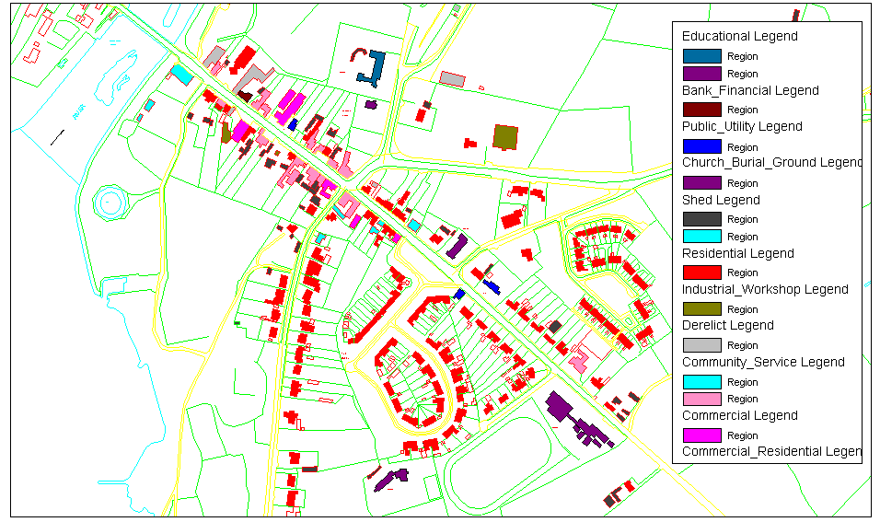

Community
Community uses are represented within the settlement in the form of the Community Centre, which is currently being refurbished. In addition, the Lanesboro Development Co-op is located along the Main Street.

The Midland Health Board have a health centre on the Rathcline road and There are primary and secondary educational facilities in Lanesboro, Located along the Ballymahon road and adjacent to the power station.

Public Realm
Small rural towns in the Midlands generally have a higher level of service provision than their population would suggest as the urban structure is generally quite weak, meaning that each serves a wide rural hinterland. Therefore, at any one time, a large proportion of the people using the town live some distance away and are there for a specific commercial, social or administrative purposes. These people generally drive into town, do their shopping or visit the post office, bank or health centre and drive home, not tending to linger. For this reason, the need for public circulation and amenity space has been limited and the level of provision has been commensurate with this demand.

With the designation of settlements for concentrated development under the County Development Plan, 2003-2009, one of the aims is to create a pleasant environment in which to live work and visit. This will require the upgrading and enhancement of the public realm in the town in tandem with the concentration of development and resultant increase in the population residing in the settlement.

Paths
Many of the paths throughout the town have been repaired in recent times and some upgraded to brick cobble lock. However, parking along the street has caused the kerbs to deteriorate in places, particularly in the core area and in the vicinity of the church.

No paths are evident to the parking area behind the community centre, which leads down to the amenity area for the town, perhaps indicative of the level and frequency of use of the area for parking. Paths along the Rathcline Road are in particularly poor repair.

Open Space
With the notable exception of the amenity area on the shores of Lough Ree, there are few areas of public open space within the town core. The lawn area to the front of the Green housing estate has little amenity potential due to its location and layout.

Potential had been identified in the above chapters for the strengthening of the urban structure, which would include the provision of circulation and passive recreation space in the urban setting.

Landscaping
Soft landscaping throughout the settlement is poor or absent, with the exception of the park like situation existing along the banks of the Shannon and Lough Ree which appears extensively used by locals for walking.

Hard surfacing along the street is poor and the street lacks a specific focal or gathering place where people can congregate. The Lough Ree Development co-operative has installed decorative lighting standards along the bridge, however, lighting standards and bollards throughout the town tend to be severe and solely functional in design.

Walkways
Walkways exist along the Shannon and desire lines have been established in the Commons North area, however, these have little connection with the town in either visual or psychological terms.

Development Pressure
Development pressure in the area would appear to be quite stable in comparison with other areas of the County. The effects of the Rural Renewal Tax Incentive Scheme, introduced in 1998, do not appear to be as pronounced as other Lakeland areas within the County, Lough Gowna in particular.

Studies have been carried out on the potential feasibility of tourism developments in the area, however, these developments have yet to come to fruition.

Development Potential
There is good scope for further development in Lanesboro. Several opportunities exist for the strengthening of the urban structure, have been outlined above, which could be carried out in conjunction with the development of the town.

The location of the town at the top of Lough Ree is an untapped resource, with vast potential for the development of amenity and leisure based facilities. However, this needs to be carried out in a very sensitive manner in order to avoid damage to the fragile ecosystems that exist in the area. The position of Lanesboro in close proximity to sites of natural, archaeological and cultural interest has yet to be exploited.

As previously discussed in the description of the area, the core area has been developed in a linear format, with development to the rear of the main street prevented due to lack of access. The establishment of an access to the rear of these buildings, from the existing parkland area to the Rathcline Road would maximise the development potential of the properties along the main street and potentially provide a double frontage which would take cognisance of the lakeside location and potential use of the existing or enhanced amenity area.

The potential for the sustainable re-use of the power station once decommissioned in 2018 is an area that should also be explored. Although outside the timescale of this plan, decisions on proposed land uses in the area should be sufficiently flexible and robust to cope with potential long-term changes in the local physical and socio-economic environment of the settlement. The location of an industrial park or similar development in close proximity to the power station may be appropriate in terms of economies of scale, relating to existing infrastructure, services and utilities.

Proposals

Design Principles

Local Character
At present, Lanesboro retains much of the character of a seventeenth century planted settlement, but bears little relationship to the adjacent river Shannon and Lough Ree. This plan aims to strengthen character in the following manner:

- Promote development that will fill gaps in the streetscape and strengthen horizontal and vertical building lines.
- Strengthen urban structure in the areas identified as weak in Figure 2.
- Increase the vibrancy of the settlement by opening up back lands to development
- Relate new developments to the River and Lake where possible, in a sensitive manner

In addition to this section, developments should take cognisance of the design standards contained in the County Development Plan 2003-2009 (see Appendix 2), relating to materials, access density etc.

Densities
Densities of new residential development will be considered between 12 and 20 to the hectare. This is considered suitable in an area designated as a local growth centre, however, higher density developments will be considered in the area outlined as the commercial core (see Figure 3) and where designed and finished to a high quality.

Similarly, lower density developments may be suitable in certain areas, where it can be demonstrated that the nature of the development requires it, for example, in the case of sheltered housing provision. In general, lower densities are considered more suitable to those areas within the development boundary of the town that are located outside of the core as shown in Figure 3.

Access and Circulation
One of the central aims of this Plan is to enhance and promote the vitality and vibrancy of the core area of Lanesboro. As discussed in previous sections, conflict between through traffic and parked cars is a major issue in Lanesboro, particularly at peak times. In addition, parking on footpaths and within the realm of the pedestrian has a negative impact on the human scale of the settlement and damages kerbs and footpaths.

It is proposed as part of this plan that a new access road to the rear of the Main Street be established, connecting the car-park at the community centre with the Rathcline Road. It is envisaged that this will reduce congestion in the town centre in the following ways:

- Rationalise parking along the Main Street
- Provide an alternative route of entry and exit onto the Rathcline Road
- Provide a double frontage to the Main Street and increase permeability between the main thoroughfare and the lake/river area.
- Provide an additional car-parking area to the rear of the Main Street

In addition, there may be potential to provide accessibility between the Rathcline Road and the Ballymahon Road, and the Ballymahon Road and the Longford Road. These options will be considered in the medium to long term and in the assessment of applications for planning permission to develop these areas.

Commercial Development
This plan supports commercial development in appropriate areas as outlined under the following sections. The aim is to promote and encourage the vibrancy and vitality of the core area for as much of the day as possible, and, as such, mixing of compatible uses will be encouraged where appropriate.

Services and Facilities
Water supply in the Lanesboro area is operating with spare capacity at present, the main limiting factor to substantial development in the area being the sewerage system, which is located adjacent to the lake and in need of upgrading. Roscommon County Council are currently in the process of upgrading sewerage facilities in Ballyleague and the potential is currently being explored for the installation of a system that will serve the settlement on both sides of the river.

Amenities and Recreation
As previously stated, the location of Lanesboro offers many advantages in terms of the provision of amenities and recreation. The County Development Plan, 2003-2009 outlines areas for the development of “honey pot” tourism facilities and names Lanesboro specifically as an area of high potential. This plan aims to build on this potential through the designation of two high profile sites within the town for the development of a suitable facility.

Open Spaces
Open spaces throughout the town, with the exception of the river/lake side are generally limited to the spaces contained within housing estates. The area to the front of the Green is an attractive open space in a prominent location that may provide a valuable congregation area with limited works.

Zonings

To be read in conjunction with attached Zoning Map

Commercial Core
This area is the heart of Lanesboro where the majority of the town’s functions take place. The aim of this zoning is to facilitate and enhance this range of functions and to provide a vibrant town centre throughout the day and evening.

Mixed commercial, office, retailing and residential uses are considered appropriate in this area and access to and development of back lands will be promoted where feasible and particularly where this facilitates the other development objectives in this section, including the provision of the access/roadway and parking facilities to the rear of the Main Street.

Social/Community
This zoning covers the educational, community, religious ant other social and community uses within the town. Provision will be made where necessary for the expansion of these areas into adjacent commercial or residentially zoned areas where required and where existing uses are compatible.

Residential
Residential uses will be promoted in areas zoned within the town. This zoned area will also facilitate the provision of other neighbourhood level facilities such as crèches and local convenience retailing.

All residential development shall be designed to a high standard. Materials, layout and aspect shall reflect the character of the town and its lakeside location.

Densities shall be in the region of 12 – 20 to the hectare, subject to design criteria and suitability of layout. Layouts shall be designed to maximise residential amenity, promote the development and enhancement, where appropriate, of identity and character and facilitate existing and future vehicular and traffic circulation within Lanesboro. The Local Authority may prescribe lower densities where it is considered that these are desirable in the context of an overall layout for the area.

All residential development shall be carried out in tandem with the provision of suitable pedestrian facilities including lighting and footpaths. Access to recreational facilities, including existing walking or amenity routes will be provided where these are within reasonable proximity.

Industrial/Commercial
The industrial zoning is located primarily to the north of the town in the vicinity of the power station. The Local Authority will promote the continued use of the site for electricity generation and the future development of suitable industries in order to provide an employment base of the population of the town and its wider hinterland.

Recreational
Improvement and enhancement of walkways and the installation of appropriately designed signage throughout the amenity areas will be promoted.

The potential for the provision of a children’s play area in an appropriate location will be investigated over the plan period.

This zoning is primarily located along the shores of the Shannon, with a portion located at the Green in front of the Church on the Ballymahon Road. The purpose of this zoning is to provide amenity facilities for the town and its hinterland and to further develop the tourism industry in the area. This zoning is divided into the following areas:

The Green
The Green housing area is an integral part of the identity of Lanesboro, having been built by Bord na Mona in the 1950’s. The Church opposite, which is a listed building, and the elevated nature of site add to the prominence of the grassed area, making it a natural congregation and gathering area. The addition of identifying features in this area, such as bog oak sculptures and seating, would provide the basis for development of a functional congregation area in the town.

Seating at this point would be important, particularly for older people who may need to rest on the relatively steep walk from the main area of the town. The existing mature trees and planting would mean that the works required to improve this area would be minimal.

The Riverside
The area along the banks of the Shannon is extensively used at present by locals and non-locals alike for passive and active recreational purposes. The connections from the riverside with the Commons North area adjacent make it a popular walking route, while the presence of the internationally renowned “hot-water stretch” make a highly regarded angling location. Local organisations have recently succeeded in installing fishing stands for disabled anglers, a well needed addition to the amenity potential of the banks.

The profile of the settlement from the river/lake is very low, with only the rears of the properties on the Main Street, the Leylandii planting the side of the community centre and the car park visible from the shores. Further exploration of the amenity potential of the banks will be investigated, including the potential of extending the walking area to the north of the bridge.

Development to the rear of the Main Street will be encouraged in a manner that enhances the riverside location, including the installation of native riverside planting to replace existing non-native hedging in particular.

The Car park and Lancashire Field
These are prominently located adjacent to the river with strong potential for the development of high profile leisure and amenity facilities with a possible element of interpretation and environmental education.

Development of this area could include the provision of a hotel/leisure centre with conference facilities with potential for an integrated interpretative centre. In any case, development in this area must be of the highest quality with due regard given to the sensitivity of the location. This will include a high quality finish with carefully designed form, scale, design and materials to blend in with the surrounding landscape. Layout and location of parking and ancillary facilities will be an important element in the design of any proposed development in this location.

Location of water sports and other active recreational facilities will be considered in this area, subject to stringent design criteria due to the sensitivity of the location.

High design standards will be required for the proposed leisure and amenity development, respecting the high profile and scenic location. This will include siting criteria that will minimise the intrusion of the new structure into the existing lakeshore setting and the sensitive use of design and materials to successfully incorporate the structure and its ancillary facilities into the surrounding landscape.

Protected Area/Passive Amenity
This area forms part of the NHA/SAC of the Lough Ree area, which is also protected under the County Development Plan, 2003-2009. The aim of this zoning will be to protect this area from unsuitable development, while enhancing its potential to continue as a valuable recreational and educational resource for Lanesboro.

This may involve the repair and maintenance of signage and footpaths throughout the area, management and enhancement of the ecological attributes of the area and maintenance of these activities in a way that does not compromise environmental or ecological integrity.

Signage is an important element that will help to raise awareness of the importance of the area over a wide range of disciplines from geology to ecology and ornithology. This should be designed in keeping with its surroundings. Similarly, footways should be simple and cause minimal intrusion into the landscape.

Potential Roadway/Access
Potential access have been identified in the following areas of the town, however it should be noted that the lines shown are indicative only and are subject to change in line with any proposed development in the areas concerned.

It should be noted that the road lines as shown on the attached zoning map are indicative only. The preferred method of achieving these routes is through the development control process and as conditions attached to future planning permissions.

The Planning Section will continue to work closely with the Road Design Section to promote a safer and more attractive environment for all road users.

Rear of Main Street
This area is located to the southern side of the Main Street, adjacent to the existing car parking area and Lough Ree.

Pedestrian access from the proposed parking area to the Main Street will be promoted in tandem with development in this area to further develop and enhance the vibrancy of the commercial core.

Access in this area of the town is crucial in order to provide development that will relate to the riverside location and also to provide potential parking area for the Main Street. The area as shown would open up the rear of properties along the main street and provide much needed double frontage. Suitable developments would be of a type specified in the commercial core zonings, subject to compatibility with adjacent conforming land uses and other relevant planning criteria.

Rathcline Road to Ballymahon Road
The potential for the development of this access is dependant on the development of the area involved and the application of relevant roads standards. An access in this area would help to remove the pressure off the existing junction of the N63/R392 with the Rathcline Road, while opening the intervening lands for development.

Ballymahon Road to Longford Road
This would also remove pressure from the main junction of the town, increase permeability in a north-south direction and would be progressed through the development control process.

Environmental Improvements
In those areas designated as Environmental Improvements 1 on Figure 3, footpath, lighting and parking improvements are currently being progressed. This is being carried out under the Urban and Village Renewal Scheme, in tandem with a traffic safety plan by the Road Design Section of Longford County Council. This will include the under grounding of overhead wiring in the area shown and the installation of decorative lighting standards.

In areas shown as Environmental Improvements 2, improvement and installation of pedestrian facilities, including footpaths and lighting will be progressed.

Likely Significant Effects on the Environment
For the purposes of this plan, a matrix similar to that uses in the Longford County Development Plan, 2003 –2009 has been used to assess the different objectives of the Plan, in this case, the zoning objectives, against a set of defined environmental criteria.

Environmental Aims
The following environmental aims are used to assess the zoning objectives contained within this local area plan

- The encouragement of sustainable transport

- The minimisation of waste and minimisation of pollution

- The conservation and enhancement of biodiversity and natural heritage

- The conservation of architectural, archaeological, geological, cultural and historical heritage of the County

- Rationalisation of the use of natural resources and promotion of renewable energy resources and encouragement of energy efficiency

- Protection of Landscape

Assessment of Objectives Against Environmental Aims

This exercise aims to illustrate the potential impact on the environment of the implementation of the zoning objectives outlined in this LAP
Legend:  Beneficial |Neutral  Negative

 | Environmental Aims
Zoning Objectives |  |  |  |  |  | 
- Commercial Core |  |  | | |  |  | |
- Social/Community |  |  | | | a | a | |
- Residential | a | a | a | | | | | a
- Industrial/Commercial | | | | | a | | | | | |
- Recreational | | | | | | | a | a | a
- Protected Areas/Passive Amenity | | | | | a | | | a | a
- Potential Roadway/Access | ❒ | ❒ | ❒ | | | | | ❒
- Environmental Improvements | a | | | a | a | | | a
The consolidation of development within a defined village envelope is likely to result in neutral or positive benefits on most of the environmental criteria. Most negative impacts are likely to arise in relation to the development of additional roadways, which may promote further private motorised transport and significantly alter the local landscape and the availability of habitats and corridors for wildlife. It is important that these potentially negative aspects are addressed at the planning stage and mitigation measures implemented where possible.

“The Buildings of Ireland – North Leister” Christine Casey and Alistair Rowan, 1993 Penguin, London.

