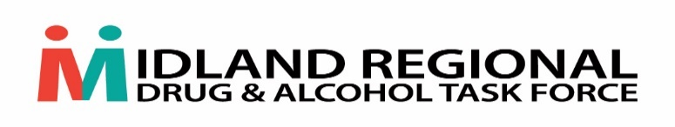

**Midland Regional Drug & Alcohol Task Force (MRDATF)**

**Small Grant Fund 2022**

**Terms & Conditions**

* Small Grant Funding is an annual once off allocation in 2022
* Applications will be accepted from Groups/Projects based within the MRDATF catchment area ie. Laois, Offaly, Longford & Westmeath
* Grants will be awarded to Groups/Projects working in the Community & Voluntary sector and not individuals. Applications will not be accepted from the Statutory sector
* Each applicant can apply for funding between €6,000 - €30,000

As this is a once off funding initiative please note the following:

* Applications must be linked to an identified action in the National Drug & Alcohol Strategy – Reducing Harm Supporting Recovery. A health-led response to drug and alcohol use in Ireland 2017-2025
* Applications cannot be submitted to support pay costs for existing/new staff members
* Applications will be accepted to support **once off initiatives only** eg. drug and alcohol related training initiatives, purchase of resources, facilitation costs, purchase of once off equipment etc
* Funding will be allocated in Q4 2022 and must be spent by the end of Q2 2023
* Applicants must specify in their application a clear plan on how they propose to utilise the resources
* Application must be accompanied by a detailed breakdown of costs
* All sections of the application form must be completed
* Progress report will be required to be submitted to the MRDATF in Q3 2023 to report on the funding initiative to include relevant outcomes & financial reporting
* Successful applicants will be required to complete and sign a HSE Application for funding form & 2022 HSE Grant Aid Agreement to govern this funding and submit relevant paperwork as required as part of this process
* MRDATF as the funder must be acknowledged on all materials/resources etc that may be developed as part of this funding initiative
* The MRDATF Finance & Governance Sub Committee will review applications received and make recommendations to the MRDATF Committee
* All applications will be given due consideration and decisions will be based on the detail of information supplied in the application form and attached financial breakdown
* Late applications will not be accepted

*Completed applications to be submitted by post to Teresa Murphy, MRDATF, Health Centre, Coosan Road, Athlone, Co Westmeath or by email:* [*Teresa.murphy8@hse.ie*](mailto:Teresa.murphy8@hse.ie)*. Closing date for receipt of applications is* ***Friday 9th December 2022 at 5pm.***

