Logging into the system
Once you click on the link to the form you will get to the following login page. If you already have an account or have been supplied a password then Enter your email address and password and click sign in. If you have not already got an account then click on Create an account. You can also go directly to the online portal at https://iapp.itouchvision.com/iappcustomer/. From here you can click on the Login or Register button in the top right to login.
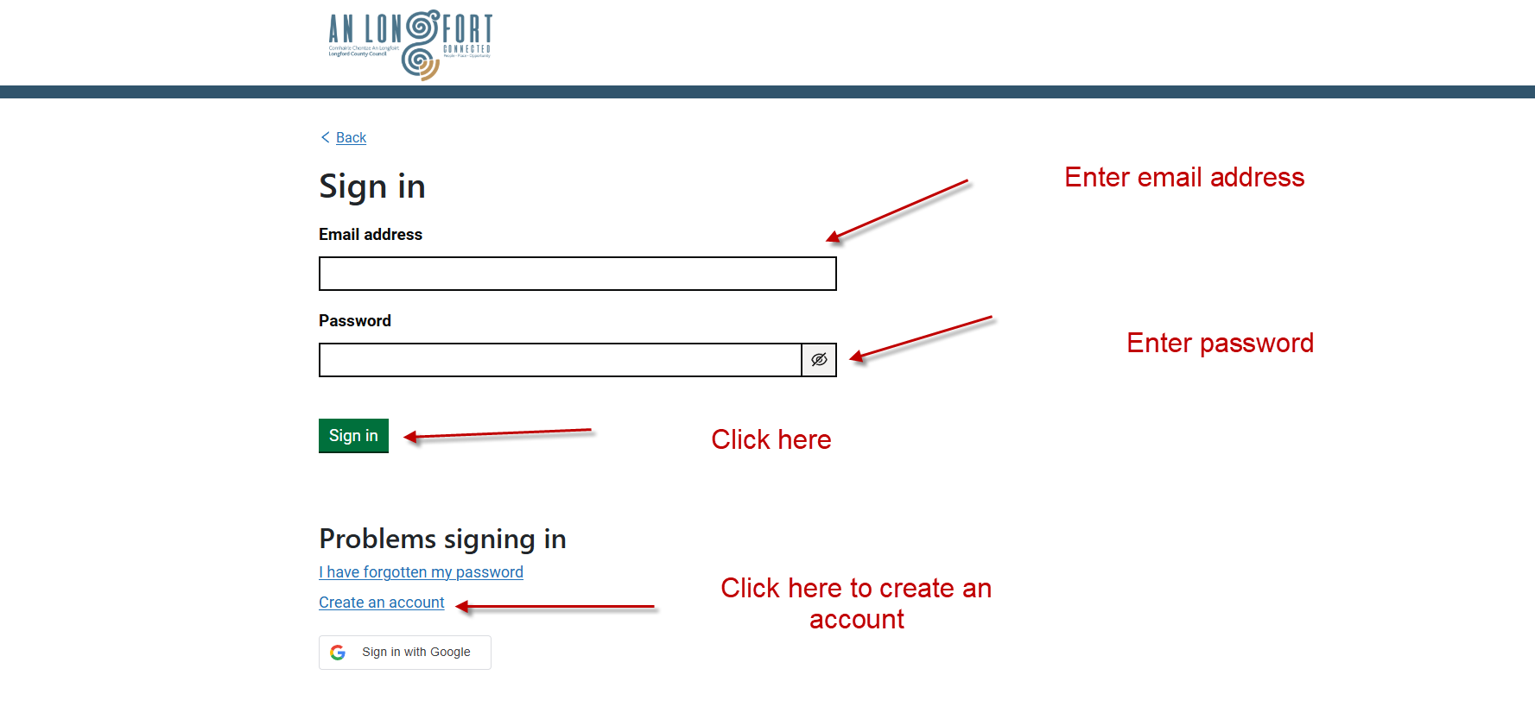
To Create a New Account
Once you click on Create an account you will get the below page to register
Put in the email and First and Last name
Create a password and confirm it and then tick the box to agree to the terms and conditions
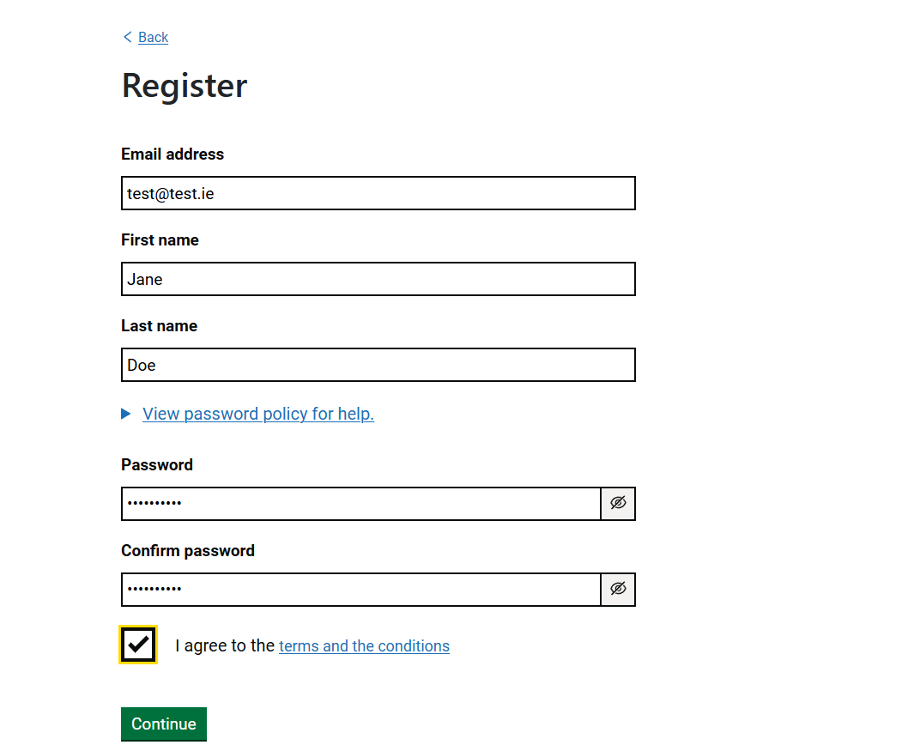
You will be asked for a phone number which should be a mobile number
Enter an Eircode and click on Find and then select the address from the drop down list
If for some reason the address is not found tick the box Address not found and you can manually enter an address
If you are completing an application on behalf of a Community Group/School or other organisation then tick the box beside I am a part of an organisation
Once setup you can continue on to the form

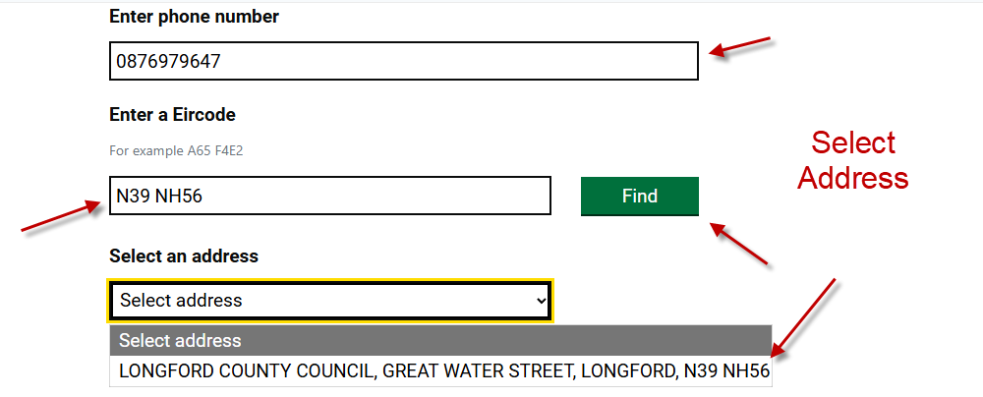
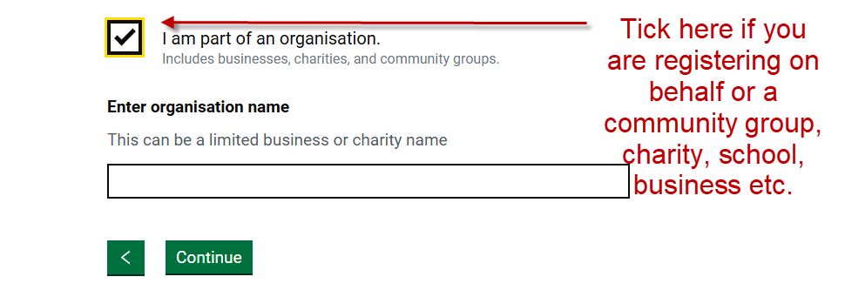
You will then be asked to Enter the organisation name

Press Continue
You will then be asked to Activate your email account.
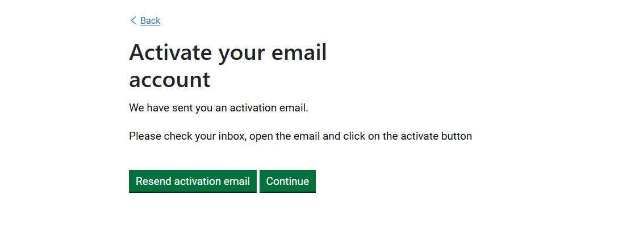
You should receive an email to the address used to register above with an Activate button. Once you click on that you will be brought to a page telling you your email is activated see below.

Press Continue and you will be brought to the sign in page where you should use the email address you used to register and the password you setup to sign in.
You will then get to the Multifactor authentication page where you will need to click on Validate to send a code to your registered email address. Once you get the email enter it on the screen and click on Continue.
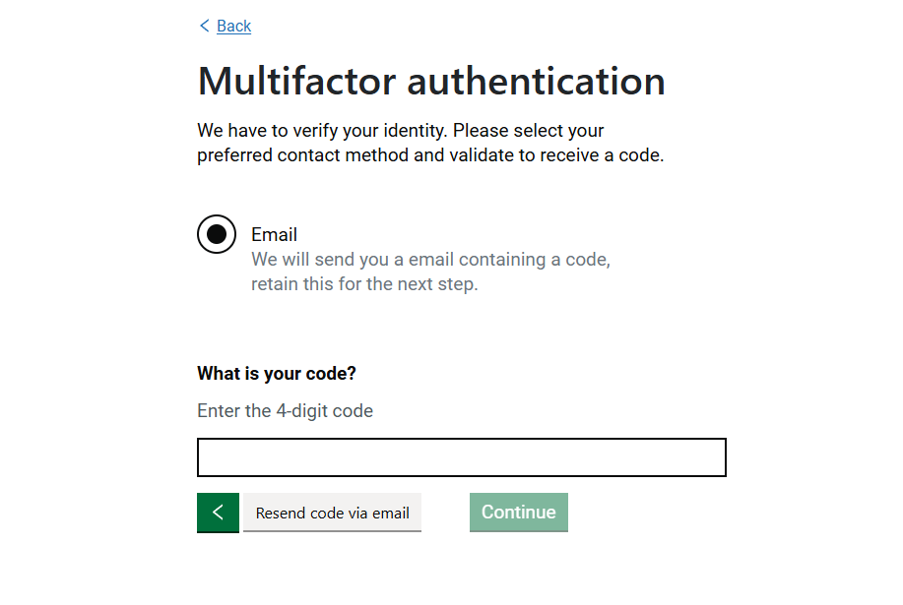
Once you press Continue you will be into the portal or the form you were trying to fill in.

