
LONGFORD COUNTY COUNCIL
Dangerous Substances Act 1972
Dangerous Substances (Flammable Liquids and Fuels Retail Stores) Regulations, 2019 Schedule 2 (Regulation 12)
For Office Use

Date Received: _______________________ Receipt No: __________________________

Register Reference: ___________________ Planning Reference: ___________________

Fee Received Date: ___________________ Premises Number: ____________________

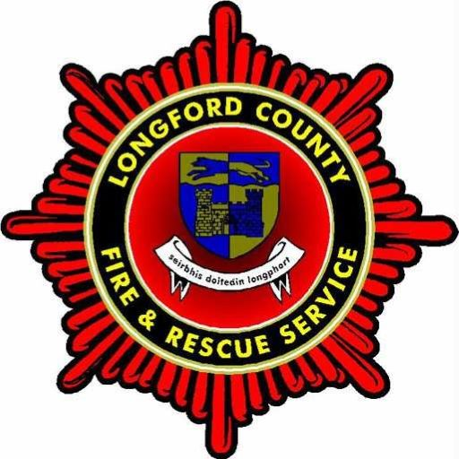

Application for:

First licence o Retail Store o
Amended licence o Kerbside Retail Store o
Renewal of a licence o
Transfer of a licence o

Proposed Period for This Licence 1 Year o 2 Years o 3 Years o

Existing Licence No. (If Applicable) _______________

1. Applicant/Licensee/Owner or Operator:

Name and address/registered office of the company, firm or person: - ___________________

___________________________________________________________________________
___________________________________________________________________________
___________________________________________________________________________

____________________________________________________

Phone No._________________ Eircode. ________________

2. Location of the proposed retail store or current kerbside retail store: -

Address _____________________________________________________________________

County ______________________________________________________________________

Place or Townland _____________________________________________________________

Ordnance Survey Map reference __________________ Eircode. _________________

3. Name of Consultant/Designer:

Name and address of person(s) or firm(s) responsible for preparation of accompanying
plans, calculations and specifications: -

_________________________________________________________________________________

_________________________________________________________________________________

Email: ______________________________________________ Phone No._________________

4. Name of licensee/owner or operator (if application is for transfer of a licence or certificate of Operation):

_________________________________________________________________________________

___________________________________________________________________________________________________________________________________________________________________

_________________________________________________________________________________

5. Particulars of Plans accompanying this application (may be detailed on separate sheet):

__________________________________________________________________________________

__________________________________________________________________________________

__________________________________________________________________________________

6. Maximum quantity of Category or Categories of flammable liquids stored or to be stored at
the store: -

Category 1: _______ litres in container stores Category 2: ______ litres in container stores

_______ litres in underground tanks ______ litres in underground tanks

_______ litres in aboveground tanks ______ litres in aboveground tanks

Category 3: _______ litres in container stores Total Capacity of Stores: ________________

_______ litres in underground tanks

_______ litres in aboveground tanks

Declaration

I, ______________________________, hereby certify that the information supplied above is true to the best of my knowledge and belief.

Signature of applicant: _____________________________________________________________

Postal address of applicant: ________________________________________________________

_________________________________________________________________________________

Date of application: ________________________________________________________________

7. Other Fuels (State units measurement) e.g. Hydrogen, LPG or caged gas cylinders etc: -

Name of Fuel: _______________________ Name of Fuel: _________________________
______ litres in container stores ______ litres in container stores

______ litres in underground tanks ______ litres in underground tanks

______ litres in aboveground tanks ______ litres in aboveground tanks

Name of Fuel: _______________________ Name of Fuel: _________________________
______ litres in container stores ______ litres in container stores

______ litres in underground tanks ______ litres in underground tanks

______ litres in aboveground tanks ______ litres in aboveground tanks

8. Amount of fee (accompanying this application): -

Proposed Period For This Licence 1 Year o 2 Years o 3 Years o

Annual Fee € ________________________________________________________

Administration Fee € 130.00__________________________________________________

Total Fee € _______________________________________________________

This licence/Certificate of Operation must be accompanied by a risk assessment and drawings as laid out in Regulation 17 and Schedule 6 of the Dangerous Substances (Flammable Liquids and Fuels Distribution and Commercial Supply Stores) Regulations, 2019.

9. Remarks: _____________________________________________________________________

