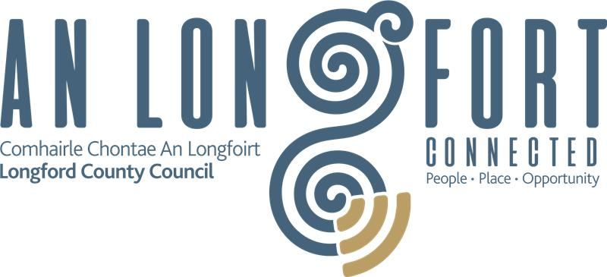

**Affordable Purchase Scheme**

**Document Checklist**

|  |  |
| --- | --- |
| **Application Type** | If you are married or cohabiting, you will need to make a joint application on the portal and the loan Approval In Principle (AIP) letter will need to be in both of your names. |
| **Photographic ID** | Valid Passport or Passport Card |
| **Proof of Right to Reside in Ireland** | For non-EU applicants, valid copy of Irish Resident Permit, indicating stamp/permission type (e.g. Stamp 4, 1G etc) |
| **Income PAYE Employees** | Salary Certificate completed by your employer, dated within the last 3 months and Employment Detail Summary, (previously known as P60) which is available from [www.revenue.ie/MyAccount](http://www.revenue.ie/MyAccount) |
| **Income Self Employed** | Documents for the previous 2 years to include Audited/Certified accounts, Current Tax Balancing Statement and Current Preliminary Revenue Tax Payment Receipt |
| **Income Social Welfare** | Statement of total benefits received from Social Welfare for previous 12 months. This may be requested via email from your local Social Welfare/Intreo office. |
| **Proof of Finance** | Loan Approval in Principle (AIP) letter from a lender or screenshot from a loan calculator. Applicants with Loan Calculator MUST have Loan Approval in Principle at the time of assessment. If you have not already applied for a mortgage, you should do so now. Your Loan Approval in Principle letter should be valid and in date. An AIP must be from a pillar bank. Pillar Banks are: Bank of Ireland, AIB, PTSB, Haven, EBS or Local Authority Home Loan.  Your Approved Mortgage amount should be four times your gross household income. Applicants with a mortgage approval amount less than four times their income are required under the Affordable Housing Legislation to show that they have maximised their mortgage capacity (i.e. have borrowed as much as they are eligible for). |
| **First Time Buyer** | Help to Buy completed application, confirming approval. If you have not already applied for Help to Buy, you should do so now, at Revenue.ie Your Help to Buy application approval must include name(s) of applicant(s) with PPSN, maximum entitlement under the scheme and expiry date. (Applicants are considered first-time-buyers only if BOTH are buying their home for the first time.) |
| **Proof of Savings** | Current statements for all Bank current accounts, saving accounts, Revolut accounts, Credit Union accounts & An Post accounts etc. for applicant(s). |
| **Fresh Start Principle** | Applicants who believe they may qualify under the Fresh Start Principle (e.g. Legal separation/divorce documents/ bankruptcy or personal insolvency etc.) should contact affordablehousing@corkcoco.ie for further information. |
| **Proof of Address** | Any one of the following documents: Current bank statement/credit union statement or utility bill (electricity, gas, internet mobile phone or telephone), clearly showing your name and address and dated within the last 3 months. |

Example of type of Document - image type files only, e.g. JPEG, PDF, PNG