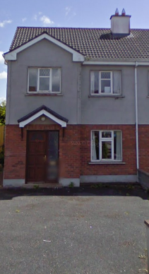–

*Choice Based Letting*

The following property is available for Choice Based Letting **64 Ardnacassa Avenue, Longford, Co. Longford**

To apply for this property please complete a [Choice Based Letting Expression of Interest Form](http://www.longfordcoco.ie/Services/Housing/Housing-Forms/General/Choice-Based-Letting-Expression-of-Interest-Form.docx) available by contacting [housingofficer@longfordcoco.ie](mailto:housingofficer@longfordcoco.ie) , phoning 043 3343499 or to download at <https://www.longfordcoco.ie/services/housing/choice-based-letting/choice-based-letting-expression-of-interest-form.docx>

Only qualified applicants whose requirements are for 3 bedroom accommodation will be considered for this property.

**Furnishings and white goods are not provided.**

**Features**

**• 3 Bed Semi-Detached, 2 Storey, Family Residence**

**• Kitchen/Dining Room**

**• Sitting Room**

**• 1 Upstairs Bathroom**

**• Double Glazed Windows and Doors**

**• Large Fenced Garden**

**• Oil Fired Central Heating**

**• Off Street Parking**

**• Tarmac Driveway**

**!!!**

**Closing Date for expressions of interest for this property is 3pm on 25th June 2021**

-

[housingofficer@longfordcoco.ie](mailto:housingofficer@longfordcoco.ie)  
[www.longfordcoco.ie](http://www.longfordcoco.ie)

043 33 43499

