COVER PAGE
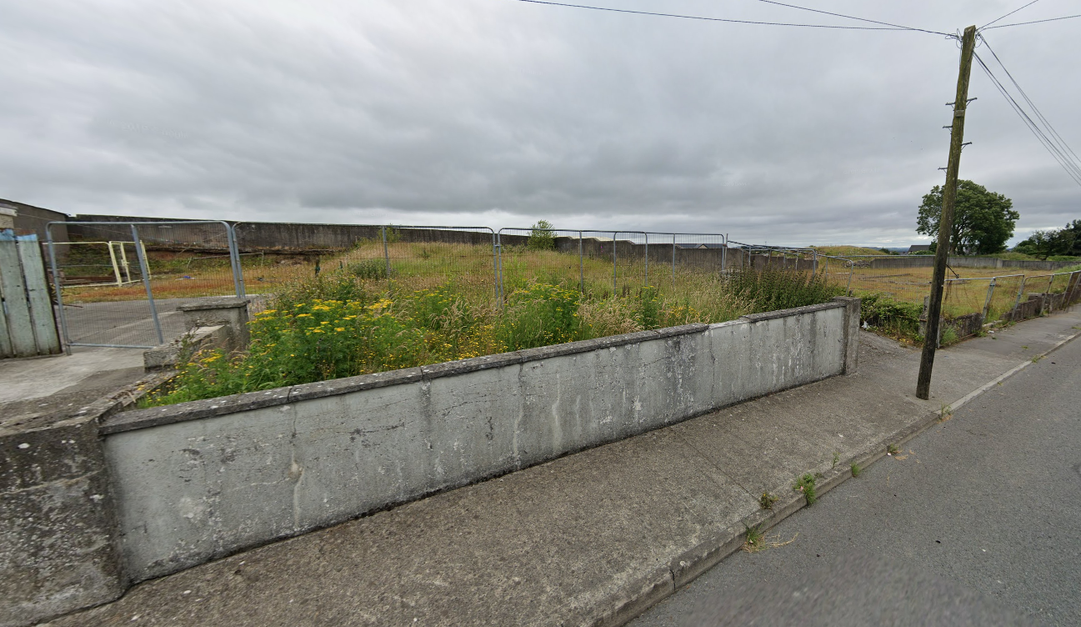
Construction of 2 no. bungalow dwelling houses, repositioning and creation of new vehicular entrance, removal of existing slab foundation, and all necessary ancillary site development works at Colmcille Terrace, Granard, Longford.

SCHEDULE
- Development Description
- Newspaper Notice
- Site Notice
- Appropriate Assessment Screening Report
- Site Location Map
- Existing & Proposed Site Plan
- Proposed Plans, Sections and Elevations
- Proposed Site Layout Drawing

