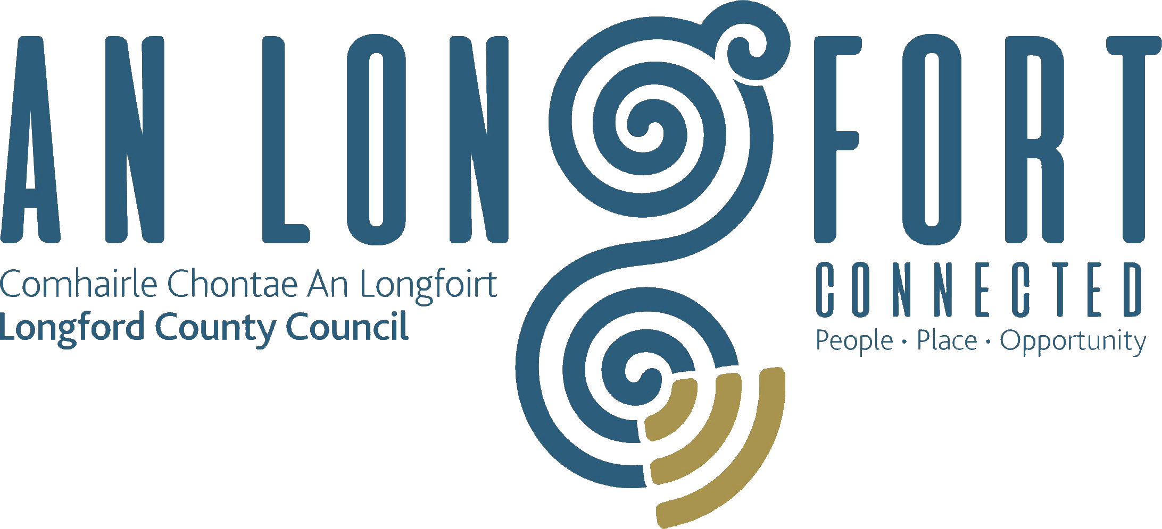

Extract from Minutes of Meeting of Longford Municipal District held on Wednesday, 23 November 2022.

Consideration of Part VIII No 100 – Proposed Skatepark with Royal Canal Greenway connection at the Old Greyhound Track, Townparks, Longford. Report in accordance with Section 179 of the Planning and Development Act 2000 (as amended) and Part 8 of the Planning & Development Regulations 2001 (as amended) – enclosed.

On the proposal of Councillor Uruemu Adejinmi and seconded by Councillor Gerry Warnock it was unanimously agreed to adopt the Part VIII, No 100 – Proposed Skatepark with Royal Canal Greenway connection at the Old Greyhound Track, Townparks, Longford. Report in accordance with Section 179 of the Planning and Development Act 2000 (as amended) and Part 8 of the Planning & Development Regulations 2001 (as amended) as circulated.

Ann Marie Mc Keon
Signed: ___________________ Date: 23 November 2022.
Ann Marie McKeon,
Meetings Administrator.



