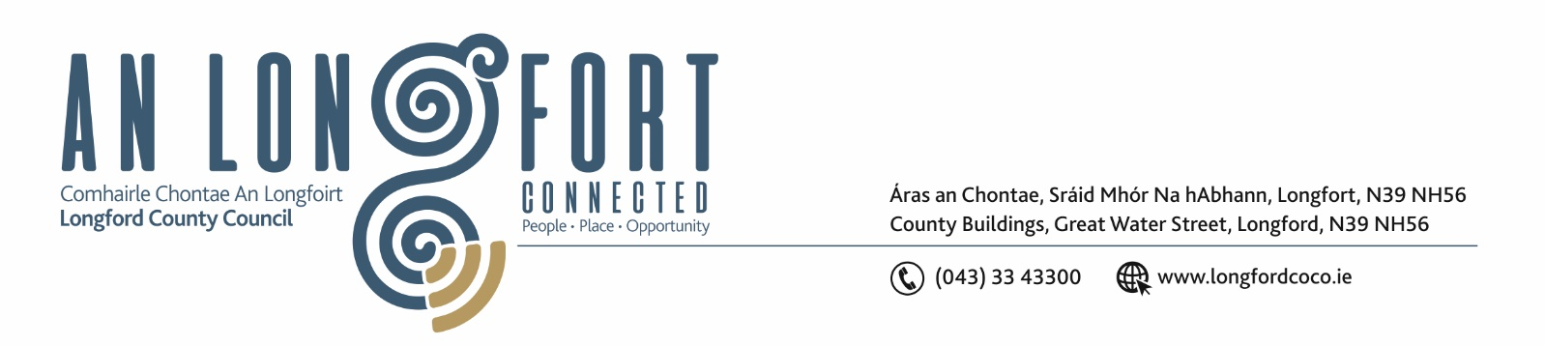

Extract from Minutes of Meeting of Longford Municipal District held on Wednesday 27 April 2022.

CONSIDERATION OF ADOPTION OF PART 8, NUMBER 89 IN
ACCORDANCE WITH SECTION 179 OF THE PLANNING AND
DEVELOPMENT ACT 2000 (AS AMENDED) AND PART 8 OF THE
PLANNING & DEVELOPMENT REGULATIONS 2001 (AS AMENDED) –
PROPOSED ALTERATIONS AND EXTENSION TO NUMBER 24
CONGRESS TERRACE AND CONSTRUCTION OF NEW SEMI-DETACHED
2 STOREY 3 BED UNIT TO SIDE/REAR GARDEN AREA AND ALL
ASSOCIATED SITE WORKS AT 24 CONGRESS TERRACE, ST.
MICHAEL’S ROAD, TOWNSPARK, LONGFORD – AS CIRCULATED.

On the proposal of Councillor Seamus Butler, seconded by Councillor John Browne
the members unanimously agreed the adoption of Part 8, number 89 in accordance
with Section 179 of the Planning and Development Act 2002 (as amended) and Part 8
of the Planning and Development Regulations 2001 (as amended) – Proposed
alterations and extension to number 24 Congress Terrace and construction of new
semi-detached 2 storey 3 bed unit to side/rear garden area and all associated site
works at 24 Congress Terrace, St. Michael’s Roads, Townspark, Longford – as
circulated.

Ann Marie Mc Keon
Signed: ___________________ Date: 27 APRIL 2022
Ann Marie Mc Keon,
Meetings Administrator.



