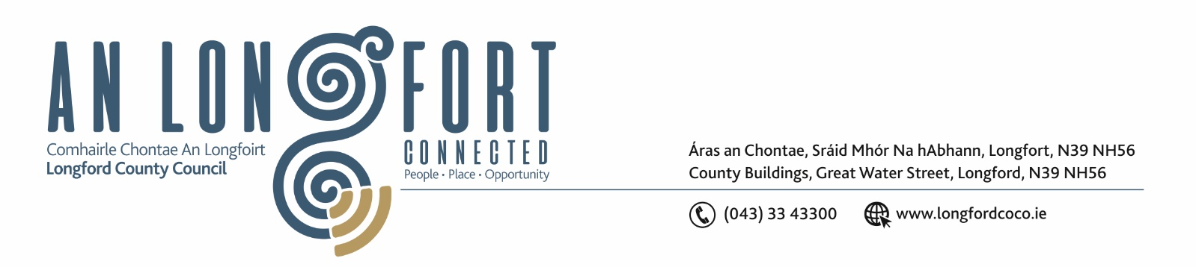

Extract from Minutes of Meeting of Longford Municipal District held on Wednesday 22 June 2022.

Consideration of Part VIII – Number 91- Conversion of an existing former healthcare facility to two number two-bedroom dwellings and all ancillary works at 2 Woodview, Newtownforbes County Longford in Accordance with Section 179 of the Planning and Development Act 2000 (as amended) and Part 8 of the Planning & Development Regulations 2001 (as amended) – as circulated

On the proposal of Councillor John Browne, seconded by Councillor Martin Monaghan the
members unanimously agreed to adopt the Part VIII Number 91 Conversion of an existing
former healthcare facility to two number two-bedroom dwelling as per report circulated

Ann Marie Mc Keon
Signed: ___________________ Date: 22 June 2022
Ann Marie Mc Keon,
Meetings Administrator.



