Proposed Variation to Longford County Development Plan 2015-2022 (Variation No. 2) to :
- Incorporate the provisions of Longford Town and Environs Local Area Plan 2016-2022 as adopted, at Appendix 1A (replacing current mapping and Text)
The purpose of the proposed variation is to provide for the areas to be covered by the Longford Town and Environs LAP within the CDP. This LAP will consolidate the zoning regime in Longford Town and Environs and provide an overall planning framework in the context of recent local government reform, incorporating zoning provisions for the Town and Environs area under the current county development Plan (CDP), town development Plan, northern environs LAP and southern environs LAP. This LAP will also provide for Masterplan areas to promote the physical, social, economic and environmental development of Longford Town in line with its designated position within the settlement hierarchy at National, Regional and County Level.
The LAP has been subject to detailed Strategic Environmental Assessment (SEA), Appropriate Assessment (AA) and Strategic Flood Risk Assessment (SFRA) processes.
The area concerned is outlined hereunder:
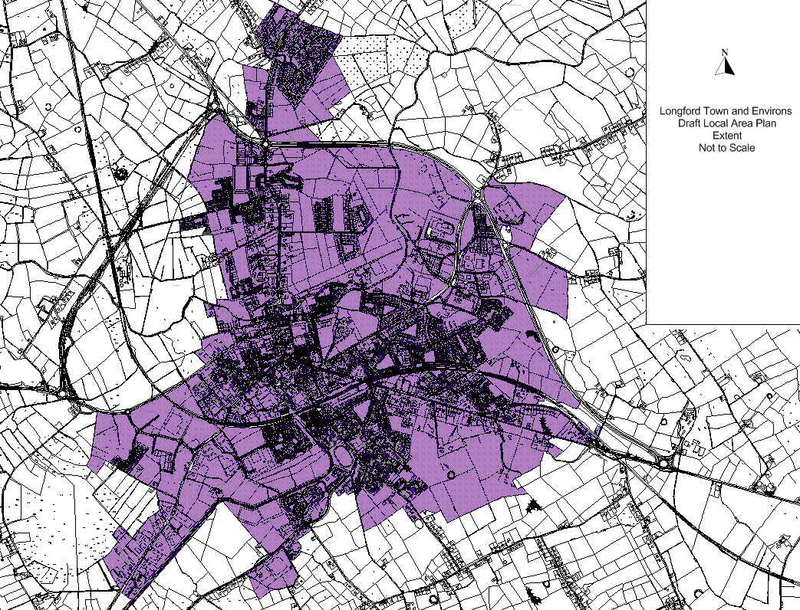
- Incorporate the provisions of the Urban Regeneration and Housing Act, 2015
The following amendment (amended text in italics) is proposed to existing policy CS 2 in the County development plan to facilitate the application of the provisions of the Urban Regeneration and Housing Act, 2015:
Functional roles of the larger towns shall be maintained and supported by the promotion of appropriate development in these areas and through the development management process and other mechanisms and initiatives, including the vacant sites levy, as opportunities arise. It is an objective of this plan to encourage and facilitate the appropriate development of sites and areas in need of development and renewal in order to prevent:
- Adverse effects on existing amenities in such areas, in particular as a result of the ruinous or neglected condition of any land
- Urban blight or decay
- Anti-social behaviour, or
- A shortage of habitable houses or of land suitable for residential use or a mixture of residential and other uses
Lands designated for regeneration within the “Town Core” and “Residential” character areas in the Longford Town and Environs Local Area Plan may include lands in need of development and/or renewal in the context outlined above and will be examined to determine if there are sites where the Vacant Site Levy is applicable under the provisions of Urban Housing and Regeneration Act 2015 and all associated regulations and guidance.
The Proposed Variation has been subject to SEA and AA Screening processes and SEA and AA Screening Reports and associated SEA and AA Screening Determinations accompany the Proposed Variation on public display.
This proposed Variation and associated SEA and AA Screening documents should be read in conjunction with the Draft Local Area Plan Document and associated SEA Environmental Reports, Stage 2 AA Natura Impact Report and SFRA document.

