SEA Screening Report

for

Proposed Material Variation No. 1

of the

Longford County Development Plan
2015-2021

Determination of the need for Environmental Assessment in terms of provisions of Article 13K of the Planning and Development (Strategic Environmental Assessment) Regulations 2004 as amended

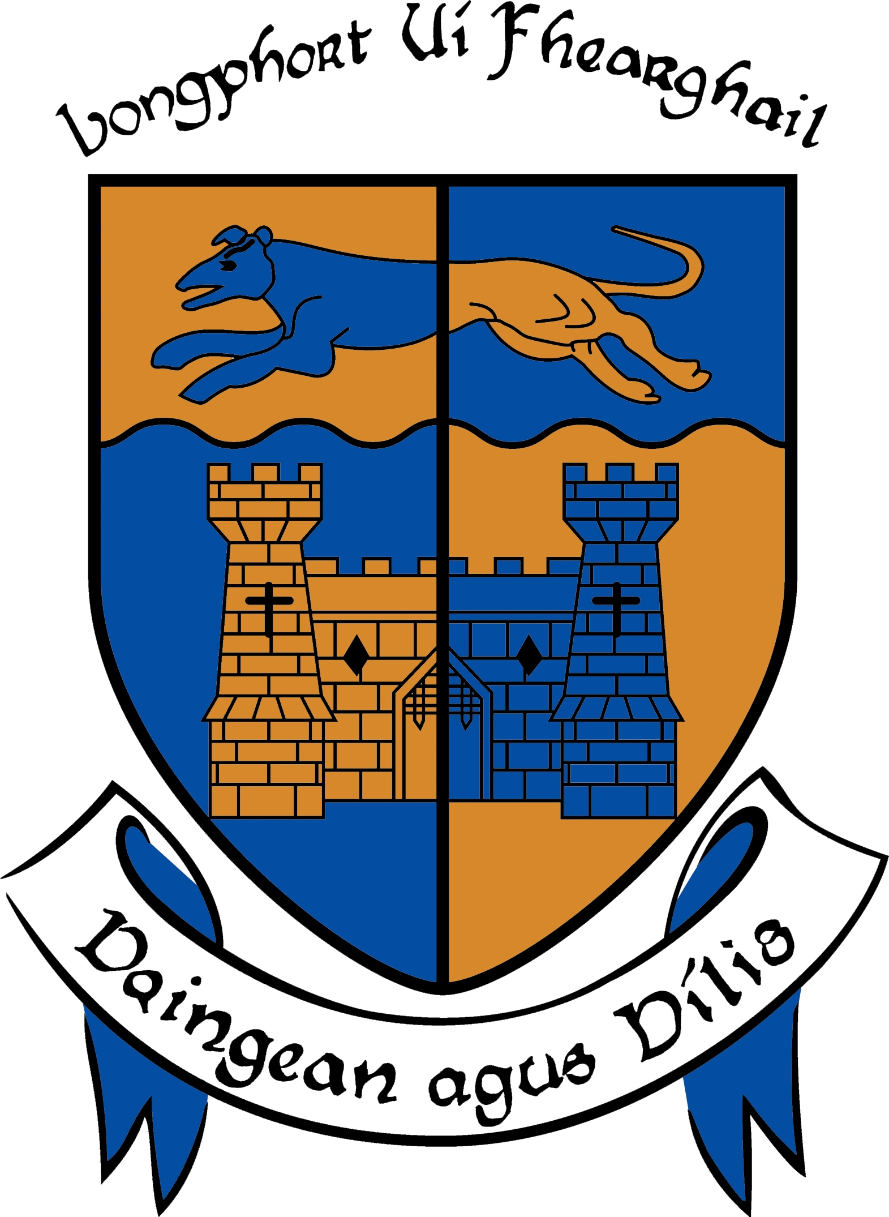

Planning Department
Longford County Council
April 2015
CONTENTS

Strategic Environmental Assessment Screening Report for Proposed Variation No. 1 to Longford County Development Plan 2015 – 2021

- Introduction
- Summary of the Proposed Variation
- Assessment in terms of Schedule 2A of the Planning and Development (Strategic Environmental Assessment) Regulations 2004 as amended
- Consultation
- Determination

Appendix 1 Consultation with Environmental Authorities and Observations Received

1.0 INTRODUCTION

Longford County Council proposes to make a variation to Longford County Development Plan 2015 – 2021 under Section 13 of the Planning and Development Act (as amended).

In accordance with Article 13K of the Planning and Development (Strategic Environmental Assessment) Regulations 2004 (as amended), where a Planning Authority proposes to make a variation of a development plan under Section 13 of the Planning Act, it shall, before giving notice under Section 13 (2) of the Planning Act, consider whether or not the proposed variation would be likely to have significant effects on the environment, taking into account of relevant criteria set out in Schedule 2A of the SEA Regulations.

Where the Planning Authority, following this consideration, determines that the proposed variation would be likely to have significant effects on the environment, the proposed variation shall be accompanied by an Environmental Report which identifies, describes and evaluates the likely significant effects on the environment of implementing the proposed variation. However, where the Planning Authority determines that the proposed variation would not be likely to have significant effects on the environment, the Planning Authority shall give notice of this determination to the environmental authorities and shall allow the environmental authorities 3 weeks within which to make a submission or observation in relation to whether or not, in their opinion, the proposed variation would be likely to have significant effects on the environment. Following receipt of any submission or observation, the Planning Authority shall determine whether or not the proposed variation of the development plan would be likely to have significant effects on the environment, taking account of relevant criteria set out in Schedule 2A and any submission or observation received from the environmental authorities.

As soon as practicable after making a determination the Planning Authority shall (a) make a copy of its decision, including, as appropriate, the reasons for not requiring an environmental assessment, available for public inspection at the offices of the planning authority during office hours, and (b) notify its decision to any environmental authorities.

2.0 SUMMARY OF THE PROPOSED VARIATION

It is proposed to amend the zoning in the Ballymahon Zoning map of the Longford County Development Plan 2015 – 2021. The zoning change affects an area located close to the junction of the N55 and the R392. The site itself is bounded to the northwest by the River Inny and the south east by the N55. There is an existing car sales operation on site, which has been in operation for approximately 20 years at this location and the purpose of the current variation is to regularize the situation on the site and to enable the landowner to carry out improvement works to the site through the development management process.

The screening of the proposed variation will have particular regard to the SEA carried out for the Longford County Development Plan 2015 – 2021 and will particularly focus on any possible new significant effects that might arise from the proposed change, compared to those evaluated as part of the SEA. This SEA evaluated the County Development Plan with regard to:
- biodiversity, flora and fauna
- population and human health
- soil
- water
- air and climatic factors
- material assets
- cultural heritage
- landscape.

Where significant effects were identified, these were addressed through mitigation measures incorporated into the final adopted plan. Any development occurring on foot of the County Development Plan is and will continue to be bound by these measures.

3.0 ASSESSMENT IN TERMS OF SCHEDULE 2A OF THE PLANNING AND DEVELOMENT (STRATEGIC ENVIRONMENTAL ASSESSMENT) REGULATIONS 2004 AS AMENDED

The Planning Authority is required to determine whether or not the proposed variation would be likely to have significant effects on the environment, taking account of criteria set out in Schedule 2A of the Regulations. This assessment is set out below:

1.0 THE CHARACTERISTICS OF THE PLAN HAVING REGARD, IN PARTICULAR, TO:
1.1 The degree to which the plan sets a framework for projects and other activities, either with regard to the location, nature, size and operating conditions or by allocating resources.
The proposed variation refers to a change in zoning of an area of land of 0.12hectares within the Ballymahon zoning area to accommodate the regularization of the planning situation on the ground. The nature of the proposed variation is such that no new environmental impacts occur, that would not have occurred under the existing zoning.

1.2 The degree to which the plan or programme influences other plans or programmes, including those in a hierarchy.
The variation would not significantly influence any other plans or programmes, as it fits within the County Development Plan.

1.3 The relevance of the plan or programme for the integration of environmental considerations in particular with a view to promoting sustainable development
The variation, as proposed, would allow the landowner through the development management process, to improve the situation on the ground and provide a buffer from the River Inny and as such promote the general sustainable development of the area.

1.4 Environmental problems relevant to the plan or programme
The proposed variation has been evaluated against the following environmental factors, as per the Strategic Environmental Assessment for the County Development Plan:
Biodiversity, flora and fauna
The proposed variation and any development that arises therefrom, would not result in any additional significant, adverse impacts on biodiversity, flora and fauna that were not already identified and addressed in the Strategic Environmental Assessment for the County Development Plan.
Population and human health
The proposed variation and any development that arises therefrom, would not result in any additional significant, adverse impacts on population and human health that were not already identified and addressed in the Strategic Environmental Assessment for the County Development Plan.
Soil
The proposed variation and any development that arises therefrom, would not result in any additional significant, adverse impacts on soil that were not already identified and addressed in the Strategic Environmental Assessment for the County Development Plan.
Water
The proposed variation and any development that arises therefrom, would not result in any additional significant, adverse impacts on surface or ground waters or on the risk of flooding that were not already indentified and addressed in the Strategic Environmental Assessment for the County Development Plan.
Air and climatic factors
The proposed variation and in particular, any development that arises therefrom, would not result in any additional significant, adverse impacts on air and climatic factors that were not already identified and addressed in the Strategic Environmental Assessment for the County Development Plan.
Material assets
The proposed variation and any development that arises therefrom, would not result in any additional significant, adverse impacts on material assets that were not already identified and addressed in the Strategic Environmental Assessment for the County Development Plan.
Cultural heritage
The proposed variation and any development that arises therefrom, would not result in any additional significant, adverse impacts on cultural heritage that were not already identified and addressed in the Strategic Environmental Assessment for the County Development Plan.
Landscape
The proposed variation and in particular, any development that arises therefrom, would not result in any additional significant, adverse impacts on landscape that were not already identified and addressed in the Strategic Environmental Assessment for the County Development Plan.

1.5 The relevance of the plan for the implementation of European Union legislation on the environment (e.g. plans linked to waste-management or water protection).
The proposed variation is not required for the implementation of the European Union legislation.

2.0 CHARACTERISTICS OF THE EFFECTS AND OF THE AREA LIKELY TO BE AFFECTED, HAVING REGARD, IN PARTICULAR TO:
2.1 The probability, duration, frequency and reversibility of the effects:
No significant adverse effects have been identified.

2.2 The cumulative nature of the effects:
No significant adverse effects have been identified.

2.3 The transboundary nature of the effects:
The proposed variation is site specific and will not have any transboundary effects.

2.4 The risks to human health or the environment (e.g. due to accidents):
No significant adverse effects on human health have been identified. Any future development arising on foot of the variation will be required to conform to the development standards set out in the Longford County Development Plan.

2.5 The magnitude and spatial extent of the effects (geographical area and size of the population likely to be affected):
No significant adverse effects have been identified.

2.6 The value and vulnerability of the area likely to be affected due to:
a) special natural characteristics or cultural heritage,
The location of the area which is the subject of this variation is adjoining the River Inny, approximately 5.2km from the nearest designated Natura 2000 site. The proposed variation will have positive effects as it will provide additional protection to the River Inny by way of a buffer zone along the riverside. With respect to cultural heritage, no significant adverse effects on cultural heritage are likely to arise from the proposed variation.

b) exceeded environmental quality standards or limit values,
None identified

c) intensive land-use,
The variation would not result in more intensive land use than that already on site and that were not already identified and addressed in the Strategic Environmental Assessment for the County Development Plan.

2.7 The effects on areas or landscapes which have a recognised national, European Union or international protection status.
There are no areas which have a recognized national, European Union or international protection status affected by the proposed variation.

4.0 CONSULTATION

As part of the Strategic Environmental Assessment screening process, consultation is required with designated environmental authorities set out in the Planning and Development (Strategic Environmental Assessment) (Amendment) Regulations 2011.Any submissions received are taken into consideration by the County Council in determining whether or not the proposed variation would be likely to have significant effects on the environment. The relevant authorities notified were:

CONSULTEE | OBSERVATIONS
Environmental Protection Agency (EPA) | Observations received
Department of Environment, Community and Local Government (DECLG) | No comment
Department of Agriculture, Food and the Marine (DAFM) | No comment

Appendix 1 contains a copy of the notification sent to the designated authorities along with a copy of the observations received. A summary of the observation received is detailed below:

A submission was received from the EPA in which it was noted that the flood risk maps prepared for the County Development Plan identify the Variation area as being at risk of significant flooding and identifies the site as being Indicative Flood Risk Zone A. in light of this the EPA recommend that the proposed re-zoning and development of these lands is appropriate to the risk of flood identified. It is noted that the site that is the subject of the current variation has been in operation for in excess of 20 years and has had at no time experienced flooding. The proposed variation will not result in an overall intensification of uses on the site and therefore it is not considered that the proposed variation will increase the flood risk at this location.

Conclusion

It is considered that a strategic environmental assessment is not required in respect of the proposed variation of the Longford County Development Plan 2015 – 2021. Taking account of the criteria set out in Schedule 2A of the Regulations and submissions received, the proposed variation is not likely to have such a significant effect on the environment to warrant a Strategic Environmental Assessment. This determination considers the proposed variation within the framework of the overall plan taking account of the policies and objectives set out in the Plan and the Appropriate Assessment Screening Report of the proposed variation undertaken.

5.0 DETERMINATION

Having considered the proposed variation in accordance with the criteria set out in Schedule 2A of the Planning and Development (Strategic Environmental Assessment) Regulations 2004 (as amended) and the submission of the designated environmental authority, it is considered that the proposed variation to the Longford County Development Plan 2015 – 2021 would not be likely to have such significant effects on the environment to warrant a full Strategic Environmental Assessment.

A Strategic Environmental Assessment is therefore not necessary for the proposed variation.

Appendix 1

Consultation with Environmental Authorities and Observations Received

Consultee

March 24th, 2015.

Re: SEA Screening of proposed material variation no. 1 of Longford County Development Plan 2015 – 2021.

Dear Sir/Madam,

I am writing in relation to the preparation of a proposed variation to the current Longford County Development Plan 2015 – 2021, under section 13 of the Planning and Development Act 2000, as amended.

Under The Planning and Development (Strategic Environmental Assessment) Regulations 2004 (S.I. No. 436 of 2004), the proposed variation has been subject to a Screening Process whereby the likely effects of the variation were assessed according to the environmental significance criteria contained in Schedule 2A of the Planning and Development Regulations 2004.

It is concluded that a full Strategic Environmental Assessment is not mandatory as the area to be rezoned under the variation is currently in use and has been for the past 20 years and the currently proposed variation is to allow the regularization of the site through the development management process, the area in question is 0.12 hectares in size and would not involve any physical changes to the site.

Please find enclosed the accompanying screening report and a copy of the proposed variation.

I would be grateful if the following Screening Exercise can be consulted and would appreciate your response regarding the need for a formal Strategic Environmental Assessment. I would also be obliged if a response to our request could be received within three weeks of receipt of this letter.

If you have any further queries I can be contacted at 043 3343476 and at loconnor@longfordcoco.ie.

Yours sincerely,

Lorraine O’Connor

________________________

Assistant Planner
Longford County Council

Ms Lorraine O’ Connor
Assistant Planner,
Longford County Council,
County Buildings,
Great Water Street,
Longford

13th April 2015 Our Ref: 150304.1

Re. SEA Screening of Proposed Material Variation No. 1 of Longford County Development Plan 2015-2021

Dear Ms O’ Connor,

The Environmental Protection Agency (EPA) acknowledges your notice, dated 24th March 2015, regarding the above and notes its contents.

SEA Determination
We note your position with regard to the need for Strategic Environmental Assessment (SEA) of the Proposed Variation No. 1 to the County Development Plan 2015-2021, hereafter referred to as “the Variation”.
Specific Comments on the Variation

We note that the flood risk maps prepared for the County Development Plan identify the Variation area as being at risk of significant flooding. The Ballymahon Zoning and Flood Map Accompanying the County Development Plan identifies the site as being Indicative Flood Risk Zone A

In light of this, we recommend that the proposed re-zoning and development of these lands is appropriate to the risk of flooding identified. You should also ensure that Variation is fully consistent, as relevant, with the requirements of The Planning System and Flood Risk Management – Guidelines for Local Authorities (DEHLG/OPW, 2009).

Future Amendments to the Draft Plan
It is a matter for Longford County Council to determine whether or not any future proposed Amendments/Variation would be likely to have significant effects on the environment. This assessment should take account of the SEA Regulations Schedule 2A Criteria (S.I. No. 436 of 2004).

A copy of your decision regarding the determination should be made available for public inspection at your offices, local authority website and should also be notified to any Environmental Authorities already consulted.150304.1 EPA Screening Comments Prop Mat Alt No.1 Longford CDP 13.04.15 2
Should you have any queries or require further information in relation to the above please contact the undersigned. I would be grateful if an acknowledgement of receipt of this submission could be sent electronically to the following address: sea@epa.ie.

Yours sincerely,

Cian O’ Mahony
Scientific Officer
SEA Section
Office of Environmental Assessment
Environmental Protection Agency
Regional Inspectorate
Inniscarra, County Cork

