1. Introduction

  - Background

This Drumlish Plan has been prepared as a Local Area Plan (LAP) in accordance with the statutory requirements of the Planning and Development Act 2000 and subsequent amendments.

The Plan takes the form of a Written Statement, and accompanying Zoning Plan and Townscape Proposals Map. If any conflict or ambiguity arises between what is contained in the written statement and the supporting plans, the written statement will take precedence.

The purpose of the Plan is to inform the general public, statutory authorities, developers and other interested bodies and set out a framework for the future development of the village over the plan period 2006 – 2012.

The need for this plan arises from the unprecedented demand for residential development land in the Drumlish area and the need to properly plan for future expansion of Drumlish in a co-ordinated and sustainable manner. Appendix 1 identifies a SWOT (Strengths, Weaknesses, Opportunities and Threats) analysis of the area, from which many of the objectives and policies are conceived. Drumlish is identified as a local growth centre in the County Development Plan 2003-2009.

This plan has been prepared within the context of Agenda 21 and the need for sustainable development to protect the environment for future generations. In accordance with the SEA Directive (2001/42/EC) and the Planning & Development (Strategic Development Assessment) Regulations, 2004, the proposed Local Area Plan was screened to ascertain if the plan required the preparation of an Environmental Report. The Screening Report was sent to the designated Environmental Authorities and it is the opinion of the Planning Authority that a Strategic Environmental Assessment is not required.

1.2 National and Regional Planning Context

National Context

In preparing this plan regard has been given to national and regional trends. Primarily, this LAP is fully consistent with the National Spatial Strategy 2002-2020 which provides a sustainable policy framework for balanced social and economic development and population growth for Ireland.

In relation to County Longford, Longford is described as an important County Town that is strategically placed on national road and rail links and should be enhanced in competitive terms to drive development at the county level. Therefore the role of towns and villages, such as Drumlish, is to take pressure off development in the open countryside and channel it into more sustainable and compact forms.

The Strategy advocates that such settlements grow in an orderly and planned fashion with particular emphasis on creating a high standard of urban design, promoting compact, public transport friendly and sustainable urban/village areas thus avoiding features such as urban sprawl. In terms of villages and rural areas, the strategy also advocates that demand for housing within easy reach of larger towns should be harnessed positively to strengthen the residential and other functions of smaller towns. This can be achieved by enabling villages to attract residential and other developments through availability of land and capacity of services.

Regional Planning Guidelines

Consideration has also been given to the recently adopted Midlands Regional Planning Guidelines. Although Drumlish is not specifically defined within these guidelines, it is important that Drumlish assists in the consolidation of the region’s growth, whilst providing for sustainable and viable rural communities. Figure 1 highlights Drumlish’s role within the Midland Regional Planning Guidelines Strategic Development Framework.

Figure 1: Role of Drumlish within the Midland Regional Planning Guidelines Strategic Development Framework (Source: Regional Planning Guidelines, Midland Regional Authority, 2004.)

1.3 County Development Plan Context

The County Development Plan is the statutory development plan for the County of Longford in the years 2003-2009. This Local Area Plan has been prepared under Section 3 of the Longford County Development Plan, 2003 – 2009. Section 3.1.1 of the plan outlines the hierarchy of settlements in the County and defines the role of Drumlish as a local growth centre whereby,

“These settlements will continue to provide settlement centres for the population and local level goods and services provision. The potential for tourism and amenity development… is recognised and shall be promoted and encouraged where appropriate in the Local Area Plans which shall be prepared for these locations.” (Longford County Development Plan)

1.4 Previous Plans

There are no previous statutory Local Area Plans for Drumlish, however, Drumlish Enterprise Group have created an Area Action Plan 2004. Many of the recommendations of the plan have been taken into account in the preparation of this Local Area Plan.

1.5 Strategic Objective of the Drumlish Local Area Plan

The strategic objective of the LAP is as follows;

To set out a clear framework for the next six years for the sustainale development of Drumlish identifying sufficient suitable lands for future housing, industry, commerce, open space uses and community facilities whilst protecting and preserving the village’s intrinsic character, heritage and amenity, positively contributing to the quality of life.

The Local Area Plan sets out policy statements and objectives in response to specific development issues affecting Drumlish. A flexible zoning policy is considered appropriate for Drumlish, given the size and function of the village. The zoning provisions are indicated on the Zoning Map, see Map 1. It is the intention of the Planning Authority that the zoning of specific areas for a particular use shall not exclude other uses in that area provided they are compatible with the dominant use.

The Plan addresses the existing townscape quality of the central core of Drumlish and identifies opportunities for environmental enhancement of the area. Environmental Improvement proposals are indicated on the Townscape Appraisal, see Map 2.

In general, the Local Area Plan for Drumlish is designed to stimulate development and direct it to appropriate locations. It is within the framework of the Plan that public services will be provided and investment decisions made. This Plan should be read in conjunction with relevant policies and objectives on the County Development Plan 2003 – 2009.

1.6 Goals of the Plan

The Drumlish LAP establishes a vision for the village, enabling its continued vitality and viability striking a balance between preserving its traditional character and facilitating the requirements of modern day living. The plan will concentrate on establishing new linkages, improving accessibility and determining suitable land uses for the village.

The overall strategic goals of the LAP are as follows:

- Promote the development of Drumlish.

- Implement the policies and objectives of the County Development Plan.

- Sustain and enhance the role of Drumlish as a community and commercial service centre to the surrounding rural hinterland.

- Sustain Drumlish’s role within County Longford, within the context of the Regional Planning Guidelines.

- Provide for the orderly expansion of the village.

- Provide sufficient and suitably located land in order to meet the land use needs of the various functions of the town over the plan period.

- Facilitate the provision of employment generating land to afford the opportunity to live and work within the village.

- Provide the necessary road infrastructure, public utilities and services, recreational and community facilities in order to satisfy the development needs of the village.

- Facilitate the provision of improved amenities within the town, and to secure the redevelopment and renewal of obsolete areas.

- Secure safe and convenient movement corridors within the area, including pedestrian and cycle paths.

- Enhance and protect the environment and heritage of the town including the renewal of obsolete areas and the preservation of buildings and other features of historic, artistic, cultural or social interest.

2. Profile and Resource Base

2.1 Context

Drumlish is situated in the north of the County approximately 8.3 miles (13.4 kilometres) from Longford Town via the R198 which is the main route from Longford Town to Cavan Town. Drumlish lies west of a ridge of low hills running north-eastwards from Newtownforbes to Arvagh in County Cavan. The village also lies close to the Cavan and Leitrim borders.

Figure 2: Regional Context

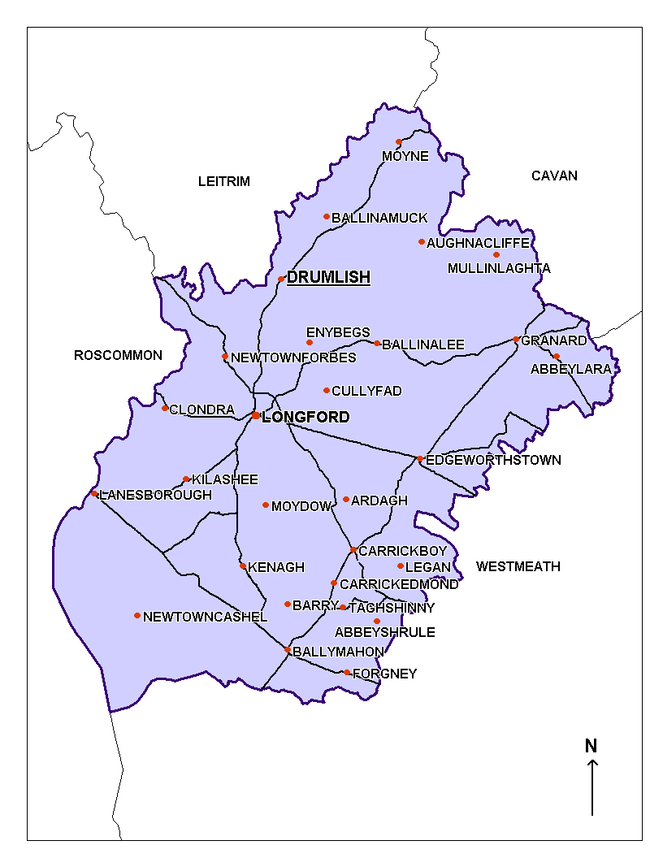
2.2 Character and Historical Background

Drumlish is a picturesque village which comes together at a central crossroads. The village’s organic development around the crossroads provides a compact, central core for Drumlish and lends the village a sense of cohesion.

The popularity of the area is reflected in the substantial growth of the village in recent years. Typically, the settlement pattern was reflective of any traditional Irish village that followed a linear pattern of development. Recent changes, however, have seen pockets of housing developments emerge within the town. The new housing developments have been of a very high standard and have greatly enhanced the appearance of the village.

Historically, Drumlish takes its name from the Irish meaning for ‘sheltered hillside’. Originally part of the ancient parish of Killoe, Drumlish obtained independence and became known as the parish of Monaduff in 1822. In 1834, the parish then became known as Drumlish.

Drumlish is historically recognised through the association of the people with the Land War in January 1881. The people of Drumlish are known for being victorious over Lord Granard and his bailiffs and achieving the retention of their residences at reduced rates. More recently, however, Drumlish has become known for producing successful singers.

Image 1; Land War Monument, St. Mary’s Street, Drumlish

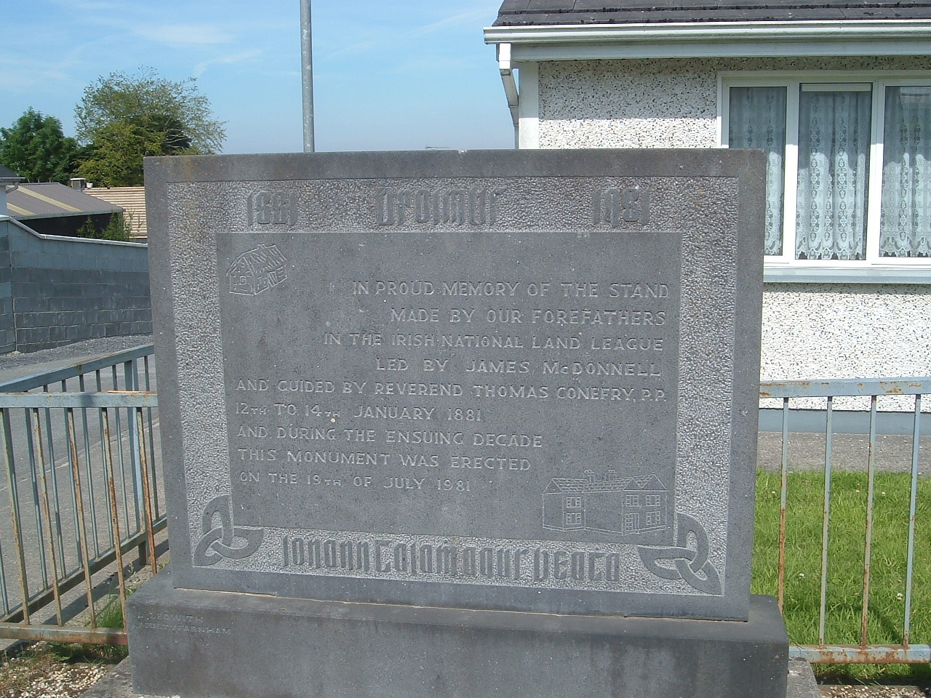

2.3 Population and Demography

Since 1991, Drumlish has witnessed an increase in population. Figure 3 illustrates that during the period 1991 to 1996, the village experienced an actual increase of 28 persons or a percentage increase of 3.5%. Between 1996 and 2002, the village experienced an actual increase of 30 persons and had a percentage increase of 3.6%. This is partly due to the strengthening of the residential function of the village as a result of its proximity to Longford Town.

Figure 3: Population Trends 1991 – 2002

Area | 1991 | 1996 | 2002 | Change 1991 – 1996  Actual / % | Change 1996 – 2002  Actual/%
Drumlish | 771 | 799 | 829 | 28 / 3.5% | 30 / 3.6%
County | 30,269 | 30,166 | 31,127 | -130 / -0.4% | 961 / 3%

Resulting from the number of housing units granted planning permission since 2002, and the number of new dwellings which are now under construction, it is evident that the population of Drumlish is set to increase. Permission has been granted for 358 new dwellings, of which 76 are now occupied. On the basis of these figures the population of Drumlish since 2002 has presently increased by an estimated 20%. However, once all 358 dwellings are occupied, Drumlish will potentially experience approximately a 100% increase in population since 2002.

Figure 4: Estimated and Projected Population Trends

Area | Estimated Population Increase 2002 to Present (%) | Projected Population Increase  (%)
Drumlish | 20% | 100%

In addition, there is also a demand for social housing in the village. The Housing Department of Longford County Council currently has 47 applicants for social housing in that area. Since 2002, 20 dwellings have been allocated for social housing with 5 additional dwellings currently in the process of being allocated for social housing in Drumlish.

Need for additional zoned land?

Longford is located wholly within the Northern Development Area, as identified in the Midland Regional Planning Guidelines, 2004. Future population growth, taking account of both recent trends and the strategic goals, to this development area would need to grow between the range of 8,000 to 11,000 in the period to 2020. Taking the maximum level of growth of 11,000, the projected population growth for Drumlish for this period is 127 persons. This would mean that 44 additional dwellings are required to 2020. It is clear from the calculations above that Drumlish is in excess of the population allocation as forecast in accordance with the Midland Regional Planning Guidelines, therefore additional residential zoning should be of an extremely sensitive nature, adaptive and responsive to the needs and nature of the settlement.

There is approximately 35 hectares of undeveloped land zoned standard density residential and approximately 13 hectares of undeveloped land zoned low density residential. Although portions of this land are practically not developable at this stage, this will allow for an additional 875 dwellings to be built at a density of 25 units per hectare and 65 dwellings at a density of 5 units per hectare. This is in excess of the population allocation as forecast in accordance with the Midland Regional Planning Guidelines. Therefore there is no need to zone any further land residential within this plan.

The portions of land that are zoned standard density residential are close to other residential developments and consolidate the existing fabric of the town. In addition this area is easily serviced from the viewpoint of water and sewerage. The land that is zoned as low density residential is reflective of the infrastructure within Drumlish. Height difficulties create many problems in attempting to service this area from the perspective of sanitary and foul drainage. Further, this area contains important views and perspectives that are worth preserving.
2.4 Village Functions

Over much of their history, towns and villages such as Drumlish have been vital economic and cultural hubs, profoundly influencing, as well as being influenced by their rural hinterlands. The challenge for the future is to sustain and enhance the viability and diversity of such settlements by pursuing their appropriate development and growth.

Drumlish is a service centre for the rural hinterland. It provides educational, religious, commercial, employment, financial and administrative functions for the village and the surrounding rural area.

Drumlish is relatively well serviced having a number of supermarkets, a butcher, a filling station, hairdressers and drapery. There are also a number of pubs and restaurant facilities within the village. There is a credit union which provides financial services to the community, complemented by the Post Office which provides financial and administrative services to the village.

Image 2: O’Reilly’s Pub, Drumlish | 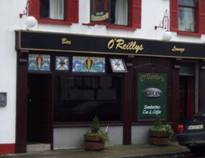
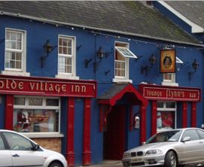 | Image 3: The Olde Village Inn, Drumlish
Image 4: The Post Office, Drumlish | 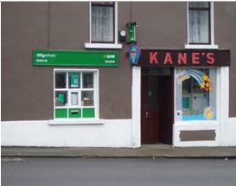

St. Mary’s RC Church can be found within Drumlish village, with the catholic graveyard nearby. The Protestant church that was situated on the Hill Road was unfortunately demolished in 1949/50. There are currently no Church of Ireland facilities within the village.

There is one national school in Drumlish, St. Mary’s, attended by 93 pupils. There is no secondary school in the village. Second level students attend schools throughout the county, however Moyne Community School, located in Moyne, is an important educational facility for the people in Drumlish. It is envisaged that as Drumlish will experience further growth, provision should be made for the future expansion and development of such educational facilities with particular attention given to that of the national school.

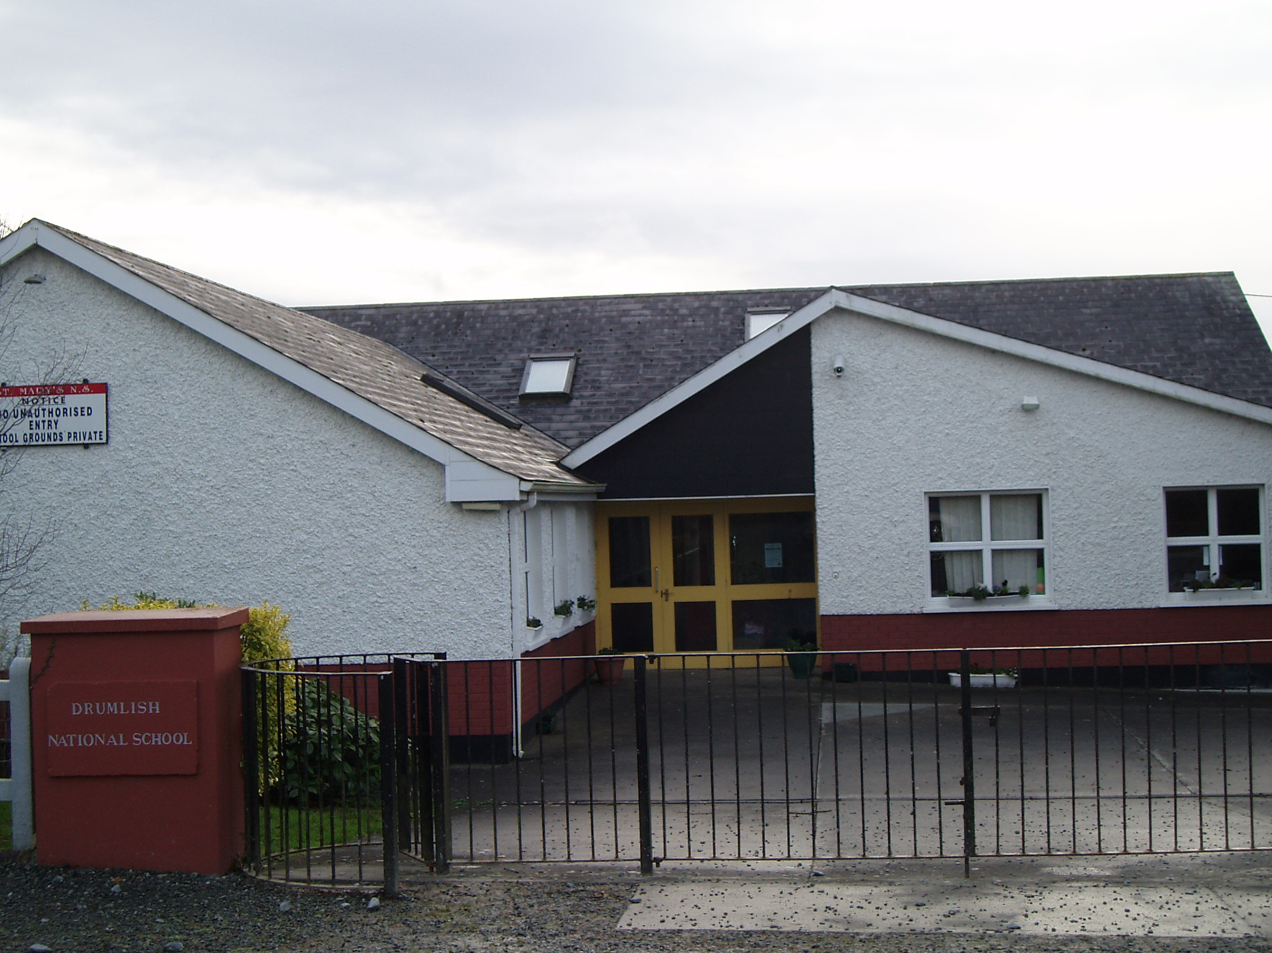 | Image 5: St. Mary’s National School, Drumlish

The village also has a health centre, Garda station, pre-school, library, pharmacy and community centre.
2.5 Built and Natural Environment

The entrances into the village are quite pleasant, however, there exists the opportunity to visually strengthen the gateways into Drumlish. Obviously future development if badly designed could prove deleterious to the village’s external view. The village itself with its wide street and extended street vista is broken to a degree by the intersecting crossroads through the town.

There is no open space that would provide a significant visual break and attractive landscape feature within the core of the village. Open space, trees and other such landscape features play an important role in adding to the character and townscape of a village. The Village Renewal Programmes administered by Longford County Council, have helped to improve the amenity of the village by paving and landscaping areas within Drumlish. Further, the Corn Mill provides an excellent opportunity to create an attractive landscape feature and area of open space for the benefit of existing and future residents, as well as visitors to Drumlish (see Image 6).

Drumlish has developed around a single street. It is typical of Irish villages with frontage depth only, little backland consolidation, skeletal development radiating out of the village. It has however, two focus points, the main one being around the cross-roads and the other St. Mary’s RC Church (see Image 7).

Image 6: The Corn Mill, Drumlish | 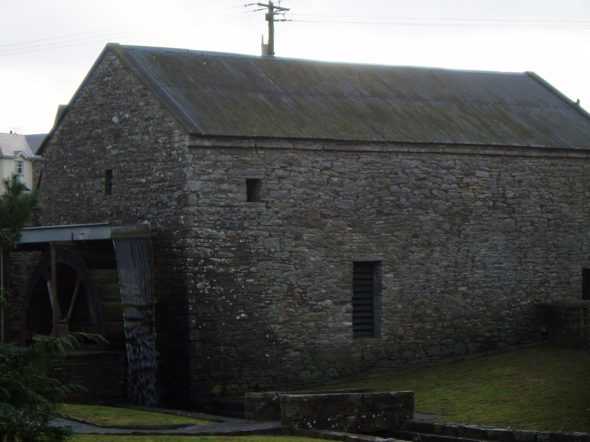
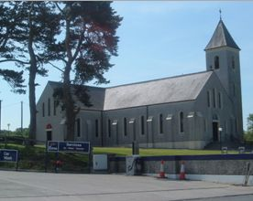 | Image 7: St Mary’s Church, Drumlish

The street elevations are strong and unfussy and are mainly nineteenth century buildings, which as a whole gives many Irish towns and villages their particular sense of character. However, the quality of many of the older structures varies with some in good repair while others have been given less care and attention. Further, it is evident that there are numerous unoccupied buildings within the village centre. It is essential that visually weak areas are improved for the benefit of Drumlish as a whole.

The County Development Plan 2003-2009, acknowledges the Cornmill in Drumlish to be of Industrial Archaeological Interest. There are currently no protected structures within the village however, based on the draft recommendations of the National Inventory of Architectural Heritage (NIAH) of the DoEHLG, there are structures worthy of protection within Drumlish. These are outlined in figure 5 (See images provided).

Figure 5: Structures Worthy of Protection.

DESCRIPTION | CONDITION | LOCATION
Water Pump: Cast-Iron water hydrant, erected c. 1870. Finial and lion’s head motif to spout, increasingly rare now. (Image 8) | Fair | Main Street, Drumlish
Mill: Mill complex built in c.1800. Simple forms and materials of these buildings show their functional past. Mill wheel in situ to east gable of north building. (Image 9) | Good | Mill Road, Drumlish
Monument: Carved limestone memorial cross, erected c. 1970. The pike motif to the railings is an interesting reference to the military history of Irish Republicanism. (Image 10) | Good | Saint Mary’s Street, Drumlish
Land War Monument: Freestanding carved limestone memorial plaque dated 1981. It commemorates the participation of the Drumlish community in the Land war in 1881 and 1882. (Image 11) | Good | Saint Mary’s Street, Drumlish
Saint Mary’s Church: Detached cruciform-plan RC Church built in 1907. The church forms a significant architectural feature in the streetscape of Drumlish.(Image 12) | Good | Saint Mary’s Street, Drumlish
Scoil Naomh Muire: Built c. 1930 detached seven-bay single-storey formally H plan primary school. The separate entrances for boys and girls are typical of the separation of the sexes in mixed rural schools.(Image 13) | Derelict | Drumlish
House A: Attached three bay, two storey house, built c. 1820, formally also in use as a shop. The irregular fenestration, small windows and relatively modest size of this building indicate its age. The retention of these features and the patina of age they provide make a positive contribution to the streetscape of Drumlish. (Image 14) | Fair | Saint Mary’s Street, Drumlish
House B: Attached five bay, two storey house, dated 1895, having canted entrance porch and with spired roof. The symmetry of the fenestration and the diminishing windows show the classical influence on this building. Although it has lost some of its fabric, it retains its overall form and structure. (Image 15) | Good | Hill Street, Drumlish
House C: Detached three bay, two storey house, built c. 1930, having two-bay single storey extension with pitched slate roof to south-west side. This is a notable example of the enduring popularity in Ireland of the three bay, two storey form with hipped roof and centralised chimneystacks. The broad frontage and detached nature of the building make it a dominant feature on the Longford Road, and a positive contribution to the streetscape of Drumlish. (Image 16) | Good | Longford Road, Drumlish
House D: Detached three bay, two storey house, built c. 1930. The art deco style render decoration to the windows is typical of its time and emphasises and enhances the structure and form of the house. (Image 17). | Good | Longford Road, Drumlish
(Source: National Inventory of the Architectural Heritage for Co. Longford, Draft Publication, DOEHLG, 2005.)

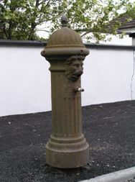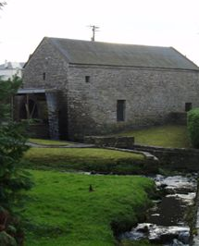
Image 8: Water Pump Image 9: Corn Mill

Image 10: Memorial Cross Image 11: Land War Monument
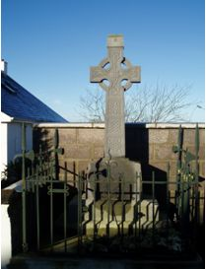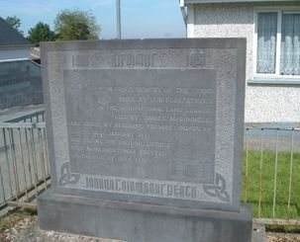
Image 12: St. Mary’s Church

Image13: Scoil Naomh Muire 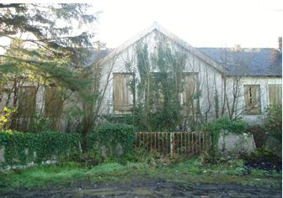

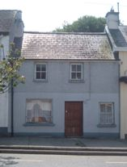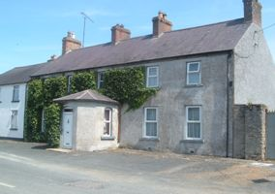
Image 14: House A Image 15: House B
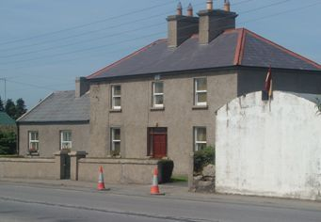 | Image 16: House C

Image 17: House D | 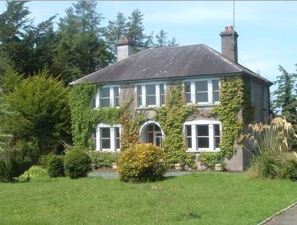

Although not considered Structures Worthy of Protection, there are particular sites within the town that are relevant from the viewpoint of Cultural Heritage. These include the sites of various old forges, the old RIC Barracks, the old bank locations and the sites of the old Catholic and protestant churches. Images of some of these features are provided overleaf.

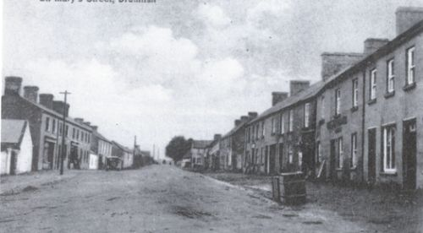
Image 18: Drumlish of Yesteryear- St. Mary’s Street (Source: Drumlish Landwar Centenary Commemorative Booklet, Landwar Centenary Committee, 1981).

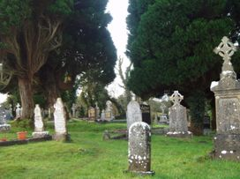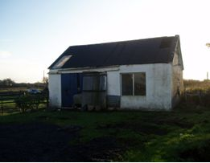
Image 19: The Old Graveyard in Drumlish (Hill Street) which Image 20: An old Forge on the Mill Road.
also houses the remains of the old Catholic Church.

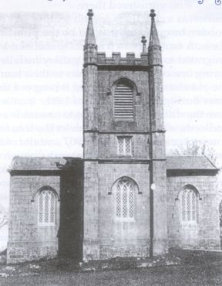

Image 21: Drumlish Protestant Church-Built in the 1800s, Drumlish Protestant Church was made from limestone and could be found on Hill Street opposite the old Catholic Church. It was demolished in 1949/50. (Source: Drumlish Down the Years, Drumlish Parish Council, 2001)

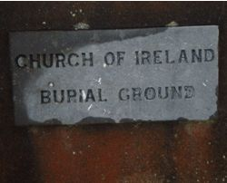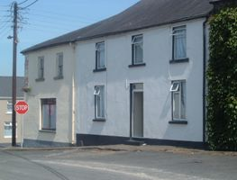
Image 22: The stone that marks the Church of Ireland Image 23: The Old Bank Buildings in Hill Street, Drumlish.
Burial Grounds on Hill Street.

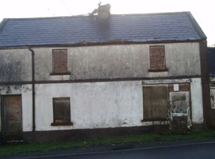 | Image 24: The site of one of the Old bakeries within Drumlish.

Image 25: The site of an old bakery in Drumlish. | 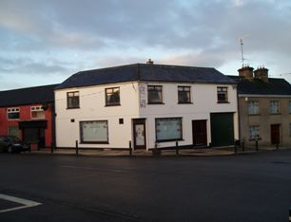

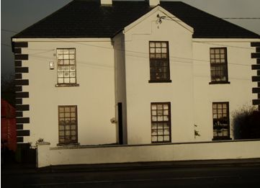
Image 26: The Old RIC Building, St. Mary’s Street, Drumlish.

In terms of backland development, the backland areas consist of rear gardens, walled yards and lanes with minimum access. Typically, there is no consistency in depth to them. They are developed as they were meant to be i.e. ancillary to the street frontage use. There is a degree of dereliction and probably under use in these areas. Overall they are intrinsic to the urban grain of the village, but have in places the potential to be developed, while preserving their role in the morphology of the settlement.

One of the greatest transformations of Drumlish, has been the surge in development of suburban-type housing throughout the village. Rarely is there any meaningful continuity with typical suburban developments, however, Drumlish presents an example of reasonably high standards. It is important that this type of development pays attention to the original settlement pattern and character of the village to avoid it threatening the consolidated development of the settlement in the future.

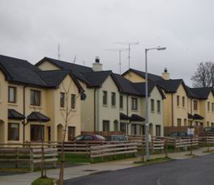 | Image 27: New Housing Development in Drumlish
Image 28: A Sample of the High Standard of New Housing in Drumlish. | 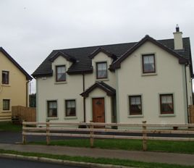

Drumlish cannot ever compete with the service and function level of nearby Longford Town, but a threshold population can help maintain local functions and services for the village and the wider community, making it more than just a dormitory settlement.

2.6 Physical Infrastructure and Servicing

Water Supply

Drumlish is currently supplied with water from the Lough Forbes Water Treatment Plant. Longford County Council has appointed a consultant engineer to prepare plans to upgrade the Lough Forbes Water Treatment Plant and this project is currently included in the DOEHLG investment programme.

Foul Drainage

The existing waste water treatment plant was designed in the early 60s to serve a 700 population equivalent. Longford County Council has appointed a consultant engineer to prepare plans to upgrade the sewage infrastructure in Drumlish and this project is currently included in the DOEHLG investment programme.

Developers will be required to take cognisance of the Planning Authority drainage plans and requirements in the preparation of planning submissions. Temporary arrangements for dealing with foul sewerage will not generally be considered.

Surface Water Drainage

Developers will be required to provide surface water outfalls, constructed to the County Council’s standards and will need to demonstrate that sufficient capacity exists in receptor watercourses. Sustainable urban drainage systems (SUDS) and other attenuation measures will be considered in all new greenfield developments. Existing watercourses should be kept open and incorporated into the landscaping of the area as much as possible.

Transportation and Movement

Drumlish experiences heavy traffic due to its location on the main route, the R198, from Longford to Cavan. Although a speed limit is imposed for the town, there still exists a problem of speeding traffic. In 2005, under the Urban and Village Renewal Programme, considerable work was carried out on the central crossroads in an attempt to visually upgrade the area and also improve the road network in the interests of safety. This has helped to control traffic to a degree in the village.

There is no Bus Eireann route scheduled for Drumlish. A private bus service operates a return service from Longford three times a day. The nearest rail station is in Longford Town which provides services to Dublin and Sligo on a daily basis. There are a number of taxi operators who provide a local service for Drumlish. It is safe to assume, however, that the commuting are mostly reliant on cars.

Footpath coverage within the area is confined to the limits of the village, but dissipates and terminates where the settlement reaches its rural edge. Further, despite significant improvements to areas of footpath under the Village Renewal Scheme, there still exists areas where the footpath coverage is inadequate and should be upgraded on the grounds of safety, promoting mobility and improving visual amenity.

There is currently minimal off-street parking located in the new Centra premises on the Longford Road, however, there does not appear to be a problem with on-street all day parking. The lack of appropriate parking facilities within the village core does deter commercial properties from locating here. Resultantly, adequate off-street parking is required to sufficiently rejuvenate the village core.

Electricity

The Planning Authority will co-operate with and facilitate the ESB in providing additional sub-stations and power lines in the area as the need for increased electrical power arises. Care will be taken to ensure that all overhead power lines do not unduly detract from the visual amenities of the area. In certain circumstances, particularly in residential areas, the under grounding of wires and cables may be required to protect the visual and residential amenities of an area.

Employment and Enterprise

The following tables are based on figures extracted from the 2002 CSO for the Drumlish DED. Although there have been significant changes in Drumlish since 2002 in terms of the residential capacity of the area, there have been relatively minimal changes in terms of employment and enterprise opportunities within the village.

The following Pie Chart provides a percentage breakdown of sectors of employment for Drumlish DED.

Figure 6: Percentage Breakdown of Sectors of Employment for Dumlish DED.

As illustrated by Figure 6, statistics show that employment is centred on manufacturing and industry, commerce and professional services. As these types of industry are not available within Drumlish in the capacity able to support the given percentages of the work force, it is safe to assume that most people travel to their place of employment.

Figure 7 provides a breakdown of the percentage of people’s distances traveled to work.

Figure 7: Percentage of Distance Traveled to Work.

0 miles | 1 mile | 2 miles | 3-4 miles | 5-9 miles | 10-14 miles | 15-29 miles | 30+ miles | Not Stated
3.7% | 12% | 8.2% | 9.3% | 31% | 12.1% | 6.1% | 6.3% | 11.3%

As illustrated by the above table the majority of people travel between 5-9 miles to work, which is most probably to Longford Town. Figure 8 provides a breakdown of journey times of a percentage of people of Drumlish DED to their place of work or education.

Figure 8: Percentage of People’s Journey Times to their Place of Work or Education.

<15 minutes | 15-<30 minutes | 30-<45 minutes | 45-<60  minutes | 60-<90  minutes | 90+  minutes
45% | 30% | 16.7% | 4.6% | 1.8% | 1.9%

Statistics show that there are a considerable number of people in the area travelling less than 15 minutes to their place of work or education. It can be assumed that a large amount of these people are school-goers as there is not enough employment in the locality to account for these numbers. A large proportion of people also travel between 15 and 30 minutes to work which once again suggests that most people work in nearby Longford Town.

Given the population expansion over the recent years, the amount of people that travel beyond Drumlish to work, the settlement’s proximity to Longford Town and the village’s need to diversify and become more than just a dormitory settlement, it is evident that Drumlish has the potential to expand in terms of Employment and Enterprise. Accordingly 15 hectares is zoned for Light Industrial/ Technological use/ Commercial Warehousing use.

Social Housing

All residential zoned developments will be subject to the Part V (social and affordable housing) as in the Planning and Development (Amendment) Act, 2002.

2.7 Development History

Drumlish has been subject to a number of housing developments, and subsequent population increase, in recent years. It is important for the sustainable development of the area that the potential pressures of such expansion are adequately recognised and catered for within any future developments.

2.8 Development Potential

There is good scope for further development in Drumlish. Several opportunities exist for the strengthening of the urban structure, which could be carried out in conjunction with the development of the town.

There are a number of areas in the town that represent significant opportunities. Therefore the strengthening of these areas is particularly important for the sustainable development of Drumlish. The Planning Authority have determined the following areas as either offering potential for development, or as being in need of improvement.

Development Opportunity 1: The Corn Mill

The Corn Mill in Drumlish is an extremely attractive benefit for the village. It is envisaged that the Corn Mill will be reoccupied to enable the village to exploit the potential of having such an asset. An application has been granted to enable the re-development of the Mill as a restaurant and bar area, with an adjoining craft shop and offices. The Mill’s advantageous location with full frontage onto the R198, will encourage people passing through the town to stop. This will provide Drumlish with a unique opening for attracting outside economic input that will improve and enhance the sustainability of the village.

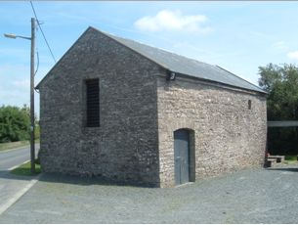 | Image 29: The Corn Mill

Development Opportunity 2: The Village Walkway

Given the high levels of traffic that flow through Drumlish, The Planning Authority recognised the need to develop a safe walkway within the village. It is envisaged that this walkway will provide a welcome area of open space for the residents and visitors of Drumlish. Permission has been granted to re-develop the river that runs to the Corn Mill. This provides the perfect opportunity to incorporate the river into the landscape of the town. It is proposed that the walkway will extend from the Corn Mill, along the river, to the Mill Pond and throughout the village. The area shall be redeveloped to create a high quality river walkway that will be beneficial to residents and attractive for visitors to Drumlish.

This walkway will also promote tourism within the village and will be encouraged in tandem with the other existing amenity walks that exist in, and in close proximity to, the village.

Image 30: The River within Drumlish that will be a focus point of the Village Walkway. | 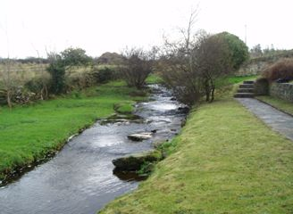

Development Opportunity 3: Replica Mill Building

Resulting from the need to develop the approach roads into Drumlish, providing attractive entrances to the town, it is proposed that a replica mill building be constructed adjacent to the current mill building on the opposite side of the road. Given that the entrance into the town on Mill Road is dominated by new residential developments, this replica corn mill will successfully demarcate the village edge, enhance its visual appearance and provide further investment opportunity for the village.

Area of Improvement: Village Core

There are a number of areas within the town that are visually weak. Two areas in particular are, the derelict buildings that exist in St. Mary’s Street (See Image 31) and the corner buildings at the junction of the crossroad and Hill Street (See Images 32-33). It is essential for the vitality and viability of Drumlish that these areas are sufficiently upgraded. Upgrading these areas will not only visually enhance the village, but will also attract investment and therefore could potentially provide jobs for the people of Drumlish. Currently, the core of the village has developed in a linear format with no backland development, resulting from lack of access. It is hoped that backland consolidation to the rear of St. Mary’s Street and Hill Street, will maximise the development potential of the village core properties. Rejuvenation of the village core could potentially restore the area to optimum levels of commercial and residential use, thus improving the sustainability of the settlement centre and diversifying the use of the village.

Area 1
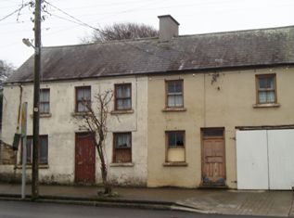 | Image 31: Derelict properties within the village core that could be transformed to commercial properties, given appropriate backland consolidation.

Area 2

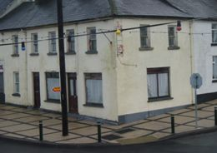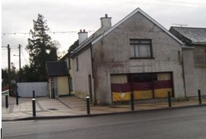
Image 32: The Corner Building at the junction of St. Image 33: The Corner Building at the junction of the
Mary’s Street and Hill Street. Longford Road and Hill Street.

3. Development policies

3.1 Development Strategy

The future development of Drumlish is based on the neighbourhood concept. The basic principles of the neighbourhood concept are underpinned by the aim of securing more sustainable patterns of development. Access to employment, shopping, education, health, leisure and social facilities are all important criteria in determining where future housing growth should be directed. Accessibility to such facilities is also a key element, and housing should be directed to locations where walking and cycling to shops, the local primary school and areas of open space are easily achieved.

3.2 Sustainable Development

This Local Area Plan is important in terms of achieving sustainable development in Drumlish by focusing development on the village centre, where people can live and work in close proximity, thus reducing the dependency on the car.

Aims

- Strengthen the fabric of the existing settlement, creating and maintaining a vibrant and thriving urban community with a sufficient level of physical, social and economic infrastructure and services.

- Provide a high quality physical development pattern and pleasant, sustainable environment in which the population of Drumlish can live, work, interact and recreate safely, and provide a catalyst for social and economic development and regeneration.

- All new development in urban and rural situations shall be guided by sustainable development principles.

3.3 Strategic Objectives and Development Policies

1. Housing

Drumlish has experienced considerable pressure for residential development in recent years owing primarily to its close proximity and accessibility to Longford Town. The Planning Authority considers Drumlish to be suitable for some further sensitive greenfield residential development owing to its accessibility and its undeveloped potential to be more than just a dormitory settlement. Significant potential also exists to incorporate infill development within the pre-existing village core and to this end, it would be expected that any new developments would be of a density, character and architectural quality that would contribute to the consolidation of the village streetscape, and not purely a replication of more ‘anywhere’ suburban styles of development. Development in the village can offer an opportunity to conserve and enhance the settlement.

For this plan the total amount of undeveloped land that is zoned for standard density residential purposes is approximately 35 hectares (86 acres). Further, 13 hectares (32 acres) is zoned for low density residential that is undeveloped. The amount of land identified to accommodate growth in the period to 2012 is guided by a number of factors such as infrastructure, proposals to upgrade the services available, and the capacity of the sewerage treatment plant.

It is the intention of the plan that the village develops with a distinct design quality, building upon its background as a village, and that the scale and density of such development is appropriate to its character. It is also intended to avail of every opportunity to improve the physical fabric of the village. The character would be further enhanced by improvements to the street finishes, footpaths and public domain generally, and by the redevelopment of key neglected sites and obsolete areas.

Residential developments will be about enhancing community rather than just be about ‘buildings’. A good design process can assess the potential relationship between and functions of new and existing developments. This understanding can be used to connect developments to the village both physically and psychologically.

Too often internal standards of private developments are below minimum accepted in the Social Housing Design Guidelines, issued by the DOEHLG. The Planning Authority will therefore insist fully upon the minimum standards required.

Accordingly, the Strategic Objectives and Policies are outlined as follows:

Strategic Objectives

- Secure the provision of high quality, social and affordable and sustainable residential accommodation in sufficient supply to meet the demand for new houses in Drumlish for the next six years.

- Secure a high standard of residential design and encourage the ‘creation of places’ with a sense of local distinctiveness and legibility. Including imaginative and interesting layouts with a range of house types/styles and a range of densities. Continuity can be achieved if reference is made to the qualitative aspects of the existing village fabric.

- All residential developments shall meet minimum standards set out in the Social Housing Design Guidelines.

- Facilitate the linkage of new developments to community and social infrastructure such as the school, open spaces and recreational space.

- Prevent ribbon development and suburbanisation as it militates against the organised development of towns and villages. It is the objective of the council to ensure that this does not occur particularly on radial routes from the village.

- Secure a high standard of landscaping in residential developments, with the provision of adequate public and private open space, amenity areas and pedestrian links.

- Secure high quality residential uses as part of development on backlands as part of an expanded village core.

Policy

Having regard to the above strategic objectives, The Planning Authority’s policy is as follows;

H1 In general 12-25 units per hectare will be acceptable subject to the highest urban and architectural design standards.

H2 Any new residential development on residentially zoned land will be required to comply with Part V of the Planning and Development Act, 2000, in terms of the provision of social and affordable housing, at a rate of 20% of the overall development, as specified in the Housing Strategy.

H3 Require developers to contribute to or provide the full costs of piped services, public lighting and other infrastructure which facilitate all new residential developments, including roads, footpaths, piped services and other facilities, whether within or outside the site.

H4 Require developers to provide high quality designs and finishes, that shall include the provision of decorative street furniture, pavement treatment and lighting.

H5 The developer will normally be required to reserve 15% public open space in association with new developments and/or may be required to contribute (either financially or with land) towards the assembly of a larger public park for the benefit of the settlement as a whole. All open space shall be heavily landscaped as part of the development and provided with woodland areas and walks linked to other areas of public open space. Private open space to the rear of dwellings shall be provided at a minimum of 11metres in length, extending for at least the width of the dwelling.

H6 Protect and improve residential amenities in existing residential areas.

H7 Maintain the character of the village by requiring that boundary treatments to all new developments within the village are consistent and utilise materials indigenous to the area. The Council require that existing boundaries of character and value are retained where appropriate within new developments.

H8 Secure that open space is linked through new and existing developments which will provide for the incorporation of amenity/ecological corridors and secure pedestrian accesses to community facilities.

H9 Maintain the provision of social housing in the village by the housing authority.

H10 Development that occurs at the edge of the village should appropriately and adequately demarcate the village edge, providing visually attractive and welcoming entrances to the village.
2. Retail/ Commercial

While Drumlish’s residents would do their main shopping in Longford Town, the village is still a locally important retail and commercial centre with a number of shops, pubs and community facilities. The Planning Authority considers it important to protect the existing retail/commercial function of the village to meet the needs of the existing population and to expand the range of services to sustain the proposed population.

The Planning Authority will facilitate the development of Drumlish as a service centre for its rural hinterland. Proposals for commercial and retail development wishing to locate to the area of the settlement shall be directed to the confines of the areas designated for village centre activities, in order to consolidate the functional heart of Drumlish.

Any applications for retail development in Drumlish will need to be consistent with the policies in this plan and those of the County Development Plan. Cognisance needs to be taken of the Retail Strategy for Longford. In smaller villages and towns such as Drumlish, it is important that the existing provision of retail development is maintained and enhanced in the interests of sustainability and in the interest of ensuring that all residents of the county have easy access to basic convenience goods.

Accordingly the strategic objectives and policy are outlined as follows:

Strategic Objectives

- Maintain and consolidate the role of Drumlish as a local retail and service centre for the surrounding rural hinterland.

- Ensure that as the population of the area expands, there are sufficient retail outlets to meet the needs of residents of the area.

- Encourage retail development schemes to provide a variety of unit sizes compatible with the character of the area in which they are situated.

Policy

Having regard to the above strategic objectives, The Planning Authority’s policy is as follows;

RC1 Permit the provision of new small scale retail development and commercial outlets of a range and type consistent with the growth of the village and located in an expanded mixed-use village core.

RC2 Require that provision be made for adequate car and cycle parking in respect of new retail and commercial development in accordance with the Planning Authority’s standards for retail/commercial uses. Only in exceptional circumstances will any alternative be considered by the Planning Authority.

RC3 Secure that the scale, layout, form and design of all new retail development is appropriate and respects and enhances its townscape setting. The same applies to the refurbishment of existing properties.

RC4 Require that any new retail development or commercial outlet shall locate, where possible, within a brownfield site in the village core before considering occupying a greenfield site at the edge of the village core.

3. Employment and Enterprise

Drumlish has historically been a service centre for the surrounding rural hinterland. Currently, few enterprises exist in or near the town. There are currently few employment opportunities locally and consideration needs to be given to the requirements of the future population.

It is Council policy to provide for employment generating uses in Drumlish and take advantage of its position on the R198 and attract inward investment. Employment opportunities should be provided locally to offer greater opportunity for residents to find work closer to home and subsequently reduce the need to travel to work.

A total of approximately 15 hectares of land is zoned for Light Industrial/technological/Commercial warehousing uses on the Longford Road approaching the settlement. These lands should accommodate employment expansion in the village beyond the time of the current plan.

Accordingly, the strategic objectives and policy are outlined as follows:

Strategic Objectives

- Identify sufficient land for light industrial/technological use with optimum accessibility that will increase economic activity without compromising the environmental, residential or amenity value of an area.

Policy

Having regard to the strategic objective, the Planning Authority’s Policy is as follows;

E1 Encourage opportunities for rural diversification locally and to zone land where appropriate for light industrial, technological, commercial, warehousing etc related activities.

E2 Require developers to pay the full cost of all infrastructure, which facilitates development, including roads, piped services, footpaths and other utilities.

E3 Facilitate the continuity and encourage the expansion of enterprises having regard to the protection of the amenity and economic value of neighbouring properties.

E4 Sites to be developed for industrial and service purposes shall be required to be designed to the highest architectural standards to provide quality environments with adequate provision for landscaping, car and truck parking and circulation.

E5 Development that occurs at the edge of the village should appropriately and adequately demarcate the village edge, providing visually attractive and welcoming entrances to the village.

E6 Secure the protection of the environment through promoting the use of ‘clean technology’ in existing and proposed industrial developments.

4. Tourism

Tourism is extremely underdeveloped within Longford in its entirety. However, in line with the County Development Plan, the potential for tourism and amenity development is recognised. Accordingly, tourism should be promoted and encouraged in order to tap into an unexplored economic venture for the benefit of the village.

Accordingly, the Strategic Objectives and Policy are outlined as follows:

Strategic Objectives

- Promote the development of tourism in the village and surrounding area in a sustainable way through the conservation, enhancement and promotion of the village’s built and natural environment.

- Protect and Promote the architectural, historical and heritage features within the village as part of the overall encouragement of Drumlish as a tourist destination.

Policy

Having regard to the Strategic Objectives, the Planning Authority’s Policy is as follows;

T1 Encourage sustainable market led tourism developments of an appropriate scale while at the same time maintaining the quality of the environment.

T2 Consider the potential of the possible development of areas and structures unique to Drumlish, such as the Corn Mill, as tourist attractions.

5. Transportation and Movement

Although strategically located on the R198, the village at the moment is not troubled by on street all day parking. However given the population expansion that is inevitable within the village, certain existing services, such as the credit union or health centre could perhaps be examined for parking measures. The limited bus service provided by a private company, offers little opportunity for those without a car.

Accordingly, the Strategic Objectives and Policy are outlined as follows:

Strategic Objectives

- Aid the facilitation of greater access to modes of transport other than the private car such as bus, coach, cycling etc.

- Monitor the nature of parking on the street and aid changes when problems are identified.

- Promote walking and cycling by maintaining and enhancing existing facilities to provide a convenient, safe and pleasant environment.

- Develop a ‘greenway’ or ‘nature’ network walkway to serve the settlement and surrounding area.

- Reserve access points to undeveloped zoned lands and require developers of land to contribute to the development of any proposed access roads.

- Encourage and facilitate community initiatives to provide bus-based local transport for the community.

- Encourage the provision of bus halting/set down points outside schools or other community uses to facilitate safety and access.

- Progress the Drumlish Urban and Village Renewal Programme for improved linkages through pavement resurfacing and extension, if approved by the DOEHLG.

Policy

Having regard to the Strategic Objectives, the Planning Authority’s Policy is as follows;

TM1 Investigate the provision of off-street car parking and cycle parking areas within the village core.

TM2 Enhance pedestrian and cycle permeability from the centre of the village to the development boundary on all access roads, in association with further development in the village.

TM3 Link, where possible, new residential areas with community and social infrastructure.

TM4 Require developers, where possible, to provide accesses to the rear of properties in order to promote the development of backlands and also to aid the provision of off-street car parking facilities. An off-street car park is proposed on Map 1 that will facilitate commercial development within the village core.

6. Recreation, Amenity and Open Space

The Planning Authority recognises the role open space plays in creating quality healthy environments and providing facilities for the youth of the community and it shall seek to provide a hierarchy of well linked and integrated open spaces, both passive and active, that will benefit the community as a whole. While there is a GAA pitch close to the centre of the village, it has no public park or playgrounds.

An area which totals approximately 14 hectares is zoned for amenity open space uses. Although currently underdeveloped it is envisaged that the area will provide a needed source of open space within the village.

Accordingly, the Strategic Objectives and Policies are outlined as follows:

Strategic Objectives

- Provide for, protect and improve the provision, attractiveness and accessibility of public open space, intended for use for recreational or amenity purposes.

- Locate such passive and active spaces within the settlement and accessible to as many people as possible.

- Preserve and enhance areas of recognised character, historic landscapes, protected structures, townscapes, streetscapes, stone walls, fine views, open land and other recognised heritage and amenity assets along with their attendant settings, for purposes of amenity, recreation and tourism.

- Have the preservation of trees as a prime consideration in the determination of applications for sites containing trees of amenity value.

- Encourage the provision of a children’s play area within the village.

- Zone appropriate lands for open space within the village, which includes a river walkway/ linear park, effectively linking the village with its natural features for the benefit of the community.

Policy

Having regard to the strategic objectives, the Planning Authority’s Policy is as follows;

OS1 Impose a development levy of residential developments for the provision of recreational, sporting and amenity services as a contribution towards the cost of the provision of a community sports/recreational facility within the village.

OS2 Require developers to retain existing stone walls, trees, shrubs and hedges and protect from damage during construction. Where it is agreed with the Planning Authority that tree/hedge removal is necessary for example, for access purposes, these shall be replaced within the site with appropriate species as agreed by the Planning Authority.

OS3 Protect and enhance the open nature of lands between urban areas and guard against over development.

OS4 Preserve existing rights of way and develop new pedestrian ways connecting development areas to the village.

OS5 Protect views, prospects and settings of amenity value through appropriate land use zoning.

OS6 Encourage the provision of planted buffer zones, where needed, to ameliorate the visual impact of new development on external views or approaches to the settlement.

OS7 Reserve an area for a playground/park as indicated on Map 1.

OS8 Develop a linear walkway within the village from the Cornmill, along the river and extending throughout the town. This will provide a safe route for walking and cycling which is separated from traffic.

7. Village centre- Renewal and Environmental Improvements

The built environment and the manner in which buildings, structures and spaces relate to each other, influences the quality of the environment and are also extremely important in developing a sense of place. It is an environment that constantly evolves to meet our changing needs. The Planning Authority recognises the importance of new development and renewal in maintaining an attractive and vibrant village centre in Drumlish. The Planning Authority also recognises the efforts of local businesses and property owners in enhancing the appearance of their own premises, which can make important contributions to the overall quality of the townscape.

Environmental improvement within the village core is vital to the future success of the village, and will assist in attracting future investment. Tree avenue planting, footpath widening, paving and street furniture will assist in enhancing the character of the village. Already Drumlish has gained significant environmental improvements from the Urban and Village Renewal Scheme to the cost of 218, 544 euros. This involved the improvement of the central crossroads within the town. It is hoped that this work will be continued subject to funding from the DOEHLG. Images are presented below illustrating the before and after.

New developments or environmental improvements will be assessed to determine their effect on the setting and appearance of the established streetscape.

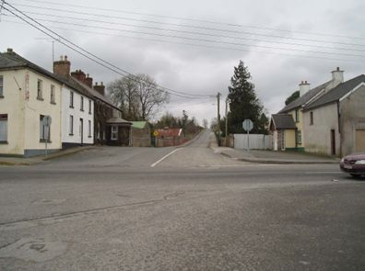 | Image 34 (Before): View up Hill Street, showing little footpath coverage.

Image 35 (Before): View from the Crossroads to the Longford Road, illustrating the lack of footpath coverage and dangerous road layout. | 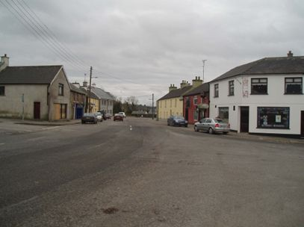

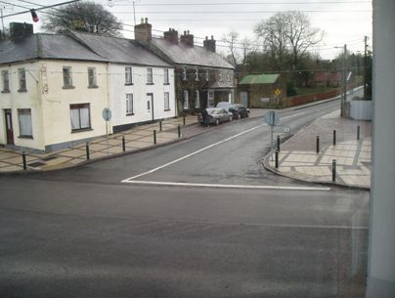 | Image 36 (After): View up Hill Street.

Image 37 (After): View towards the Longford Road illustrating pavement extension and resurfacing. | 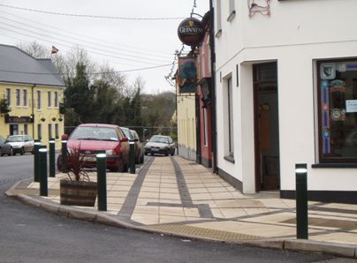

Accordingly, the Strategic Objectives and Policies are outlined as follows:

Strategic Objectives

- Sustain and enhance the vitality and viability of the village centre through the strengthening of the mix of uses and the refurbishment or appropriate redevelopment of existing buildings and sites.

- Secure reuse of vacant first floor premises within the village centre.

- Secure the redevelopment and/or refurbishment of the high numbers of derelict or rundown properties within the village core.

- Secure the enhancement of the streetscape of Drumlish, through the appropriate design of buildings and alterations at development or redevelopment stage.

- Progress the Drumlish Urban and Village Renewal Programme environmental improvement project if approved by the DOEHLG.

Policy

Having regard to the strategic objectives, the Planning Authority’s Policy is as follows;

VC1 Ensure that development within the village core is of mixed use. Mixed use developments in town/village centres are appropriate in attaining sustainable development objectives, creating opportunities to live, work and shop within the rural settlement centre.

VC2 Secure the redevelopment of derelict and run down buildings within the core of Drumlish, with particular attention paid to those buildings on St. Mary’s Street.

VC3 Facilitate, where possible, the further extension of pavement resurfacing and environmental improvement works under the Urban and Village Renewal Works.

VC4 Secure, where possible, the development of approach roads into the village centre with attention paid to the name plates and also any other distinctive features on these roads.

VC5 Development that occurs at the edge of the village should appropriately and adequately demarcate the village edge, providing visually attractive and welcoming entrances to the village.

VC6 Require that any development within the village core is sensitively carried out and consistent with the design principles outlined in the County Development Plan.

8. Preservation and Conservation

The Built Environment forms an important part of our cultural heritage. The physical survivals of our past are to be valued and protected as a central part of our common heritage. Their presence adds to the quality of our lives, by enhancing the familiar and sustaining the sense of local distinctiveness, which is an important aspect of the character and appearance of our towns, villages and countryside.

The Planning Authority considers it desirable that buildings and features of historic, heritage and architectural importance are protected for the enjoyment and benefit of future generations. On examination of Drumlish, it is evident that there are various structures worthy of protection. These are outlined in Figure 5. Development should take place in such a way as to incorporate the amenities offered by these structures.

Accordingly the Strategic Objectives and Policies are outlined as follows:

Strategic Objectives

- Secure the preservation of the relevant structures outlined by the Draft National Inventory for Architectural Heritage for County Longford.

- Compile and maintain a record of any other structures or monuments which is of special architectural, historical, archaeological, artistic, cultural, scientific or technical interest.

- Protect and preserve stone walls, existing hedgerows and healthy mature and developing trees by incorporating them into the site layout of any new developments and to encourage new planting and the replacement of lost hedgerows and trees using native species.

Policy

Having regard to the strategic objectives, the Planning Authority’s Policy is as follows;

PC1 Prohibit any development, alterations or modifications to the buildings and other features worthy of protection, that would detract from or destroy the essential character of the building or feature listed.

PC2 Identify structures of local character and distinctiveness as part of the Townscape Appraisal (Map 2).

PC3 Refer all planning applications for development that would impinge upon any known structure worthy of protection to the Department of the Environment, Heritage and Local Goverment and the Architectural Advisory Unit, and, where considered necessary on the advice of the DoEHLG, to prohibit any development that would irreplaceably damage any such structure or monument.

PC4 Encourage the restoration of any structures or monuments listed in the structures worthy of protection.

PC5 Retain, protect and integrate vegetation into new developments. This includes mature and groups of trees, hedgerows and vegetation of importance to wildlife.

PC6 Promote greater habitat and species diversity through the planting of trees and shrubs native to the Drumlish area within new developments. New developments should include landscaping designed to protect and retain natural features such as existing trees, hedges and shrubs.

PC7 Preserve identified views of scenic landscapes as indicated on the Townscape Appraisal Map (Map 2).

9. Education and Community Facilities

As the population of Drumlish expands, the need for additional educational, childcare and community facilities will arise. Accordingly, the zoning plan has identified extended lands for St. Mary’s National School. Additional lands for the Community Hall and Health Centre and Graveyard, may also need to be safeguarded when reviewing the plan.

Accordingly, the Strategic Objectives and Policies are outlined as follows:

Strategic Objectives

- Secure that there are sufficient appropriate educational and community facilities available to meet the needs of the residents of the area.

- Secure that enough land is zoned within the six year plan to facilitate their longer term role in the village.

- Promote childcare facilities within appropriate locations, such as residential areas, places of employment, or educational establishments and where possible convenient to public transport and safe pedestrian routes.

- Promote the sufficient use of all community buildings by supporting effective management and shared use proposals.

Policy

Having regard to the Strategic Objectives, the Planning Authority’s Policy is as follows;

EC1 Co-operate with and assist statutory and voluntary bodies in the provision of new educational and community facilities in Drumlish as the need arises.

EC2 Consider the imposition of conditions on all new residential development within the area for the purposes of facilitating the provision of additional educational/community facilities.

EC3 Identify new or existing locations for childcare facilities and consider favourably applications based on need, accessibility, public road safety and other plan policies.

10. Energy

Energy provision within the settlement is currently meeting requirements. It is assumed that sufficient capacity exists for the scale of development likely to take place in the Drumlish area over the plan period. Longford County Council recognises the need to adopt a more sustainable approach to energy production and promotes the use of renewable energy, passive and low energy houses.

Accordingly, the Strategic Objectives and Policies are outlined as follows:

- Facilitate and promote investigation into the provision of potential alternative, renewable energy sources.

- Encourage low energy and passive houses.

Policy

Having regard to the Strategic Objectives, the Planning Authority’s Policy is as follows:

E1 Co-operate with and assist statutory and voluntary bodies in the provision of alternative and renewable sources of energy, where deemed appropriate by the Planning Authority.

E2 Favour and promote the use of energy efficient homes, through encouraging alternative and renewable sources of energy where appropriate.

4. Zonings

The zonings are intended to be flexible, provided that the basic concepts of proper planning, residential amenity and good design practice are adhered to. Any proposed development should be compatible with the primary zoning use and should not detract from the amenity of the area. These zonings should be read in conjunction with the Development Plan Design Standards, particularly in relation to design, materials, public open space and parking requirements.

4.1 Residential

- To primarily provide for residential development; to preserve and improve residential amenity, dwellings and compatible uses including social and community facilities, open spaces and local shopping facilities

The principles of sustainable development shall be taken into account when considering applications for residential development in the area, including the use of higher housing densities, natural, locally sourced materials, energy efficiency and transport implications, the impact on the existing ecology and compatibility with local environmental conditions.

4.2 Commercial/Residential

- To primarily provide for commercial/retail development with a possible element of residential development

Development carried out under this zoning should have regard to the dual use of the zoning, and, in particular, shall have regard to the retail strategy for the County. Developers should be cognisant of the high profile locations of this zoning and design, whereas siting and materials should be chosen accordingly.

4.3 Industrial/Commercial/Warehousing

- To primarily provide for industrial/workshop and warehouse development including compatible uses such as offices and distribution.

Zonings of industrial nature are indicative and are adaptable to the nature, size and requirements of future employment/industrial development. The creation of local employment is the primary aim of this zoning. Hi-tech business/office, and light industrial developments will be considered within this zoning.

4.4 Social/Community/Education

- To primarily provide for social and community facilities

This zoning provides for facilities that serve the community as a whole such as schools, community centres, crèches, nursing homes, etc.

4.5 Recreational/Open Space

- To primarily provide for recreational open space and ancillary structures

The proposed village walkway and public park would provide a recreational backbone to the town which would provide a wildlife corridor and a potential link to other walking routes, facilitating the establishment of a pedestrian network of pathways.

4.6 Low Density Residential

- To primarily provide for low density residential development

This zoning is designed to facilitate residential development on a much smaller scale, responding to infrastructural concerns, reinforcing the traditional role of the settlement and guarding against over-development.

4.7 Low Density Residential with Provision of Village Walkway

- To primarily provide for low density residential development, with provision of the village walkway at the developer’s expense on developing the site.

This zoning is designed to facilitate residential development on a much smaller scale, responding to infrastructural concerns, reinforcing the traditional role of the settlement and guarding against over development.

It is intended to achieve the village walkway through the development management process, as conditions on any future planning permissions. Specific zonings in this regard are outlined within the zoning map (Map 1) of the plan.

4.8 Residential with provision of Village Walkway

- To primarily provide for residential development; to preserve and improve residential amenity, dwellings and compatible uses including social and community facilities, open spaces and local shopping facilities. This shall be in tandem with provision of the village walkway at the developer’s expense on developing the site.

The principles of sustainable development shall be taken into account when considering applications for residential development in the area, including the use of higher housing densities, naturally, locally sourced materials, energy efficiency and transport implications, the impact on the existing ecology and compatibility with local environmental conditions.

It is intended to achieve the village walkway through the development management process, as conditions on any future planning permissions. Specific zonings in this regard are outlined within the zoning map (Map 1) of the plan.

4.9 Residential with provision of New Access Road to the R198

- To primarily provide for residential development; to preserve and improve residential amenity, dwellings and compatible uses including social and community facilities, open spaces and local shopping facilities. This shall be in tandem with provision of a new access road from the Derawley Road onto the R198 and the closing of the existing Derawley Road/R198 Junction, at the developer’s expense on developing the site.

The principles of sustainable development shall be taken into account when considering applications for residential development in the area, including the use of higher housing densities, naturally, locally sourced materials, energy efficiency and transport implications, the impact on the existing ecology and compatibility with local environmental conditions.

The new access road to the R198 and closing of the existing Derawley Road/R198 junction, will be facilitated within the specific zoning as outlined on Map1, on developing the site. It is intended to achieve these works through the development management process, as conditions on any future planning permissions. The precise nature of the works, including the road line and access and egress points, will be designed in tandem with the Roads Department of Longford County Council. Specific zonings in this regard are outlined within the zoning map (Map 1) of the plan.

4.10 Extended Village Core

- To primarily provide for the consolidation of backlands that allows for residential development combined with elements of commercial and retail facilities.

Development carried out under this zoning should have regard to the dual use of the zoning, and, in particular, shall have regard to the retail strategy for the County. This will allow and facilitate the strengthening of the village core.

4.11 Parking Area

- To primarily provide for organised, off street parking within the core of the settlement.

This zoning is designed to alleviate haphazard parking and improve the flow of traffic within the town. Pedestrian access from proposed parking areas to the village core will be promoted in tandem with development, in the interests of safety and to further develop and enhance the vibrancy of the settlement core.

4.12 Environmental Improvement Works

- To primarily provide for the improvement of the built environment within the settlement.

This designation is designed to facilitate the improvement of the built environment and public realm within the settlement. Works under this designation includes the provision and improvement of footpaths. The majority of these works will be subject to funding from the DoEHLG.

4.13 Infrastructural and Service Provisions

This refers to the provision of elements such as link roads, car parks, playgrounds, the nursing home and the proposed Replica Mill Building. The word ‘notional’ is used as precise locations for such elements are, as yet, undetermined. It does not refer to the provision of such elements as these shall be provided by the relevant bodies where appropriate. In relation to the provision of the Proposed Playgounds, it may be appropriate that only one playground is provided, subject to proper planning conditions.

Industrial Link Road

The Industrial link road will be facilitated within each specific zoning as outlined on Map 1, on developing the site. It is intended to achieve the industrial link road through the development management process, as conditions on any future planning permissions. The exact road line and access and egress points within this area will be designed in tandem with the Roads Department of Longford County Council. Specific zonings in this regard are outlined within the zoning map (Map 1) of the plan.

Residential Link Roads

The residential link roads will be facilitated within each specific zoning as outlined on Map 1, on developing the sites. It is intended to achieve the residential link roads through the development management process, as conditions on any future planning permissions. The exact road line and access and egress points within this area will be designed in tandem with the Roads Department of Longford County Council. Specific zonings in this regard are outlined within the zoning map (Map 1) of the plan.

Notional Car Parking

Notional Car parking, as defined by ‘Yellow Triangles’, shall be facilitated within specific Extended Village Core/Backland Development zonings as outlined on Map 1. ‘Notional Car Parks’ shall be provided by developers at their own expense, on developing the site. The preferred method of achieving this is through the development management process, as conditions attached to future planning permissions. Where it is not possible to provide parking for the proposed development within the site, charges will be levied for parking provided within this area by the Local Authority in accordance with an approved schedule of charges.

Pedestrian access from proposed parking areas to the village core will be promoted in tandem with development, to further develop and enhance the vibrancy of the commercial core.

5. Likely Significant Effects on the Environment

For the purposes of this plan a matrix has been applied to assess the different zoning functions against a set of defined environmental criteria.

Environmental Aims

The following environmental aims are used to assess the zoning objectives contained within this draft local area plan:

- The encouragement of sustainable transport

- The minimisation of waste and minimisation of pollution

- The conservation and enhancement of biodiversity and natural heritage

- The conservation of architectural, archaeological, geological, cultural and historical heritage of the County

- Rationalisation of the use of natural resources and promotion of renewable energy resources and encouragement of energy efficiency

- Protection of Landscape

Figure 9: Assessment of Zoning Objectives Against Environmental Aims.

 | Strategic Environmental Aims
Zoning Objectives |  |  |  |  |  | 
1. Mixed Use |  |  | | | a | a | |
2. Residential |  |  | | | | | a | 
3. Recreational | | | | | a | | | | | |
4. Light Industrial/Technological |  | | | ❒ | | | a | ❒
5. Institutional: Religious/Education/Community |  |  | a | a | a | |
6. Extended Village Core |  |  | | | a | | | |
7. Amenity Open Space | | | | | a | a | a | 
8. Industrial Link Road |  | | | ❒ | | | | | |
9. Residential Link Road |  | | | | | | | | | |
10. Village Walkway | | | | | a | a | a | 
11. Carpark |  | | | ❒ | | | | | ❒
12. Proposed Playground. | | | | | a | | | | | |
13. Proposed Nursing Home | | | | | | | | | a | |

Legend: Beneficial  Negative |Neutral

The consolidation of development within a defined village envelope is likely to result in neutral or positive benefits on most of the environmental criteria. Most negative impacts are likely to arise in relation to the development of additional roadways and the industrial area, which may promote further private motorised transport and alter the local landscape and the availability of habitats and corridors for wildlife. It is important that these potentially negative aspects are addressed at the planning stage and mitigation measures implemented where possible.

Map 1:
Drumlish Zoning Map

Map 2:
Drumlish Townscape Appraisal

Appendix

Appendix 1: S.W.O.T. Analysis
Element | Strengths | Weaknesses | Opportunities | Threats
Morphology | Layout of the centre of Drumlish is a central crossroads creating the potential for a compact physical form. | Entrances to the town that demarcate the town edge are weak. | High quality appropriate designs and landscaping on the approaches into the town would help define and enhance the town boundaries.  High quality development within the town centre may consolidate the functional ‘heart’ of Drumlish. | Pressure for new residential developments may result in the stretching of the settlement morphology and erosion of the village fabric.
Public Realm | Interesting mix of building heights and facades within the town centre.  The centre of Drumlish houses many historically relevant buildings that contribute to the Public Realm.  Recent environmental improvement works have also created high quality pavement surfaces, adding to the overall appearance. | There still exists many poor quality pavement surfaces.  The centre of the town has many derelict and unoccupied buildings that detract from the visual appearance of the Public Realm. | High quality street furniture and pavement surfaces will greatly enhance the streetscape.  The redevelopment of the core of the village remains possible through backland consolidation, thus providing better opportunities to attract commercial development. | Inappropriate development that pays little attention to the existing and traditional features of the town will detract from the public realm.
Housing | Good quality new housing developments that have attracted numerous people to the area. | Much of the older housing within the centre of the town is either derelict or unoccupied. | An opportunity exists to redevelop the core of the town through encouraging high quality residential developments that contribute to the character of the town. | There exists the danger of inappropriately expanding the village through the provision of residential developments that undermine the fabric of a consolidated village core.
Element | Strengths | Weaknesses | Opportunities | Threats
Open Spaces | The Corn Mill, mill race and river provides an attractive feature that could be incorporated into open space. | Little open or amenity space available for community uses. | Significant land, natural and manmade features available that can be incorporated into the creation of high quality open spaces. | Development at the expense of, or without consideration to, open spaces would be detrimental to the town.
Infrastructure | Good road network on the R198 that makes Drumlish accessible. | Speeding within the town and restricted opportunity for parking provision for commercial properties that may want to locate in the centre of the town.  Problems exist regarding the current sewerage system and water treatment plant. | The potential exists through backland consolidation to provide off-street car parking.  The sewage infrastructure and water treatment plant are currently included in the DOEHLG investment programme. | Increased traffic through the town resulting from Drumlish’s location on the R198.  That development will take place contrary to sanitary concerns.
Services | Good level of service provision within the town that includes supermarkets, a health centre, pharmacy and post office. | Little opportunity to attract services to the centre of the town resulting from limited ground space and parking facilities. | Use of backlands can provide needed lands for significant commercial development, thus attracting more services. | That new services within the area will locate on Greenfield sites contradicting the need to develop the core of Drumlish.
Employment and Enterprise | Low level of unemployment. | Limited local employment and enterprise opportunities within the town. | Significant land available to develop as light industrial/technological, thus creating more job opportunities locally and strengthening economic investment within the town. | That the majority of the workforce, particularly the young, will continue to leave the area.
Tourism | Strong raw assets, such as the Corn Mill, and community involvement. | Many features remain significantly underdeveloped from a tourism viewpoint. | There exists excellent potential within Drumlish to develop natural features/areas and buildings of historical | Inappropriate or low quality design may damage the village’s character, reducing the potential for tourism.
Element | Strengths | Weaknesses | Opportunities | Threats
Tourism Continued… |  |  | significance in order to maximise tourist potential.

The term ‘Present’ refers to the date of carrying out this research which was Nov/Dec 2005.
The Projected Population Increase is based on the permissions granted for new dwellings before December 2005 and is dependent on these dwellings obtaining occupancy.
The term ‘Commercial’ does not include traditional commercial functions that should locate within the village core.

