1. Introduction

  - Background

This Kenagh Plan has been prepared as a Local Area Plan (LAP) in accordance with the statutory requirements of the Planning and Development Act 2000 and subsequent amendments.

The Plan takes the form of a Written Statement, and accompanying Zoning Plan and Townscape Proposals Map. If any conflict or ambiguity arises between what is contained in the written statement and the supporting plans, the written statement will take precedence.

The purpose of the Plan is to inform the general public, statutory authorities, developers and other interested bodies and set out a framework for the future development of the village over the plan period 2006 – 2012.

The need for this plan arises from the unprecedented demand for residential development land in the Kenagh area and the need to properly plan for future expansion of Kenagh in a co-ordinated and sustainable manner. Appendix 1 identifies a SWOT (Strengths, Weaknesses, Opportunities and Threats) analysis of the area, from which many of the objectives and policies are conceived.

This plan has been prepared within the context of Agenda 21 and the need for sustainable development to protect the environment for future generations. In accordance with the SEA Directive (2001/42/EC) and the Planning & Development (Strategic Development Assessment) Regulations, 2004, the proposed Local Area Plan was screened to ascertain if the plan required the preparation of an Environmental Report. The Screening Report was sent to the designated Environmental Authorities and it is the opinion of the Planning Authority that a Strategic Environmental Assessment is not required.
1.2 National and Regional Planning Context

National Context

In preparing this plan regard has been given to national and regional trends. Primarily, this LAP is fully consistent with the National Spatial Strategy 2002-2020 which provides a sustainable policy framework for balanced social and economic development and population growth for Ireland.

In relation to County Longford, Longford is described as an important County Town that is strategically placed on national road and rail links and should be enhanced in competitive terms to drive development at the county level. Therefore the role of towns and villages, such as Kenagh, is to take pressure off development in the open countryside and channel it into more sustainable and compact forms.

This strategy is translated to a regional level by the Regional Planning Guidelines for the Midlands Region. Although Kenagh is not specifically defined within these guidelines, it is important that Kenagh assists in the consolidation of the region’s growth, whilst providing for sustainable and viable rural communities. Figure 1 highlights the Midland Regional Planning Guidelines Strategic Development Framework.

Figure 1: Midland Regional Planning Guidelines Strategic Development Framework (Source: Regional Planning Guidelines, Midland Regional Authority, 2004.)

1.3 County Development Plan Context

The County Development Plan is the statutory development plan for the County of Longford in the years 2003-2009. This Local Area Plan has been prepared under Section 3 of the Longford County Development Plan, 2003 – 2009. Section 3.1.1 of the plan outlines the hierarchy of settlements in the County and defines the role of Kenagh as an area covered by a village policy statement. However, given the growth of the area in recent years it is now more appropriate to create a Local Area Plan for the village. Accordingly Kenagh shall be defined as a Local Growth Centre whereby;

“These settlements will continue to provide settlement centres for the population and local level goods and services provision. The potential for tourism and amenity development… is recognised and shall be promoted and encouraged where appropriate in the Local Area Plans which shall be prepared for these locations.” (Longford County Development Plan)

1.4 Previous Plans

There are no previous plans for Kenagh, however, there are previous zonings under the Longford County Development Plan 2003-2009 which provided for residential development and the application of Part V of the Planning and Development Act, 2000 (as amended).

1.5 Strategic Objective of the Kenagh Local Area PLan

The strategic objective of the LAP is as follows;

To set out a clear framework for the next six years for the sustainale development of Kenagh identifying sufficient suitable lands for future housing, commercial, amenity and community facilities whilst protecting and preserving the village’s intrinsic character, heritage and amenity, positively contributing to the quality of life.

The Plan sets out policy statements and objectives in response to specific development issues. A flexible zoning policy is considered appropriate in this instance, given the size and function of the village. The zoning provisions are indicated on the Zoning Map, see Map 1. It is the intention of the Planning Authority that the zoning of specific areas for a particular use shall not exclude other uses in that area provided they are compatible with the dominant use.

The Plan addresses the existing townscape quality of the central core of Kenagh and identifies opportunities for environmental enhancement of the area. Environmental Improvement proposals are indicated on the Townscape Appraisal, see Map 2.

In general, the LAP for Kenagh is designed to stimulate development and direct it to appropriate locations. It is within the framework of the Plan that public services will be provided and investment decisions made. This Plan should be read in conjunction with relevant policies and objectives on the County Development Plan 2003 – 2009.

1.6 Goals of the Plan

The Kenagh LAP establishes a vision for the village, aimed at enabling its continued vitality and viability striking a balance between preserving its traditional character and facilitating the requirements of modern day living. The plan will concentrate on establishing new linkages, both within and outwards from the central area, improving accessibility and determining suitable land uses for the village.

The overall strategic goals of the LAP are as follows:

- Promote the appropriate development of Kenagh for its existing and future residents.

- Implement the policies and objectives of the County Development Plan and enhance the role of Kenagh as a community and commercial service centre to the surrounding rural hinterland, within the context of the Regional Planning Guidelines.

- Provide for the orderly expansion of the village, identifying sufficient and suitably located land in order to meet the land use needs of the various functions of the town over the plan period.

- Promote the provision of necessary infrastructure, including public utilities and services, recreational and community facilities in order to satisfy the development needs of the village.

- Secure safe and convenient circulatory links within the area, particularly in relation to pedestrian and cyclist paths.

- Enhance and protect the environment and heritage of the town including the renewal of obsolete areas and the preservation of buildings and other features of historic, artistic, cultural or social interest.

2. Profile and Resource Base

2.1 Context

Kenagh is situated in the south of the County approximately 8 miles (13 kilometres) from Longford Town, via the R397 and N67. The R397 dissects Kenagh and leads on to Ballymahon via the R392. Further, the village is situated adjacent to the Royal Canal which flows from Dublin to Clondra in Co. Longford. The Canal once provided an important transport link to the village and it is envisioned that once the Canal is fully restored, it will provide an important tourist link to the village.

Figure 2: Regional Context

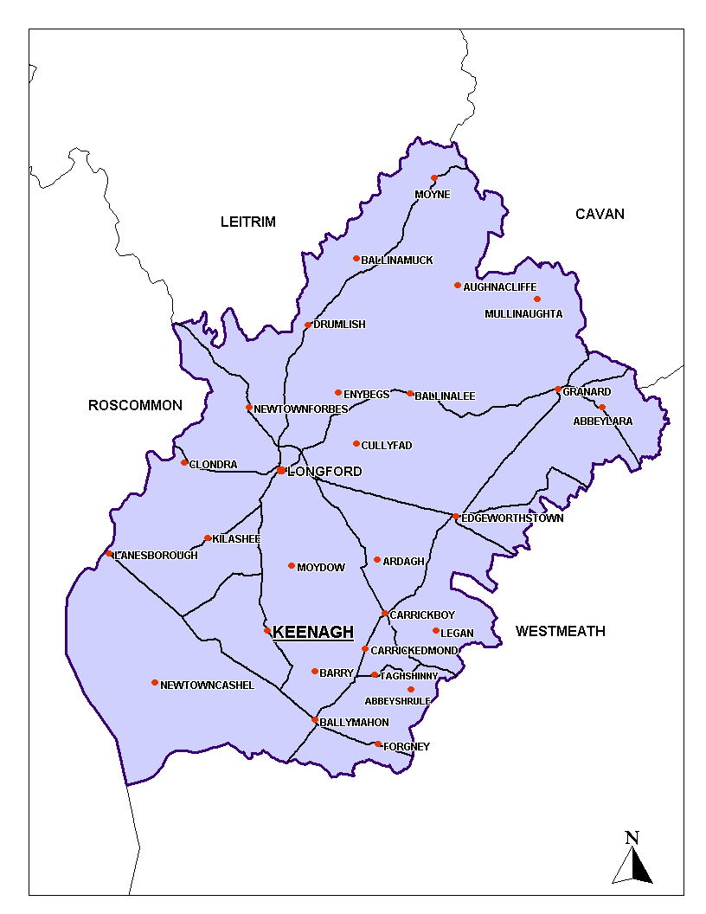

2.2 Character and Historical Background

Kenagh is a picturesque rural village with a wide main street and relatively charming street frontage. The popularity of the area is reflected in the substantial growth of the village in recent years. Typically, the settlement pattern was reflective of any traditional Irish village that followed a linear pattern of development. Recent changes, however, have seen pockets of housing developments emerge within the town.

The name Kenagh derives from the Irish word ‘Caonach’ meaning moss. The village was accordingly named after acres of land on which moss grew on stone around the Mosstown Estate. The village itself was built around the estate by the Kingstons between the years of 1837 to 1843.

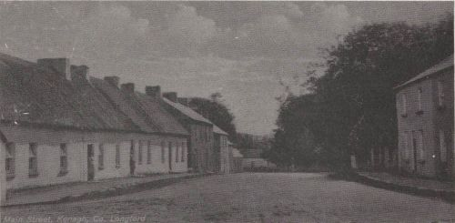

Image 1: Kenagh Village in the early 1900s. (Source: Kilcommoc and its People, Edited by P. Egan 1981)
2.3 Population and Demography

Since 1991, Kenagh has witnessed an increase in population. Figure 3 illustrates that during the period 1991 to 1996, the village experienced an actual increase of 5 persons or a percentage increase of 2.3%. Between 1996 and 2002, the village experienced an actual increase of 2 persons and had a percentage increase of 0.9%.

Figure 3: Population Trends 1991 – 2002

Area | 1991 | 1996 | 2002 | Change 1991 – 1996  Actual / % | Change 1996 – 2002  Actual/%
Kenagh | 218 | 223 | 225 | 5 / 2.3% | 2 / 0.9%
County | 30,269 | 30,166 | 31,127 | -130 / -0.4% | 961 / 3%

Resulting from the number of housing units granted planning permission since 2002, and the number of new dwellings which are now under construction, it is evident that the population of Kenagh is set to increase. Permission has been granted for 261 new dwellings, of which approximately 10 are now occupied. On the basis of these figures the population of Kenagh since 2002 has presently increased by an estimated 10%.

Need for additional zoned land?

Longford is located wholly within the Northern Development Area, as identified in the Midland Regional Planning Guidelines, 2004. Future population growth, taking account of both recent trends and the strategic goals, to this development area would need to grow between the range of 8,000 to 11,000 in the period to 2020. Taking the maximum level of growth of 11,000, the projected population growth for Kenagh for this period is approximately 100 persons, resulting in 35 additional dwellings until 2020. It is clear from the calculations above that Kenagh is in excess of the population allocation as forecast in accordance with the Midland Regional Planning Guidelines, therefore additional residential zoning should be of an extremely sensitive nature, adaptive and responsive to the needs and nature of the settlement.

There is approximately 4 hectares of undeveloped land zoned standard density residential and approximately 23 hectares of undeveloped land zoned low density residential. This will allow for an additional 100 dwellings to be built at a density of 25 units per hectare and 115 dwellings at a density of 5 units per hectare respectively. Therefore there is no immediate need for further residentially zoned land over the lifetime of this plan.

2.4 Village Functions

Over much of their history, towns and villages such as Kenagh have been vital economic and cultural hubs, profoundly influencing, as well as being influenced by their rural hinterlands. The challenge for the future is to sustain and enhance the viability and diversity of such settlements by pursuing their appropriate development and growth. Increased mobility has meant that many traditional village functions are now obsolete. The challenge is to retain local level services, a sense of neighbourhood and sustainability.

Kenagh is a service centre for the rural hinterland. It provides educational, religious, commercial, employment, financial and administrative functions for the village and the surrounding rural area. Kenagh is relatively well serviced having a number of shops, a hardware store, bakery, hairdressers and drapery. There are also a number of pubs and restaurant facilities within the village and a Post Office which provides financial and administrative services.

The village also has a Garda station, community centre, health centre and GAA facilities.

Image 2: Newman’s Lounge, Keenagh. | 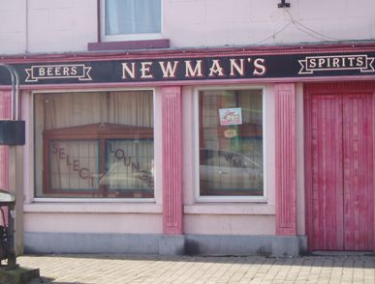

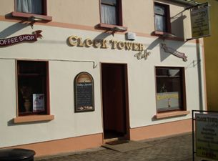 |  | Image 3: The Clock Tower Café,
Image 4: The Health Centre. | 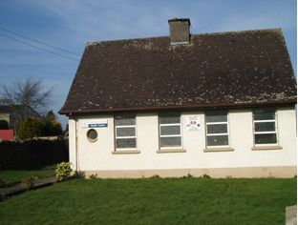
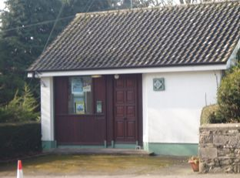 |  | Image 5: Garda Station.

St. Dominic’s RC Church can be found within Kenagh village, with the catholic graveyard nearby in Kilcommoc. St. George’s Church of Ireland is also located within Kenagh and has an adjoining graveyard.

There is one national school in Kenagh, Naomh Dominic N.S., attended by 85 pupils. There is no secondary school in the village therefore second level students attend schools throughout the county. It is envisaged that as Kenagh will experience further growth, provision should be made for the future expansion and development of such educational facilities with particular attention given to that of the national school.

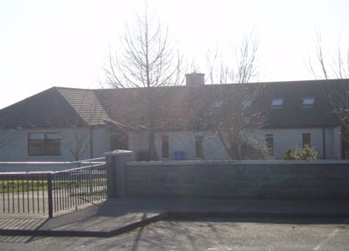

Image 6: St. Dominic’s National School, Kenagh.
2.5 Built and Natural Environment

The entrances into the village are well maintained, however, the opportunity exists to visually strengthen these gateways.

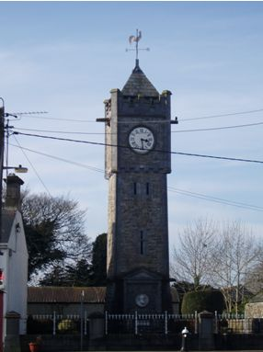
Image 7: The Harman Memorial Clock Tower

The Harman Memorial Clock Tower offers an attractive landscape feature within the core of the village and creates an impressive entrance from the east. Open space, trees and other such landscape features play an important role in adding to the character and townscape of a village. Kenagh is particularly fortunate to have such expanses of open space provided by the Mosstown Estate. There are numerous trees spread throughout the estate and throughout the village itself that add character to the village and therefore should be protected. These features are complemented by tracts of forestry that create a notable backdrop to the village particularly on entering Kenagh from the north-west. In addition to this, the village has numerous stone walls that enhance the character, and should be maintained where possible.

The street elevations consist primarily of nineteenth century buildings that are strong and symmetrical in design, which gives many Irish towns and villages their particular sense of character. In a similar fashion to many streetscapes there are later period insertions of varying quality. It is important that any future development within this streetscape is carried out to the highest standard and enhances the character and identity of the settlement.

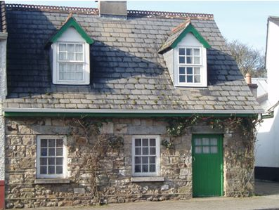
Image 8: A house in Kenagh that adds to the unique character and identity of the village.

The Clock Tower in Kenagh is recognised within the County Development Plan’s, 2003-2009, list of Protected Structures. Based on the draft recommendations of the National Inventory of Architectural Heritage (NIAH) of the DoEHLG, there are other structures worthy of protection within Kenagh that could be included for protection. These are outlined in Appendix 2 with accompanying images.

In addition to the Structures Worthy of Protection within the settlement, there are monuments included in the Record of Protected Monuments and Places (RMP) for County Longford. These monuments contribute to the archaeological heritage of Kenagh. The monuments are as follows (see recorded monuments on Townscape Appraisal Map);

Monument Townland Monument Number
Standing Stone Site Mosstown LF022-005
Pigeon House Mosstown LF022-006
Ringfort Corlea LF022-016
Ringfort Corlea LF022-017
Togher Corlea/Clonbreany LF022-018
Archaeological Complex Corlea/Derrynaskea/Mosstown LF022-057
Various Toghers Corlea LF022-0570 – LF022-05740
Archaeological Complex Corlea/Mosstown/Clonbreany LF022-058
Various Toghers Corlea/Clonbreany LF022-05801 – LF022-05815
Possible Togher Corlea LF022- 059
Togher Corlea LF022-067

The backland areas have until recently consisted of rear gardens, walled yards and lanes with unlimited access. Typically, there is no consistency in depth and these areas have been developed as uses ancillary to the established street frontage. There is a degree of dereliction and an element of under use in some of these areas. Overall they are intrinsic to the urban grain of the village, but have in places the potential to be developed, while preserving their role in the morphology of the settlement.

2.6 Physical Infrastructure and Servicing

Water Supply

Kenagh is currently supplied with water from a spring well within a limestone aquifer that is in close proximity to the town. This method of water supply is to be investigated as part of the Ballymahon Regional Water Supply Scheme which began in January 2006.

Foul Drainage

The existing waste water treatment plant was constructed circa 1986 to serve a 500 population equivalent. Longford County Council is in the process of appointing a consultant engineer to prepare plans to upgrade the sewage infrastructure in Kenagh.

Developers will be required to take cognisance of the Planning Authority drainage plans and requirements in the preparation of planning submissions. Temporary arrangements for dealing with foul sewerage will not generally be considered.

Surface Water Drainage

Developers will be required to provide surface water outfalls, constructed to the County Council’s standards and will need to demonstrate that sufficient capacity exists in receptor watercourses. Sustainable urban drainage systems (SUDS) and other attenuation measures will be considered in all new greenfield developments. Existing watercourses should be kept open and incorporated into the landscaping of the area as much as possible.

Transportation and Movement

Kenagh experiences substantial traffic due to its location on the R397, however, this does not appear to pose significant problems within the town. A Bus Eireann route is scheduled for Kenagh and operates a return service from Longford once a day. The nearest rail station is in Longford Town which provides services to Dublin and Sligo on a daily basis. There are taxi operators who provide a local service for Kenagh. It is safe to assume, however, that the commuting are mostly reliant on cars.

Footpath coverage within the area is confined to the limits of the village and dissipates and terminates where the settlement reaches its rural edge. It is proposed under the Urban and Village Renewal Scheme that an area of footpath is provided on the Island Road into Kenagh Village in order to extend the village walkway from the canal to the village. Upgrading the footpath will promote safety, promote mobility and improve visual amenity. This is indicated as Environmental Improvement Works on the Townscape Appraisal Map (Map 2).

There is currently minimal off-street parking located within Kenagh Village, however, there does not appear to be a problem with on-street all day parking. Adequate off-street parking should be provided by future developers to sufficiently rejuvenate the village core.

Electricity

The Planning Authority will co-operate with and facilitate the ESB in providing additional sub-stations and power lines in appropriate areas of the village, as the need for increased electrical power arises. The under grounding of wires and cables will be required, where feasible, as part of new developments in order to protect the visual and residential amenities of an area.

Employment and Enterprise

Employment and enterprise are provided at an appropriate level to sustain the village of Kenagh. Zoning will be provided to adequately maintain existing enterprises, while at the same time, sustaining the village characteristics of Kenagh.

Social Housing

Development within residential zoned areas will be subject to Part V (social and affordable housing) as in the Planning and Development Act, 2000 (as amended). The requirements for social and affordable housing under the current housing strategy are 20%.

2.7 Development History

Kenagh has been subject to a number of housing developments, and subsequent population increase, in recent years. It is important for the sustainable development of the area that the potential pressures of such expansion are adequately recognised and catered for within any future developments.
2.8 Development Potential

Opportunities exist for the strengthening of the village structure, which could be carried out in conjunction with the development of the settlement. The strengthening of the following areas is particularly important in terms of the sustainable development of Kenagh.

Development Opportunity 1: Village Walkway and Extended Walkway Network

In order to provide a safe area of public open space within the village, a Village Walkway has been outlined for Kenagh. It is proposed that this walkway will extend throughout the village, providing an appropriate area of open space for residents and visitors. The Walkway will extend from the north of the village, throughout the Mosstown Estate, along The Kenagh River and back into the village towards its southern edge. This will establish an extensive village walkway network, creating arecreational backbone and providing an important wildlife corridor. As Kenagh is situated adjacent to the Royal Canal and close to Corlea Vistor Centre, it is also envisaged that the walkway will incorporate a route that adjoins the Royal Canal and the Visitor centre, thus linking Kenagh Village with a potential County wide walking network. This will create an important point of access to and from the Canal in particular.

Once the Royal Canal is fully restored, villages such as Kenagh, with its concentration of heritage features and heightened accessibility through the village walkway, will benefit. The extended walkway network will incorporate aspects of the rural hinterland that are unique to the Kenagh area. One such feature is ‘Limetree Avenue’ which extends for almost 1km as identified on Map 3. It will also provide a pedestrian/cyclist route to the Corlea Visitor Centre and Trackway from the Village. The Corlea Visitor Centre documents the findings of iron age trackways and paraphernalia that range between 2000 and 6000 years old, that were found in bogland within the vicinity. The Village Walkway is indicated on the Zoning and Townscape Appraisal Maps whereas the extended walkway is outlined on Map 3.

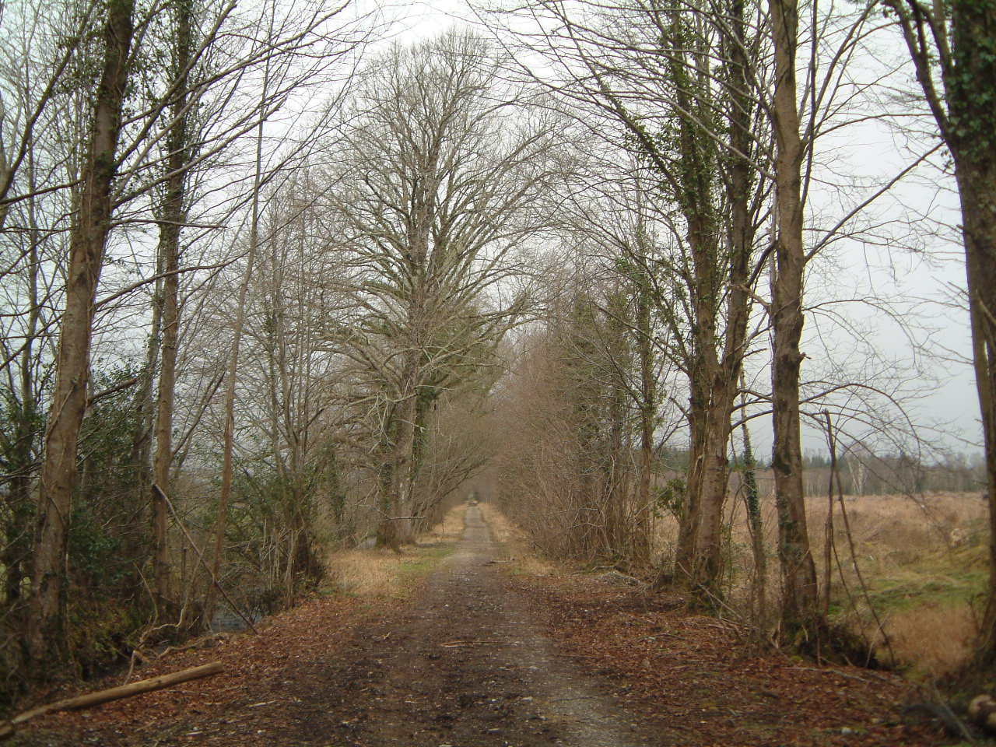
Image 9: View down Limetree Avenue.

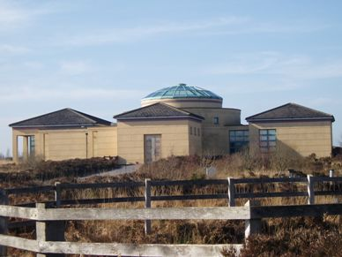
Image 10: Corlea Visitor Centre which provides information about the iron age trackway that was uncovered in Corlea Bog.
Areas of Improvement

There are a number of areas within the village that could be visually upgraded. It is essential for the vitality and viability of Kenagh that these areas are sufficiently upgraded. Upgrading these areas will visually enhance the village and make the village more attractive to inward investment.

Area 1: The Old St. Dominic’s Parochial Centre

The Old Parochial Centre visually detracts from the entrance into Kenagh on approaching the village from the south-west. The building is currently for sale and any future development on this site should be of the highest architectural design standards, adequately demarcate the village edge and create an appropriate entrance into the village, thus enhancing the character of the area.

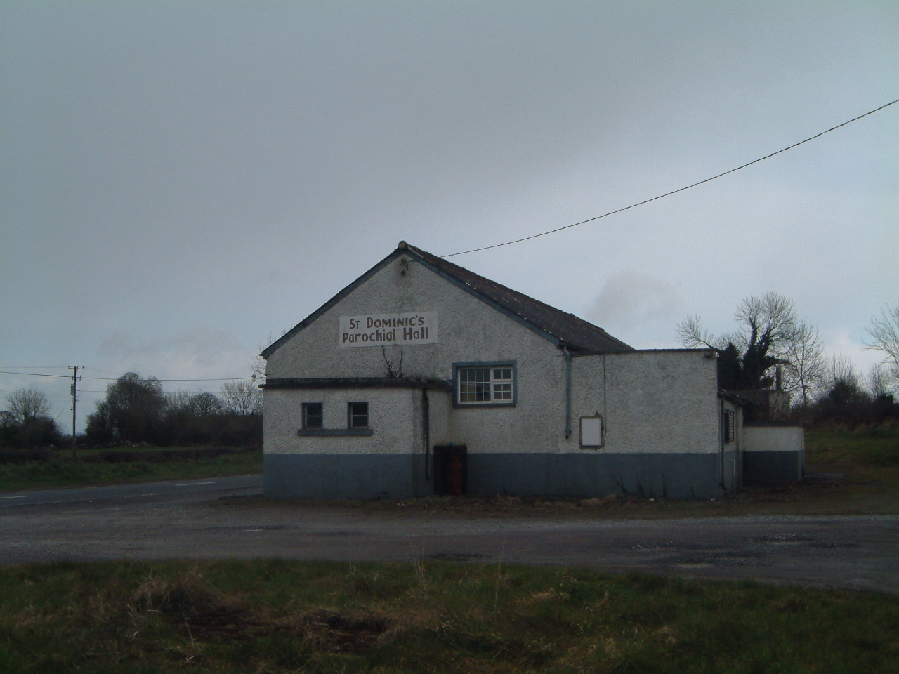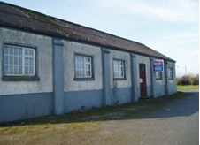

Images 11 and 12 : Old St. Dominic’s Parochial Hall.

Area 2: Old Garages on the Cartron Road

The old garages, located opposite the Old Methodist Church on the Cartron Road, detract from the impressive entrance the Clock Tower creates on approaching the village from the East. Permission has been granted to demolish these garages and erect 4 houses on the site. This will potentially rejuvenate the area and visually enhance this gateway into the village.

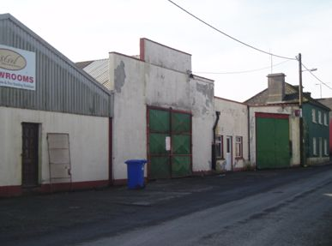
Image 13: The Old Garages, Cartron Road, Kenagh.

Area 3: O’ Boyles Bar

O’Boyles, opposite the Clock Tower, occupies an important corner site within the village. Given the context of this building, it should be visually improved in order to enhance the streetscape. The building height should be increased to conform with the adjoining buildings providing visual integration and continuity within the streetscape. Upgrading such features will not only visually enhance the village, but could potentially attract investment to the area. Figure 5 emphasises the important context that the building occupies and the images illustrate how O’Boyle’s Bar could look if rejuvenated.
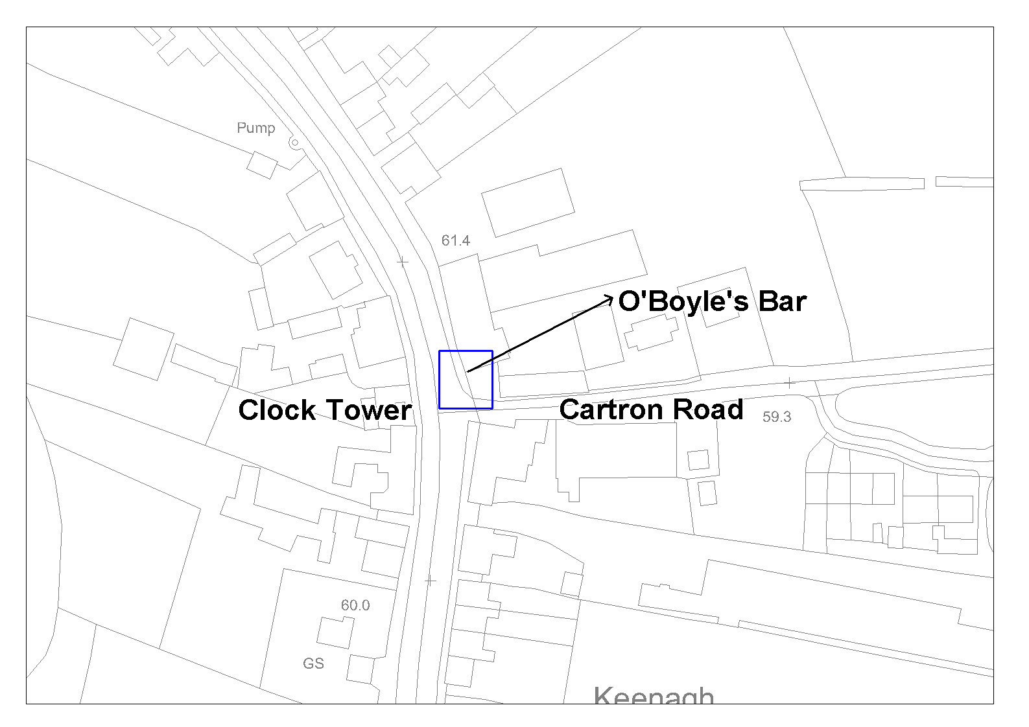
Figure 4: Map indicating the important corner site occupied by O’Boyle’s Bar.

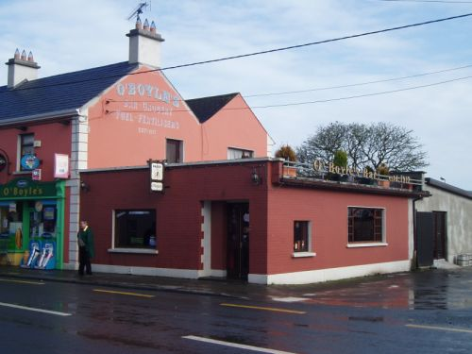
Image 14: O’Boyle’s as it stands now.
Image 15: Sketch of how O’Boyle’s could look if rejuvenated.

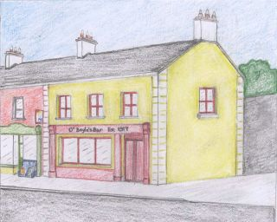
3. Development policies

3.1 Development Strategy

The future development of Kenagh is based on a ‘neighbourhood’ concept. The basic principles of this concept are underpinned by the aim of securing more sustainable patterns of development. Access to employment, shopping, education, health, leisure and social facilities are all important criteria in determining where future housing growth should be directed. Accessibility to such facilities is also a key element, and housing should be directed to locations where walking and cycling to shops, the local primary school and areas of open space are easily achieved.

3.2 Sustainable Development

This Local Area Plan aims to achieve sustainable development in Kenagh by focusing development on the village centre, consolidating resources and reducing the dependency on the car.

Aims

- Strengthen the built fabric of the existing settlement, creating and maintaining a vibrant and thriving community with an appropriate level of physical, social and economic infrastructure and services.

- Provide a high quality physical development pattern and an attractive, sustainable environment in which the population of Kenagh can live, work, recreate and interact, providing a catalyst for social and economic development and regeneration.

- All new development to be guided by sustainable development principles.

3.3 Strategic Objectives and Development Policies

1. Housing

Kenagh has experienced considerable pressure for residential development in recent years due, in part, to its close proximity and accessibility to Longford Town and relative proximity to Athlone and Mullingar. Potential exists for further sensitive residential development owing to its accessibility and its undeveloped potential. Significant potential also exists for infill development within the existing village core area. New developments should be of a density, character and architectural quality that would contribute to the consolidation of the village streetscape and offer an opportunity to conserve and enhance the settlement.

The amount of land identified to accommodate growth in the period to 2012 is guided by a number of factors such as infrastructure, proposals to upgrade the services available, and the capacity of the sewerage treatment plant. The total amount of undeveloped land that is zoned for standard density residential purposes is approximately 4 hectares (9.88 acres). Further, an estimated 23 hectares (56 acres) is zoned for low density residential that is undeveloped.

It is the intention of the plan that the village develops with a distinct design quality, building upon its background as a village, and that the scale and density of such development is appropriate to its character. It is also intended to avail of every opportunity to improve the physical fabric of the village as part of new development. These measures would include installation of high quality paving materials and street furniture particularly as part of the redevelopment of key neglected sites and obsolete areas.

Residential developments will promote the enhancement and reinforcement of a sense of community rather than just be about establishing ‘buildings’. A good design process can assess the potential relationship between and functions of new and existing developments. This understanding can be used to connect developments to the village both physically and psychologically. All proposed new residential developments will be assessed against the Social Housing Design Guidelines, issued by the DOEHLG.

Accordingly, the Strategic Objectives and Policies are outlined as follows:

Strategic Objectives

- Secure adequate zoned land to cater for the provision of high quality, sustainable residential accommodation to meet the demand for new houses in Kenagh for the next six years.

- Facilitate the linkage of new developments to community and social infrastructure such as the school, open spaces and recreational space.

- Prevent ribbon development and suburbanisation as it militates against the organised development of towns and villages. It is the objective of the council to ensure that this does not occur, particularly on radial routes from the village, through the creation of an attractive village settlement in which to live.

- Secure a high standard of landscaping in residential developments, with the provision of adequate public and private open space, amenity areas and pedestrian links.

- Secure high quality residential uses as part of development on backlands as part of an expanded village core.

Policy

Having regard to the above strategic objectives, The Planning Authority’s policy is as follows;

H1 Secure a high standard of residential design and encourage the ‘creation of places’ with a sense of local distinctiveness and legibility, including imaginative and interesting layouts with a range of house types/styles and a range of densities. Reference should be made to the qualitative aspects of the existing village fabric to achieve continuity and a sense of identity throughout the village.

H2 Any new residential development on residentially zoned land will be required to comply with Part V of the Planning and Development Act, 2000, in terms of the provision of social and affordable housing, at a rate of 20% of the overall development, as specified in the Housing Strategy.

H3 Require developers to contribute to or provide full costs of piped services, public lighting and other infrastructure which facilitate all new residential developments, including roads, footpaths, piped services and other facilities, whether within or outside the site.

H4 Require developers to provide high quality designs and finishes, that shall include the provision of decorative street furniture, pavement treatment and lighting.

H5 The developer will normally be required to reserve a minimum of 15% public open space in association with new developments and/or may be required to contribute (either financially or with land) towards the assembly of a larger public park for the benefit of the settlement as a whole. All open space shall be appropriately landscaped as part of the development and provided with woodland areas and walks linked to other areas of public open space. Private open space to the rear of dwellings shall be provided at a minimum of 11metres in length, or at least the width of the dwelling. A reduction in this requirement will only be considered in exceptional circumstances, where it is necessary to achieve a particular layout or where required by village structure.

H6 Protect residential amenities and improve associated facilities.

H7 Maintain the character of the village by requiring that boundary treatments to all new developments within the village are consistent and utilise materials indigenous to the area. The Council require that existing boundaries of character and value are retained where appropriate within new developments.

H8 Ensure linkages of open space in new and existing developments to provide for the incorporation of amenity/ecological corridors and pedestrian permeability throughout the village centre.

H9 Development that occurs at the edge of the village should appropriately and adequately demarcate the village edge, providing visually attractive and welcoming entrances to the village.

H10 The provision of an individual dwelling may be considered within the amenity zoning as part of the normal planning process where all of the following criteria have been met:
- The lands have been owned by the applicant's immediate family for at least the last ten years
- The applicant has clearly demonstrated local associations and need
- The applicant agrees to accept an occupancy condition for a specified period
- No other lands are available to that person outside of the amenity zoned area

Applications of this nature should incorporate the highest architectural design standards and the location of the house shall be to the satisfaction of Longford County Council in order to minimise the impact on the amenity land. All relevant technical requirements in terms of road safety, service availability and the safe disposal of domestic effluent must be satisfactorily addressed in addition to all other normal planning criteria.

2. Retail/ Commercial

Kenagh village is a locally important retail and commercial centre with a number of shops, pubs and community facilities. The Planning Authority considers it important to protect the existing retail/commercial function of the village to meet the needs of the existing population and to expand the range of local level services to sustain the proposed population.

The Planning Authority will facilitate the development of Kenagh as a service centre for its rural hinterland. Proposals for commercial and retail development shall be directed to the areas designated for village centre activities in order to consolidate and enhance the functional heart of Kenagh. Any applications for retail development in Kenagh should be consistent with the policies in this plan and the Retail Strategy for Longford.

Accordingly the strategic objectives and policy are outlined as follows:

Strategic Objectives

- Maintain and consolidate the role of Kenagh as a local retail and service centre for the surrounding rural hinterland.

- Ensure that as the population of the area expands, there are sufficient local level commercial and retail outlets to meet the needs of residents of the area.

- Encourage appropriate commercial development, providing a variety of unit sizes compatible with the character of the area in which they are situated.

Policy

Having regard to the above strategic objectives, The Planning Authority’s policy is as follows;

RC1 Encourage the provision of new local level retail development and commercial outlets of a range and type consistent with the growth of the village and located in the village core.

RC2 Require that physical or financial provision be made for adequate car parking in respect of new retail and commercial development in accordance with the Longford County Development Plan’s standards.
RC3 Ensure that the scale, layout, form and design of all new retail development is appropriate and respects and enhances its village setting. Longford County Council will promote the refurbishment of existing derelict or underused properties in the village centre.

RC4 In the assessment of applications for commercial/retail development, priority shall be given to a choice of brownfield sites in the village core prior to consideration of a greenfield site elsewhere within the village.

3. Enterprise and Industry

A total of approximately 1.5 hectares of land is zoned for Light Industrial/ technological/Commercial warehousing uses on the Cartron Road approaching the settlement. These lands should accommodate enterprise expansion in the village over the plan period.

Accordingly, the strategic objectives and policy are outlined as follows:

Strategic Objectives

- Identify sufficient land for light industrial/technological use with optimum accessibility that will increase economic activity without compromising the environmental, residential or amenity value of an area.

Policy

Having regard to the strategic objective, the Planning Authority’s Policy is as follows;

E1 Encourage opportunities for rural diversification locally and to zone land where appropriate for light industrial, technological, commercial, warehousing etc related activities.

E2 Require developers to contribute to the cost of all infrastructure, which facilitates development, including roads, piped services, footpaths and other utilities.

E3 Facilitate the continuity and expansion of existing enterprises, having regard to the protection of the residential amenity and compatibility of neighbouring properties.

E4 Sites to be developed for industrial and service purposes shall be designed to the highest architectural standards and provide high quality environments with adequate provision for landscaping, car and truck parking and circulation.

E5 Ensure the protection of the environment through encouraging high quality developments that take into account control of emissions and potential pollutants.

4. Tourism

Significant undeveloped tourism and amenity potential exists within Longford County, which is recognised in the County Development Plan.

Accordingly, the Strategic Objectives and Policy are outlined as follows:

Strategic Objectives

- Promote the development of sustainable tourism in the village and surrounding area through the conservation, enhancement and promotion of the village’s built and natural environment.

- Protect and Promote the architectural, historical and heritage features within the village as part of the overall promotion of Kenagh as a tourist destination.

Policy

Having regard to the Strategic Objectives, the Planning Authority’s Policy is as follows;

T1 Encourage sustainable market led tourism developments of an appropriate scale while maintaining the quality of the environment.

T2 Promote the development of areas and features unique to Kenagh, such as the Village Walkway that includes the Royal Canal, as tourist facilities in conjunction with existing established attractions such as the Corlea Interpretative Centre.

5. Transportation and Movement

The facilitation of parking measures should be appropriately addressed given the impending population expansion associated with ongoing development within the village. The car remains the dominant transport mode in the area. The bus service, provides limited travel opportunity for those without the use of a car.

Accordingly, the Strategic Objectives and Policy are outlined as follows:

Strategic Objectives

- Facilitate greater use of alternative modes of transport other than the private car such as walking, cycling and public transport.

- Promote walking and cycling by maintaining and enhancing existing facilities to provide a convenient, safe and pleasant environment.

- Encourage the development of a ‘greenway’ or ‘nature’ network walkway to serve the settlement and surrounding area.

- Reserve access points to undeveloped zoned lands and require developers of land to contribute to the development of any proposed access roads.

- Encourage and facilitate community initiatives to provide bus-based local transport for the community.

- Encourage the provision of bus halting/set down points outside schools or other community uses to facilitate safety and access.

- Progress the Kenagh Urban and Village Renewal Programme for improved linkages through pavement resurfacing and extension, subject to DOEHLG approval.

Policy

Having regard to the Strategic Objectives, the Planning Authority’s Policy is as follows;

TM1 Investigate the provision of off-street car parking and cycle parking areas within the village core and address shortfalls through the development control process.

TM2 Enhance pedestrian and cycle permeability from the centre of the village to the development boundary on all access roads, in association with further development in the village.

TM3 Encourage the provision of pedestrian links from new residential areas to community and social infrastructure.

TM4 Promote the development of zoned backland areas and promote the provision of off-street car parking facilities through the development control process.

6. Recreation, Amenity and Open Space

The Planning Authority recognises the role open space plays in creating high quality healthy, attractive environments and providing facilities for the youth of the community. In this regard it shall seek the provision of a hierarchy of well linked and integrated open spaces, both passive and active, that will benefit the community as a whole. While there is a GAA pitch within the centre of the village there are no associated public parks or playgrounds.

An area which totals approximately 52.3 hectares is zoned for amenity open space uses. It is envisaged that this area will provide a needed source of open space within the village. (See Map 1).

Accordingly, the Strategic Objectives and Policies are outlined as follows:

Strategic Objectives

- Provide for, protect and encourage the provision of new public open space, and the existing attractiveness and accessibility of public open space, intended for recreational or amenity purposes within the village.

- Locate such passive and active spaces within the settlement and accessible to as many people as possible.

- Preserve and enhance areas that contribute to the unique identity and character of the village such as historic landscapes, protected structures, townscapes, streetscapes, stone walls, views, open land and other recognised heritage and amenity assets along with their attendant settings, for purposes of amenity, recreation and tourism.

- Have the preservation of trees as a prime consideration in the determination of applications for sites containing trees of amenity value.

- Encourage the provision of a children’s play area within the village.

- Zone appropriate lands for open space within the village, including a river walkway/ linear park, linking the village with its natural features for the benefit of the community.

Policy

Having regard to the strategic objectives, the Planning Authority’s Policy is as follows;

OS1 Proposed residential developments shall contribute to the provision of recreational, sporting and amenity services.

OS2 Developers shall, where possible, retain existing stone walls, trees, shrubs and hedges and protect from damage during construction. Where it is agreed with the Planning Authority that tree/hedge removal is unavoidable, for example, in the interests of safety, these shall be replaced with appropriate species within the site.

OS3 Promote the development of new pedestrian routes connecting development areas to the village.

OS4 Protect important views, prospects and landscape settings of amenity value through the development control process.

OS5 Promote the establishment of a linear walkway within the village from the Mosstown Estate, along the river and extending throughout the town.

7. Village Centre- Renewal and Environmental Improvements

The built environment and the manner in which buildings, structures and spaces relate to each other, influences the quality of the environment and is important in developing a sense of place. The Planning Authority recognises the importance of new development and renewal in maintaining an attractive and vibrant village centre in Kenagh. The Planning Authority also recognises the role of local businesses and property owners in enhancing the appearance of their own premises, which can make an important contribution to the overall quality of the townscape.

A vibrant, attractive and inviting village core is essential in maximising its development potential and attracting future investment. Landscaping, footpath improvements, paving and the installation of high quality street furniture will assist in enhancing the character of the village. New developments or environmental improvements will be assessed to determine their ability to contribute to the setting and appearance of the established streetscape.

Accordingly, the Strategic Objectives and Policies are outlined as follows:

Strategic Objectives

- Sustain and enhance the vitality and viability of the village centre through the strengthening of the mix of uses and the refurbishment or appropriate redevelopment of existing buildings and sites.

- Encourage reuse of vacant premises within the village centre and the redevelopment and/or refurbishment of any derelict or rundown properties that emerge within the village core.

- Secure the enhancement of the streetscape of Kenagh, through the appropriate design of buildings and alterations at development or redevelopment stage.

- Progress the Kenagh Urban and Village Renewal Programme environmental improvement project.

Policy

Having regard to the strategic objectives, the Planning Authority’s Policy is as follows;

VC1 Ensure a suitable mix of uses within the village core, creating opportunities to live, work and shop within the rural settlement centre.

VC2 Secure the redevelopment of derelict and run down buildings within the core of Kenagh and require that the refurbishment of existing buildings conform to appropriate design standards, which reflect the style, proportions and materials of key buildings existing within the streetscape.

VC3 Facilitate the further extension of pavement resurfacing and environmental improvement works under the Urban and Village Renewal Programme.

VC4 Secure, where possible, the development of approach roads into the village centre with attention paid to the name plates and any other features that positively contribute to the character and identity of the village.

VC5 Development that occurs at the edge of the village should appropriately and adequately demarcate the village edge, providing visually attractive and inviting entrances to the village.

VC6 Development within the village core shall be carried out sensitively and consistent with the broad design principles outlined in Section 7 of the County Development Plan.

8. Preservation and Conservation

The Built Environment forms an important part of our cultural heritage. The physical reminders of our past are to be valued and protected as a central part of our common heritage. Their presence adds to the quality of our experience, by enhancing the familiar and sustaining the sense of local distinctiveness and identity, which is an important aspect of the character and appearance of our towns and villages.

The Planning Authority considers it desirable that buildings and features of historic, heritage and architectural importance are protected for the enjoyment and benefit of future generations. There are various structures worthy of protection within Kenagh. These are outlined in Appendix 2. New development should be compatible with and incorporate the key features and elements of these structures.

Accordingly the Strategic Objectives and Policies are outlined as follows:

Strategic Objectives

- Secure the preservation of the relevant structures outlined by the Draft National Inventory for Architectural Heritage for County Longford.

- Compile and maintain a record of any other structures or monuments which is of special architectural, historical, archaeological, artistic, cultural, scientific or technical interest.

- Protect and preserve stone walls, existing hedgerows and healthy mature and developing trees by incorporating them into the site layout of any new developments and to encourage new planting and the replacement of lost hedgerows and trees using native species.

Policy

Having regard to the strategic objectives, the Planning Authority’s Policy is as follows;

PC1 Prevent development, alterations or modifications to the buildings and other features worthy of protection, that would detract from or destroy the essential character of the building or feature listed.

PC2 Identify and protect structures of local character and distinctiveness as part of the Townscape Appraisal (Map 2).

PC3 Refer all planning applications for development that would impinge upon any known structure worthy of protection to the Department of the Environment, Heritage and Local Government and the Architectural Advisory Unit, and, where considered necessary on the advice of the DoEHLG, to prevent development that would inappropriately and irreplaceably damage any such structure or monument.

PC4 Encourage the restoration/conservation/preservation of any structures or monuments listed in the structures worthy of protection at Appendix 2.

PC5 Retain, protect and integrate existing features such as stone walls, important trees, hedgerows and vegetation of importance to wildlife.

PC6 Promote greater habitat and species diversity through the planting of trees and shrubs native to the Kenagh area within new developments. New developments should include landscaping designed to protect and retain natural features such as existing trees, hedges and shrubs.

PC7 Preserve identified scenic views of scenic landscapes, where possible, as indicated on the Townscape Appraisal Map (Map 2).

PC8 Preserve the identified areas of forestry and trees, where possible, as indicated on the Townscape Appraisal Map (Map 2).

PC9 Protect any features outlined in the Record of Monuments and Places for County Longford and prevent development that would detract from or destroy the essential character of the Monument. Any development that may impinge on such monuments shall be referred to the Minister of the Environment, Heritage and Local Government, as a prescribed body.

9. Education and Community Facilities

As the population of Kenagh expands, the need for additional educational, childcare and community facilities will arise. Accordingly, the zoning plan has identified lands for the St. Dominic’s National School. In addition, the provision of suitably scaled retirement facilities will also be considered over the plan period in appropriate areas.

Accordingly, the Strategic Objectives and Policies are outlined as follows:

Strategic Objectives

- Ensure that there are sufficient and appropriate educational and community facilities available to meet the needs of the residents of the area and to facilitate their longer term role in the village.

- Promote the establishment of childcare facilities within appropriate locations, such as residential areas, places of employment, or educational establishments and, where possible, convenient to public transport and safe pedestrian routes.

- Promote the efficient use of all community buildings by supporting effective management and shared use proposals.

Policy

Having regard to the Strategic Objectives, the Planning Authority’s Policy is as follows;

EC1 Co-operate with and assist statutory and voluntary bodies in the provision of new educational and community facilities in Kenagh as the need arises.

EC2 Consider the imposition of appropriate conditions on all new residential development within the area for the purposes of facilitating the provision of additional educational/community facilities.

EC3 Identify new or existing locations for childcare facilities and consider favourably applications based on need, accessibility, public road safety and other plan policies.

10. Energy

Energy provision within the settlement is currently meeting requirements. It is assumed that sufficient capacity exists for the scale of development likely to take place in the Kenagh area over the plan period. Longford County Council recognises the need to adopt a more sustainable approach to energy production and promotes the use of renewable energy, passive and low energy houses.

Accordingly, the Strategic Objectives and Policies are outlined as follows:

- Facilitate and promote investigation into the provision of potential alternative, renewable energy sources.

- Encourage low energy and passive houses.

Policy

Having regard to the Strategic Objectives, the Planning Authority’s Policy is as follows:

E1 Co-operate with and assist statutory and voluntary bodies in the provision and promotion of alternative and renewable sources of energy, where deemed appropriate.

E2 Favour and promote the use of energy efficient homes, through encouraging passive house technology and alternative, renewable sources of energy where feasible.

4. Zonings

The zonings are intended to be flexible, provided that the basic concepts of proper planning, residential amenity and good design practice are adhered to. Any proposed development should be compatible with the primary zoning use and should not detract from the amenity of the area. These zonings should be read in conjunction with the Development Plan Design Standards, particularly in relation to design, materials, public open space and parking requirements.

4.1 Residential

- To primarily provide for residential development; to preserve and improve residential amenity, dwellings and compatible uses including social and community facilities, open spaces and local shopping facilities

The principles of sustainable development shall be considered when assessing for residential development in the area, including the use of higher housing densities, natural, locally sourced materials, energy efficiency and transport implications, the impact on the existing ecology and compatibility with ability to improve local environmental conditions. Expansion of social/community/educational facilities may be considered under this zoning where appropriate.

4.2 Commercial/Residential

- To primarily provide for commercial/retail development with a possible element of residential development

Development carried out under this zoning should have regard to the dual use of the zoning, and, in particular, shall have regard to the retail strategy for the County. Developers should be cognisant of the high profile locations of this zoning and design, whereas siting and materials should be chosen accordingly.

4.3 Social/Community/Education

- To primarily provide for social and community facilities

This zoning provides for facilities that serve the community as a whole such as schools, community centres, crèches, nursing homes, etc.

4.4 Recreational/Amenity Open Space

- To primarily provide for recreational open space and ancillary structures

The proposed village walkway will provide a recreational backbone to the town, create a wildlife corridor, a potential link to other walking routes, and facilitate the establishment of a pedestrian network of pathways. Sporting facilities are also considered under this zoning where appropriate.

4.5 Low Density Residential

- To primarily provide for low density residential development

This zoning is designed to facilitate residential development on a much smaller scale, responding to infrastructural concerns, reinforcing the traditional role of the settlement and guarding against over-development.

4.6 Extended Village Core

- To primarily provide for the consolidation of backlands that allows for residential development combined with elements of commercial and retail facilities.

Development carried out under this zoning should have regard to the dual use of the zoning, and, in particular, shall have regard to the retail strategy for the County. This will allow and facilitate the strengthening of the village core. Parking provision and expansion of existing enterprises, where appropriate, will be considered within this zoning.

4.7 Industrial/Commercial/Warehousing

- To primarily provide for light industrial/workshop development including compatible uses.

Zonings of industrial nature are indicative and are adaptable to the nature, size and requirements of future employment/industrial development. Hi-tech business/office, and light industrial developments will be considered within this zoning.

4.8 Infrastructural and Service Provisions

This refers to the provision of elements such as car parks. The word ‘notional’ is used as precise locations for such elements are, as yet, undetermined. It does not refer to the provision of such elements as these shall be provided by the relevant bodies where appropriate.

4.8.1 Notional Car Parking

Notional Car parking as defined by ‘Yellow Triangles’ shall be facilitated within specific Extended Village Core/Backland Development zonings as outlined on Map 1. ‘Notional Car Parks’ shall be provided by developers at their own expense, on developing the site. The preferred method of achieving this is through the development management process and as conditions attached to future planning permissions.

5. Likely Significant Effects on the Environment

For the purposes of this plan a matrix has been applied to assess the different zoning functions against a set of defined environmental criteria.

Environmental Aims
The following environmental aims are used to assess the zoning objectives contained within this draft local area plan:

- The encouragement of sustainable transport

- The minimisation of waste and minimisation of pollution

- The conservation and enhancement of biodiversity and natural heritage

- The conservation of architectural, archaeological, geological, cultural and historical heritage of the County

- Rationalisation of the use of natural resources and promotion of renewable energy resources and encouragement of energy efficiency

- Protection of Landscape

Figure 5: Assessment of Zoning Objectives Against Environmental Aims.

 | Strategic Environmental Aims
Zoning Objectives |  |  |  |  |  | 
1. Mixed Use |  |  | | | a | a | |
2. Residential |  |  | | | | | a | 
3. Recreational | | | | | a | | | | | |
4. Institutional: Religious/Education/Community |  |  | a | a | a | |
5. Extended Village Core |  |  | | | a | | | |
6. Amenity Open Space | | | | | a | a | a | 
7. Village Walkway | | | | | a | a | a | 
8. Carpark |  | | | ❒ | | | | | ❒
9. Light Industrial/Technological |  | | | ❒ | | | a | ❒

Legend: Beneficial  Negative |Neutral

The consolidation of development within a defined village envelope is likely to result in neutral or positive benefits on most of the environmental criteria. Most negative impacts are likely to arise in relation to the development of additional carparking and the industrial zoning, which may promote further private motorised transport and alter the local landscape and the availability of habitats and corridors for wildlife. It is important that these potentially negative aspects are addressed at the planning stage and mitigation measures implemented where possible.

Map 1:
Kenagh Zoning Map

Map 2:
Kenagh Townscape Appraisal

Map 3:
Kenagh Walking Network Map

Appendix

Appendix 1: S.W.O.T. Analysis

Element | Strengths | Weaknesses | Opportunities | Threats
Morphology | Layout of the centre of Kenagh is a wide main street creating the potential for a compact physical form. | Entrances to the town that demarcate the town edge are weak. | High quality appropriate designs and landscaping on the approaches into the town would help define and enhance the town boundaries.  High quality development within the town centre may consolidate the functional ‘heart’ of Kenagh. | Pressure for new residential developments may result in the stretching of the settlement morphology and erosion of the village fabric.
Public Realm | Interesting mix of building heights and facades within the town centre.  The centre of Kenagh houses many historically relevant buildings that contribute to the Public Realm. | The centre of the town has later period insertions that detract from the visual appearance of the Public Realm and character of Kenagh. | High quality street furniture and pavement surfaces will greatly enhance the streetscape.  Future design could reinforce the village style and consolidate the character of Kenagh. | Inappropriate development that pays little attention to the existing and traditional features of the town will detract from the public realm.
Housing | Good quality new housing developments that have attracted numerous people to the area. | Over-development may detract from the character of the area. | An opportunity exists to redevelop the core of the town through encouraging high quality residential developments that contribute to the character of the town. | There exists the danger of inappropriately expanding the village through the provision of residential developments that undermine the fabric of a consolidated village core.
Element | Strengths | Weaknesses | Opportunities | Threats
Open Spaces | The Mosstown Estate and adjoining Royal Canal provide attractive features that could be incorporated into open space amenity use. | Some areas remain underdeveloped for community uses. | Significant land, natural and manmade features available that can be incorporated into the creation of high quality open spaces. | Development at the expense of, or without consideration to, open spaces would be detrimental to the town.
Infrastructure | Good road network on the R397 that makes Kenagh accessible. | Speeding within the town and heavy traffic flow. | The potential exists to ensure developers provide appropriate off-street car parking. | Increased traffic through the town resulting from Kenagh’s location on the R397.
Services | Good level of service provision within the town that includes supermarkets, a bakers and post office. | Little opportunity to attract services to the centre of the town resulting from limited ground space and parking facilities. | Use of backlands can provide needed lands for significant commercial development, thus attracting more services. | That new services within the area will locate on Greenfield sites contradicting the need to develop the core of Kenagh.
Tourism | Strong raw assets, such as the Mosstown Estate and Royal Canal. | Many features remain significantly underdeveloped from a tourism viewpoint. | There exists excellent potential within Kenagh to develop natural features/areas and buildings of historical significance in order to maximise tourist potential. | Inappropriate or low quality design may damage the village’s character, reducing the potential for tourism.

Appendix 2: Structures Recommended for Inclusion in Record of Protected Structures.
DESCRIPTION | CONDITION | LOCATION
Harman Memorial Clock Tower: Free standing three stage Gothic Revival Clock Tower dated 1878. Exhibits finely executed carved and cut limestone and marble detailing. This monument was erected by the tenants of local landlord King Harman at the end of the nineteenth century. | Excellent | Keenagh
Mill: Mill complex built in c.1810. Roughcast rendered roughly coursed limestone walls. Set at a bend in the road at the north end of a mill complex incorporating mill race to west of site and interconnecting mill ponds to south. It was a source of employment for the town until 1912, when it accidentally burned down. | Poor | Mosstown, Keenagh
White Gates: Gateway built c. 1920 comprising ashlar limestone entrance piers on square plan with carved limestone base, stringcourse and capping and surmounted by carved sandstone eagle motifs. The gate piers where built after the first World War by Belgian refugees, before the demolition of Mosstown House in 1962. | Good | Keenagh
Demesne Boundary Wall: Rubble limestone demesne boundary wall, built c. 1750, having projecting rubble limestone piers at irregular intervals. | Fair | Mosstown Demesne, Mosstown, Keenagh.
Pigeon House: Detached octagonal plan three storey former dovecote, built c. 1760, now disused. An unusal octagonal dovecote of elegant Georgian proportions retaining interesting features including raised render detailing and gracefully proportioned blind openings which give the appearance of a piano nobile over basement storey. | Good | Mosstown, Keenagh.
St. Dominic’s Roman Catholic Church: Detached pentagonal plan Roman Catholic church dated 1981, having four bay nave elevation and splayed projecting walls to entrance porch. An attractive post-modern Roman Catholic church with a striking profile and pleasant artwork by Ray Carroll. Built by Limerick architects John and Nuala Hernan. | Excellent | Keenagh
Houses (A): Attached houses built c.1820. House to north west three bay two storey with single bay two storey extension. House to south east two bay two storeys with pitched slate roof, rendered end chimney stacks and cast-iron rainwater goods. Attractive attached houses retaining early features such as timber sliding sash windows and stone sills. Both houses set adjacent to Main Street, Keenagh. | Good | Keenagh
Water Pump: Cast- iron water pump, erected c. 1940, now disused. Square concrete base, banded and fluted shaft with conical cap, fluted spout and slender curving handle. Manufactured by the Shannon Foundry in Limerick. | Excellent | Keenagh
Post Box: Cast-Iron wall mounted round headed post box, built c. 1930, with Celtic revival style P&T (Department of Posts and Telegraphs). Sited on gate pier adjacent to post office building. Its celtic revival style lettering is typical of the post-independence period in Ireland. | Excellent | Keenagh
Methodist Church: Detached single cell Gothic Revival style Methodist Church, built c. 1820. This former Methodist Church retains many attractive features and materials including unusual gable end windows, delicately cast hood mouldings, a fine timber door with decorative cast-iron hinges, chamfered limestone sills and some leaded glass. Church architecture is often a reflection of the local ecclesiastical and social history and the presence of a Methodist Church in Keenagh that one of the more prominent landowning families in the area professed this faith. | Fair | Keenagh
House (B) (Thatched): End of terrace three bay single storey thatched house built c. 1800, now disused. Pitched thatched roof with rendered chimney stacks. This house is an attractive example of the vernacular tradition in Ireland. | Excellent | Keenagh
DESCRIPTION | CONDITION | LOCATION
The Candy Bar: End of terrace, two bay, two storey house, built c.1880, in use as shop. This attractive house retains its original character and form in features and materials such as timber sliding sash windows and a timber battened door. It is the last late nineteeth century building remaining on this terrace. | Good | Keenagh
Brookfield House: Detached L plan three bay two storey house, built c. 1860. A pleasing middle sized house of balanced proportions. Interesting features include the limestone and cast-iron gate piers and double leaf gates. In spite of some alterations, including recent refenestration, this house exists largely in its early form and retains much of its original fabric. | Good | Keenagh
School (now in use as a House): Detached cruciform plan three bay two storey former school, built c. 1830, with single bay two storey lean to extension to front façade, multiple bay two storey extensions and single storey lean to extension to rear. Closed in the early 1970’s this school was a Church of Ireland run boarding school until 1900, at which time it became a national school. | Good | Keenagh
St. George’s Church of Ireland: Detached single cell Church of Ireland dated 1832. An ornate and finely executed Gothic style Church of Ireland Church exhibiting fine craftsmanship in carved limestone detailing distributed generously throughout the building. Built in 1832 by Jane Dowager, Countess of Ross (Newcastle Demesne) to the designs of architect William Farrell. | Excellent | Keenagh
Mosstown House: Random rubble limestone walled garden complex, built c. 1760, now in use for equestrian training. Roughly coursed limestone walls to north west corner of complex, built c.1860. Set within grounds of Mosstown Demesne. These largely intact and attractive walled gardens exhibit fine stonework, a simple but pleasant gardener’s shed and charming and curious Tudor Revival style entrance doors to the north west corner. | Excellent | Keenagh
Lock Keeper’s House: Detached three-bay single storey former lock keeper’s house, built c. 1815. Sited adjacent to the Royal Canal at Coolnahinch Bridge and the 41st lock from Dublin. Though altered to the rear, this lock keeper’s cottage retains its overall original form and exhibits attractive features such as the blind recessed segmental-headed arches to window and door openings. Blind recessed arches were commonly enjoyed as architectural motifs in canal architecture, particularly in the Lock Keeper’s houses of canal architect Thomas Omer. | Excellent | Keenagh
Coolnahinch Bridge: Single arch Road bridge over Royal Canal, built c 1815. An elegant canal bridge with well executed cut limestone detailing. Terminating ashlar limestone piers on square plan. Sited close to the 41st lock on the canal. | Excellenet | Keenagh
Lock: Single stage lock on the Royal Canal built c. 1815, having ashlar limestone walls and timber and iron lock gates to either end. The 41st lock on the Royal Canal retains original materials and finishes and is a good exmple of an early nineteenth century canal lock. Image No. | Excellent | Keenagh
House (C): Detached two bay, two storey former house, built c. 1810, now disused. Set adjacent to road and west of mill complex. This structure may have been associated with the large and impressive mill complex to the east. | Fair | Keenagh
House/Gate lodge (D): Detached gable fronted, two bay single storey former gate lodge, built c. 1870. An attractive house with detailing reminiscent of the Tudor Revival Style popular in the mid to late nineteenth century. It is one of the few surviving demesne structures on the former Mosstown Estate, the Seat of Viscount Newcomen in the seventeeth century and subsequently Alexander Kingston. | Good | Keenagh
DESCRIPTION | CONDITION | LOCATION
House/Gate Lodge(E): Detached L plan single storey Tudor revival style former gate lodge, built c. 1830. Retains distinctive features including original timber framed leaded glass windows, decorative bargeboards and carved limestone detailing to the interior of the porch. Set adjacent to the road south-west of Mosstown House. | Good | Keenagh
(Source: National Inventory of the Architectural Heritage for Co. Longford, Draft Publication, DOEHLG, 2005.)

Image 16: The Harman Memorial Clock Tower

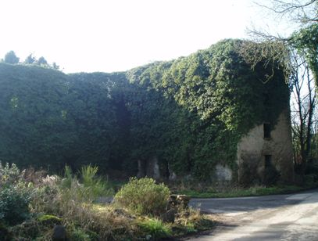
Image 17: The Old Mill Complex

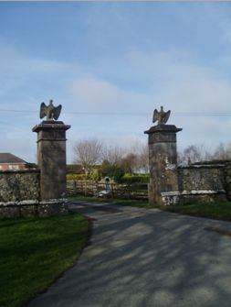
Image 18: White Gates

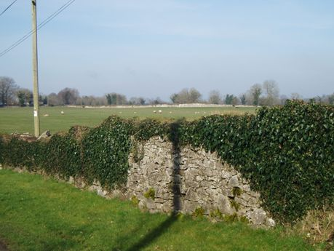
Image 19: Demesne Boundary Wall
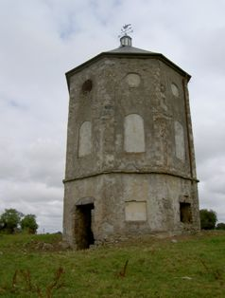
Image 20: The Dovecote/ Pigeon House, Kenagh.
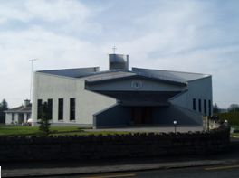 |  | Image 21: St. Dominic’s RC Church, Kenagh.
Image 22: Houses (A), Kenagh | 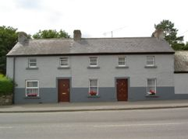

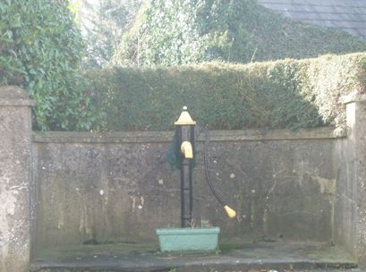
Image 23: Water Pump, Kenagh.


Image 24: Post Box
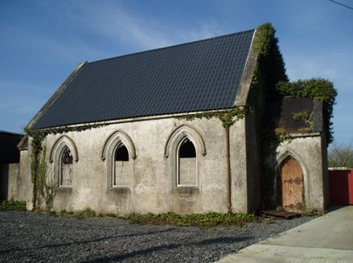
Image 25: Methodist Church, Kenagh.

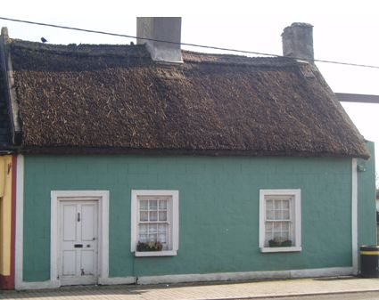
Image 26: Thatched House (B), Kenagh.

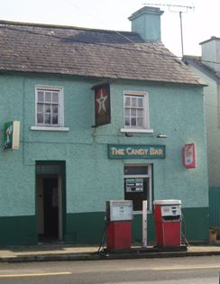
Image 27: The Candy Bar, Kenagh.

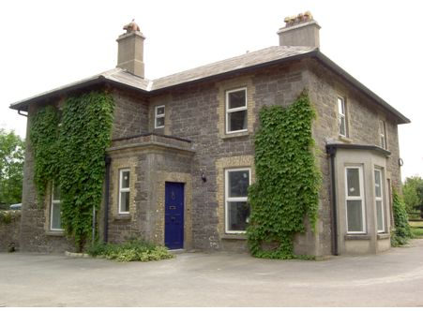
Image 28: Brookfield House, Kenagh.
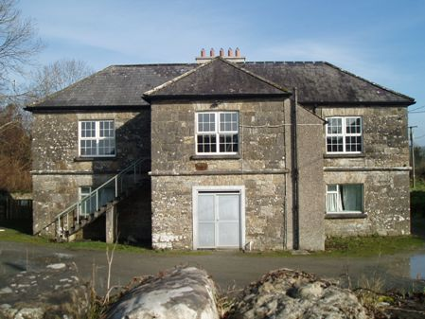
Image 29: Old School, Kenagh.
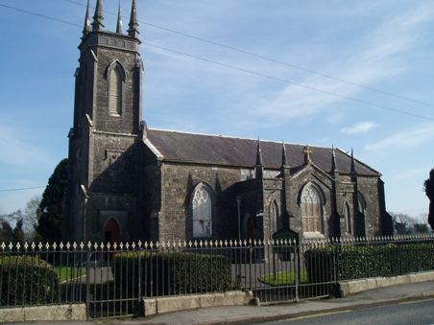
Image 30: St. Georges Church of Ireland.
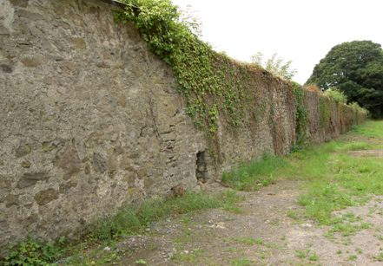
Image 31: Mosstown House Walled Garden.

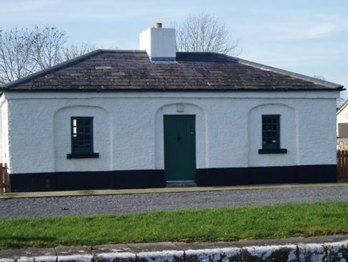
Image 32: Lock Keeper’s Cottage.

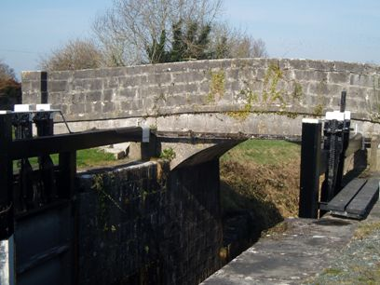
Image 33: Coolnahinch Bridge.

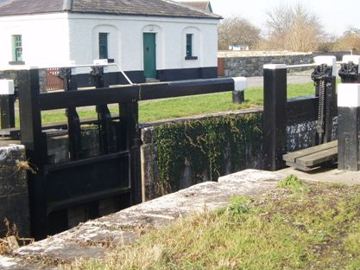
Image 34: 41st Lock on the Royal Canal

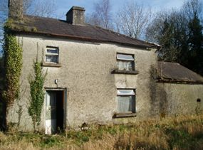 | Image 35: House (C), Kenagh.

Image 36: House (D) , Kenagh | 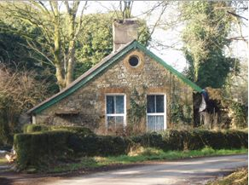

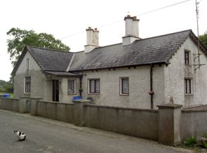 | Image 37: House (E), Kenagh

The term ‘Commercial’ does not include traditional commercial functions that should locate within the village core such as office, financial, service etc.

