

An online meeting of the Longford URBACT Local Group was held on 4th October 2021. The regeneration officer outlined the progression of the project and ongoing difficulties experienced by the ULG and all partners due to the pandemic and associated restrictions.

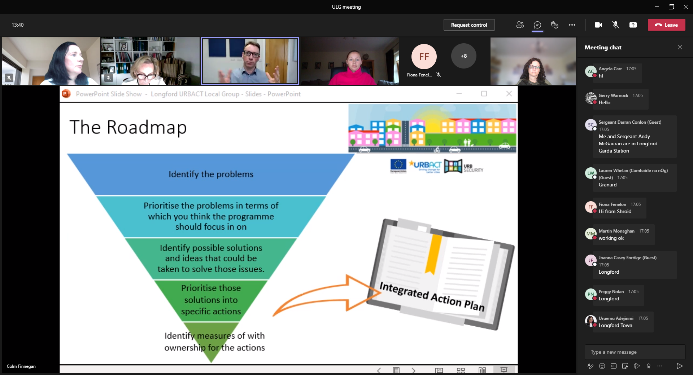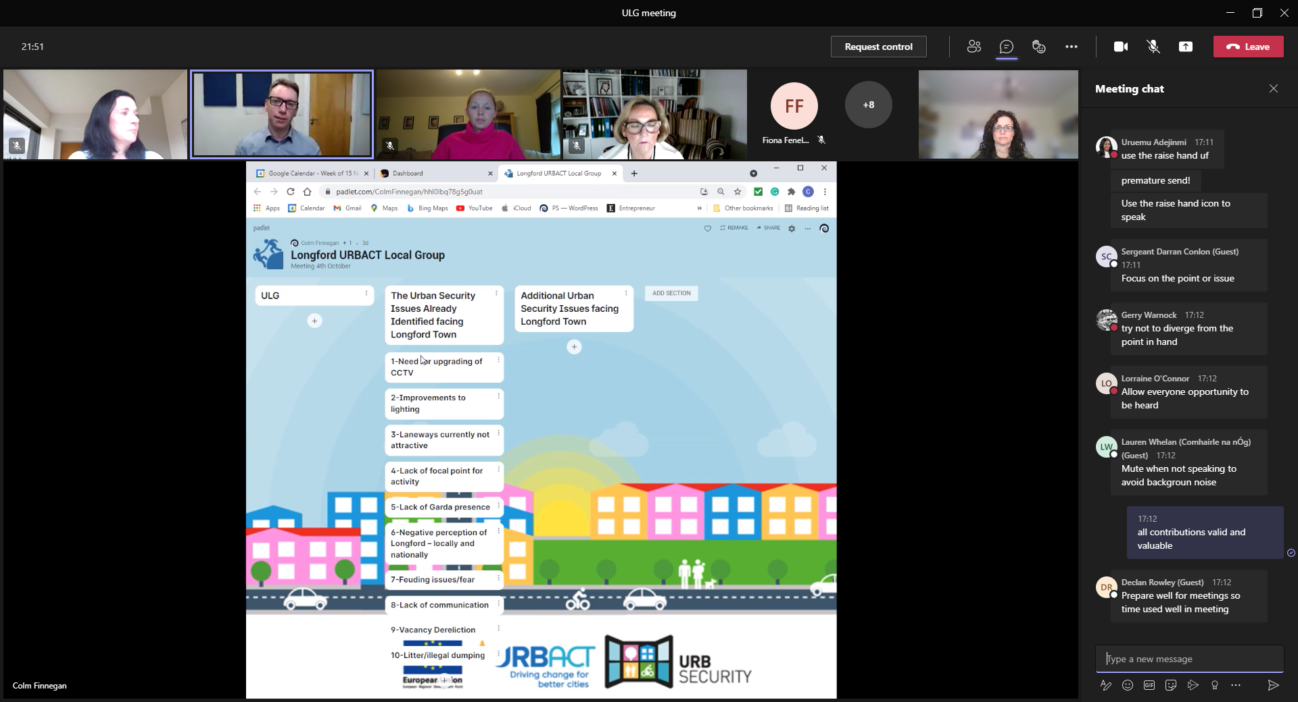.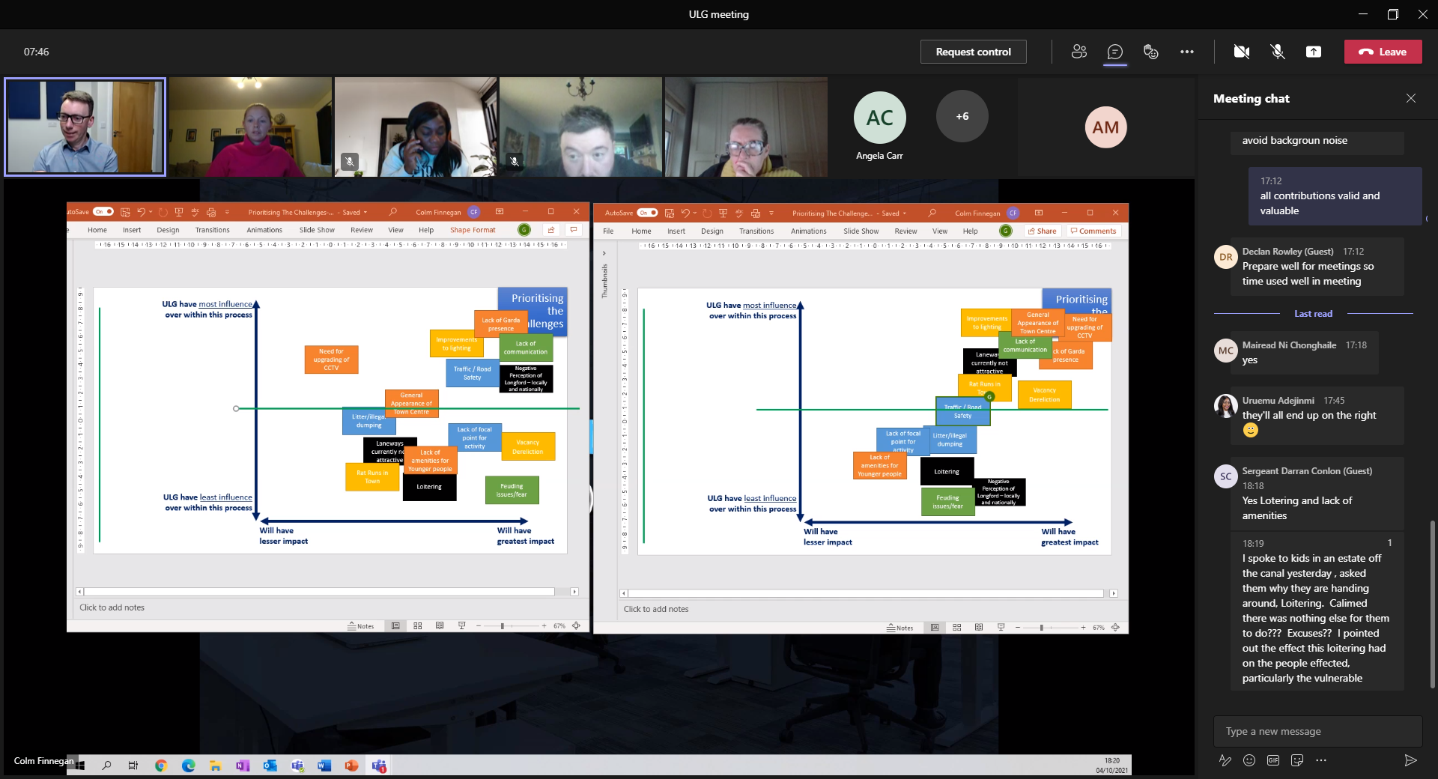

*Screenshots of ULG workshops*

The ULG, guided by an independent facilitator, then engaged in two workshop exercises. These assessed the issues that have been identified impacting on security in Longford Town to date and their current relevance. Several new issues were identified, and all were then prioritised in terms of their potential impact and the influence that the ULG as a group have in implementing achievable solutions over the plan timeframe. Further sessions will focus on actions to address these and form the basis of the Draft IAP.

The next transnational meeting will be hosted online by Michalovce on 27-28 October 2021 and will focus on how to survey citizens and evaluate impacts. This will also contain a mid-term review of the project and focus on the preparation of draft integrated area plans by the end of the year.

The next ULG meeting has been scheduled for 2 November 2021.

[**https://www.facebook.com/regenerationlongford/**](https://www.facebook.com/regenerationlongford/)

[**https://www.facebook.com/urbsecur/**](https://www.facebook.com/urbsecur/)

[**https://twitter.com/UrbSecurity**](https://twitter.com/UrbSecurity)

**Longford URBACT Local Group Meeting – October Update**

**TITLE TITLE TITLE TITLE TITLE TITLE TITLE TITLE TITLE TITLE**

**CONTACTS**

Name

Phone number

Email address

Press-release Press-release Press-release Press-release Press-release Press-release Press-release Press-release Press-release Press-release Press-release Press-release Press-release Press-release Press-release Press-release

Press-release Press-release Press-release Press-release Press-release Press-release Press-release Press-release Press-release Press-release Press-release Press-release Press-release Press-release Press-release Press-release Press-release Press-release Press-release Press-release Press-release Press-release

Press-release Press-release Press-release Press-release Press-release Press-release Press-release Press-release Press-release Press-release Press-release Press-release Press-release Press-release Press-release Press-release Press-release Press-release Press-release Press-release

Press-release Press-release Press-release Press-release Press-release Press-release Press-release Press-release Press-release Press-release