Active Travel Scheme LD/25/0008
Killashee SRTS_St. Earnan’s NS
Zone A

Section 38 Road Traffic Act 1994
Determination Report



Longford County Council

June 2026

Contents
1 Introduction 3
2 The proposed development will consist of: 3
3 Stage 1: Determining the Applicability of Section 38 4
3.1 Assessment of Traffic Calming Measures 4
3.2 Public Road Boundaries 4
3.1 Conclusion for Stage 1 4
4 Stage 2: Environmental Impact Assessment (EIA) & Appropriate Assessment (AA) Screening 4
4.1 Environmental Impact Assessment (EIA) Screening 4
4.2 Appropriate Assessment (AA) Screening 5
5 Stage 3: Planning Considerations (Part 8 of the Planning and Development Regulations, 2001) 5
6 Final Conclusion 5
7 Recording of this Determination 6

Introduction
The purpose of this document is to determine if the works described herein, which are proposed to be carried out by Longford County Council Active Travel Section, are appropriate for assessment and implementation in accordance with Section 38 of the Road Traffic Act 1994. The Department of Transport have published a guidance document on Section 38 works and it sets out types of works that can be undertaken, processes that apply for permanent works and procedures for temporary or ‘trial’ works. Such processes and procedures allow for consultation and related Traffic Works Orders (Chief Executive Orders).
It is an essential part of this process that there is a Recorded Determination of whether the works can progress under the provisions of the Section 38 procedure outline in the Oct 2023 Guidance Document. This is the record of that determination.
St. Earnan’s National School, Killashee was selected as a round 3 school under the National Transport Authority’s Safe Routes to School Programme.
Following a series of audits and engagements with key Stakeholders and Longford Co. Council, the Green Schools officer from An Taisce developed and issued a Delivery Plan for St. Earnan’s National School, Killashee.
The delivery plan identified the key issues specific to the school relating to existing traffic conditions at the school and surrounding approaches and listed a series of recommendations for consideration in a design to mitigate against the issues raised.
Longford County Council in consultation with The National Transport Authority (NTA) has developed a preliminary design for the school based on the recommendations of the Delivery Plan. Following approval from the NTA, the Section 38 process was initiated.

The proposed development will consist of:
The creation of a school zone in the vicinity of St. Earnan’s National School, Killashee. The provision of traffic calming measures to control traffic speeds on the approach routes to the school.

Stage 1: Determining the Appropriateness of the Section 38 Procedure:
The Roads Act, 1993 defines a “public road” as meaning “a road over which a public right of way exists and the responsibility for the maintenance of which lies on a road authority”.

Assessment of Traffic Calming Measures
There is a broad scope of interventions on public roads which fall within the definition of “traffic calming measures” for the purposes of the legislation.
Extract from Road Traffic Act 1994, Section 38 (9);
“traffic calming measures” means measures which—
(b) restrict or control the speed or movement of, or which prevent, restrict or control access to a public road or roads by, mechanically propelled vehicles or powered personal transporters (whether generally or of a particular class) and measures which facilitate the safe use of public roads by different classes of traffic (including pedestrians, people driving powered personal transporters, and cyclists),
and includes for the purposes of the above the provision of traffic signs, road markings, bollards, posts, poles, chicanes, rumble areas, raised, lowered or modified road surfaces, ramps, speed cushions, speed tables or other similar works or devices, islands or central reservations, roundabouts, modified junctions, works to reduce or modify the width of the roadway and landscaping, planting or other similar works.”
Based on the proposed project, the following works qualify as traffic calming under Section 38(9) of the Road Traffic Act 1994:
- Ramps – Slows traffic and improves the safety of vulnerable road users.
- Surface Colour Changes & Road Markings – Provides visual clues to alert drivers to pedestrian and cyclist priority areas.
- Pencil-Shaped Bollards – Defines pedestrian spaces and prevents unauthorized parking.
- Reduce signage clutter - Provides better visual clues to alert drivers to pedestrian and cyclist priority areas.
- Traffic calming measures are intended to enhance road safety, improve pedestrian and cyclist access, and create a more structured and organized road environment.

Types of Measures
There is a broad scope of interventions on public roads which fall within the definition of “traffic calming measures” for the purposes of this legislation. This can include such items, inter alia, as:
• Roadway alterations to enhance safety,
• Filtered permeability
• Construction or enhancement of footpaths,
• Pedestrianisation of sections of public roads,
• Construction of pedestrian and/or cycle crossings,
The above list is not exhaustive in any way, but is illustrative of the range of road measures falling within the scope of Section 38.

Public Road Boundaries
All proposed works are within the public realm, comprising of the roadway in accordance with Section 2 of the Roads Act 1993, these areas are classified as public roads.

Conclusion for Stage 1
Based on the assessment, the proposed works meet the definition of traffic calming under Section 38(9) and are within the public road boundaries. Therefore, Section 38 is the appropriate procedural mechanism unless additional development consents or approvals are necessary.

Stage 2: Environmental Impact Assessment (EIA) & Appropriate Assessment (AA) Screening

Environmental Impact Assessment (EIA) Screening
The proposed works do not fall under the project classifications or thresholds requiring an Environmental Impact Assessment (EIA) under EU Directive 2011/92/EU:
- Annex I Projects (EIA Mandatory):
- Motorways and express roads.
- Construction of a new four-lane road or widening of an existing two-lane road over 10 km.
- Annex II Projects (Irish Regulations for EIA Thresholds):
- Busways (not bus lanes), service areas, new bridges over 100m, tunnels over 100m.
- Four-lane road construction of 500m+ in urban areas or 8km+ in rural areas.
Given the limited scope i.e. signing and lining and limited environmental impact of this project, an EIA is not required.

Appropriate Assessment (AA) Screening
The works are very limited in nature, i.e. signing and lining, ramps and will not have a significant effect on adjacent Natura sites, the following conclusion was reached regarding the site of the proposed works:
- The proposed development will not have significant effects on the integrity of any Natura 2000 site.
- No Appropriate Assessment is required.
- A Natura Impact Statement (NIS) is not necessary.

Stage 3: Planning Considerations (Part 8 of the Planning and Development Regulations, 2001)
There are a number of exemptions from the Part 8 Procedure, with one of those exemptions relating to certain proposals under Section 38 of the Road Traffic Act 1994.
Section 38 relates to the provision or removal of traffic calming measures by a local authority ”in respect of public roads in their charge.”
“Traffic calming measures” are defined in Subsection (9) of Section 38 as meaning.
“measures which –
(b) restrict or control the speed or movement of, or which prevent, restrict or control access to a public road or roads by, mechanically propelled vehicles (whether generally or of a particular class) and measures which facilitate the safe use of public roads by different classes of traffic (including pedestrians and cyclists),
and includes the provision of traffic signs, road markings, bollards, posts, poles, chicanes, rumble areas, raised, lowered or modified road surfaces, ramps, speed cushions, speed tables or other similar works or devices, islands or central reservations, roundabouts, modified junctions, works to reduce or modify the width of the roadway and landscaping, planting or other similar works.
Section 179(6) (bb) of the Planning and Development Act of 2000, which states the following exemption:-
“works, other than works involving road widening, to enhance public bus services or improve facilities for cyclists provided under section 95 (as amended by section 37 of the Road Traffic Act 1994) of the Road Traffic Act 1961 or under section 38 of the Road Traffic Act 1994”.

Accordingly, any works “to enhance public bus services or improve facilities for cyclists” which are delivered under Section 38 of the Road Traffic Act 1994, are exempted from the normal local authority Part VIII planning process.”

Therefore the proposed works for the Safe Routes to School scheme are exempt under the legislation and a Part 8 planning process is not required.
The project does not exceed the following Part 8 thresholds:
- New road construction or realignment exceeding 100m (urban) or 1km (rural).
- Construction of a new bridge or tunnel.
As the works do not surpass these limits, a Part 8 planning process is not required.

Final Conclusion
The proposed works fall within the scope of Section 38 and do not require additional development consents. The project may proceed under the Section 38 procedure outlined in the October 2023 Guidance Document (Appendix A).
Furthermore, in line with Section 95 of the Road Traffic Act 1961, consultation with An Garda Síochána is required. Given these works are permanent, the Standard Procedure specified in the Section 38 Guidance Document should be followed and it is deemed the appropriate procedure.

Recording of this Determination
It is necessary to record this formal determination of the suitability of Section 38 Procedure and therefore I request that this decision should be recorded in a formal decision record and published on the local authority’s website. This allows the public to become aware that such a decision has been taken in respect of the applicable proposal.

I so recommend,

Signed: 
Brian Kelly Senior Executive Engineer –
Active Travel Section,
Longford County Council.
12th June 2026
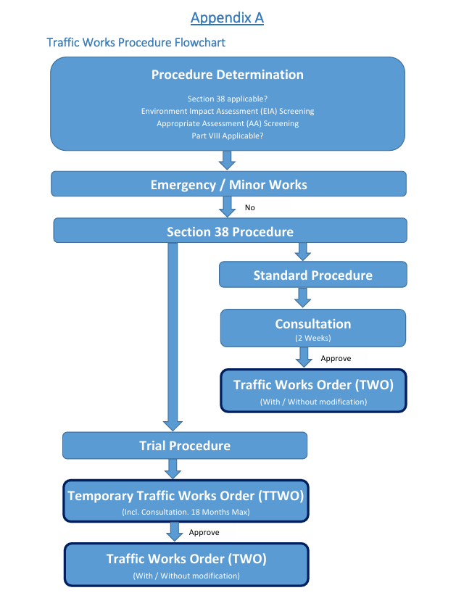

Appendix B
