LONGFORD ROAD SAFETY ACTION PLAN REVIEW 2024

The following tables list actions related to these priority areas as outlined in the Government Road Safety Strategy 2021-2030 and the local actions which have been identified as being deliverable by the Longford Road Safety Action Plan.

**Priority Area**

**Safe roads and roadsides -** Safe roads and roadsides involve the planning, design and operation of roads and roadsides and provides the framework for safe road and vehicle use.

**Government Road Safety Strategy Actions**

|  |  |  |  |
| --- | --- | --- | --- |
| **Action Number** | **Action -High Impact Actions** | **Lead**  **/Support Agency** | **Status** |
| 2 | Support the delivery of road safety improvement schemes and minor realignment schemes on national roads to create forgiving roadsides, self-explaining roads and a safe environment for vulnerable road users. | TII/LA | Ongoing |
| 4 | Implement low cost safety Schemes as identified on the Regional and Local Road Network | DoT, CCMA / LA | Ongoing |
| 5 | Schemes will be prioritised on an annual basis from the National Cycle Network over the period 2022 to 2025 for segregated walking and cycling facilities to be constructed on the National, Local and Regional road networks in County Longford, to provide safe cycling and walking arrangements for users of all ages | DoT, NTA, CCMA /LA | On Track |

|  |  |  |  |  |  |
| --- | --- | --- | --- | --- | --- |
| **Action Number** | **Action – Support Actions** | **Lead**  **/Support Agency** |  | | **Status** |
| 55 | Support the implementation of the National Cycle Manual within Cycle Scheme design guidance aligned with the Safe System Approach and include appropriate training. | DOT, NTA/LA | |  | Ongoing |
| 56 | Support the Review and recommendations on facilitating cyclists and pedestrians at junctions, including measures that do not require powered traffic signals. | DoT, NTA/LA | |  | Ongoing across all active travel projects |
| **Action Number** | **Action – Support Actions** | **Lead**  **/Support Agency** | |  | **Status** |
| 58 | Undertake the Heavy Good Vehicle (HGV) mobility policy review for the County | LA | |  | Consideration of HGV permits ongoing.  HGV parking policy in Longford Town.  No county wide policy re HGV mobility. |
| 61 | Continue to Complete LA 16 Collision Reporting and Evaluation Procedure forms where a fatality, or collision that is likely to become fatal, has occurred. Min 70% Target. | DoT, LA/TII | |  | Ongoing programme in response to fatal collisions  Complete 2024 |
| 62 | Provide timely and appropriate road traffic collision data to local authorities, and agencies with responsibility for road improvement  and maintenance, to inform their work. | RSA, DoT, CCMA / LA | |  | GDPR Issues to be resolved Nationally |
| 63 | Review and make recommendations for the provision of a dedicated road safety engineering resource in Longford to progress road safety schemes and strategy actions. | DoT, LA | |  | On track |
| 64 | Ensure correct people are identified locally to take part in all training provided on Design Manual for Urban Roads and streets (DMURS) and the National Cycle Manual (NCM) | TII,NTA,CCMA/LA | |  | Training will be availed of where provided  2024 -Webinars on NCM |
| 66 | Engage with TII on all training/Guidance on collision analysis and reporting from an engineering perspective, and design of roads utilising the safe system approach | TII/LA | |  | No training in 2024 re collision analysis  No specific training in 2024 re design of roads utilising safe systems approach, ongoing briefings at conference. and standards updates. LCC will avail of any training where provided. |
| 68 | Publish/Renew the Councils prioritised plan on road  building construction and maintenance (including footpaths and cycle lanes) on an annual basis. | CCMA,LA | |  | Publish councils prioritised plan of roadworks  Roadworks scheme book compiled annually and on PMS |
| 69 | Implement the upgrade of public lighting to appropriate standards using LED lighting to improve visibility and enhance safety  for road users. | CCMA, LA | |  | Ongoing |
| 71 | Facilitate the improvement of rural bus stop facilities in line with a Safe System approach on the National Road Network in line with a safe system approach | TII/LA  (NTA) | |  | New programme by NTA to commence in 2025 |
| 72 | Work with the NTA and Bus Eireann to Improve visibility, lighting and age friendly seating at regional and local bus stops in Co Longford to enhance safety for those waiting for a bus. | NTA/LA | |  | New programme by NTA to commence in 2025 |

**Priority Area**

**Safe speeds -** Safe speeds are a central element of the Safe System approach. It involves consideration of road and vehicle planning and design, the setting of injury-minimising speed limits, as well as public education and awareness, and the enforcement of these limits.

|  |  |  |  |
| --- | --- | --- | --- |
| **Action Number** | **Action - High Impact Actions** | **Lead**  **/Support Agency** | **Status** |
| 6 | Stakeholders will co-operate locally with recommendations from working group set up to examine and review the framework for the setting of speed limits. Speed limit reviews will be carried out in accordance with DOT Guidelines , 30 kph zones implemented in housing estates | LA/DOT | Ongoing in accordance with DoT instructions. Local Road review completed in 2024. |
| 7 | LCC will maintain and promote the Collision Prevention programme to ensure communication and co-operation between LCC and other agencies | LA/TII/AGS/  DOT | Ongoing |
| 8 | LCC and AGS will continue to review traffic speeds and conditions at schools and high risk locations and implement safety works where appropriate | TII,NTA,AGS/LA | Ongoing |
| **Action Number** | **Action – Support Actions** | **Lead**  **/Support Agency** | **Status** |
| 76 | Deliver and support education and awareness interventions to raise awareness of the benefits of and build community support for 30 kph zones in urban areas | RSA/CCMA,LA | Awaiting updated legislation and guidance from Government and DoT. |
| 78 | Extend the number of 30kmh speed limit zones in high-risk  locations (urban city/town centres) for Vulnerable Road Users in line with best practice models and National Guidelines. | LA/DoT | Review of Urban areas in 2025 |
| 79 | Examine the feasibility of 30kmh speed limit or lower in school vicinities and report on progress. | LA/DoT | Guidance from DOT awaited |

**Priority Area**

**Safe road use -** Safe road use incorporates a wide range of safety behaviours such as compliance with the posted speed limit, driving without impairment (due to alcohol, drugs, fatigue or distraction), helmet wearing, seat belt wearing and correct use of child restraints.

**Government Road Safety Strategy Actions**

|  |  |  |  |
| --- | --- | --- | --- |
| **Action Number** | **Action – High Impact Actions** | **Lead**  **/Support Agency** | **Status** |
| 22 | Promote the Governments Road Safety Strategy and the Councils Road Safety Plan amongst Stakeholders and the Public | RSA/LA/AGS | Ongoing |
| **Action Number** | **Action – Support Actions** | **Lead**  **/Support Agency** | **Status** |
| 94 | Maintain the Road Safety Working Together Group (RSWTG) to co-ordinate multi-agency Road Safety policy and implementation at a local level | RSWTG All Stakeholders | Established |
| 95 | The RSWTG to publish a multi-agency Road Safety  Action Plan and to publish an annual review on progress with implementation. | RSWTG All Stakeholders | Drafting of Local Road Safety Plan Phase 2 2025-2027 is in progress.  Adoption of Draft Annual Action Plan 2025-2027 is anticipated in March 2025 |
| 133 | Implement specific educational measures aimed at protecting vulnerable road users. | RSA/LA, AGS | Ongoing |
| 136 | Develop and Launch a standardised guide to reducing road safety school gate risk. | RSA/various  agencies | Awaiting Standarised Guide, currently using NTA Guidance under the Safe Routes to School Programme |
| 137 | Deliver and support road safety campaigns targeting drivers to highlight the risks faced by Vulnerable Road Workers | RSA/LA, AGS | Ongoing |
| 140 | Empower local community groups to strive for safer and more liveable streets in their locality by providing them with the tools, checklists and supports necessary to be proactive participants in road safety | LA/AGS/Various Groups | Ongoing |
| 151 | Prepare, implement and share with partner agencies an annual Garda Roads Policing Operations Plan. | AGS/various  agencies | Ongoing |

**Priority Area**

**Safe and healthy modes of travel** - Safe and healthy modes of travel acknowledge that there is a substantial difference in fatal and serious injury risks across different modes of travel. To promote and protect road users engaging in public or active transport.

**Government Road Safety Strategy Actions**

|  |  |  |  |
| --- | --- | --- | --- |
| **Action Number** | **Action -High Impact Actions** | **Lead**  **/Support Agency** | **Status** |
| 39 | LCC will cooperate with the TII , NTA and other agencies to seek approval for the development of Active Travel Networks and Greenways | TII/NTA,LA | Ongoing |
| 40 | LCC will continue to seek funding for improved active travel infrastructure | DoT/ LA, NTA, RSA | Ongoing |
| 41 | Encourage modal shift to support Environmental, Safety and Health objectives by promoting the use of sustainable and active modes of  travel. | DoT/ LA, NTA, | Ongoing |
| 42 | Promote and support an expanded Cycle Right training programme which includes online theory and practical skills for children and adults. | DoT/ LA | Ongoing |
| **Action Number** | **Action – Support Actions** | **Lead**  **/Support Agency** | **Status** |
| 176 | Collaboration between the LA, TII and NTA to develop comprehensive cycle network plans covering the Longford Area | NTA/TII/LA | Complete |
| 177 | Roll out of the Safe Routes to Schools Programme and provide “front of school” treatments to those schools agreed with the NTA and An Taisce  -2 Schools 2022  -Up to 4 schools 2023  -6 schools 2024 | NTA, CCMA,  LA/RSA | On Track |

By implementing the four priority intervention areas of the safe system approach, we are delivering international best practice.

Of the seven safe system Priority areas, the council has no lead or support role under the following three priority areas.

**Priority Areas**

* + **Safe work-related road use** - Safe work-related road use involves the planned, systematic safety management of work journeys on the roads, aiming to reduce the risk of death and serious injuries.
  + **Safe vehicles -** The safe vehicles element of the Safe System approach addresses the safety of road users both inside and outside the vehicle through legislative standards, consumer information, public procurement and industry initiatives.
  + **Post-crash response -** Post-crash response concerns the rescue, treatment and rehabilitation of survivors of road traffic collisions and aims to reduce the severity and consequences of injuries in the event of a collision



**Highlights of works undertaken in 2024 in line with the Action Report are as follows:**

**Action 2** - Support the delivery of road safety improvement schemes and minor realignment schemes on national roads to create forgiving roadsides, self-explaining roads and a safe environment for vulnerable road users.

Roads Safety Improvement schemes on National Roads

* N63 Farannyhoogan – 2km section of N63 to the west of Longford Town – scheme progressed through Part 8 planning stage.

**Action 4** - Implement low cost safety Schemes as identified on the Regional and Local Road Network Low cost safety Schemes implemented on the Regional and Local Road Network 2024

* Drumlish – Mohill road Junction realignment
* Drumlish – Pedestrian crossing on R198 at Esker Glen.
* L-1011 Knockloughlin – signage on approach to bend
* Smear Cornadrung – Junction sightline improvement.
* Gleann Riada – Traffic Calming

**Action 5** - Schemes will be prioritised on an annual basis from the National Cycle Network over the period 2022 to 2025 for segregated walking and cycling facilities to be constructed on the National, Local and Regional road networks in County Longford, to provide safe cycling and walking arrangements for users of all ages.

* Two Major segregated cycling and pedestrian schemes in Longford town commenced construction in August 2023 on the on the N63 Ballinalee road and the R198 Battery Road Longford. The former of these schemes was completed in 2024 with the creation of 1.9km of new high quality segregated cycle tracks. The other scheme on the Battery Road is 80% complete as of end 2024. When complete this will see a further 1.3km of segregated cycle track opened to the public in Q1 2025.
* In November 2024 works commenced on two other Active Travel Projects in Granard. When complete this will see the creation of more than 730m of new shared footpath that will link from the Garda station on Main street Granard, up Barrack Lane and across to the R194 Longford Road out as far as Ard Scoil Phadriag.
* 300 metres of new footpath has been Constructed on the Fisherstown road in Clondra in November 2024.

**Action 22** Promote the Governments Road Safety Strategy and the Councils Road Safety Plan amongst Stakeholders and the Public

* Road Safety Working Together Committee met in April and November 2024. Work ongoing through the RSWTG to oversee and co-ordinate the review and preparation of Phase II of the Local Road Safety Plan and Annual Action Plan 2025-2027 ensuring alignment with the Governments National Road Safety Strategy 2021-2030.
* Review and publish the Longford Road Safety Action Plan 2024.

**Action 40** LCC will continue to seek funding for improved active travel infrastructure

* By the end of 2024 nearly €3m grant funding will have been awarded to Longford County Council in 2024 through the NTA’s Active Travel programme.

**Action 42** Promote and support an expanded Cycle Right training programme

* LCC Cycle Right trained tutors are scheduling schools for training on an ongoing basis.
* 16 schools are booked under the Cycle Right Scheme for 2024/2025

**Action 55** Support the implementation of the National Cycle Manual within Cycle Scheme design guidance aligned with the Safe System Approach and include appropriate training.

* Specialists consultants procured and appointed on 12 separate Active Travel projects to deliver designs in line with the new cycle designs manual.

**Action 56** Support the Review and recommendations on facilitating cyclists and pedestrians at junctions, including measures that do not require powered traffic signals.

* Junction tightening works which have incorporated 14 no. raised priority pedestrian crossings on junction arms without traffic signals have been completed in 2024. These are located in Granard, Drumlish and Longford town.

**Action 133** Implement specific educational measures aimed at protecting vulnerable road users

Longford Fire Service organized a series of open days throughout 2024 in the towns of Longford, Longford, Granard, Ballymahon, Edgeworthstown and Lanesborough, aimed at raising awareness about fire prevention, fire safety, and road safety. These events provided a valuable opportunity for the community to engage with local firefighters and gain essential knowledge on these critical topics.

One of the highlights of the open days was the use of virtual reality (VR) headsets, which allowed attendees to experience immersive simulations demonstrating the devastating impacts of road traffic accidents. Firefighters conducted a practical road traffic exercise in the yard showcasing their skills and the procedures they follow during emergency situations.

Kids Court Road Safety Initiative- Work with Longford Community Safety Partnership and An Garda Síochána Longford to deliver up to 8 Kids Court activities in Primary Schools across Longford. Schools will be selected based on An Garda Síochána recommendations around the levels of speeding issues reported in an area/by a school. The aim of this initiative is to empower young people to have an active role in community safety in their area, to increase driver awareness of speed limits and their own driving behaviour in towns/villages near schools and for overall community awareness to help reduce speeding.

**Action 137** Deliver and support road safety campaigns targeting drivers to highlight the risks faced by Vulnerable Road Workers

* The Lifesaver Project by An Garda Siochana is continuing which is a hard hitting Road Safety Educational Programme aimed at having a real and lasting positive influence on how people behave on the roads—Target audience is TY students
* Road Safety Event delivered by An Garda Síochána Community Police unit in Granard Mart targeting TY Students from 2 Granard Secondary Schools.

**Action 140** Empower local community groups to strive for safer and more liveable streets in their locality by providing them with the tools, checklists and supports necessary to be proactive participants in road safety

* A number of initiatives undertaken by different stakeholders in 2024 e.g. Road Safety Department, Community Department and An Garda Siochana in the promotion of the Road Safety Plan, and road safety campaigns to provide the local community with the tools, checklists and supports necessary to be proactive participants in Road Safety. Examples of these were engagement at the Longford Microsoft Dreamspace showcase, targeting in excess of 400 Primary School Children, Longford Community Safety and Wellbeing Expo targeting in excess of 700 TY Students, National Ploughing Day Road Safety Stand, and participation at the Road Safety Event in support of An Garda Síochána Community Police unit in Granard Mart targeting TY Students from 2 Granard Secondary Schools.

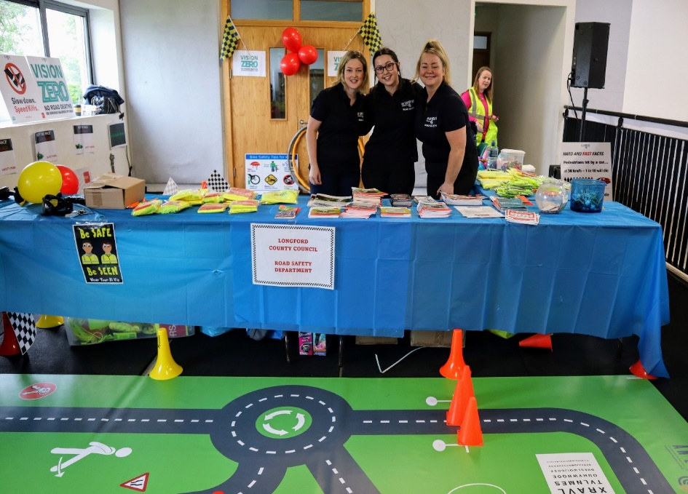

**Action 176** Collaboration between the LA, TII and NTA to develop comprehensive cycle network plans covering the Longford Area

* A cycle network plan has been developed by the NTA in conjunction with Longford County Council for both Longford town and the Longford County. A new Local transport plan has also been created by Longford County Council for Longford Town which also identifies the cycle network.

### Action 177 Roll out of the Safe Routes to Schools Programme and provide “front of school” treatments to those schools agreed with the NTA and An Taisce

### -2 Schools 2022

-Up to 4 schools 2023

* To date a total of 6 schools in Longford have advanced through the Safe Routes to School Programme with delivery plans developed for 4 no. of these schools. Works are completed at Scoil Mhuire Newtownforbes and 3 other schools are advancing through design stages.

