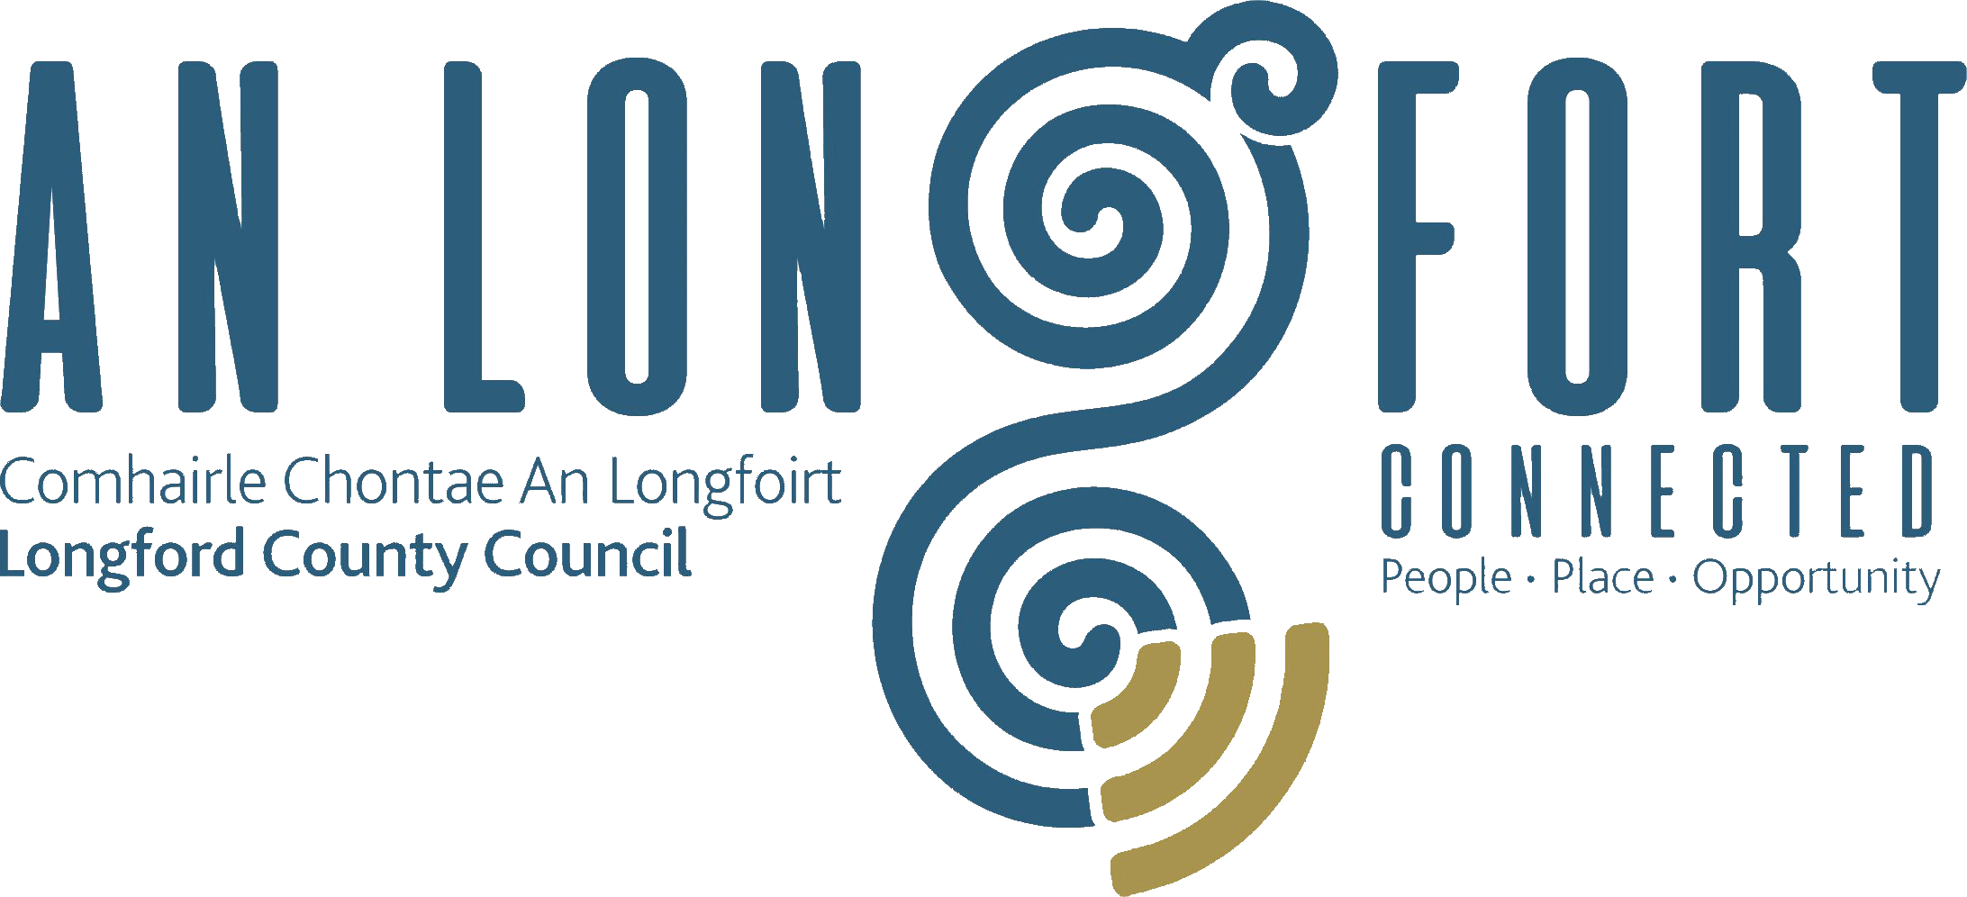

**ECONOMIC ENTERPRISE & RURAL DEVELOPMENT**

**STRATEGIC POLICY COMMITTEE**

**Minutes of** **Economic Enterprise & Rural Development Strategic Policy Committee Meeting**

**Location: Council Chamber & Microsoft Teams**

**Date Wednesday, 19 February 2025**

**Time: 11.30am**

**PRESIDING**: Councillor Gary Murtagh

**PRESENT**: Councillor Mark Casey, Niall Gannon, Martin Monaghan, Seamus Butler, Loretto Grogan, John Coyle

**IN ATTENDANCE:**  Mr. Paul Newell – A/Director of Services

**APOLOGIES**: Fintan McGill, John Kiernan, Margaret McDonald

**MEETINGS**

**ADMINISTRATOR**: Ms. Lorraine McKee

1. **INTRODUCTION**

Chairperson Gary Murtagh welcomed the members to the Economic Enterprise & Rural Development Strategic Policy Committee meeting.

The minutes of the meeting of the Economic Enterprise & Rural Development Strategic Policy Committee on 5 November 2024 were adopted by Councillor Martin Monaghan and seconded by Councillor Seamus Butler.

1. **DECLARATION OF INTERESTS**

No declaration of interests declared.

1. **WORK PROGRAMME**

John Brannigan, Director of Services provided an overview of the work programme for the term of this Strategic Policy Committee. This included the following:-

* Small Business Support Scheme 2025
* Heritage Strategy
* Age Friendly Strategy
* Library Strategy
* Creative and Culture Strategy
* Art Strategy
* Collection Development Policy
* Record Management Policy
* Library Usage Policy
* Usage of Equipment and Resources Policy
* Possible Archive & Museum Development Strategy

1. **SMALL BUSINESS SUPPORT SCHEME 2025**

John McKeon, Director of Services made a presentation to the Committee on the Small Business Support Scheme 2025. The presentation included the following:-

* The Longford Strategic Business Plan 2025 – 2029
* Local Property Tax
* Commercial Rates
* Rent Reviews
* Parking Charges
* General Municipal Allocations
* Commercial Rates – Properties to Revenue Relationship
* Net Effective Rates increases over 5 Years
* Return on Investment from Commercial Rates
* Longford County Council growth over last decade
* Budget 2025 – Record Expenditure

1. **NIGHT TIME ECONOMY PRESENTATION**

Karen Reilly, Night-Time Economy Officer made a presentation to the Committee on Developing Longford’s Night-Time Economy. The presentation included the following:-

* What is the Night-Time Economy
* Why is it Important?
* Key Pillars of Longford’s NTE Strategy
* What’s Next**?**

1. **DATE OF NEXT MEETING**

The proposed date for the next meeting of the Economic Enterprise & Rural Development Strategic Policy Committee is 29 April 2025 to which the members unanimously agreed.

This concluded the business of the meeting.

**Signed:**

**Lorraine McKee**

**Meetings Administrator**

**Confirmed and adopted at Economic Enterprise & Rural Development Strategic Policy Committee Meeting held on the 29 April 2025.**

**Signed:**

**Chairperson**