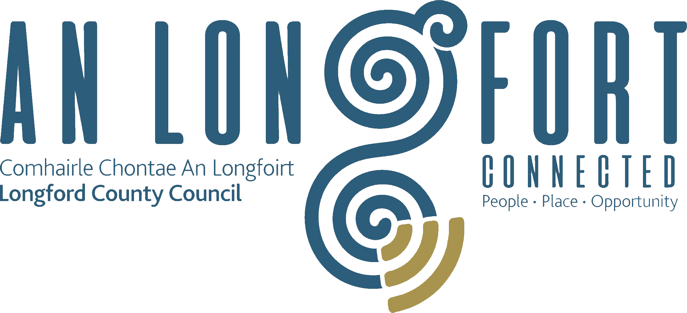

**CLIMATE ACTION AND PLANNING**

**STRATEGIC POLICY COMMITTEE**

**Minutes of** **Climate Action and Planning Strategic Policy Committee Meeting**

**held via Microsoft Teams on Wednesday, 20th October 2021**

**at 3pm**

**PRESIDING**: Councillor Garry Murtagh, Chairperson.

**PRESENT**: Councillor - Uruemu Adejinmi, Gerry Hagan, Peggy Nolan, Mark Casey.

Francesca Pawelczyk, Pat Murphy, Pat Claffey.

**IN ATTENDANCE:**  Mr. John Brannigan, Director of Services

Mr. Tom Murtagh, Senior Engineer

Ms. Lorraine McKee – Administrative Officer

Mr. Michael King – Veterinary Officer

**APOLOGIES**: Andrew Mc Hugh.

**MEETINGS**

**ADMINISTRATOR**: Ann Marie Mc Keon

**ADOPTION OF MINUTES.**

On the proposal of Francesca Pawelczyk seconded by Pat Claffey it was unanimously agreed to adopt Minutes of Climate Action and Planning Strategic Policy Committee meeting held on the 21st July 2021, as circulated.

**MATTERS ARISING FROM MINUTES**.

None

**DECLARATION OF INTERESTS.**

None

.

**CIRCULAR ECONOMY –** Presentation by Dr. Sarah Miller/Breda Murphy, Revamp.

Dr. Sarah Miller gave a brief presentation on the Circular Economy covering the following headings:

* Linear Economy
* Circular Economy Guiding Principles
* Maximising Value
* Designing out waste
* Using regenerative & restorative systems and practice
* Differentiating between consumable and durable components and adapting production accordingly

– Consumables – sustainable, natural, biodegradable, non-toxic –Durables – built for reuse and cascading

* Business Models - Sharing and Leasing
* Business Models – Industrial Symbiosis
* Business Models – Product as a Service
* Business Models – Repair, Reuse & Remanufacturing
* Community Based Reuse in Ireland
* Policy Support for a Circular Economy
* Rediscovery Centre
* Education, Training & Citizen Engagement
* Demonstrating Circularity
* Demonstrating & Supporting Reuse Social Enterprise

Ms. Breda Murphy presented a detailed report on Revamp 3R in Longford Town:

Revamp 3R is an innovative furniture recycling and reuse initiative of the Longford Employment, Development and Information Centre (EDI). Revamp 3R was established initially in 2002 as a training project for long -term unemployed young people. In 2003, the project expanded and now strives to promote the re -use of unwanted high -quality low -cost household furniture to people living in Co Longford and the surrounding counties.

A Social enterprise whose core objective is to achieve a social, economic, and environmental impact, through the recycling and upcycling unwanted goods.

Revamp 3R provides ongoing support to address issues of high unemployment and social exclusion through the provision of vocational skills training, employment opportunities and tailored support.

Revamp 3R aims to become the first Centre of excellence for the circular economy in the Midlands Region through the promotion of upcycling, community education and jobs creation

REVAMP 3Rstore aims to continue to support the community by keeping materials/products in-use in the economy for as long as possible.

Circular Economy Key Benefits for Society are:

* Minimization of waste and pollution
* Extension of the useful life of products and materials
* Regeneration of natural systems

The members welcomed both presentations and highlighted the need to change people’s mindsets and how this is a difficult challenge but there was an urgent need to reduce waste going into the Land Fill Sites. Breda and Sarah responded to the questions raised by the members.

**“FOOD PROVENANCE IN LONGFORD TOWN”** – Presentation by Lorcan O’Connor

Lloyd.

Lorcan outlined the Projects Objectives.

* Understand the awareness of food provenance in Longford town as a case study for trends across similar profile medium-sized urban settlements in Ireland.
* Examine the potential for the development of urban agriculture programmes in Longford Town.

The study sought to build a theory in answer to the following research questions:

1. What is the consumer's awareness of food provenance?

2. Does food provenance matter to the consumer?

3. What are the socio-economic factors present that may influence healthy food

choices?

4. How would local communities respond to an urban agriculture project?

Mixed-method approach to research; Quantitative Survey and Qualitative Interviews

141 Longford residents participated in the survey

4 Longford experts participated in the interview

Recommendations

The level of interest in food provenance and sustainable local food in Longford is significant and there are opportunities to introduce urban agricultural projects in Longford town. Pilot scheme project would be a strong starting point to gather real-world practical data and begin training programmes with willing participants. Small-scale community farm could provide subsistence to participants and their families, focusing on good quality healthy food. A longer-term goal would be for the community farm to shorten the distance between production and consumption, inspiring active participants rather than passive consumers.

The members welcomed the presentation and Councillor Uruemu Adejinmi looked forward to working with Lorcan to assist him in progressing this project.

**DERELICT SITES POLICY.**

Tom Murtagh, Senior Engineer referred to the national legislation on derelict sites and in particular Longford County Council’s policy document related to derelict sites which was adopted by the Council on the 8th May 2019. Tom informed the members that this policy was presented today seeking approval to amend one paragraph.  This amendment is required following consultation and recommendation from the Local Government Auditor.

The change is as follows:

**Current plan:**

The owners of properties that are entered in the Register of Derelict Sites may be liable to pay an annual levy to the Council. The Council may decide not to impose a levy on a derelict property, in instances where it is deemed that the cost of imposing such a levy would potentially out-weigh the financial benefit accruing from the levy.

**Proposed change to plan:**

The owners of properties that are entered in the Register of Derelict Sites shall be liable to pay an annual levy to the Council. Arrears follow up will be carried out on a case by case basis having regard to all the provisions of the current Derelict Sites Legislation, including hardship.

Tom responded to the questions raised by the members.

On the proposal of Councillor Peggy Nolan seconded by Councillor Uruemu Adejinmi it was unanimously agreed to accept the proposed Draft Policy on Derelict Sites. The proposed policy will now be forwarded to the full Council for final approval.

**CONSIDERATION OF CHANGES IN DOG POUND FEES**

Michael King, County Veterinary Officer presented the following to the members:

|  |  |
| --- | --- |
| **Current Fee (2012)** | **Revised Fee - 2021** |
| Surrender Fee - €40 | Surrender Fee - €50 |
| Impounding Fee in respect of first occasion - €40 | Impounding Fee in respect of first occasion - €50 |
| Impounding Fee for repeat impounding - €80 | Impounding Fee for repeat impounding - €100 |
| Impounding Fee in respect of first occasion on which a dog of a Restricted Breed is impounded - €100 | Impounding Fee in respect of first occasion on which a dog of a Restricted Breed is impounded - €150 |
| Repeat Impounding Fee in respect of a dog of a Restricted Breed, escalated by additional €100 for each time dog is impounded | Repeat Impounding Fee in respect of a dog of a Restricted Breed, escalated by additional €150 for each time dog is impounded |
| Kennel Fee from second day onwards - €10 per day | Kennel Fee from sixth day onwards - €15 per day. |
| Rehoming Fee - €40 which included Dog Licence. | Rehoming Fee - €100 plus Dog Licence. |

The members highlighted the great work carried out by this department and noted that it was ten years since the last review on charges.

On the proposal of Councillor Gerry Hagan seconded by Councillor Peggy Nolan, it was unanimously agreed to accept the proposed Draft changes to the Dog Pound Fees. The proposed document will now be forwarded to the full Council for final approval.

**DATE OF NEXT MEETINGS - 2022**

The members noted the dates of the meetings for 2022.

This concluded the business of the meeting.

Ann Marie Mc Keon

**Signed: _______________**

**Ann Marie Mc Keon**

**Meetings Administrator.**

**Confirmed and adopted at Climate Action and Planning Strategic Policy Committee Meeting held on the 21st January 2022.**

*Garry Murtagh*

**Signed: _______________**

**Chairperson.**