

CLIMATE ACTION AND PLANNING
STRATEGIC POLICY COMMITTEE

Minutes of Climate Action and Planning Strategic Policy Committee Meeting
held in the Council Chamber, Aras an Chontae,
Great Water Street, Longford on Tuesday, 21st January 2020 at 4.30 p.m.

PRESIDING: Councillor Gerard Hagan, Chairperson.

PRESENT: Councillors - Mark Casey, Garry Murtagh, Peggy Nolan,
Marcella O’Connor, Francesca Pawelczyk and Anna Delaney

APOLOGIES Councillor Joe Flaherty.
Andrew McHugh and Sharon Devlin

IN ATTENDANCE: Mr. Tom Murtagh, Acting Director of Services.
Mr. Donal MacAnBheatha, Senior Planner.
Mr. Michael King, Veterinary Officer.
Ms. Aoife Moore, Senior Executive Planner.

MEETINGS
ADMINISTRATOR: Anne Lee.

INTRODUCTION.

Councillor Hagan welcomed the members to the inaugural meeting of the Climate Action and Planning Strategic Policy Committee and gave details regarding the support staff for this Strategic Policy Committee.

The members present introduced themselves.

DECLARATION OF INTERESTS.

None.

STANDING ORDERS – circulated.

On the proposal of Councillor P. Nolan seconded by Councillor G. Murtagh, it was agreed to adopt the Standing Orders, in principal, subject to any amendments being proposed by the members. The Chair requested the members to submit any amendments to A. Lee.

CLIMATE CHANGE ADAPTATION STRATEGY – circulated.

Tom Murtagh briefed the members on the Climate Change Adaptation Strategy which was adopted by Longford County Council in September 2019 and replied to queries raised by the members on the following issues –

- Single use plastic.
- Rewards Scheme for recycling plastic.
  - Reverse vending machines.

COUNTY DEVELOPMENT PLAN PROCESS.

Donal Mac An Bheatha, Senior Planner, briefed the members on the preparation of the Draft County Development Plan 2021 – 2027, which formally commenced on the 26th September 2019.

NEXT MEETING.

11th May 2020.

This concluded the business of the meeting.
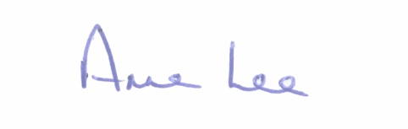

Signed: _______________
Anne Lee,
Meetings Administrator.

Confirmed and adopted at Strategic Policy Committee Meeting held on the
21st July 2020.

Signed: _______________
Chairperson.

