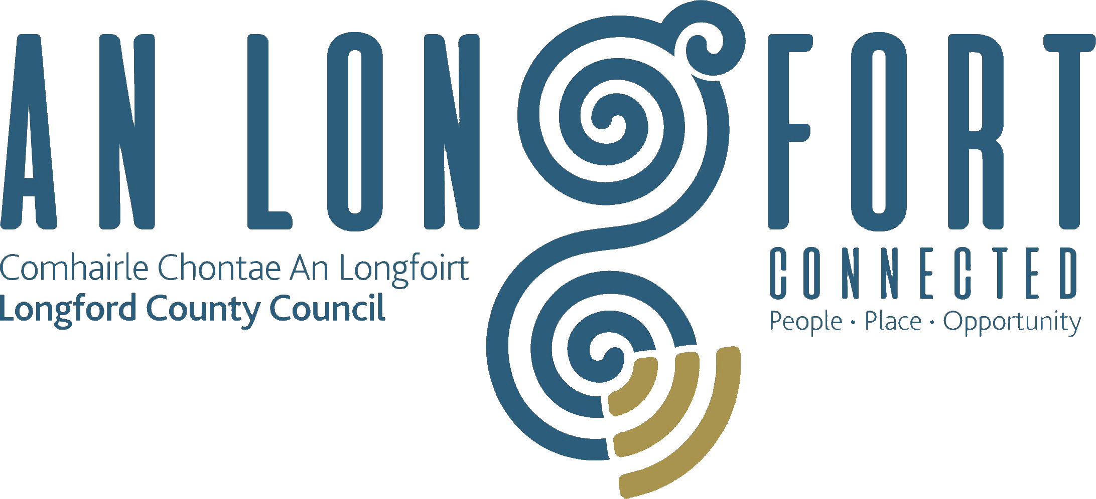

CLIMATE ACTION AND PLANNING
STRATEGIC POLICY COMMITTEE

Minutes of Climate Action and Planning Strategic Policy Committee Meeting
held via Microsoft Teams on Wednesday, 3rd February 2021
at 3.00 p.m.

PRESIDING: Councillor Gerard Hagan, Chairperson.

PRESENT: Councillor - Uruemu Adejinmi, Mark Casey, Garry Murtagh, Peggy Nolan.
Andrew McHugh, Francesca Pawelczyk, Anna Delaney,
Marcella O Connor and Sharon Devlin.

IN ATTENDANCE: Mr. John Brannigan, Director of Services.
Mr. Tom Murtagh, Senior Engineer.
Mr. Donall Mac An Bheatha – Senior Planner
Ms. Nora O’Farrell – Senior Executive Officer
Ms. Lorraine McKee – Environment
Ms. Aoife Moore – Regeneration
Ms. Sheila Healy – Planning
Ms. Barbara Heslin, Director of Services
Ms. Ann Marie Mc Keon, Administrative Officer
Ms. Nora O’Farrell, Senior Executive Officer

MEETINGS
ADMINISTRATOR: Anne Lee

ADOPTION OF MINUTES.

On the proposal of Councillor Peggy Nolan seconded by Councillor Gary Murtagh, it was unanimously agreed to adopt Minutes of Climate Action and Planning Strategic Policy Committee meeting held on the 21st October 2020, as circulated.

MATTERS ARISING FROM MINUTES.

None

DECLARATION OF INTERESTS.

None

SUPPLEMENTARY STANDING ORDERS – REMOTE MEETINGS – circulated.

Supplementary Standing Order for Remote Meetings, adopted at November meeting of Longford County Council, were noted.

MID SHANNON UNESCO BIOSPHERE RESERVE PROPOSAL.

Donall Mac An Bheatha gave a comprehensive presentation on the Mid Shannon UNESCO Biosphere Reserve proposal. Donall answered any questions and addressed all concerns the Members had in relation to the proposal.

Biospheres are UNESCO Man and the Biosphere (MAB) Programme and are international sites of excellence where active conservation sits alongside responsible development; ‘living landscapes’ where there is a more balanced relationship between people and nature.

The proposed Preliminary Working Boundary of Mid Shannon & Environs BR is based on the logic which aligns with sub-catchments developed by EPA under the Water Framework Directive. This is a flexible preliminary boundary and is a good starting point.
Lough Ree, at the centre of the proposed BR, is surrounded by three sub-catchments of the Upper Shannon Catchment natural watershed demarcation. The natural demarcation of the proposed boundary captures the northerly direction flow of water towards Lough Ree to its out-flow point at Athlone.

Compared to most places in the world and most biosphere regions, we have an outstanding combination of wetland landscapes, nature, wildlife, culture and heritage – together with vibrant proactive communities and resilient rural workforce who want to thrive and have a good quality of living.

- Nomination Form Application (submission to UNESCO for September 2021).
- Cost €5,000 per local authority.
- Prepare tender document for e-Tender January to mid-February 2021.
- Engage consultants to complete Nomination Form & Consultation Process March-May 2021. Steering Group to liaise with Consultants throughout process.
- Update Public Representatives June-July.

The Members fully supported the project.

CLIMATE ACTION REGIONAL OFFICE (CARO)

Link on briefing from the Climate Action Regional Office (CARO) was circulated to members.
Tom Murtagh, Senior Engineer gave a report on the Local Authority Climate Action Training Programme and responded to questions raised: -
- Set up in 2018 in response to Action 8 of the 2018 National Adaptation Framework
(NAF) – Planning for a Climate Resilient Ireland. The 4 Climate Action Regional Offices were established to drive climate action at both regional and local levels
- The Climate Charter is one of the measures included in the Government’s Climate
Action Plan to tackle Climate Breakdown, which names local authorities as Lead Partners in 8 Actions and as Key Stakeholders in a further 22
- The Charter was developed in consultation with the local government sector and
commits signatories to a number of objectives to address the climate challenge and advocate for climate action and behavioural change among citizens
- Six Key Training Pillars
- Training to raise awareness of the Role of Local Authorities in leading on Climate
Action at local and community levels
- All members of the Climate Action and Planning Strategic Policy Committee to be
offered training in the area of Climate Action

NEXT MEETING

21st April 2021

This concluded the business of the meeting.

Signed: ______________________
Anne Lee
Meetings Administrator.

Confirmed and adopted at the Climate Action & Planning Strategic Policy Committee Meeting held on the 21st April 2021.

Signed: _______________
Chairperson.

