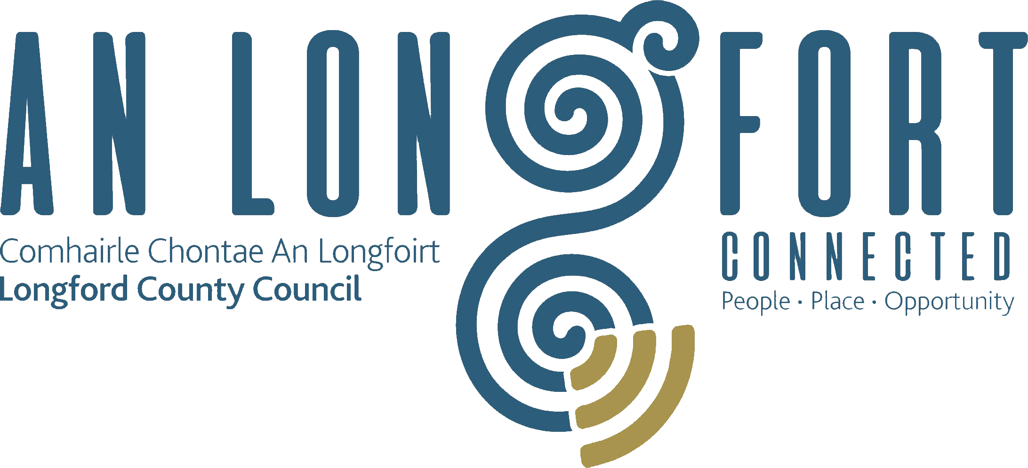

**GOVERNANCE STRATEGIC POLICY COMMITTEE**

**Minutes of Governance Strategic Policy Committee Meeting**

**held via Microsoft Teams on Tuesday**

**20th October 2020 at 3.00 p.m.**

**PRESIDING**: Councillor Mick Cahill, Chairperson.

**PRESENT**: Councillors – Seamus Butler, John Browne, Colin Dalton,

P.J. Reilly.

Fulton Grant, Pamela Martin, Teresa Kearney, Brendan Murtagh Kerie Murray.

**IN ATTENDANCE:**  John McKeon, Director of Services/Head of Finance.

Nora O’Farrell, Senior Executive Officer.

**MEETINGS**

**ADMINISTRATOR**: Anne Lee.

**ADOPTION OF MINUTES – circulated.**

On the proposal of Councillor S. Butler seconded by Councillor C. Dalton, it was agreed to adopt minutes of Governance Strategic Policy Committee meeting held on the 29th July 2020.

**MATTERS ARISING FROM MINUTES.**

None.

**DECLARATION OF INTERESTS.**

None.

**PRESENTATION ON THE BUDGETARY PROCESS IN LOCAL AUTHORITIES.**

John McKeon gave a comprehensive presentation on the Budgetary Process in Local Authorities under the following headings -

* 7 Stage Budgetary Process in accordance with Local Government Act 2014.
* Prescribed Periods (Budgetary Timelines)
* Members Reserved Functions throughout the Budgetary Process.
* 3 Important Meetings
  + Local Property Tax Variation Meeting.
    - Funding already secured as a result of the ‘Longford Model’.
    - Funding Applications currently in progress.
    - Return on Investment for Longford LPT Payers
    - Distribution of LPT by LPT Payer within Local Authorities.
    - Impact of current variation on Longford LPT Payers.
    - Overall Expenditure Acceleration – Last 5 Years
  + General Municipal Allocation (Municipal District GMA Meetings)
  + Statutory Budget Meeting.
* COVID 19 – Escalating Financial Implications for Longford County Council.
  + Reduced Income – Increased Costs.
  + Potential Impact National v Local.
  + Supports to Rate Payers – Restart Grants.
  + Monthly Lost Income.
  + Increased Expenditure – Once Off and Ongoing.

John replied to queries raised by the members.

**NEXT MEETING.**

2nd February 2021.

Councillor S. Butler suggested that a presentation be given a the next SPC meeting regarding the Standards in Public Office Commission (SIPO) which oversees ethics, electoral, state finance and lobbying legislation.

This concluded the business of the meeting.

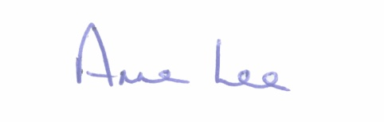

**Signed: _______________**

**Anne Lee,**

**Meetings Administrator.**

**Confirmed and adopted at Strategic Policy Committee Meeting held on the**

**2nd February 2021.**

**Signed: _______________**

**Chairperson.**