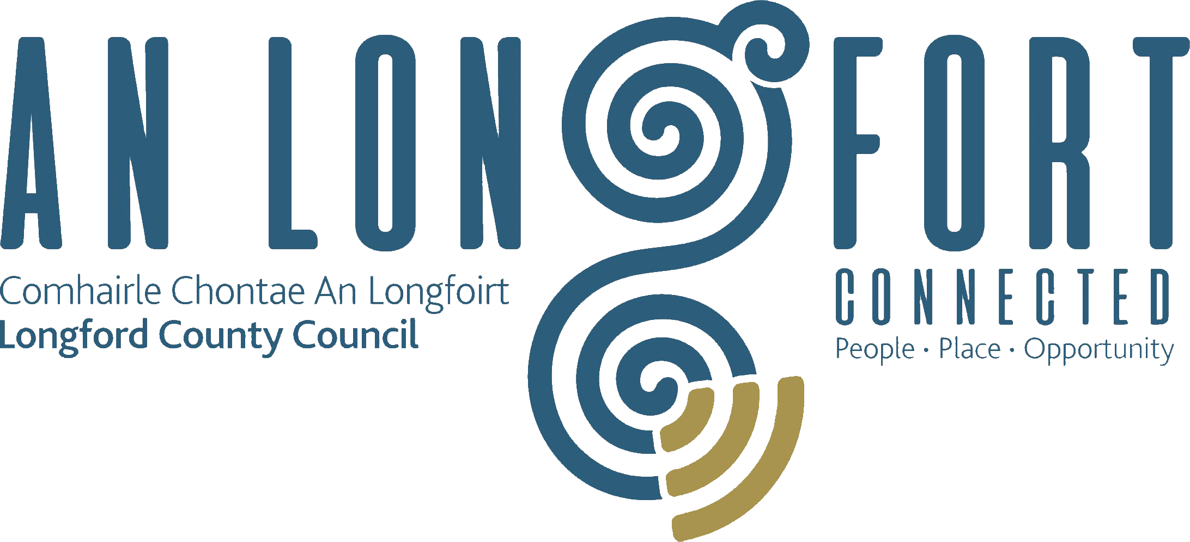

**GOVERNANCE STRATEGIC POLICY COMMITTEE**

**Minutes of Governance Strategic Policy Committee Meeting**

**held in the Council Chamber, Aras an Chontae,**

**Great Water Street, Longford on Wednesday, 29th January 2020 at 3.00 p.m.**

**PRESIDING**: Councillor Seamus Butler, Chairperson.

**PRESENT**: Councillors - John Browne and P.J. Reilly

Fulton Grant and Teresa Kearney.

**APOLOGIES** Councillors – Mick Cahill and Micheal Carrigy.

**IN ATTENDANCE:**  John McKeon, Director of Services/Head of Finance.

Nora O’Farrell, Senior Executive Officer.

Linda Hogan, Data Protection & Information Compliance Officer.

**MEETINGS**

**ADMINISTRATOR**: Anne Lee.

**INTRODUCTION.**

Councillor Butler welcomed the members to the inaugural Governance Strategic Policy Committee Meeting. Councillor Butler confirmed that there is still one outstanding member to be appointed to the Committee representing ICTU.

John McKeon stated that the Governance Strategic Policy Committee will focus attention on the development of policy in the following areas, which when considered and agreed by the SPC will be forwarded to the County Council for approval -

* Risk Management
* Health and Safety
* Control and Compliance
* Ethics
* ICT
* GDPR
* Broadband
* Digital and Social Media strategies.
* HR Training and Staff Development.

John outlined, in detail, the key areas in each heading.

John also gave details regarding the operation of Longford County Council’s external Audit Committee.

**DECLARATION OF INTERESTS**

None.

**STANDING ORDERS**

On the proposal of Councillor P. J. Reilly seconded by Councillor J. Browne, it was agreed to adopt Standing Orders, as circulated. The Standing Orders will be forwarded to Longford County Council for confirmation.

**PRESENTATION ON GDPR - Linda Hogan.**

Linda briefed the members regarding The Data Protection Act 2018 and the EU General Data Protection Regulation (GDPR) which came into effect on the 25 May 2018 and which represent a substantial expansion of data protection laws but basic rules remain the same (personal data must be processed lawfully, fairly, transparent manner, limited to its original purpose, minimum personal data obtained, accurate, stored only for as long as necessary, integrity & confidentiality). The Act introduces a new concept of accountability – controllers must be able to demonstrate how they comply with Data Protection legislation, must be a lawful basis for processing personal data;

Linda gave a very comprehensive presentation on Data Protection and replied to queries raised by the members.

**NEXT MEETING.**

28th April 2020.

This concluded the business of the meeting.



**Signed: _______________**

**Anne Lee,**

**Meetings Administrator.**

**Confirmed and adopted at Strategic Policy Committee Meeting held on the**

**29th July 2020.**

**Signed: _______________**

**Chairperson.**