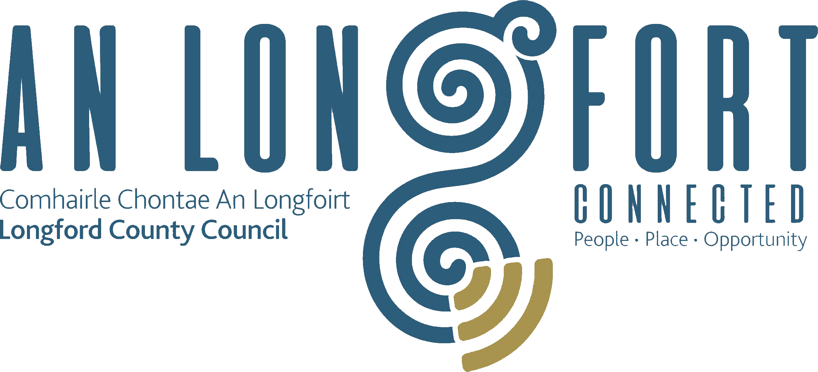

**GOVERNANCE STRATEGIC POLICY COMMITTEE**

**Minutes of Governance Strategic Policy Committee Meeting**

**held in Longford Rugby Club, Demesne, Longford on Wednesday,**

**29th July 2020 at 3.00 p.m.**

**PRESIDING**: Councillor Mick Cahill, Chairperson.

**PRESENT**: Councillors – Seamus Butler, John Browne, P.J. Reilly.

Fulton Grant, Pamela Martin, Teresa Kearney, Brendan Murtagh

**APOLOGY:** Councillor Colin Dalton.

**IN ATTENDANCE:**  John McKeon, Director of Services/Head of Finance.

Nora O’Farrell, Senior Executive Officer.

Danny Lynch, Head of Information Systems.

Marguerite Donoghue, IS Project Leader -GIS.

**MEETINGS**

**ADMINISTRATOR**: Anne Lee.

**ADOPTION OF MINUTES – circulated.**

On the proposal of Councillor J. Browne seconded by Councillor S. Butler, it was agreed to adopt minutes of Governance Strategic Policy Committee meeting held on the 29th January 2020.

**MATTERS ARISING FROM MINUTES.**

None.

**DECLARATION OF INTERESTS.**

None.

**LONGFORD COUNTY COUNCIL DIGITAL RESPONSE TO COVID-19 CRISIS.**

Danny Lynch gave a comprehensive presentation regarding the Council’s Digital Response to the COVID-19 crisis under the following headings –

* Update of Remote Access Policy and procedure.
* Communications to All Staff.
* Procurement and Provision of Laptops – Remote Access Software.
* Deployment of Microsoft Teams.
* Deployment of Cisco Jabber – staff phones.
* Increased User Support.
* Implementation of Community Call Helpline.
* HR Operational Dashboards.
* Operation of Business Restart Grant application process.
* Interview Process using Microsoft Teams.
* Staff Briefings by Management.
* Operation of Social Media and County Council website.
* Security Awareness Training.
* Challenges Ahead – Resources, Electronic Document Management.

The Chairperson and members complimented all in the IT Section for their excellent ongoing work during the COVID-19 Pandemic and acknowledged the many challenges faced by the Team.

John McKeon, on behalf of the Management Team, also acknowledged the staff in the IT Section for their speedy adaptation to the situation.

**Management Report.**

Nora O’Farrell, Senior Executive Officer, Corporate Section addressed the meeting.

Nora stated that the Management Report is part of the ongoing governance of the Council and is intended to:

* assist the elected members discharge their governance responsibilities
* oversee the executive in the delivery of the policies that the elected members have decided on
* to have oversight of the Chief Executive’s discharge of executive functions.

The recent adoption of the Council’s Corporate Plan presented an opportunity to review the format of the report. The report is required in accordance with the LG Acts and is circulatedto each Member of the Council as required under the Local Governments Acts.

The first report was circulated in 2014.

A proposal was developed and presented by SEO Corporate Services to Management Team and the recommendations to revise report were approved earlier this year.

Revised report format has resulted in -

* a professional structured Corporate report whilst continuing to ensure Elected Members receive sufficient detail on all service areas in the Management Reports
* Publication on the website to ensure the public and sectoral representatives have regular access to factual information on the work of the Council
* Increased openness and transparency.

**NEXT MEETING.**

20th October 2020.

This concluded the business of the meeting.

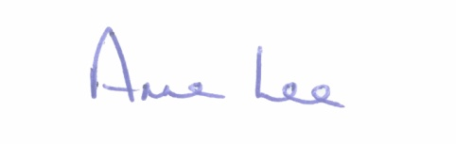

**Signed: _______________**

**Anne Lee,**

**Meetings Administrator.**

**Confirmed and adopted at Strategic Policy Committee Meeting held on the**

**20th October 2020.**

**Signed: _______________**

**Chairperson.**