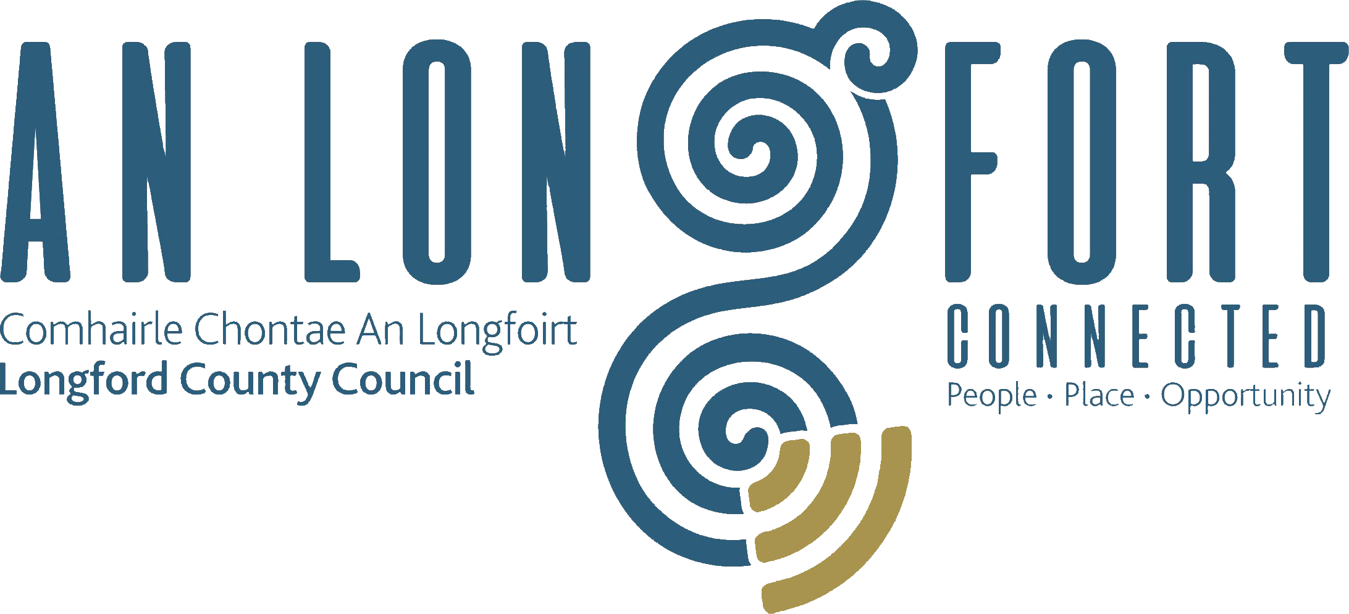

**GOVERNANCE STRATEGIC POLICY COMMITTEE**

**Minutes of Governance Strategic Policy Committee Meeting**

**held via Microsoft Teams on Tuesday**

**2nd February 2021 at 3.30 p.m.**

**PRESIDING**: Councillor Mick Cahill, Chairperson.

**PRESENT**: Councillors – Seamus Butler, John Browne, Colin Dalton,

P.J. Reilly.

Fulton Grant, Pamela Martin, Teresa Kearney, Brendan Murtagh Kerie Murray.

**IN ATTENDANCE:**  John McKeon, Director of Services/Head of Finance.

Nora O’Farrell, Senior Executive Officer.

Mr. Danny Lynch, Head of Information Systems.

Ms. Christine Kelleher, Broadband Officer.

Ann Marie Mc Keon, Administrative Officer

**MEETINGS**

**ADMINISTRATOR**: Anne Lee.

**ADOPTION OF MINUTES – circulated.**

On the proposal of Councillor John Browne seconded by Councillor Seamus Butler, it was agreed to adopt minutes of Governance Strategic Policy Committee meeting held on the

20th October 2020.

**MATTERS ARISING FROM MINUTES.**

None

**DECLARATION OF INTERESTS.**

None

**SUPPLEMENTARY STANDING ORDERS – REMOTE MEETINGS – circulated.**

The Supplementary Standing Orders for Remote Meetings adopted at the November meeting of Longford County Council were noted.

**CORPORATE PLAN 2019-2024 IMPLEMENTATION.**

Nora O’Farrell gave a very comprehensive presentation on the Council’s Corporate Plan and responded to questions raised.

The presentation covered areas including

* Value of the Corporate Planning Process
* Implementation in Year 1
* Monitoring and Review Framework

MT & CPG - Key Leadership Roles in Preparation

* Review
* Evaluation
* CPG Annual Review & CPG Review Outcome that objectives to make Longford
  + A thriving County
  + A Safety County.
  + A Greener County
  + A County for Everyone
* Draft Service Delivery Plan approved by Council & published on Website

Councillor Seamus Butler thanked Nora and asked that this item be placed on the Agenda for the December meeting. John Mc Keon Director of Services thanked Nora for her very comprehensive report and informed the meeting that a lot of work had gone into the Corporate Plan and when the NOAC review was completed he would put this item back on the agenda.

**COUNTY LONGFORD DIGITAL STRATEGY UPDATE**

Mr. Danny Lynch and Ms. Christine Collins gave a detailed update on the Community Digital Projects and replied to queries raised: -

* There are areas in Ireland with the Fastest and Slowest Broadband Speeds
* In 2016 Legan was reported nationally to have the slowest broadband
* The BCP will provide high speed broadband access to communities that don’t have it in the amber area of the NPB, in advance of homes and businesses receiving future proofed broadband to their doors”
* As in other communities, bringing this initiative to fruition has taken a lot of hard

work and dedication by many people from various groups and organisations, and

community buy in.

* “We have to sell this and one of the advantages is that people who returned to

Longford because of Covid-19 restrictions, etc., are now able to find fast and

efficient internet locally, so they can carry out their work from home”

* Greater accessibility, greater focus and massive opportunity
* Digital Strategy 2020 – 2023
* Consultations and Engagement
* Strategy Pillars
* Infrastructure and Connectivity
* Longford NBI Design Map and BCP Network
* Smart Communities
* Digital Economy and Enterprise
* Digital Transformation
* Implementation to date

Broadband connection points

WiFi4EU Project

Eduroam

Map Alerter

Remote Working

Grow Remote

[www.longford.ie](http://www.longford.ie)

Accessibility Software for websites

John Mc Keon commended the IT section and stated how they were the most cost effective and best value for money in their sector according to the NOAC report. They received the National Excellence in Local Government Award for the Use of Remote Working Technology in November 2020.

**STANDARDS IN PUBLIC OFFICE COMMISSION (SIPO).**

Nora O’Farrell gave a comprehensive presentation in response to request made at previous

SPC meeting -

**Presentation included**

* Information on Establishment of SIPO & membership Role of Supervisory body that oversees compliance with legislation concerning ethical issues for all persons holding public office
* Ethics Annual Declarations
* Declarations of Interests
* Codes of Conduct - Elected Members & Employees
* Consequences of failure to comply & Offences
* Ethical Framework
* Ethics Registrar Role & Duties
* What is not a declarable or beneficial interest
* Role of the Cathaoirleach/Chief Executive
* Role of the Standards in Public Office Commission

The following queries were raised at meeting

* Can the published Register of Interests be viewed online
* Do many if any, members of public come in to view same

Nora O Farrell undertook to follow up on the first query and revert back to the SPC.

John McKeon responded to the second query and provided the requested information and Nora O Farrell will provide further update on the position in relation to 2021 at year end.

**NEXT MEETING.**

20th April 2021.

This concluded the business of the meeting.

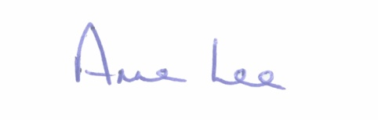

**Signed: _______________**

**Anne Lee,**

**Meetings Administrator.**

**Confirmed and adopted at Governance Strategic Policy Committee Meeting held on the**

**20th April 2021.**

**Signed: _______________**

**Chairperson.**