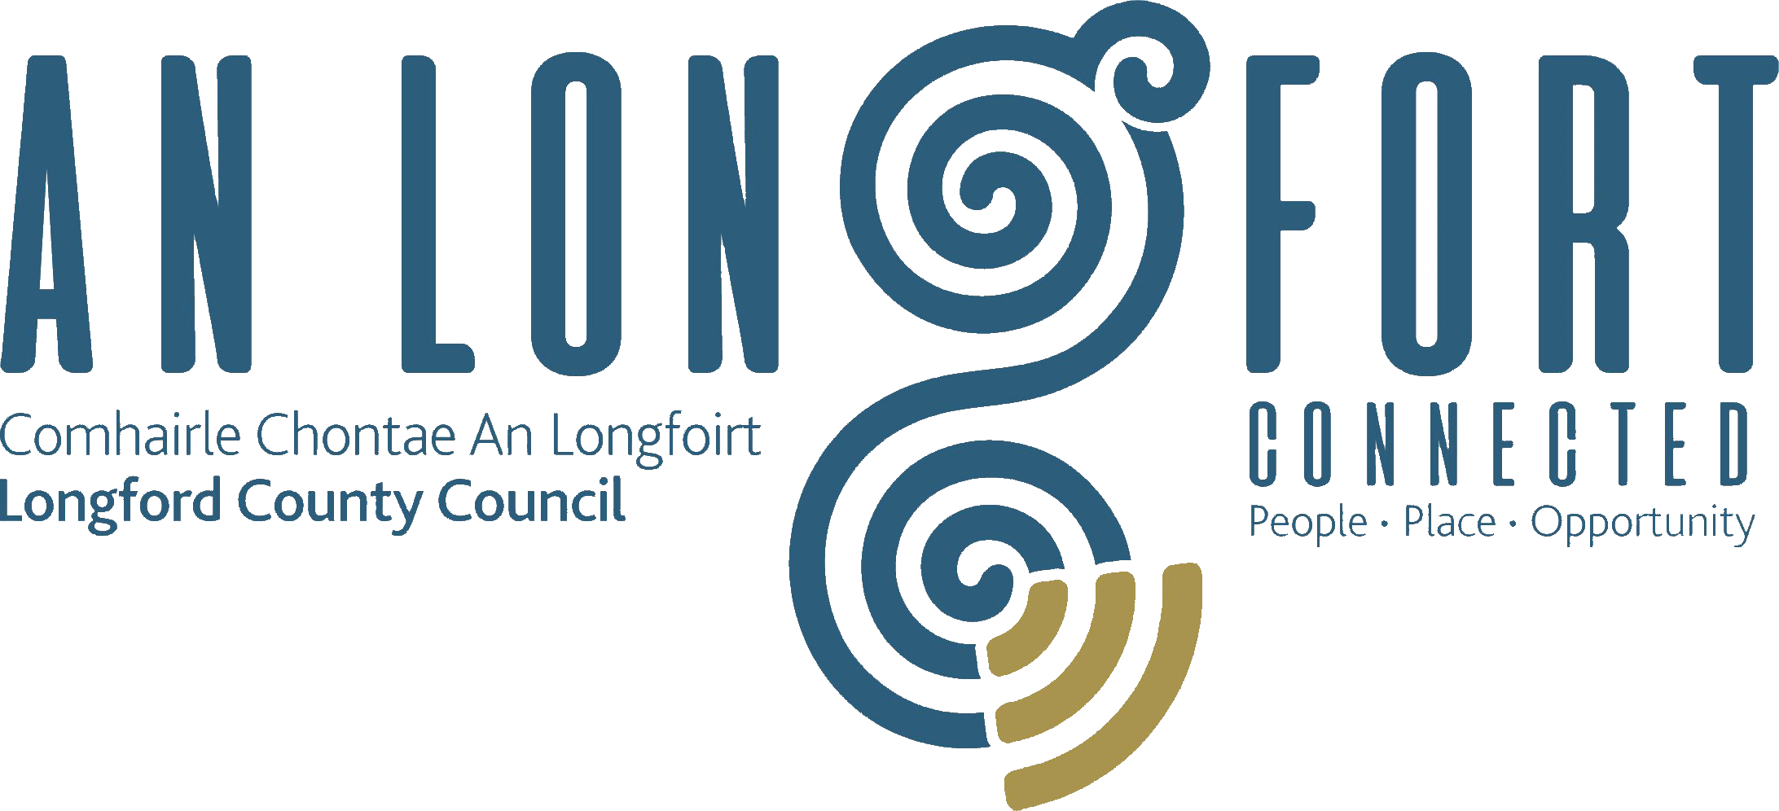

**GOVERNANCE STRATEGIC POLICY COMMITTEE**

**Minutes of Governance Strategic Policy Committee Meeting**

**held via Microsoft Teams on Tuesday**

**20th April 2021 at 3.00 p.m.**

**PRESIDING**: Councillor Mick Cahill, Chairperson.

**PRESENT**: Councillors – Seamus Butler, John Browne, Colin Dalton,

Pamela Martin, Brendan Murtagh, Karie Murray.

**APOLOGIES:** Councillor PJ Reilly

Teresa Kearney, Fulton Grant

**IN ATTENDANCE:**  John McKeon, Director of Services/Head of Finance

Nora O’Farrell, Senior Executive Officer

Daniel Lynch, Head of Information Systems

Lorraine O Connor, Executive Planner

Terry Rooney, Senior Executive Officer

**MEETINGS**

**ADMINISTRATOR**: Ann Marie Mc Keon.

**ADOPTION OF MINUTES – circulated.**

On the proposal of Councillor Seamus Butler seconded by Councillor John Browne, it was agreed to adopt minutes of Governance Strategic Policy Committee meeting held on the 2nd February 2021.

**MATTERS ARISING FROM MINUTES.**

Standards in Public Office Commission (SIPO).

Councillor Seamus Butler asked for update on the query raised at previous meeting.

Nora indicated as mentioned by John at previous meeting that during the time responsibility for Ethics had sat that Directorate that no member of the public had one came into view the Register.

In terms of the question in relation to the Register being made available online Nora advised that the legislation is very specific and provides that the Register is kept at the offices and available for public inspection. She confirmed in response to query in context of offices being closed that persons can have access to the offices by appointment under the current level 5 restrictions and inspection of the Register of Interests will be facilitated if requested

**DECLARATION OF INTERESTS.**

None.

**COUNTY LONGFORD DIGITAL PROJECTS UPDATE**.

Councillor Mick Cahill welcomed Danny Lynch to the meeting. Danny gave an overview on what’s happening with the Digital project and projections for the future: -

* Recap on Strategy 2021 to 2023
* Four Pillars to Strategy
* Infrastructure & Connectivity
* Smart Communities
* Digital Economy and Enterprise
* Digital Transformation
* 7 Deployment areas in Longford
* 8 BCP and Wifi’s – Numbers connecting are increasing.
* WIFI4EU – Town Wifi – 625 New Users – 1004 Returning Users
* Number of Webinars took place in March/April 2021
* Electronic Management Document
* Digital Divide
* Hybrid Video Meetings Solution for Council Chamber
* Digital PMDS

The members raised the following queries which Danny responded to: -

* KN Networks are they working on the Broadband Plan
* Do you automatically connect to the Wifi when you pull up at a location that has BCP
* In Longford town how do you connect to the Wifi
* Where were the 625 users
* Promotion of this service to the public

Danny explained that Eir may have contracted KN Networks to do work on the broadband or they could be carrying out repairs. When you are at a location that has BCP you select the BCP wifi and you connect to that and a page will open up and you put in your mobile number and they will send you a code and you put the code in and you are connected to the wifi there and it’s the same in the town. The 625 users were new users who connected to the wifi in Longford town, Drumlish and Ballymahon in the month of March.

Currently looking at promoting the town wifi and BCP through social media, as it’s a brilliant resource for all the towns to have.

John Mc Keon acknowledged the great work done by IT and the Chamber of Ireland award which they won. There are two or three items which would be worthy of awards on the national stage again. Funding has been identified for a number of initiatives this year, including the electronic document management system and the upgrading of the chamber. We will provide updates as these projects progress.

**LONGFORD COUNTY COUNCILS DRAFT POLICY ON STRATEGIC VISION ON RURAL WORKING HUBS.**

Mick Cahill welcomed Terry Rooney and Lorraine O’Connor to the meeting and congratulated them both on the historic announcement yesterday on the Rural Redevelopment Funding (RRDF) for Ballymahon. Fantastic work is being done by the regeneration team, the leadership that Lorraine and Terry have shown in helping the community through this process is outstanding. A lot of work is being done by regeneration all over the County under the remit of John Mc Keon and the help that is being provided to the community is second to none.

The people of Ballymahon were absolutely thrilled with the announcement, when the Minister spoke yesterday evening about bringing old buildings back to life and you see what is being proposed in Ballymahon its phenomenal. Lorraine has done outstanding work in educating the communities and leading out on the work with these groups.

We now have a large number of successful regeneration projects throughout the county in terms of funding and it is now critical that we have a properly resourced & structured team in place to bring all the various projects to delivery and completion, while maintaining the future project pipeline. I want to compliment everyone again.

John Mc Keon responded that we are head and shoulder above our peers around the country. Twenty-four projects were successful under the Rural Redevelopment Fund (RRDF) around the country with the fourth highest allocation coming to Longford.

We are now up there with the larger counties in terms of successful funding applications and it is all down to the regeneration team and the ~~coactivity~~ connection and the collaboration with the communities.

We have been very successful in a number of large projects and we recognise the need to have the right structures and resources in place to deliver these projects and that is something that the management team will be working on.

Terry thanked everyone for the support that has been given to the regeneration team and it made him think back to 2015 when the elected members looked for a regeneration team to be put in place and this followed on from the success of dealing with unfinished estates. We have moved from securing thousands to millions. Last month we secured ten million and another six million this month and we may have another announcement next month.

This has happened because of the support from the elected members and the communities out there who come up with the great ideas and it’s a privilege to work with every one of them. There are only ten of us in the team and its fabulous to work with them all.

Seamus Butler asked for clarity on the Urban Regeneration monies in Longford as the letter of offer hasn’t arrived yet and it is not known when this will come as it will determine the priorities of what projects will be done. John Browne acknowledged the works of the regeneration team. Terry responded that work has started on prioritising projects and the letter of offer hasn’t come, but it hasn’t impeded on the planning process either.

Lorraine thanked everyone for their kind words and explained that the team have been working on this (Draft Policy on the strategic vision for Rural Working Hubs) for the last year, it came from a European Project where they partnered with Finland.

The idea of developing the strategy and guidance document came from conversations that they had with community groups and the consultation process that they carried out over the last number of months outlines the policy in place before the members today.

The following points were highlighted -

* Co-operation Project with Leader Aisapari, Finland​
* ​Develop a strategic vision for the development of rural working hubs​
* Develop supports for organisations seeking to develop hubs
* Typically, co-working spaces developed within a town or village centre to create new opportunities for people to work within their local area, on an ad hoc, part time or full-time basis
* Important role in rural regeneration​
* Covid-19 has accelerated change toward remote working​
* Longford currently has no operational rural working hub – Regional Assemblies

‘Regional Co-Working Analysis’ (Regional Assemblies of Ireland, September 2020)​

* Making Remote Work​
* Our Rural Future Plan​
* Public Sector set to have 20% working remotely​
* Western Development Commission – Atlantic Economic Corridor Enterprise Hubs Project​
* Grow Remote​
* Making Remote Work​
* **Policy Objective 1:** A Town Centre First approach will be adopted in all rural working hub proposals​
* **Policy Objective 2:** Longford County Council proposes a tiered approach to rural working hub development, as outlined in the strategy and organisations will be required to undertake a business plan to demonstrate the demand for a rural working hub in a specific area​
* **Policy Objective 3:** An internal working group will be established to assess proposals for rural working hubs submitted to Longford County Council for funding support. ​

**Guidance for the Development of Rural Working Hubs**

* Remote working has become increasingly popular

It creates many positive opportunities for employers, employees and the communities in which they are based.

* Remote working facilitates work outside of a traditional office environment so instead of commuting to an office each day to work from a designated desk, remote employees can work close to home within their local communities.
* The Covid-19 pandemic has led to the rapid increase in remote working throughout the country.
* This in turn brings life and activity back into town and village centres and increases the capacity of the local community to be more sustainable.
* Longford County Council supports the development of rural working hubs within County Longford and seeks to support communities and organisations in the development of hubs.
* This guidance has been designed to support organisations seeking support from Longford County Council in the development of hubs as a practical guide.
* The Council will engage with and provide guidance and advice on planning, broadband availability, supports available, etc. to private sector organisations wishing to develop hubs.
* The terms “remote working” and “rural working hubs” are used to describe many different types of work and workplace.
* Longford County Council has adopted a cross departmental approach to the development of rural working hubs, identifying the Regeneration Department as the primary contact for queries on the development of hubs.
* Any proposal for a hub will be considered by an internal working group to ensure that full consideration of the feasibility and sustainability of a project is considered
* Organisations interested in seeking support from Longford County Council for the development of a hub should contact Longford County Council Regeneration Department via email
* **Key Considerations in Development of Rural Working Hubs**
* Why
* Development of Business Plan
* Availability of Sufficient Broadband Connect
* Resources
* Booking System
* Facilities
* Management Model
* Branding and Marketing
* Innovation
* Sustainability
  + **There are many challenges in establishing Rural Working Hub**

John Mc Keon clarified the three most important factors to be considered for the establishment of any hub is sustainability, financial viability and operational and management competency and you need all three items for a successful hub.

Seamus Butler recognises funding as the biggest issue. There is a transitional LEADER grant available for capital only, but you can’t draw down funding for day to day running use.

PR is also an issue and we should be utilising our communication officer.

Implementation & Delivery needs to progress now and asked that for the July Agenda that we could have an Implementation & delivery Plan for all the Regeneration Programmes we currently have.

John Browne has reservations on the viability of hubs in the longer term.

Mick Cahill agreed with the proposal to have an Implementation & Delivery Plan on the July Agenda.

On the proposal of Councillor Seamus Butler seconded by Councillor John Browne, it was unanimously agreed to accept the proposed Draft Policy on Strategic Vision on Rural Working Hubs. The proposed policy will now be forwarded to the full Council for final approval.

**DATE OF NEXT MEETING**

20th July 2021.

This concluded the business of the meeting.

Ann Marie Mc Keon

**Signed: ___________________________**

**Ann Marie Mc Keon,**

**Meetings Administrator.**

**Confirmed and adopted at Strategic Policy Committee Meeting held on the**

**20th July 2021.**

***Mick Cahill***

**Signed: _______________**

**Chairperson.**