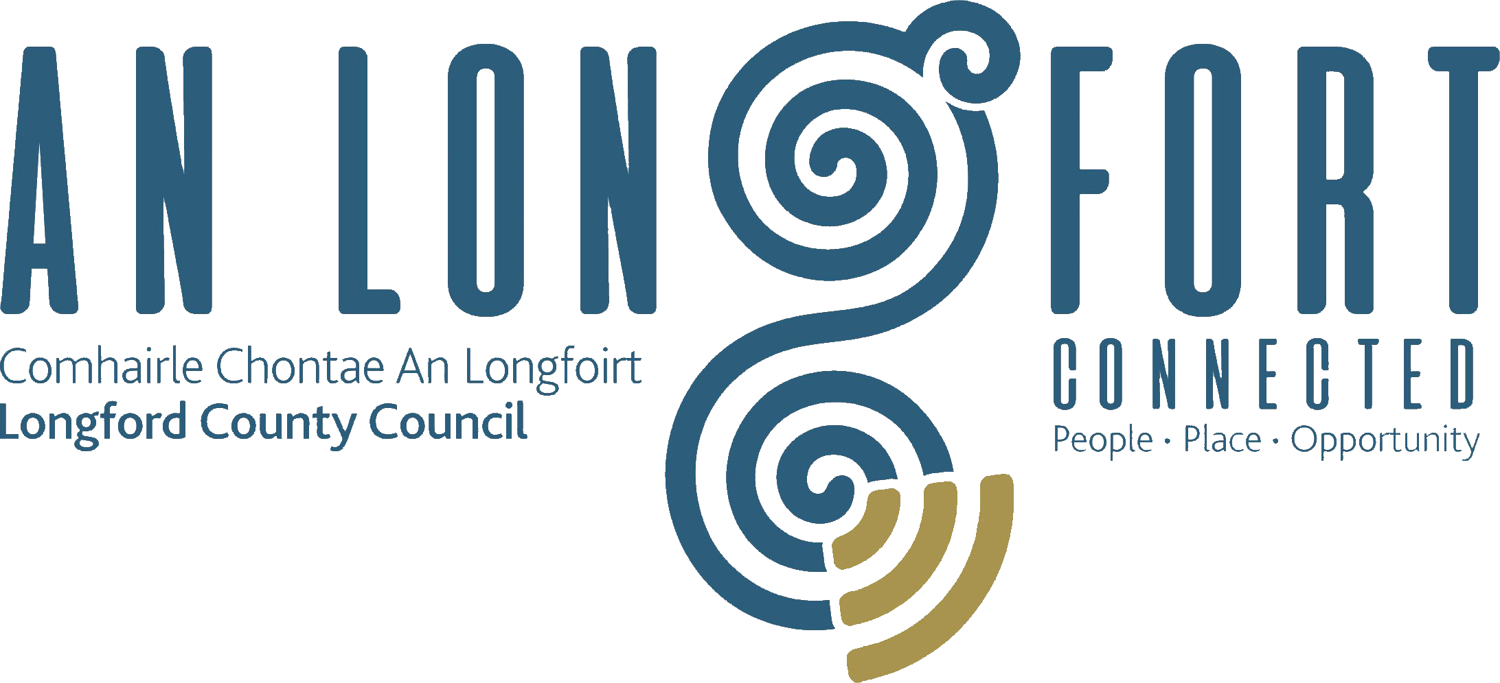

**GOVERNANCE STRATEGIC POLICY COMMITTEE**

**Minutes of Governance Strategic Policy Committee Meeting**

**held via Microsoft Teams on Tuesday**

**26 April at 3pm**

**PRESIDING**: Councillor Mick Cahill, Chairperson

**PRESENT**: Councillors – John Browne, Colin Dalton and

P.J. Reilly

Brendan Murtagh and Teresa Kearney

**APOLOGIES:** Councillor Seamus Butler

Fulton Grant, Pamela Martin and Karie Murray

**IN ATTENDANCE:**  Fema Farrell, A/Director of Services/Head of Finance

Nora O’Farrell, Senior Executive Officer

Linda Hogan, Data Protection Officer

**MEETINGS**

**ADMINISTRATOR**: Ann Marie Mc Keon.

**ADOPTION OF MINUTES – circulated**

On the proposal of Councillor PJ Reilly, seconded by Councillor John Browne, it was agreed to adopt the minutes of the Governance Strategic Policy Committee meeting held on the 2 February 2022.

**MATTERS ARISING FROM MINUTES**

None.

**DECLARATION OF INTERESTS**

None.

**PRESENTATION BY DATA PROTECTION UNIT**

Linda Hogan introduced herself to the members as Data Protection and Information Compliance Officer and Linda covered the following in her presentation to the members:

* Role of a Data Protection Officer
* Data Protection and information compliance work plan for 2021/2022
* Data Protection Compliance Report for 2021
* Recommendation Reports
* Working Groups
* Meta Compliance

The members thanked Linda for the presentation and Linda responded to the questions raised. The members asked that the Data Protection training would be rolled out to them, and Linda confirmed that it would, and she also agreed to circulate a copy of her presentation to the members.

**CONSIDERATION OF ANTI-FRAUD AND CORRUPTION POLICY – AS**

**CIRCULATED**

Acting Head of Finance, Fema Flanagan introduced herself to the members and explained that the purpose of this policy is to set out the Council’s responsibilities (and of those working on behalf of the Council) in observing and upholding the Council’s position on fraud and corruption. This policy applies to all Longford County Council elected members and employees, persons appointed by the Chief Executive (e.g., consultants, contractors) and other and other third parties working on behalf of the Council. Fema covered the following:

* What is fraud
* What is corruption
* Anti-Fraud and Corruption Policy Statement
* Supporting policies
* Discovering and report fraud
* Investigation of fraud and corruption

The members welcomed the policy and Fema responded to the questions raised.

On the proposal of Councillor Colin Dalton, seconded by Councillor John Browne it was

unanimously agreed to accept the Anti-fraud and Corruption Policy. The

proposed policy will now be forwarded to the next monthly meeting of Longford

County Council for adoption by the members.

**DATE OF NEXT MEETING**

The members noted the date of the next meeting.

This concluded the business of the meeting.

**Signed: ___________________________**

**Ann Marie Mc Keon,**

**Meetings Administrator.**

**Confirmed and adopted at the Governance Strategic Policy Committee Meeting held on the 19 July 2022.**

**Signed: _______________**

**Chairperson.**