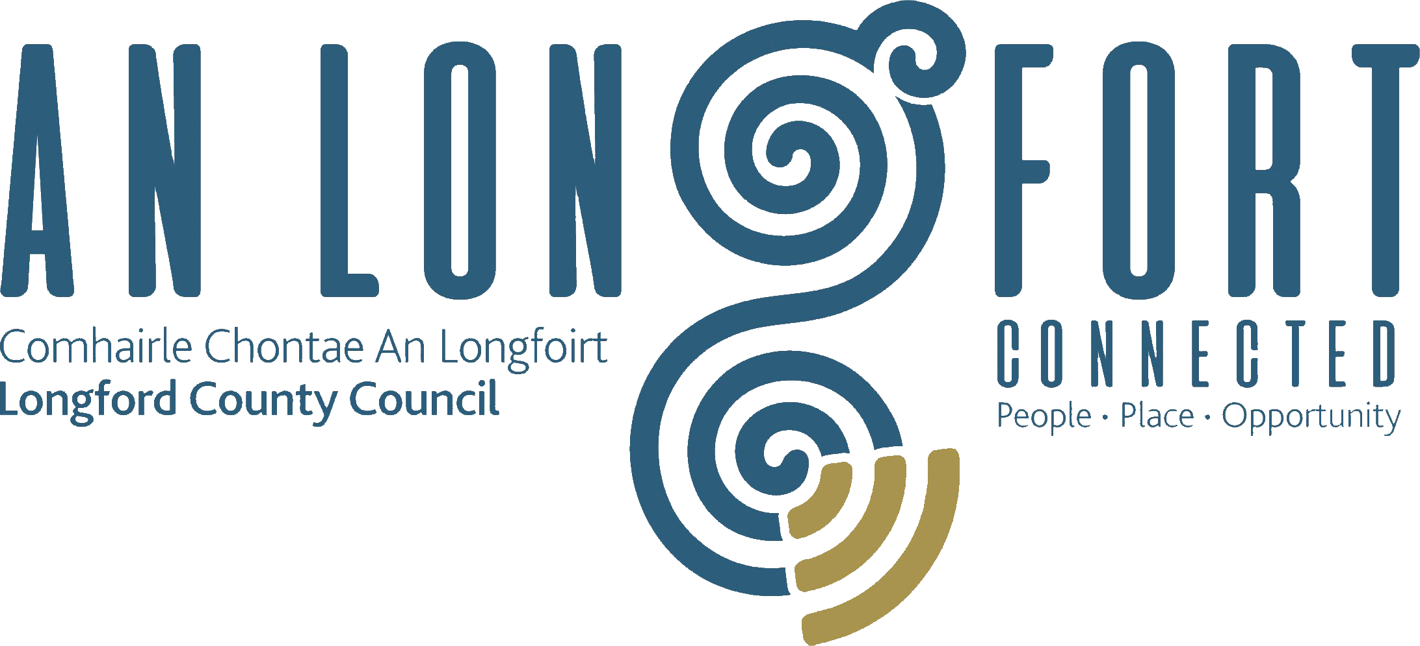

**GOVERNANCE STRATEGIC POLICY COMMITTEE**

**Minutes of Governance Strategic Policy Committee Meeting**

**held via Microsoft Teams on Tuesday**

**2 February at 3pm**

**PRESIDING**: Councillor Mick Cahill, Chairperson.

**PRESENT**: Councillors – Seamus Butler, John Browne, Colin Dalton,

P.J. Reilly.

Brendan Murtagh, Pamela Martin and Teresa Kearney.

**APOLOGIES:** Fulton Grant and Karie Murray.

**IN ATTENDANCE:**  John McKeon, Director of Services/Head of Finance

Nora O’Farrell, Senior Executive Officer

Denise Canavan, Communications Officer

**MEETINGS**

**ADMINISTRATOR**: Ann Marie Mc Keon.

**ADOPTION OF MINUTES – circulated**

On the proposal of Councillor Seamus Butler, seconded by Councillor John Browne, it was agreed to adopt the minutes of the Governance Strategic Policy Committee meeting held on the 19 October 2021.

**MATTERS ARISING FROM MINUTES**

None.

**DECLARATION OF INTERESTS**

None.

**UPDATE ON CORPORATE PLAN**

Nora O’Farrell, Senior Executive Officer gave a brief update to the members on the corporate plan:

2021 Update

* Value of the Corporate Planning Process
* Monitoring and Review Framework
* Key Leadership Roles MT & Corporate Policy Group
* Corporate Policy Group Review in 2020

2022 Update

* Corporate Plan Monitoring and Review Framework
* Corporate Policy Group Review
* National Audit and Oversight Commission (NOAC) Review
* Service Delivery Plan Application

Annual Monitoring and Review Programme - Key Deliverables

* Service Delivery Plan Adoption by Elected Members
* Management Team Briefings
* Corporate Policy Group Reviews of Corporate Plan
* Update to Governance SPC February Meeting
* Preparation of CE Corporate Plan Annual Progress Report
* Preparation of Draft Service Delivery Plan for following Year

Enables CPG in context of changes within the operating environment of the Council to:

* determine the continued validity of Corporate Plan strategies
* consider if any changes in emphasis or direction are required
* respond under the Council’s leadership with any necessary adjustments to strategies and objectives
* NOAC Review
* Annual service delivery Plan

The members welcomed the presentation and acknowledged the work involved in the process and raised questions on the following which Nora responded to:

* Service Delivery Plan – what access staff have – adoption of plan
* Monitoring
* Rural Water
* Staff Resources- usage of time
* NOAC Report

**PRESENTATION ON COMMUNICATION’S AUDIT REPORT**

Denise Canavan introduced herself as the Communications officer with Longford County Council appointed to the role in January 2021 and explained the structure in place in the communications section. Denise explained that the external review of Longford County Council’s audit of its communications function was commissioned to review the newly established communications systems and processes and to identify what, if any, gaps need to be addressed. The task included reviewing Longford County Councils communications protocols and recent media coverage as well as a visit to Longford County Council to meet with the Chief Executive and other key personnel. Denise covered the following headings:

* Resources
* Strategic Communications Plan
* Protocols
* Social Media
* Longford County Council Websites
* Internal Communications
* Communications Reporting

**Peer Review of Communications Audit Scope**

* To support work of embedding the value of good communication at every level of organisation
* To review newly established communications systems/processes
* To identify gaps, if any, to support organisation-wide rollout
* Who carried out independent audit? - Director of Project Communications, RPS Group
* Limited Overall Key Conclusions
* A lot done, more to do
* We cannot communicate enough!

**Recommendations**

* Resources
* Communications Strategy
* Protocols
* Social Media
* Websites
* Internal Communications
* Communications Reporting

The members thanked Denise for her presentation and acknowledged that Longford County Council was one of the leading authorities in the midlands when it came to communications. They recognised the work that has been done in this department since Denise took up the role.

They members commented on the following, which Denise responded to

* Revamp the website to more user friendly
* Cost of report
* Register of electors
* Longford County Council’s main sites in relation to social media
* Corporate Image
* Communication support to elected member
* Number of social media and website followers
* Internal communication
* Media monitoring
* NOAC Performance Indicator
* Recognition of Communication’s under NSAI Certification

John Mc Keon, Director of Services commended the on-going work in the communications department and looked forward to the implementation of the recommendations in the audit report.

**DATE OF NEXT MEETING**

The members noted the date of the next meeting.

This concluded the business of the meeting.

Ann Marie Mc Keon

**Signed: ___________________________**

**Ann Marie Mc Keon,**

**Meetings Administrator.**

**Confirmed and adopted at the Governance Strategic Policy Committee Meeting held on the 19 April 2022.**

***Mick Cahill***

**Signed: _______________**

**Chairperson.**