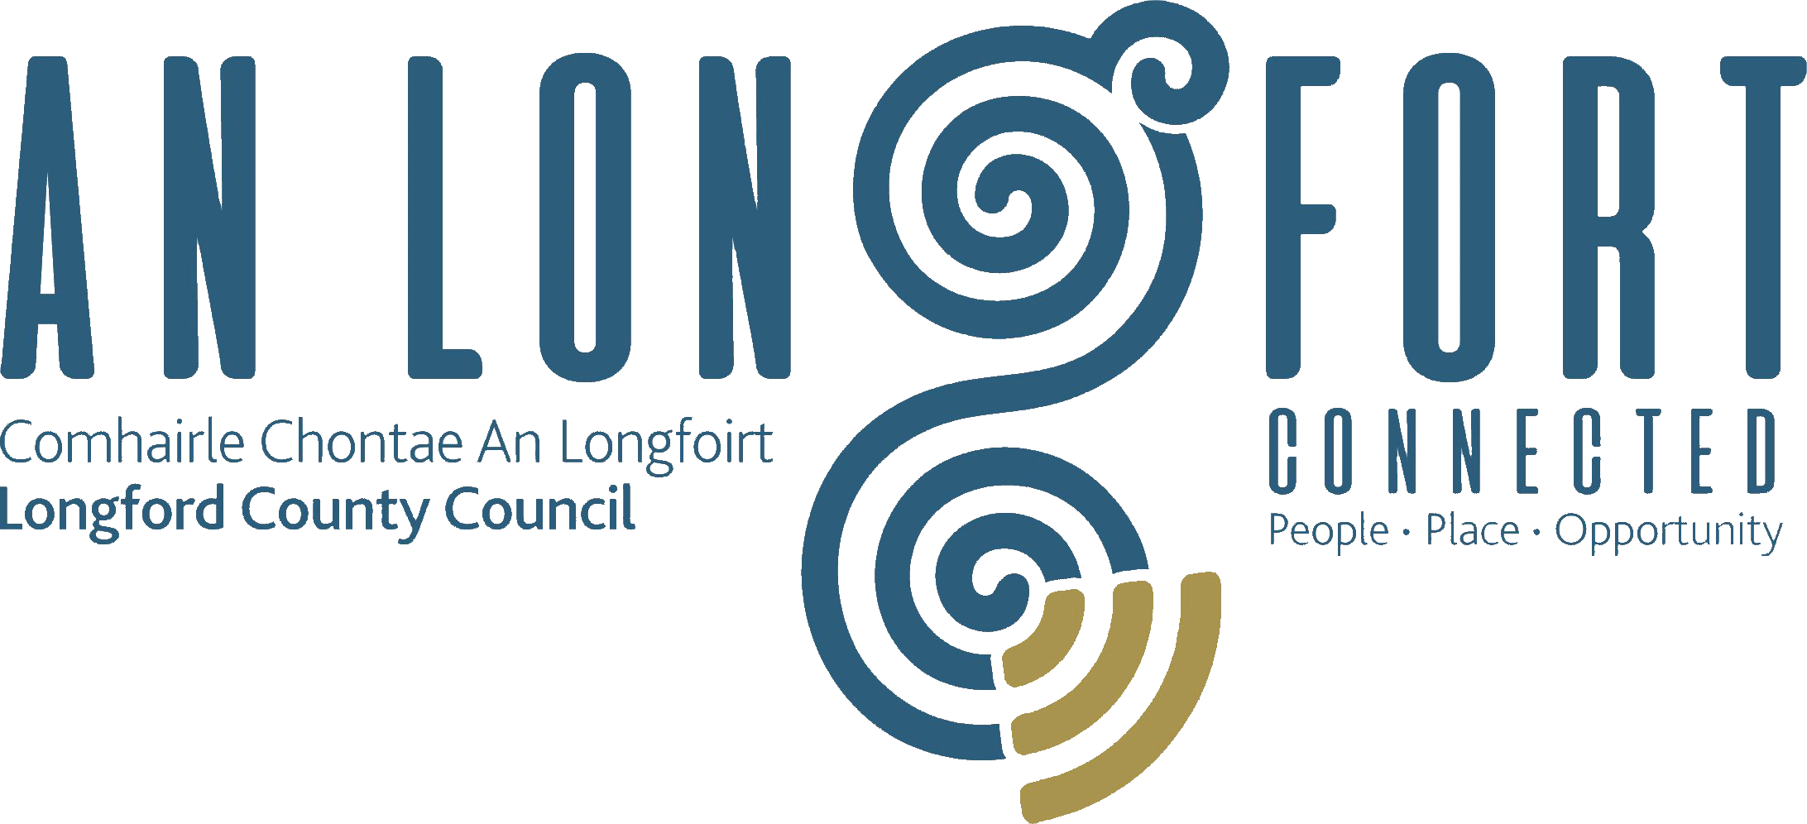

GOVERNANCE STRATEGIC POLICY COMMITTEE

Minutes of Governance Strategic Policy Committee Meeting
held via Microsoft Teams
on Tuesday 31 January 2023 at 3pm

PRESIDING: Councillor PJ Reilly, Chairperson

PRESENT: Councillors – Seamus Butler, Colin Dalton and
Mick Cahill, John Browne
Paula Llyod

APOLOGIES: Nora O’Farrell, Pamela Martin and Teresa Kearney

IN ATTENDANCE: Fema Flanagan, A/Director of Services/Head of Finance
Linda Hogan, Data Protection Officer
Ann Mulligan, Administrative Officer

MEETINGS
ADMINISTRATOR: Claire McNabola

ADOPTION OF MINUTES – circulated
On the proposal of Councillor Colin Dalton, seconded by Fema Flanagan it was agreed to adopt the minutes of the Governance Strategic Policy Committee meeting held on the 18 October 2022.

MATTERS ARISING FROM MINUTES
None

DECLARATION OF INTERESTS
None

2023 SERVICE DELIVERY PLAN
Linda Hogan gave a presentation to the members on the Service Delivery Plan 2023. One of the key annual deliverables is to present an update to the Governance SPC. Linda provided a brief overview on the 80 objectives from the 5 Directorates across the 4 themes of the Corporate Plan.

- A Greener County
- A Safer County
- A Thriving County
- A County for Everyone

Linda answered any questions raised by the members.

PROTECTED DISCLOSURE – UPDATE ON LEGISLATION CHANGES
This item is deferred to the April Meeting of the SPC.

UPDATE ON THE NATIONAL REVIEW OF FOI

Linda Hogan provided the members with an update on the national review of FOI:

Review Process
- Now at advanced stage and expected to be concluded early 2023
- Progress report on the review brought to Government mid-December
- Department continues engagement with key stakeholders to finalise its conclusions and recommendations
Next Actions at National Level
- Final findings with recommendations will be brought to the Minister for consideration in early 2023
- Final report will be presented to Government for approval and publication in Q1 2023
- Once report is approved by Government and published, amending legislation will then be tabled if required
- Implementation process will commence

2 Public Consultation Themes
- Structural Issues
- Incremental Reforms

Next steps for Longford County Council
- Make Current Information available
- An FOI Review update document for stakeholders is published on the Departments website
- Make that available to the SPC and link to Dept website
- Press Release Review of the FOI Act
- Make the document available to Elected Members MT and Senior Officers
- Include on the FOI section on Council website
- Await publication of the approved report and provide further update

Linda Hogan and Ann Mulligan (FOI Officer) answered any questions raised by the members.

Councillor Seamus Butler raised the matter of “Councillor’s Expenses” and the format of which they are publicised. It was agreed that Fema Flanagan would give an update at the next meeting.

CONFIRMATION OF DATE OF NEXT MEETING
18th April 2023

This concluded the business of the meeting.

Signed:
Claire McNabola,
Meetings Administrator.

Confirmed and adopted at the Governance Strategic Policy Committee Meeting held on the 18 April 2023.

Signed: _______________
Chairperson.

