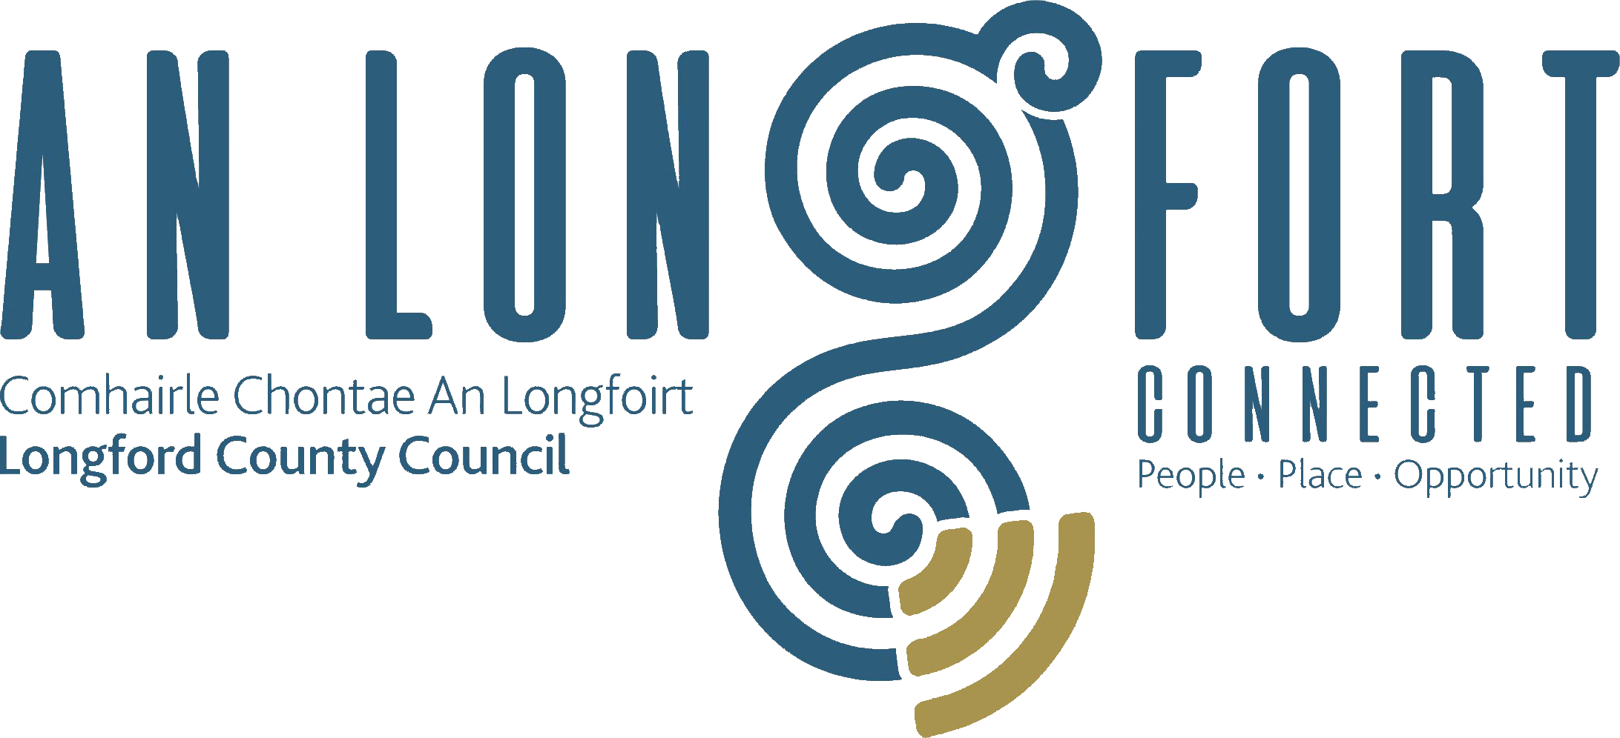

**GOVERNANCE STRATEGIC POLICY COMMITTEE**

**Minutes of Governance Strategic Policy Committee Meeting**

**held via Microsoft Teams**

**on Wednesday 31 January 2024 at 11am**

**PRESIDING**: Councillor PJ Reilly, Chairperson

**PRESENT**: Councillors –Colin Dalton, Mick Cahill, Seamus Butler

and John Browne

Pamela Martin

**APOLOGIES:** None

**IN ATTENDANCE:**  John McKeon, Director of Services/Head of Finance

Nora O’Farrell, SEO Corporate Services

Danny Lynch, Head of IT

Christine Collins, Broadband Officer

Linda Hogan Data Protection Officer

**MEETINGS**

**ADMINISTRATOR**: Claire McNabola

1. **ADOPTION OF MINUTES – circulated.**

On the proposal of Councillor Seamus Butler seconded by Councillor Colin Dalton, it was agreed to adopt the minutes of the Governance Strategic Policy Committee meeting held on the 18 October 2023 as circulated.

1. **MATTERS ARISING FROM MINUTES**

None.

1. **DECLARATION OF INTERESTS**

None.

1. **UPDATE ON DIGITAL STRATEGY**

Danny Lynch delivered a presentation on the progress of the Longford Digital Strategy to the Members. Danny highlighted the many success stories over the past year namely – Computer Science in 3 Secondary Schools in Co. Longford, success of securing €44k from the Public Service Innovation Fund and the hugely Successful Dream space Event in May 2023.

Danny outlined the 2 additional items to the Strategy:

* Computer Science in all 9 Secondary Schools in Co. Longford
* Digital Skills for all of our Citizens

Danny was delighted to advise the members that 24th May 2024 has been set for the 2024 Dream Space Event in Edgeworthstown, which is promised to be bigger and better than 2023.

Christine Collins outlined to the Members details on the **Stem Passport for Inclusion Program**:

The STEM Passport for Inclusion is an innovative initiative jointly led by Maynooth University, Microsoft Ireland, Science Foundation Ireland (SFI), and the Department of Education. This program aims to address inequalities in access to STEM (Science, Technology, Engineering, and Mathematics) careers among secondary school girls in socially disadvantaged communities.

Longford is piloting this programme in Lanesboro Community College, Moyne Community School & St Mel’s College. For the first time in this project boys will be able to participate.

The program offers a unique pathway for students to achieve a STEM qualification. It includes an educational qualification at Level 6 of the National Framework of Qualifications (NFQ).

During the programme women and men working in the STEM industry will act as mentors, providing guidance and acting as role models for the participating students

Finally, Danny also advised the Members that Longford County Council have submitted an application under the EU Just Transition Fund for €841k, the securing of these funds will be a game changer for the rollout of the Digital Strategy in Co. Longford.

The Members collectively thanked John, Danny and the entire IT Team for the excellent work they have done. Their foresight and ambition has been key to this success story.

John McKeon again acknowledged the hard work of the IT Section within Longford County Council. They are an extremely proactive section with the sector, and this is very evident in their many successful projects. John also highlighted how beneficial the securing of the EU Just Transition Fund could be for Co. Longford, this has the ability to put Longford County Councils IT Section in the Forefront of all IT Sections in the Country if the application was to be successful.

On the proposal of Danny Lynch the Members agreed to extend the Digital Strategy for a further 2 years.

1. **PROTECTED DISCLOSURES**

Nora O’Farrell gave a presentation to the members on Protected Disclosure – Update on legislation changes. One of the key annual deliverables is to present an update to the Governance SPC. Nora provided a comprehensive overview on the following topics:

* Legislation at a glance
* Objective of Protected Disclosures Legislation
* Legislation and related guidance documents
* What is a Protected Disclosure
* 2022 Act - Amendments to 2014 Act
* Relevant Wrongdoings
* Protected Disclosures Commissioner
* Protected Disclosures Longford County Council

There were no Protected Disclosures received in 2023, or since 2019.

Nora responded to questions raised by the members. The members acknowledged and thanked Nora for delivering a detailed presentation.

John McKeon advised the Members that there is currently a National Review of SPC’s taking place sector wide. Currently Longford County Council are the only County who have a Governance SPC in place. This Governance SPC is seen a very good example and one of great importance and relevance. John advised the members with this in mind, there is a survey been carried out and Members may receive a call in relation to same.

1. **DATE OF NEXT MEETING**

16th April 2024

This concluded the business of the meeting.

**Confirmed and adopted at the Governance Strategic Policy Committee Meeting held on the 15 April 2024.**

**Signed:**

**Claire McNabola**

**Meetings Administrator.**

**Signed: _______________**

**Chairperson**