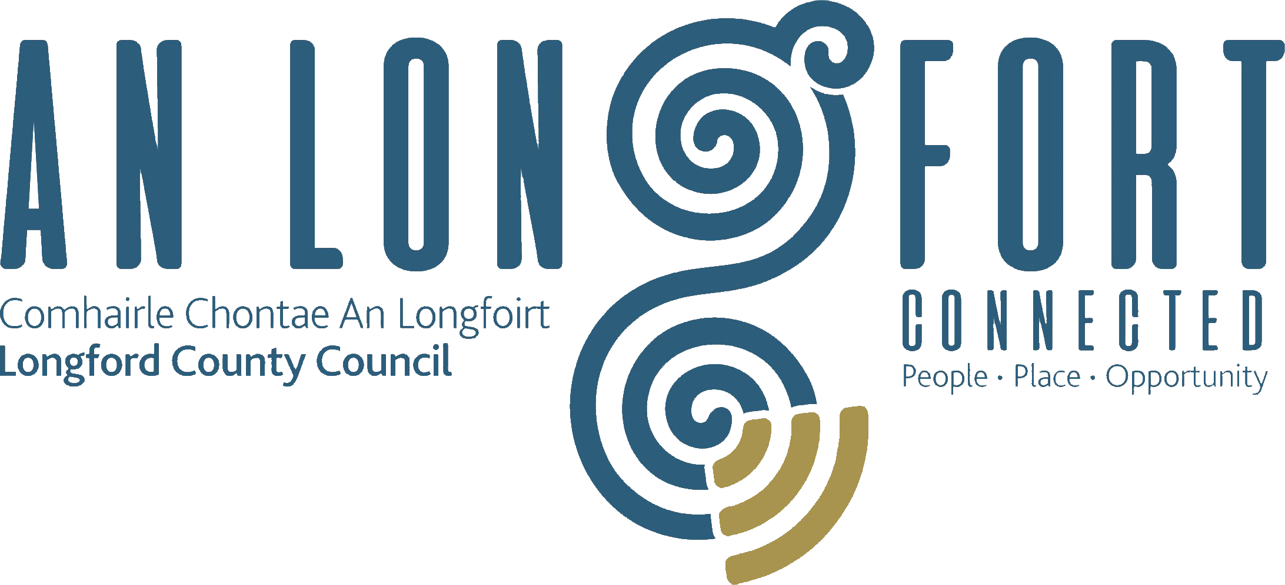

**GOVERNANCE STRATEGIC POLICY COMMITTEE**

**Minutes of Governance Strategic Policy Committee Meeting**

**held via Microsoft Teams on Tuesday**

**26th July 2021 at 3.00pm**

**PRESIDING**: Councillor Mick Cahill, Chairperson.

**PRESENT**: Councillors – Seamus Butler, John Browne, Colin Dalton,

P.J. Reilly.

Brendan Murtagh, Karie Murray.

**APOLOGIES:** Teresa Kearney, Pamela Martin and Fulton Grant.

**IN ATTENDANCE:**  John McKeon, Director of Services/Head of Finance

**MEETINGS**

**ADMINISTRATOR**: Ann Marie Mc Keon.

**ADOPTION OF MINUTES – circulated.**

On the proposal of Councillor PJ Reilly seconded by Councillor Butler, it was agreed to adopt the minutes of the Governance Strategic Policy Committee meeting held on the 22nd April 2021 with the following amendment page 4, paragraph 4 insert the word “not” before unknown.

**MATTERS ARISING FROM MINUTES.**

None.

**DECLARATION OF INTERESTS.**

None.

**PRIORITISATION OF REGENERATION PROJECTS.**

John Mc Keon gave a very comprehensive report to the members on the regeneration projects

**URDF**

Longford Connected Project - €3 million

* Commence construction August 2021
* Completed February 2022

Royal Canal Gateway Spur

* Commence construction November 2021
* Completed April 2022

Camlin Quarter, Longford Town - €10.5 million

* Consultants appointed December 2021
* Commence pipeline of projects April 202

**RRDF**

Granard Norman Heritage Park - €2.9 million

* Commence construction February 2022
* Completed January 2023

Edgeworthstown Public Realm - €1.3 million

* Commence construction October 2021
* Completed March 2022

Abbeyshrule Rural Working Hub - €522,000

* Commence construction September 2021
* Completed May 2022

Lanesboro Enhancement Project - €469,000

* Consultants appointed September 2021

Ballymahon Community Resource Centre - €6 million

* Consultants appointed November 2021
* Commence construction May 2022
* Completed April 2023

**Delivery Constraints and Challenges**

* Rapidly increasing costs of construction means insufficient funding available to complete projects
* Longer Lead Times between:-

Securing of Funding & Appointment of Consultants

Awarding of Contracts and commencement of projects

* Intense competition for skilled labour and materials regionally & nationally
* Consultants and Contractors not available to tender for work
* Local Authorities in the Region competing for same limited pool of consultants & contractors
* Many URDF & RRDF schemes awarded funding in this region over the last few years
* Impact of COVID 19
* Staff turnover in Local Authority and Private Sectors
* Availability of Skilled Labour
* Contractors picking and choosing projects on a regional & national level (Seller’s market)
* Successful Tenderers looking to re-negotiate prices

The members thanked John for the presentation and acknowledged the increasing costs of materials in the construction sector. Seamus stated that it was disappointing that the Department had not issued the letter of offer and asked if a copy of the presentation could be circulated after the meeting. The members requested that this item be kept on the agenda.

**COUNTY LONGFORD DIGITAL STRATEGY 2021 TO 2023.**

On the proposal of Councillor John Browne seconded by Councillor PJ Reilly, it was unanimously agreed to accept the proposed Draft Policy on County Longford Digital Strategy 2021 to 2023. The proposed policy will now be forwarded to the full Council for final approval.

**MYPAY**

Councillor John Browne asked if the payroll system was comprised would Longford County Council’s system be comprised. John Mc Keon explained that Mypay is a shared service used by all local authorities to pay staff and it was set up by the local authorities. The appropriate systems and firewalls are in place, but all local authorities are continuously vigilant.

**DIRECTOR OF SERVICE**

John Mc Keon confirmed that Longford County Council had successfully applied for and received Departmental sanction for the appointment of an additional Director of Service.  It also follows a significant increase in activity and recent significant funding announcements for strategic capital projects. The position was advertised with the Public Appoints Commission and the closing date for applications was last week.

The new post will have responsibility for ensuring the delivery of quality services across key services areas.  They will also have oversight of and be accountable for the strategic planning and delivery of the Council’s portfolio of multiple, and in some cases interlinking, capital construction projects.

The members welcomed this news.

**DATE OF NEXT MEETING**

19th October 2021.

This concluded the business of the meeting.

Ann Marie Mc Keon

**Signed: ___________________________**

**Ann Marie Mc Keon,**

**Meetings Administrator.**

**Confirmed and adopted at Governance Strategic Policy Committee Meeting held on the**

**19th October 2021.**

Mick Cahill

**Signed: _______________**

**Chairperson.**