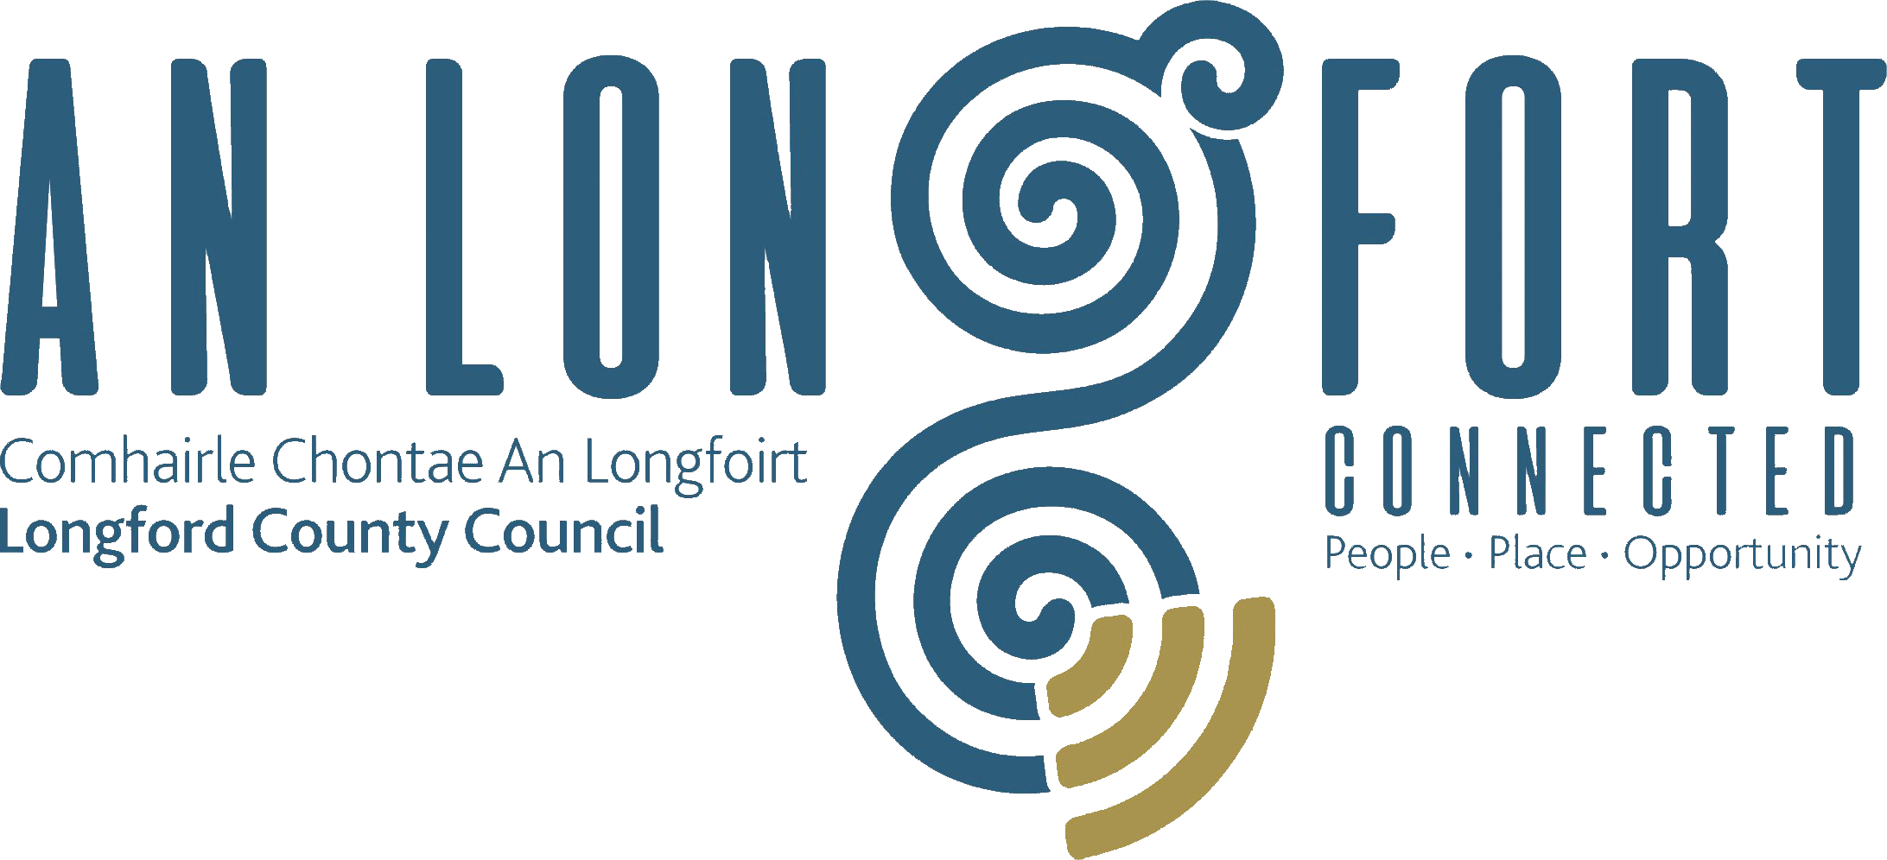

**GOVERNANCE STRATEGIC POLICY COMMITTEE**

**Minutes of Governance Strategic Policy Committee Meeting**

**held via Microsoft Teams on Tuesday**

**18 October at 3pm**

**PRESIDING**: Councillor PJ Reilly, Chairperson

**PRESENT**: Councillors – Seamus Butler, Colin Dalton and

Mick Cahill

Pamela Martin

**APOLOGIES:** Councillor John Browne

Paula Lloyd and Teresa Kearney

**IN ATTENDANCE:**  Fema Farrell, A/Director of Services/Head of Finance

Danny Lynch, Head of Information Systems

Christine Collins, Broadband & Digital Officer

Aoife Kavanagh, Administrative Officer

**MEETINGS**

**ADMINISTRATOR**: Ann Marie Mc Keon

**ADOPTION OF MINUTES – circulated**

On the proposal of Councillor Seamus Butler, seconded by Councillor Mick Cahill, it was agreed to adopt the minutes of the Governance Strategic Policy Committee meeting held on the 19 July 2022.

**MATTERS ARISING FROM MINUTES**

Councillor Seamus Butler requested an update on the Twinning Policy, the meetings administrator confirmed that it would be on the agenda for the November/December CPG and monthly meeting of Longford County Council.

**DECLARATION OF INTERESTS**

None.

**LONGFORD DIGITAL STRATEGY 2021 TO 2023 UPDATE**

Head of IT Systems, Danny Lynch and Broadband & Digital Officer, Christine Collins introduced themselves to the members and provided an update on the 2021 to 2023 Strategy as follows:

* Strategy Pillars
* Infrastructure and Connectivity
* Smart Communities
* Digital Economy and Enterprise
* Digital Transformation
* Work completed
* Networking
* Areas identified – Computer Science as a leaving certificate option
* Going forward
* Community initiatives
* Working relationship with industry and schools

The members welcomed the update and noted how excited they were on the school initiative project and remarked on the lead that the council has taken in identifying this need and reaching out to the industries in the surrounding areas to request their assistance with the project. The members stated that they looked forward to the next update.

**UPDATE ON RISK REGISTER**

Aoife Kavanagh, A/Financial Management Accounting provided a presentation to the members on the Risk Register process. The presentation included the following:

1. Introduction
2. Overview of the Corporate Risk Register
   1. Each corporate objective from the Corporate Plan considered
   2. Used guidance from IPB and information gathered with discussions with each Senior Officer as well as each Director and the Chief Executive.
   3. Articulated a high-level corporate risk and associated controls.
   4. Controls – considered the service Delivery Plans and discussions with Senior Officer Group on the operational risk registers.
   5. Some Corporate Plan objectives were grouped to avoid duplication and reduce the number of corporate risks.
   6. A risk rating agreed for each risk/control combination.
3. Corporate risk register summary
   1. A breakdown of the objectives from the Corporate Plan which included the risk category, risk likelihood, impact and rating.
4. Next steps- To review and update.

On completion of the presentation a discussion took place between the members and Aoife. Aoife responded to question from the members. The members welcomed the presentation delivered by Aoife.

**DATE OF NEXT MEETING**

On the proposal of Councillor Colin Dalton, seconded by Councillor Seamus Butler, the members unanimously agreed the dates of the 2023 meetings.

This concluded the business of the meeting.

**Signed: ___________________________**

**Meetings Administrator,**

**Ann Marie Mc Keon.**

**Confirmed and adopted at the Governance Strategic Policy Committee Meeting held on the 31 January 2023.**

**Signed: _______________**

**Chairperson.**