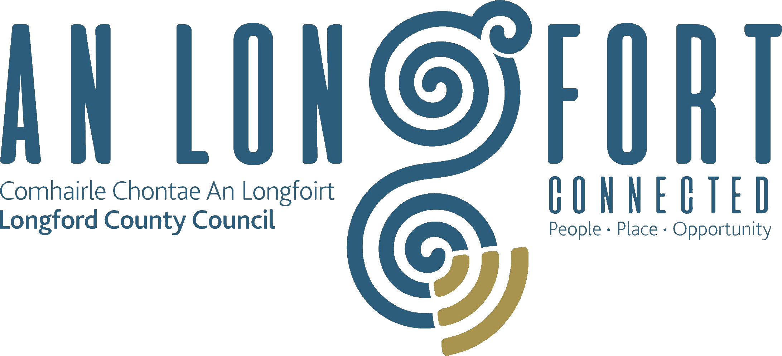

PLACEMAKING
STRATEGIC POLICY COMMITTEE

Minutes of Placemaking Strategic Policy Committee Meeting
held via Microsoft Teams on Monday, 1st February 2021 at 3.00 p.m.

PRESIDING: Councillor Paul Ross, A/Chairperson.

PRESENT: Councillors – Martin Monaghan and P.J. Reilly.
Louise Lovett, Breda Murphy, Niamh Donlon and Matt Farrell.

APOLOGIES : Councillor Colm Murray
Councillor Gerard Farrell
Vincent Fay

IN ATTENDANCE: Ms. Barbara Heslin, Director of Services.
Mr. Michael Nevin, Head of Enterprise.
Ms. Nora O’Farrell, Senior Executive Officer.
Ms. Ciaran Murphy, Senior Executive Officer.
Mr. Terry Rooney, Senior Executive Officer.
Mr. Daniel Lynch, Head of Information Systems.
Ms. Dympna Reilly, Tourism Officer.
Mr. Frank Horne, Senior Staff Officer.
Ms. Christine Collins, Broadband Officer.
Ms. Ann Marie Mc Keon Administrative Officer.

MEETINGS
ADMINISTRATOR: Anne Lee.

ADOPTION OF MINUTES.

On the proposal of Matt Farrell seconded by Councillor Martin Monaghan, it was unanimously agreed to adopt Minutes of Placemaking Strategic Policy Committee Meeting held on the 19th October 2020, as circulated.
MATTERS ARISING FROM MINUTES.

None

DECLARATION OF INTERESTS.

None

SUPPLEMENTARY STANDING ORDERS – REMOTE MEETINGS - circulated

Supplementary Standing Orders – Remote Meetings – adopted at November meeting of Longford County Council were noted.

LEO PLAN 2021.

Michael Nevin provided an update on the supports being provided to businesses, response to COVID-19 and the 2021 LEO plan. He replied to queries raised by the members. The priorities are-

- To continue to provide training and mentoring supports to small business owners that will help them to meet impending challenges and to develop more efficient and productive enterprises.
- To continue to help small firms to integrate digital platforms into their everyday business operations helping them to compete for business in larger and more regional markets.
- To continue to work with schools in creating an awareness and an appreciation of the value of entrepreneurs as wealth creators in our local economy
- To continue to support the development of business networks that will help to create possible synergies or partnerships and/or opportunities to become part of new business value chains
- To continue to work with internal and external stakeholders interested in promoting County Longford as a viable business location and to ensure that all parties that express an interest in investing in Longford are given the highest priority.
- To continue to educate the small firms’ sector on the growing importance of environmentally sustainable business practices and to help them meet their obligations in this regard by ensuring they are aware of all the potential supports available to them
- To continue to roll-out existing and new supports designed specifically as COVID-19 supports to the micro-enterprise sector
- To continue to explore the development of a portfolio of units and serviced landbanks both private and local authority owned that can help to attract and satisfy the needs of potential investors or developers
- To continue to support those firms impacted by Brexit by helping them to address the technical, administrative, logistical and market challenges posed by the new trading relationship with Britain
- To continue to work with other internal stakeholders on the production of digital and non-digital materials that highlight the business supports available thought the offices of Longford County Council and the Longford LEO office.
- To continue to support the work of County and Regional Committees working on different cooperation projects designed to bring increased prosperity to the region/county.
- To continue to support the projects funded under the Just Transition Fund and help those projects to be realised.
- To continue to support the efforts of different communities to develop viable workspaces such as digital hubs as a means of both attracting new enterprises and jobs into the county and facilitating remote working for the many commuters who leave the County to work each day.
- To continue to deliver specific supports designed to encourage the occupancy of vacant industrial units and the physical improvement of shop fronts in our main urban centres
- To continue to act as a First Stop Shop offering information, advice and guidance to anyone connected with an existing small enterprise or interested in establishing a new enterprise in County Longford
- To support communities and groups in the development and delivery of economic and enterprise projects such as the digital hub in Edgeworthstown and food hub in Lanesboro.
- To work with the Finance section on the rollout of COVID-19 business and enterprise supports such as the rates waiver scheme.

The work of the LEO office and support provided by Longford County Council to businesses was acknowledged. The team were thanked for the proactive approach taken to supporting businesses during COVID-19. The 2021 plan was agreed.

BUSINESS INCENTIVE SCHEME.

Mr. Michael Nevin outlined the proposed amendment to the Occupation of Vacant Commercial Premises Incentive Scheme for consideration by the Placemaking SPC -

The following amendment to the rules for the above Scheme were proposed and agreed at the Business Incentive Scheme Committee Meeting held on 15th December 2020.

It was proposed that the Scheme, due to expire on 31st December 2020, be extended for another year but only for applications for new industrial/manufacturing type businesses offering additional jobs.

An industrial expansion may also be deemed eligible if it moves to a larger unit and results in additional new jobs.

Terms and conditions of the scheme to be amended accordingly subject to its adoption by the members of Longford County Council.

On the proposal of Councillor PJ Reilly seconded by Councillor Martin Monaghan, it was unanimously agreed to accept the proposed amendment to the Occupation of Vacant Commercial Premises Incentive Scheme. The proposed amendment will now be forwarded to the full Council for final approval.

Michael confirmed that the Shop Front Scheme will continue for 2021. It was agreed that information on this scheme be circulated to the members and publicised on social media. This scheme will complement the work being carried out by local tidy towns committees.
COMMUNITY DIGITAL PROJECTS.

Mr. Daniel Lynch and Ms. Christine Collins gave a detailed update on the Community Digital Projects and replied to queries raised: -
- There are areas in Ireland with the fastest and slowest Broadband Speeds
- The slowest Broadband area is Legan in Longford.
- The BCP will provide high speed broadband access to communities that don’t have it in the amber area of the NPB, in advance of homes and businesses receiving future proofed broadband to their doors”
- As in other communities, bringing this initiative to fruition has taken a lot of hard work and dedication by many people from various groups and organisations, and community buy in.
- “We have to sell this and one of the advantageous is that people who returned to Longford because of COVID-19 restrictions, etc., are now able to find fast and efficient internet locally, so they can carry out their work from home”
- Greater accessibility, greater focus and massive opportunity
- Digital Strategy 2020 – 2023
- Consultations and Engagement
- Strategy Pillars
- Infrastructure and Connectivity
- Longford NBI Design Map and BCP Network
- Smart Communities
- Digital Economy and Enterprise
- Digital Transformation
- Implementation to date
Broadband connection points
WiFi4EU Project
Eduroam
Map Alerter
Remote Working
Grow Remote
www.longford.ie
Accessibility Software for websites

Michael Nevin Head of Local Enterprise highlighted the importance of having reliable and affordable Broadband in Longford to facilitate businesses. He emphasised the importance of fibre connections. He raised the cost of connections to digital hubs and commercial enterprises and said this could impact on future sustainable economic development. Michael also said that the LEO continue to engage with businesses and outlined some of the supports being provided including Trading Online Vouchers.

TOURISM STRATEGY UPDATE.

Mr Michael Nevin updated the Committee on the Tourism Strategy and provided an outline of the priority areas for 2021. He also replied to queries raised.

- Continue to market the Longford Tourism brand and generate greater awareness of County Longford as a Tourism destination.
- Continue to support the development of tourism products to increase County Longford’s attractiveness and to deliver high quality visitor experiences.
- Continue to collaborate on a Regional basis with key partners who can help to improve tourism infrastructure, products and experiences.
- Continue to work with local businesses on the ground, other council departments and community groups to ensure that the tourism sector receives the best support possible.
- Continue to work with the County Longford Tourism committee on implementation of the County Longford Tourism Strategy (2017 – 2022).
- Continue to communicate with our key target audiences through the various media, both on-line and off-line with emphasis on our new website www.longford.ie
- Continue to work with key stakeholders to ensure the new website content is kept up to date. It is planned that the new website will be launched in Quarter 1.
- Continue the development of walking brochures and itineraries.
- Continue to support tourism businesses through COVID-19.

Michael also alerted the members to the new funding scheme announced by Failte Ireland.

Matt Farrell referenced the new Maria Edgeworth project involving links with universities and the possible location of digitised materials in Edgeworthstown.

The work of the Tourism office and support provided by Longford County Council to businesses was acknowledged. The 2021 plan was agreed.

DIASPORA STRATEGY UPDATE. 2019-2023.

Update provided by Michael Nevin -
- Planned events for 2020 were impacted by COVID-19.
- Virtual STEM jobs event being planned for March to provide information on remote jobs available, local infrastructure to support remote working, etc.
- Digital Hubs in Edgeworthstown, Ballymahon, Abbeyshrule and possibly Granard could materialise in 2021/22.

INTEGRATION STRATEGY UPDATE.

Ciaran Murphy gave a detailed update and replied to questions raised by the members: -
- 14.7% of County Longford’s population classified as non-national in the 2016 Census compared with 11.6% nationally
- Immigration can help fuel economic growth, fulfil demand for labour, encourage cultural and social diversity, promote innovation and encourage diversity of ideas.
- County Longford has a multi-cultural society, and it is important that all ends of that cultural spectrum can live together in a state of harmony and respect. The native population in County Longford has been broadly welcoming of new communities. This general acceptance of immigrants enhances our image as a County and conveys a message of openness and tolerance which should encourage higher levels of outside investment and inward tourism.
- Resources need to be better targeted at areas where needs are greatest.
- Longford needs to arrive at a position where it can proudly celebrate its Traveller or non-ethnic cultures as adding value to our community.
- Plans for 2021 include
  - Expand grants
  - Update 2018 plan
  - Longford Sports Partnership development worker
  - Building capacity to assist engagement
  - Support volunteers.

Impact of COVID-19 on new communities was considered by the members and the need for translation services and the important role of the intercultural network. Ciaran is to seek information on the take up of English language courses provided by LWETB in Longford.

Many Challenges
- Education – Language, cultural differences
- Employment – Lack of opportunities, transport, childcare
- Health – GP’s at capacity
- Housing – Private rental market is at capacity, limited availability of Social Housing
- Community engagement

Actions/Impact to date
- Longford County Council ringfenced intercultural funding for Groups
- Longford County Council arranged training for frontline staff
- More engagement, new groups emerging
- Intercultural Forum hosted by the PPN and Longford County Council/quarterly meetings. (African, Polish, Asian, Pakistan, Philippine)
- Longford County Council and the PPN supporting groups to access a variety of funding schemes e.g. Africa Day
- LCC supports employment of Development workers by FAI/GAA and IRFU to support participation by disadvantaged communities including non-national.
- Increased participation in cultural & sporting activities.
- SICAP – targeting new communities.

Key Actions to Date
- Seek the appointment of an Integration Officer to build an integrated information and service delivery framework accessible to all communities. Previous applications for funding have been unsuccessful.
- Enable and expand the use of libraries as a place for community information and volunteers to support people to complete documentation outside conventional office hours
- Generate an online integration resource, for access to information about living, learning and language, work and wellbeing in Longford
- Support and reinforce community policing
- Promote and support the translation of essential integration documents into Lithuanian, Latvian, Brazilian Portuguese, Urdu and Arabic
- Promote, and encourage community engagement and representation.

The work of Community Development and support provided by Longford County Council to new communities was acknowledged. The 2021 plan was agreed.

PLAYGROUND DEVELOPMENT AND REFURBISHMENT PLANS.

Update provided by Frank Horne and Frank replied to the queries raised: -
- 24 sites developed in Longford – LCC working with Local Community Groups
- Physical activity – zip lines huge success
- Each Municipal District, in rotation, is provided with funding for the provision of new or refurbishment of existing playgrounds. 2021 will focus on works in Ballymahon MD
- Department funding is now focused on the upgrade and refurbishment of playgrounds
- External Health and Safety Audit of all playgrounds – included in the schedule of works
- Technical employees do a visual inspection once a week
- Increased accessibility of playgrounds for children with disabilities
- Quiet area for children with autism
- Support given to Sensory Garden in Ballinalee
- Insurance cover for playgrounds
- Green Gym in Mall – replacement programme. Also planned for Edgeworthstown and Aughnacliffe.
- Secured CLAR funding for playgrounds
- Move to separate green gyms and playgrounds
- Based on the agreed rotational work programme, the next refurbishment project is for Ballymahon Municipal District

The delivery of new and refurbishment of existing playgrounds was acknowledged. The proposed schedule of works was agreed for 2021 with an emphasis on refurbishment, future proofing and improving accessibility.

LEADER UPDATE.

Ciaran Murphy provided an update and replies to the members questions: -
- Extension to scheme
- 2020 entire budget allocated
- 120 projects approved €5.7 million
- €2 million paid out
- Extension to 31st March 2021
- Can be reallocated by 2022
- Transitional programme to commence 1st April – minimum aid 75%
- CAP Regulations not agreed yet
- New LEADER Programme won’t commence until 2023

Ciaran confirmed that allowance will be made for projects impacted by COVID-19
SCHEDULE OF MEETINGS FOR 2021-
- 19th April
- 19th July
- 18th October

N4 Mullingar to Roosky – Public Consultation.
Councillor Paul Ross informed the members that the N4 Mullingar to Roosky project is currently open for public consultation.

NEXT MEETING.

19th April 2021.

This concluded the business of the meeting.
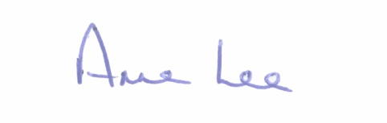

Signed: _______________
Anne Lee,
Meetings Administrator.

Confirmed and adopted at Placemaking Strategic Policy Committee Meeting held on the 22nd April 2021.

Signed: _______________
Chairperson.

