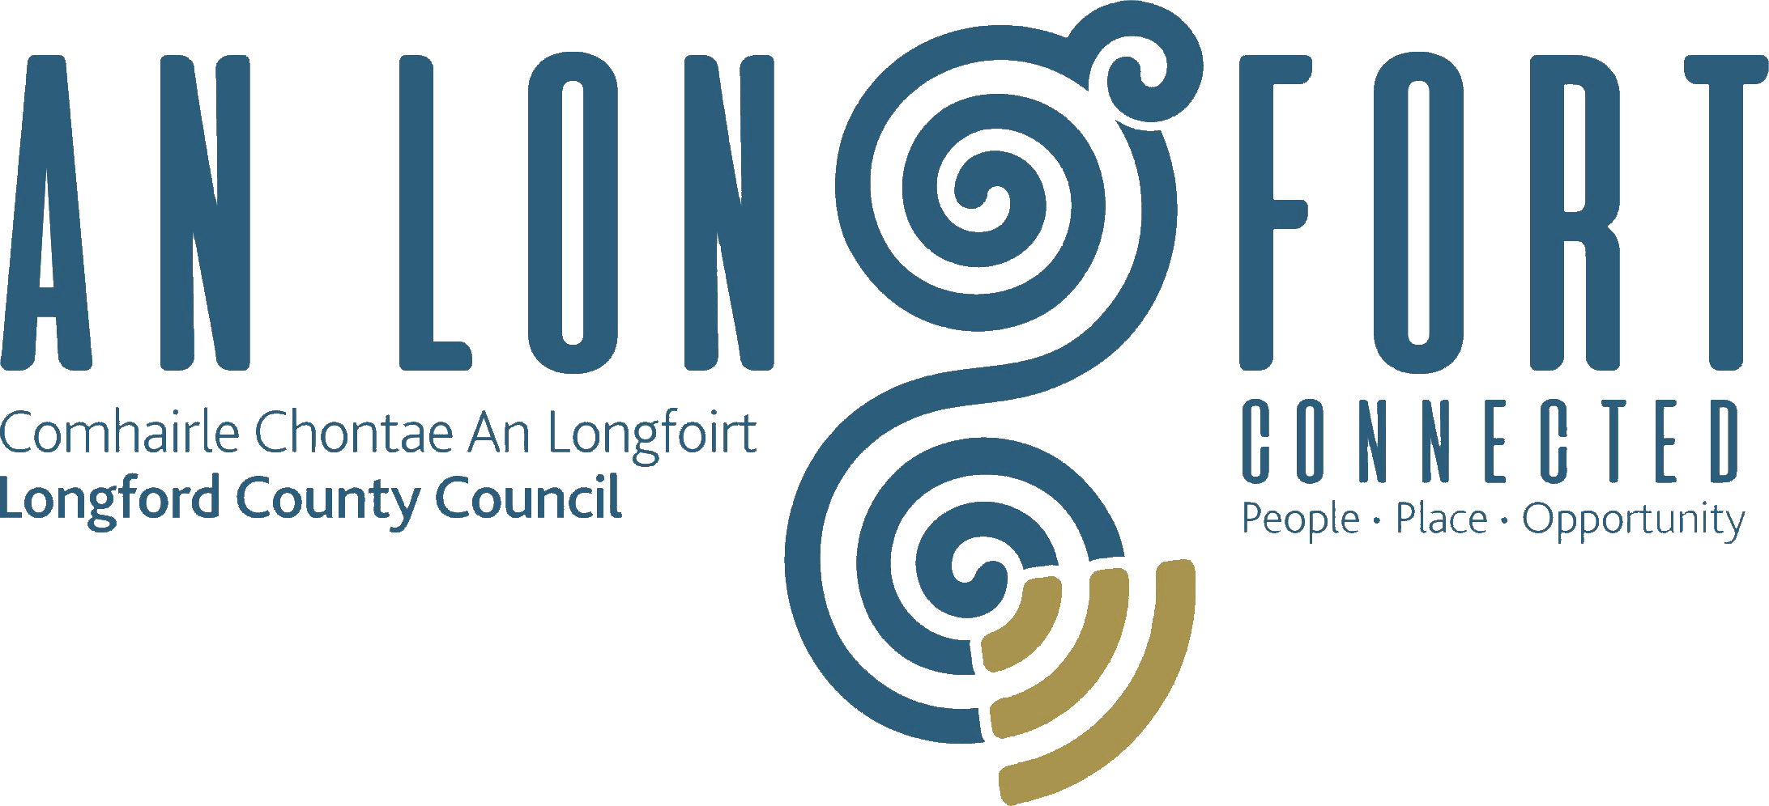

PLACEMAKING
STRATEGIC POLICY COMMITTEE

Minutes of Placemaking Strategic Policy Committee Meeting
held in the Council Chamber, Aras an Chontae,
Great Water Street, Longford on Monday 27th January 2020 at 4.30 p.m.

PRESIDING: Councillor Colm Murray, Chairperson.

PRESENT: Councillor P.J. Reilly.
Ms. Breda Murphy and Mr. Matt Farrell.

APOLOGIES Councillors – Martin Monaghan, Gerard Farrell and Paul Ross.
Ms. Louise Lovett and Ms. Niamh Donlon.

IN ATTENDANCE: Ms. Barbara Heslin, Director of Services.
Mr. Michael Nevin, Head of Enterprise.
Ms. Mary Carleton-Reynolds, County Librarian.
Mr. Terry Rooney, Senior Executive Officer.
Ms. Nora O’Farrell, Senior Executive Officer.
Ms. Ciaran Murphy, Senior Executive Officer.

MEETINGS
ADMINISTRATOR: Anne Lee.

INTRODUCTION.

Councillor Murray welcomed the members to the inaugural Placemaking Strategic Policy Committee Meeting. Councillor Murray confirmed that there is still one outstanding member to be appointed to the Committee representing Business/Commercial Sector.

The members present introduced themselves.

DECLARATION OF INTERESTS

None.

STANDING ORDERS.

On the proposal of Councillor P.J. Reilly seconded by Ms. Breda Murphy, it was agreed to adopt Standing Orders, as circulated.

BRIEFING ON SERVICE DELIVERY AREAS.

Briefings were provided on the following Service Delivery Areas -

- Library, Heritage and Archives - Mary Carleton Reynolds.

- Local Enterprise Office - Michael Nevin.

- Corporate Services - Nora O’Farrell

- Regeneration Programme - Terry Rooney

- Community and Enterprise - Ciaran Murphy.

Barbara Heslin stated that the Placemaking Strategic Policy Committee will focus attention on the development of policy in the areas listed above, which when considered and agreed by the SPC will be forwarded to the County Council for approval.
Barbara suggested that if any of the members of the SPC wish to recommend any areas which they consider the SPC should review, that they email the Chairperson or Meetings Administrator.

REVIEW OF BUSINESS INCENTIVE SCHEME.

The following amendment to the Business Incentive Scheme was agreed and will be forwarded to Longford County Council for approval –

“That an industrial or retail expansion may be deemed eligible if it moves to a larger unit and results in increased job numbers.”

NEXT MEETING.

27th April 2020.

This concluded the business of the meeting.
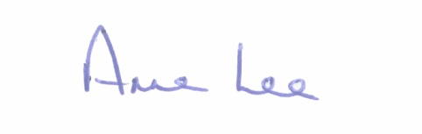

Signed: _______________
Anne Lee,
Meetings Administrator.

Confirmed and adopted at Strategic Policy Committee Meeting held on the
27th July 2020.

Signed: _______________
Chairperson.

