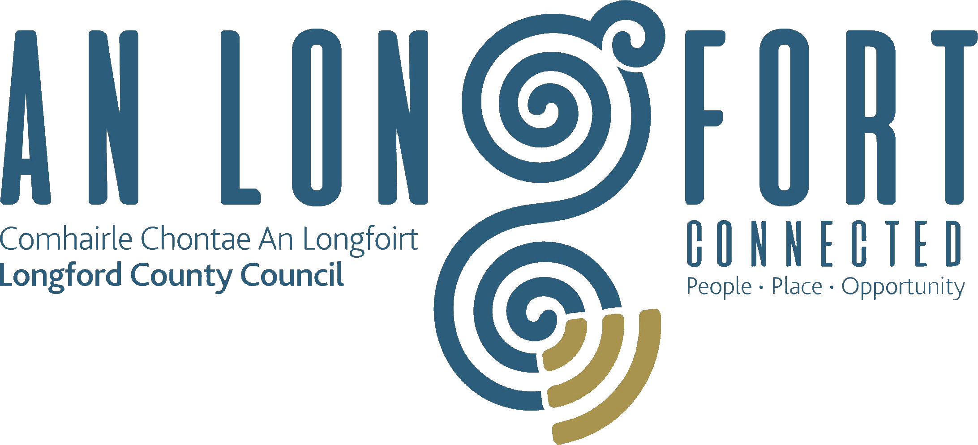

PLACEMAKING
STRATEGIC POLICY COMMITTEE

Minutes of Placemaking Strategic Policy Committee Meeting
held in Longford Rugby Club, Demesne, Longford,
on Monday, 27th July2020 at 3.00 p.m.

PRESIDING: Councillor Gerard Farrell, Chairperson.

PRESENT: Councillors – Martin Monaghan, Colm Murray,
P.J. Reilly and Paul Ross.
Niamh Donlon, Louise Lovett and Matt Farrell.

APOLOGIES : Breda Murphy and Vincent Fay.
Terry Rooney, Senior Executive Officer.

IN ATTENDANCE: Ms. Barbara Heslin, Director of Services.
Mr. Michael Nevin, Head of Enterprise.
Ms. Mary Carleton-Reynolds, County Librarian.
Ms. Nora O’Farrell, Senior Executive Officer.
Ms. Ciaran Murphy, Senior Executive Officer.

Ms. Sarah Morgan, Planning Policy & Research Officer,
Laois | Longford | Offaly | Westmeath

MEETINGS
ADMINISTRATOR: Anne Lee.

ADOPTION OF MINUTES.

On the proposal of Councillor P.J. Reilly seconded by Councillor C. Murray, it was unanimously agreed to adopt Minutes of Placemaking Strategic Policy Committee Meeting held on the 27th January 2020, as circulated.
MATTERS ARISING FROM MINUTES.

None.

DECLARATION OF INTERESTS

None.

UPDATE ON JUST TRANSITION.

Sarah Morgan gave a comprehensive update on the Midlands Just Transition – copy of presentation attached to Minutes.

Sarah replied to queries raised on the following issues –

- Just Transition Fund Stage 1 and Stage 2.
- 1st Progress Report issued by the Just Transition Commissioner.
- Progress to date.

In response to a query regarding the Midlands Regional Transition Team, Sarah confirmed that a meeting of the Restructured Midlands Regional Transition Team (comprising Chief Executives and Cathaoirligh of the relevant Local Authorities.) is scheduled for
7th September.

Councillor Paul Ross asked for an update on the current funding applications and queried the opportunities for funding in the future. Sarah confirmed that announcements on the 2020 Just Transition applications were expected in September and that future National and European funding opportunities could arise. Councillor Paul Ross emphasised the importance of communities directly impacted by the closure of the power station and loss of Bord na Mona jobs be prioritised for funding allocations.

Councillor Gerard Farrell welcomed the recommendation of the Just Transition Commissioner regarding further opportunities for the power stations in Lanesboro and Shannonbridge. He also suggested that the working groups and steering group membership be reflective of the communities impacted.

The Committee recognised the work of the Council is supporting, developing and submitting projects for the Just Transition Fund.

LOCAL ENTERPRISE OFFICE – COVID-19 RESPONSE AND SUPPORTS FOR BUSINESS.

M. Nevin provided an update regarding the Local Authority’s response to COVID-19. He stated that the Local Enterprise Office was identified as a critical essential service with a focus on supporting businesses in adapting to the challenges presented by COVID-19.

Michael listed the supports which the Local Enterprise team continue to provide to local businesses during these challenging times and also gave details regarding projects which he is directly involved in.

Michael stated that details regarding the Restart Grant Plus will be placed on the Council’s website when received from the Department.

Michael referred to the last client satisfaction survey on the performance of LEO offices carried out by the Department, which rated Longford’s LEO satisfaction rating at 96%.

Michael gave details regarding Training provided between 1st April to 9th July this year.

Michael also noted the shop front scheme which is being supported by the LEO office and asked Committee members to promote this scheme.

Councillor Paul Ross complimented Michael and the LEO team on the supports and assistance being provided to businesses during these challenging times.

NOTICE OF MOTION REFERRED FROM LONGFORD MUNICIPAL DISTRICT MEETING HELD ON THE 22ND JANUARY 2020

Business Improvement District

The following Notice of Motion was proposed by Councillor Seamus Butler and seconded by Councillor Martin Monaghan -

“That Longford Municipal District consider introducing a Business Improvement District (BID) in the retail core of Longford Town.”

It was agreed that Councillor Butler’s Motion be referred to the Placemaking Strategic Policy Committee for consideration.

M. Nevin gave a summary regarding the key objectives of the Business Improvement Districts scheme which is to develop and implement a series of new and additional initiatives designed to both further promote and improve the trading environment for the area within the BID boundary in which ratepayers operate their business.
It is also designed to improve the image of towns from a tourist perspective and improve the quality of life for residents and workers in the BID area.
The role of the Local Authority is to facilitate schemes proposed by groups of ratepayers. The Local Authority ensure the scheme is appropriate and collect the money on behalf of the BID Company.
It was agreed that further research be carried out on the BID Scheme and the item be included on the Agenda for the next Placemaking SPC Meeting.

REGENERATION PROGRAMME – URDF (URBAN REGENERATION DEVELOPMENT FUND) AND RRDF (RURAL REGENERATION DEVELOPMENT FUND) PROJECTS AND APPLICATION.

Deferred to next Placemaking SPC Meeting.

CREATIVE IRELAND – LONGFORD PROGRAMME.

Mary Reynolds stated that throughout COVID-19 Pandemic the Local Authority has kept in contact with artists and creatives and with Backstage Theatre and have supported them as much as possible in delivering programmes online and using social media. The Council also highlighted the importance of having an online presence and made them aware of grants available through LEO and the Arts Council.

The focus is on the development of programmes to support wellbeing and mental health. The Council successfully applied for funding for projects including an intergenerational choir project on getting children and their grandparents singing together and will be rolling this project out in the autumn with a primary school, St. Christophers and Longford Older Persons Council.

A very successful Bealtaine Festival was held – the highlight being the Virtual Afternoon Tea Dance in Thomond Lodge in Ballymahon.

The annual Cruinniu na nÓg Festival took place online in June.

The Still Voices Film Festival will go ahead online this year in August with over 150 films being featured.

It is hoped that The Midlands Busking Festival will take place in Longford town on the
15th August.

Heritage Week this year will take place from 15th-23rd August with a very exciting and full programme.

Funding has been secured to support professional development for artists and creative businesses.

The Centenary programme will focus on schools to emphasise our history, heritage and create a sense of place. The month of November has been designated as History Month with particular emphasis on Longford Decade of Centenaries. Longford was one of the counties with the most intense activity in the War of Independence, especially in 1920-21.

Mary stated that most of the planned annual programme is now going ahead online although many of the annual festivals had to be cancelled.

COMMUNITY DEVELOPMENT – LEADER PROGRAMME, COMMUNITY SUPPORT GRANTS AND COMMUNITY ENHANCEMENT PROGRAMME.

Ciaran Murphy gave details on the following Programmes and replied to queries raised –

- LEADER Rural Development Programme 2014-2020.
- Community Support Grants
- Community Enhancement Programme.

In response to a query by Councillor PJ Reilly, Ciaran confirmed that people and organisations can contact LCRL in relation to LEADER funding if they have an idea for a project. He also confirmed that we are awaiting details of the new LEADER programme.

In response to a query by Matt Farrell in relation to financial support for Community Groups, C. Murphy clarified that funding is not allocated for operational costs under these schemes.

L. Lovett spoke regarding the COVID-19 Stability Fund administered by Pobal on behalf of the Department of Rural and Community Development.

Shop Signage – Matt Farrell.

M. Farrell emphasised the need for consistency for signage on Shop Fronts.

It was agreed that this issue be referred to the Strategic Infrastructure Strategic Policy Committee for consideration.

Casual Trading Licences – Councillor P. Ross.

The meeting was informed that the regulation of Casual Trading Licences is ongoing in the Local Authority.

NEXT MEETING.

19th October 2020.

This concluded the business of the meeting.
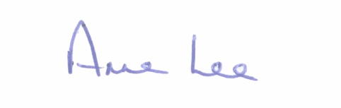

Signed: _______________
Anne Lee,
Meetings Administrator.

Confirmed and adopted at Strategic Policy Committee Meeting held on the
19th October 2020.

Signed: _______________
Chairperson.

