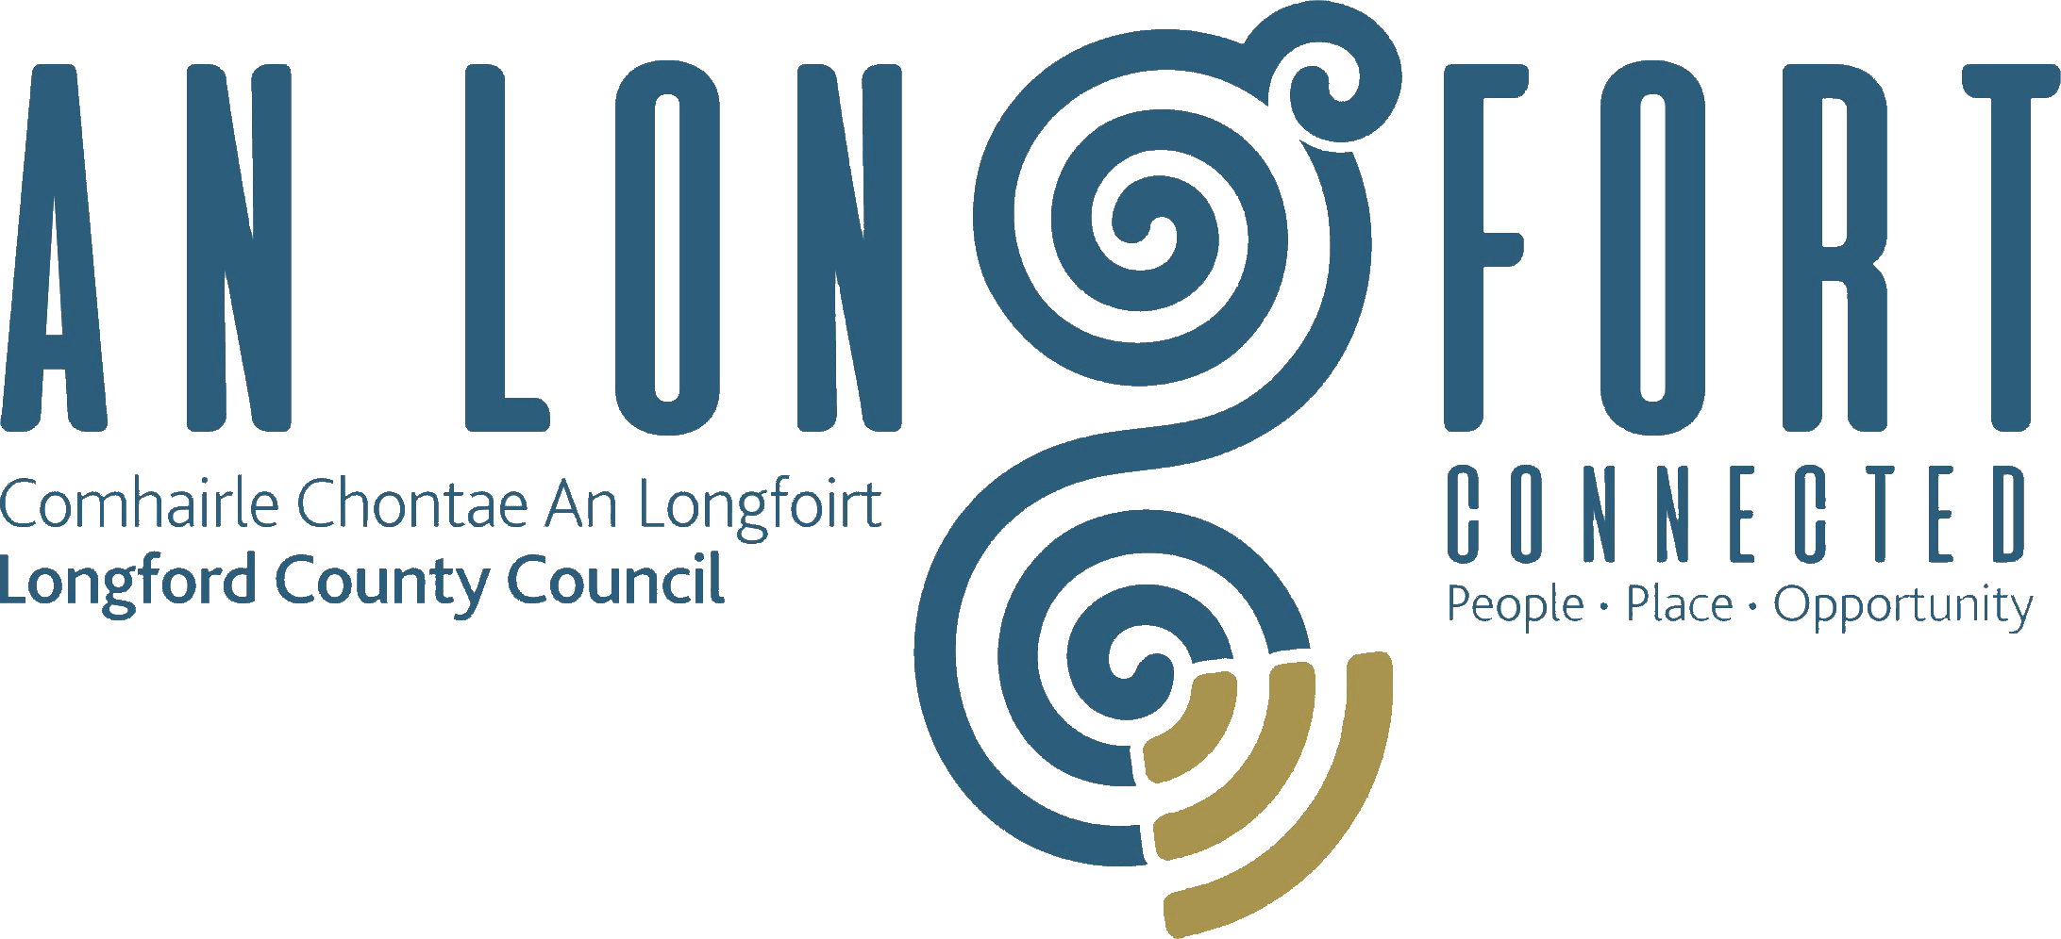

PLACEMAKING
STRATEGIC POLICY COMMITTEE

Minutes of Placemaking Strategic Policy Committee Meeting
held via Microsoft Teams on Thursday 22nd April 2021 3.45 p.m.

PRESIDING: Councillor Gerard Farrell Chairperson.

PRESENT: Councillors – Colm Murray and Paul Ross, Breda Murphy, Niamh Donlon, Vincent Fay and Matt Farrell.

APOLOGIES : Louise Lovett,

IN ATTENDANCE: Ms. Barbara Heslin, Director of Services
Ms. Nora O’Farrell, Senior Executive Officer
Ms. Mary Reynolds, County Librarian
Mr. Michael Nevin, Head of Enterprise
Mr. Terry Rooney, Senior Executive Officer

MEETINGS
ADMINISTRATOR: Claire McNabola (Acting)

ADOPTION OF MINUTES.

On the proposal of Councillor Paul Ross seconded by Michael Nevin, it was unanimously agreed to adopt Minutes of Placemaking Strategic Policy Committee Meeting held on the 1st February 2021, as circulated.
MATTERS ARISING FROM MINUTES.

Councillor Paul Ross asked Michael Nevin if any further plans had been made in relation to the Ballymahon Hub.

Michael Nevin said the planning was in the very early stages. Michael also confirmed that work is ongoing in relation to the issues being experienced by hubs in the provision of Broadband.

DECLARATION OF INTERESTS.

None

PROVISION OF WATER FILLING STATIONS

Barbara Heslin gave the Committee Members a high-level overview of the research which she had done on the Provision of Water Filling Stations. The research provided an overview of
- Approach taken by the Local Authorities
- The lead Department in the Local Authority - Environment in each case
- Locations
- Costs associated with the initiative – including cost of the unit, installation, connection costs, and maintenance
- Funding including Healthy Ireland, Municipal District allocations and central funding
- Infrastructure required – power and water connections
- Issues experienced
- Reviews carried out

Contact was also made with Westmeath County Council who are looking at provision of Water Filling Station in 8 Schools across the County, Mullingar Library and the Swimming Pool. Westmeath County Council are also looking at the Belvedere Park as a suitable location.

Barbara also noted that the Programme for Government undertakes to develop a scheme between local Authorities and Irish Water to provide drinking water fountains nationwide to reduce plastic bottle litter. No further details in relation to this initiative is available.

Barbara answered any questions raised by the Committee Members.

Feedback from the members suggested that there was not a general demand for such an initiative outside of the Longford town area.

On the proposal of Councillor Paul Ross and seconded by Councillor Colm Murray it was agreed to proceed as follows:

- To look at the possibility of funding a pilot in the Albert Reynolds Peace Park through Healthy Ireland. If the application is not successful to put the project on hold for 2021 and review again next year.
- For the Environmental Section of Longford County Council to identify the current water fountains across the County, how many/locations/level of usage, etc and look at ways of promoting the infrastructure that’s already in place

NEXT MEETING

19th July 2021

OUTDOOR DINING

Michael Nevin provided Committee Members with an overview of recently announced Outdoor Dining Scheme. The scheme will be administered through the Local Authority in each County and has 2 strands:

- Grants available for tourism and hospitality businesses
- Funding for Local Authorities to develop permanent long-term outdoor facilities

The Outdoor Dining Enhancement Scheme comprises two parts and will be delivered in partnership between Fáilte Ireland and Local Authorities across the country. Part One of the Scheme will provide funding for individual tourism and hospitality businesses to develop and increase their own outdoor seating capacity. Funding allocated under Part Two will enable Local Authorities to develop permanent outdoor public dining spaces in towns and urban centres, similar to those that exist in various European cities.

RRDF

Barbara Heslin said that Longford County Council is delighted to welcome the confirmation of €5,991,916 in funding for the Ballymahon ‘Pobal le Chéile’ project announced by Minister for Rural and Community Development, Heather Humphreys TD under the Rural Regeneration and Development Fund. Barbara highlighted the success as a credit to the work of the Regeneration Team and the collaboration between Longford County Council and the Ballymahon Town Team in developing the vision for the project and making the successful application for funding.

This concluded the business of the meeting.

Claire Mc Nabola
Signed: _______________
Claire McNabola
A/Meetings Administrator.

Confirmed and adopted at Strategic Policy Committee Meeting held on the
19th July 2021

Gerard Farrell
Signed: _______________
Chairperson.

