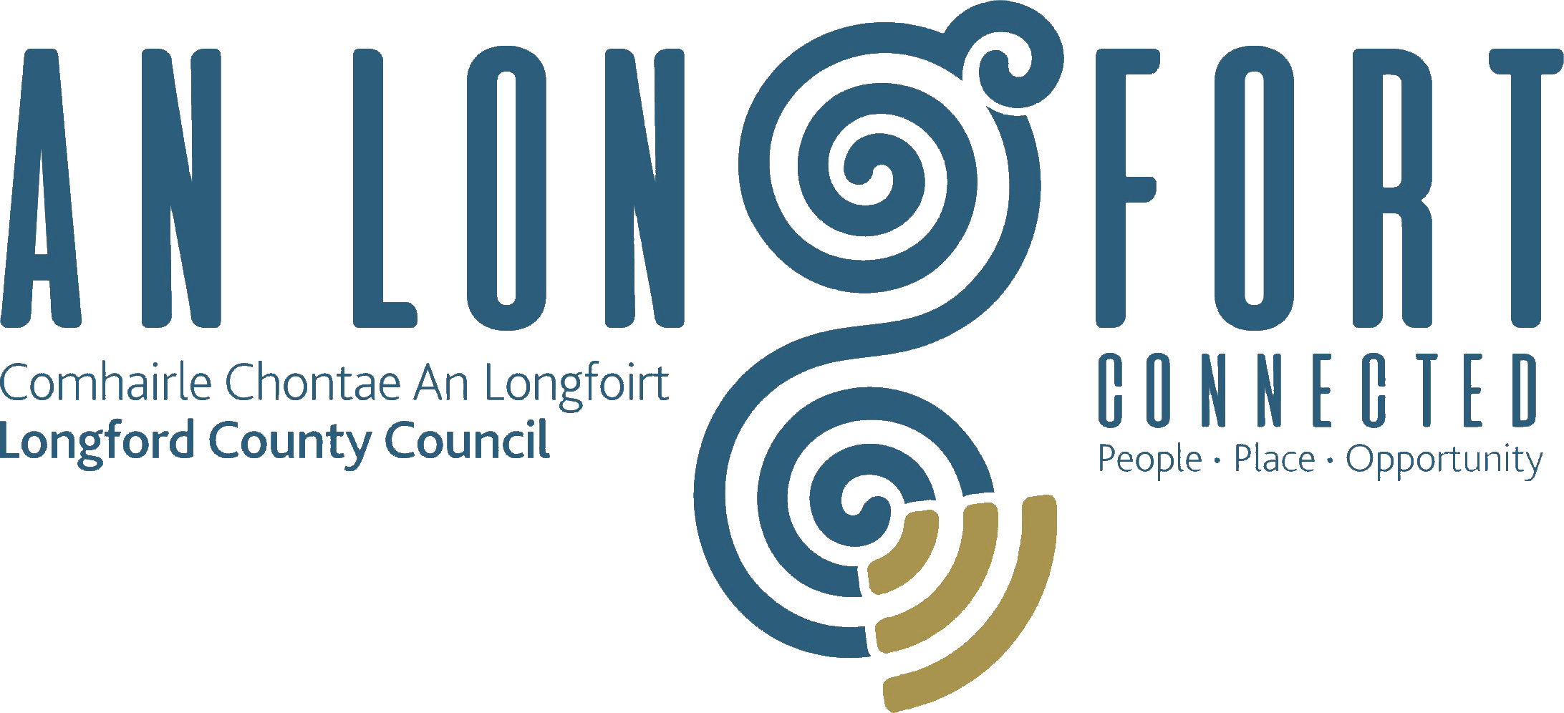

PLACEMAKING
STRATEGIC POLICY COMMITTEE

Minutes of Placemaking Strategic Policy Committee Meeting
held via Microsoft Teams on 4 April 2022 3pm

PRESIDING: Councillor Gerard Farrell Chairperson

PRESENT: Councillors – Colm Murray, Martin Monaghan, PJ Reilly and Paul Ross,
Matt Farrell, Breda Murphy, Niamh Donlon, Vincent Fay,

APOLOGIES : Louise Lovett.

IN ATTENDANCE: Ms. Barbara Heslin, Director of Services.
Mr. Michael Nevin, Head of Local Enterprise.
Mr. Ciaran Murphy, Senior Executive Officer.
Mr. Gerard Brady Head of National Policy and
Chief Economist, Ibec.

A/MEETINGS
ADMINISTRATOR: Gerard Dennigan

ADOPTION OF MINUTES.

On the proposal of Councillor PJ Reilly seconded by Michael Nevin, it was unanimously agreed to adopt Minutes of Placemaking Strategic Policy Committee Meeting held on the
31 January 2022 as circulated.

MATTERS ARISING FROM MINUTES.

None.

DECLARATION OF INTERESTS.

None.

PRESENTATION BY GERARD BRADY HEAD OF NATIONAL POLICY AND CHIEF ECONOMIST IBEC

Gerard Brady Head of National Policy and Chief Economist delivered an informative presentation to the members on the economic environment challenges and opportunities facing Longford County Council as it prepares its new Local Economic and Community Plan. The presentation included information on the following:

- We know the weakness, but progress is being made
  - Big investments in the county such as Abbotts, Panelto, Center Parcs, Framespace.
  - Some great examples of entrepreneurship in the county
  - Big improvements in Public realm, Royal Canal Greenway, various forests walks.
- The Macro Context
  - Identified 8 and focused on 4 big trends: Placemaking, Globalisation, Skills and Industry and the low carbon transition.
- Placemaking
  - Better lives better business
  - Attract and retain talent
  - Hard local infrastructure
  - Direct opportunities in the economy of placemaking
- Skills and Industry
  - A rapid improvement in IDA investment since 2017
  - Fastest growing of all small counties
  - 3rd of peers in 5-year growth
  - An opportunity exists to build on the reputational, skills and knowledge sharing advantages
  - Longford LEO continues to be the LEO with the best coverage in the country
- Opportunities in low carbon transition
  - Huge opportunities for the Midlands and Longford from the low carbon transition
  - Longford has a strong competency in construction, engineering and related supply chain
- Longford place in the global supply chain
  - Coming decades will see increased localisation, supply chain diversification and near-shoring
  - Regions need to address value prop to the global supply chain ‘why here’ in this context and focus on smart specialisation
- Five takeaways
  - Progress since 2016 has been very strong
  - The outside environment is challenging
  - Exports don’t just have to leave the place, they can be people coming to places too
  - Changing institutional landscape is an opportunity
  - We can’t be good at everything so smart specialisation is important

On completion of the presentation to the members, Chairperson Councillor Gerard Farrell thanked Gerard Brady for delivering a very positive presentation, which identified many opportunities in the county.

Michael Nevin outlined to the meeting that in line with the current day to day challenges that all encouragement isn’t gone away. Its now time to shift focus towards the opportunities within the county and make further progress.

Gerard Brady responded to Michael with some of the following points:
- Hybrid working will bring investment into the county
- Housing is still a big challenge
- Market the county. Getting 100 people into the county is the same as getting a new company into the county
- Center Parcs is a major positive for the County – has changed the perception of the county

Councillor Martin Monaghan outlined the following points to the members:
- The importance of the completion of the upgrade of the N4 bypass Mullingar to Rooskey
- Longford can be a supply chain for the country
- The importance of securing a third level Education centre in Longford linked to TUS
- Martin acknowledged the work carried out by the Local Enterprise office during Covid-19 and how supports were made available to businesses quickly

Chairperson Councillor Gerard Farrell acknowledged the importance of keeping the N4 upgrade high on the agenda.
Barbara Heslin acknowledged the detailed presentation delivered by Gerard Brady and identified it as a useful base and starting point for the members and outlined the following:
- Preparation for the new LECP
- The importance of identifying and prioritising what we can do in the county
- The large volume of people commuting into the county for work.
- The demand to get more houses built, availability of affordable housing
- The challenges in sourcing land for industry
- The importance of industry and businesses upskilling employees so that they become high earners
- Attracting business into the county and supporting entrepreneurism

REVISED PROPOSAL FOR LOCAL ECONOMIC AND COMMUNITY PLAN (LECP) STEERING ADVISORY GROUP.

Ciaran Murphy briefed the members on the revised proposal circulated and the requirement of the Placemaking Strategic Policy Committee to consider this recommendation for the following Steering Advisory Group of 12 persons.
- 4 members of the LCDC, (Chair Cllr Colm Murray and 3 PPN reps. Grace Kearney, Tara Farrell and Francesca Pawelczyk have been already nominated by the LCDC),
- 2 members of the SPC for Economic Development and Enterprise (Place-making SPC- (Cllr. Martin Monaghan and Niamh Donlon have been already nominated by the SPC),
- the Chief Officer of the LCDC,
- the Director of Service supporting the SPC for Economic Development and Enterprise,
- the Local Enterprise Office,
- 1 nominee from the Business sector - Louis Herterich,
- 1 nominee from the Agric/farming community – Andrew Mc Hugh,
- 1 nominee from the educational sector (third level -AIT)- Michael Tobin

On the proposal of Councillor PJ Reilly seconded by Councillor Colm Murray, it was unanimously agreed to the revised proposal for Local Economic and Community Plan (LEC)Steering Advisory Group.

DATE OF NEXT MEETINGS.
The dates for the meetings in 2022 were noted and agreed by the members.
- Monday 18 July 2022
- Monday 17 October 2022

This concluded the business of the meeting.

Confirmed and adopted at Strategic Policy Committee Meeting held on the
18 July 2022.

Gerard Dennigan
Signed: _______________
Gerard Dennigan
A/Meetings Administrator

Gerard Farrell
Signed: _______________
Chairperson.

