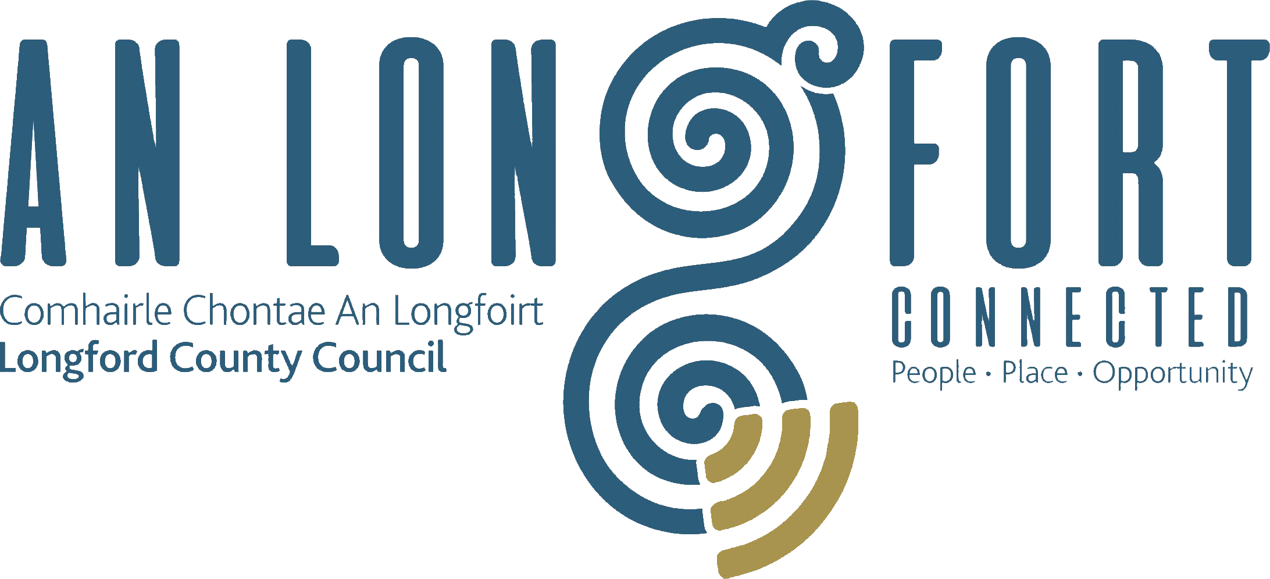

**PLACEMAKING**

**STRATEGIC POLICY COMMITTEE**

**Minutes of Placemaking Strategic Policy Committee Meeting**

**held via Microsoft Teams on 14 December 2022 2pm**

**PRESIDING**: Councillor Paul Ross Chairperson

**PRESENT**: Councillors – Colm Murray

Niamh Donlon, Matt Farrell and Vincent Fay

**APOLOGIES** : Councillors Gerard Farrell, Martin Monaghan and PJ Reilly

Breda Murphy and Louise Lovett

Ms. Martina Needham, Head Librarian

**IN ATTENDANCE:**  Ms. Barbara Heslin, Director of Services

Mr. Ciaran Murphy, Senior Executive Officer

Ms. Paula Mulry, Senior Executive Librarian

Mr. Michael Nevin, A/Director of Services

Ms. Clare Mc Nabola, Senior Staff Office

**MEETINGS**

**ADMINISTRATOR**: Ann Marie Mc Keon

**ADOPTION OF MINUTES**

On the proposal of Councillor Colm Murray seconded by Matt Farrell it was unanimously agreed to adopt Minutes of Placemaking Strategic Policy Committee Meeting held on the 17 October 2022 as circulated.

**MATTERS ARISING FROM MINUTES**

None.

**DECLARATION OF INTERESTS**

None.

**TO CONSIDER PUBLIC CONSULTATION REPORT IN RELATION TO COUNTY LONGFORD LOCAL ECONOMIC AND COMMUNITY PLAN 2023-2029- as circulated**

Senior Executive Officer, Ciaran Murphy introduced himself to the members and explained that this report is structured to include a review of the consultation process undertaken by Longford County Council in the preparation of the LECP. The report then provides an analysis of the consultation findings, organised under the LECP’s High-Level Goals. A conclusion and next steps section summarise the findings and discusses the next steps arising from the consultation. Recommendations for the next steps include the implementation of specific actions, suggestions for the ongoing monitoring and evaluation of the project, and additional considerations.

Ciaran covered the following in his presentation:

* What is the Longford LECP
* Is consultation necessary
* Limitations
* Consultation Process
* The Process
* Consultation Timeline
* Consultation Findings
* The Engagement Process
* Survey Key Findings
* Community Element
* Economic Element
* Emerging Themes
* Integrating the Feedback

Ciaran explained that in summary, throughout the public consultation process, a wide variety of community members, agencies and sector representatives engaged with the LECP. The feedback from all of these participants indicated that the High-Level Goals represent a clear and agreeable strategic direction but that to be meaningful to the community, the goals could be tailored to be more specifically to Longford. Several common themes arose across the consultation process, and these have informed the recommendation of key priority areas and actions detailed in the previous section of the report. The findings and feedback identified in this report were presented to the LECP steering group meeting in November 2022. Following the presentation, the steering group discussed the findings and agreed to update the draft High-Level Goals to ensure greater clarification and simplicity of language and a stronger reflection of the priority areas identified during the consultation process.

Ciaran noted that there was one change in the report regarding Community. The new wording is “Resilient environment and communities, where people are and feel safe and valued.”

The members welcomed the update and acknowledged the work done by the employees involved.

On the proposal of Councillor Paul Ross and seconded by Vincent Fay, the members unanimously agreed to accept the High-Level Goals as outlined to the meeting.

**CONSIDERATION OF CREATIVE IRELAND STRATEGY – as circulated**

Paula Mulry Senior Executive Librarian informed the members that The Creative Ireland Programme is an all-of-government initiative committed to enhancing access to, engagement with, and enjoyment of Ireland’s culture and creativity. Within the broad range of available definitions, creativity is considered as a set of innate abilities and learned skills; the capacity of individuals and organisations to transcend accepted ideas and norms and by drawing on imagination to create new ideas that bring additional value to human activity.

The vision of the Creative Ireland Programme 2023 - 2027 is to mainstream creativity in the life of the nation so that individually and collectively, in our personal lives and in our institutions, we can realise our full creative potential thereby promoting individual, community and national wellbeing.

The Creative Ireland Programme will deliver through collaboration and partnership promoting understanding and appreciation of the value of creativity in all its forms – whether through the arts, culture, heritage, or technology.

The Creative Ireland Programme will prioritise its work around five aspects for the period 2023-2027:

1. Creative Youth
2. Creative Communities
3. Creative Industries
4. Creative Health and Wellbeing
5. Creative Climate Action and Sustainability

The five priorities are:

* Making Longford a great place to live, work, visit and invest in (A sense of place)
* STEAM (Science, Technology, Engineering, Art, Maths) programme development in schools
* Local Cultural Economy
* Creation of Longford legacy projects
* Climate Action and Biodiversity

**Implementation**

The implementation of this strategy is key. These priorities both compliment and add value to existing council strategies aimed at developing Longford as a great place to live, work, visit and invest in. There is a synergy which interlinks and reinforces the message of all five priorities. As such, this strategy will continue to deliver projects which are cross- departmental, community focused and will continue to demonstrate the success of the collaborative approach with a community lead.

The members welcomed the strategy and thanked Paula for the presentation.

On the proposal of Matt Farrell, seconded by Niamh Donlon the members unanimously agreed to approve the strategy and to send it forward to the full council for adoption.

**DATE OF NEXT MEETINGS**

The next meeting will take place in April however the members noted and agreed to an earlier meeting if it was required.

This concluded the business of the meeting.

**Confirmed and adopted at Strategic Policy Committee Meeting held on the**

**April 2023.**

**Signed: _______________**

**Ann Marie Mc Keon**

**Meetings Administrator**

**Signed: _______________**

**Chairperson.**