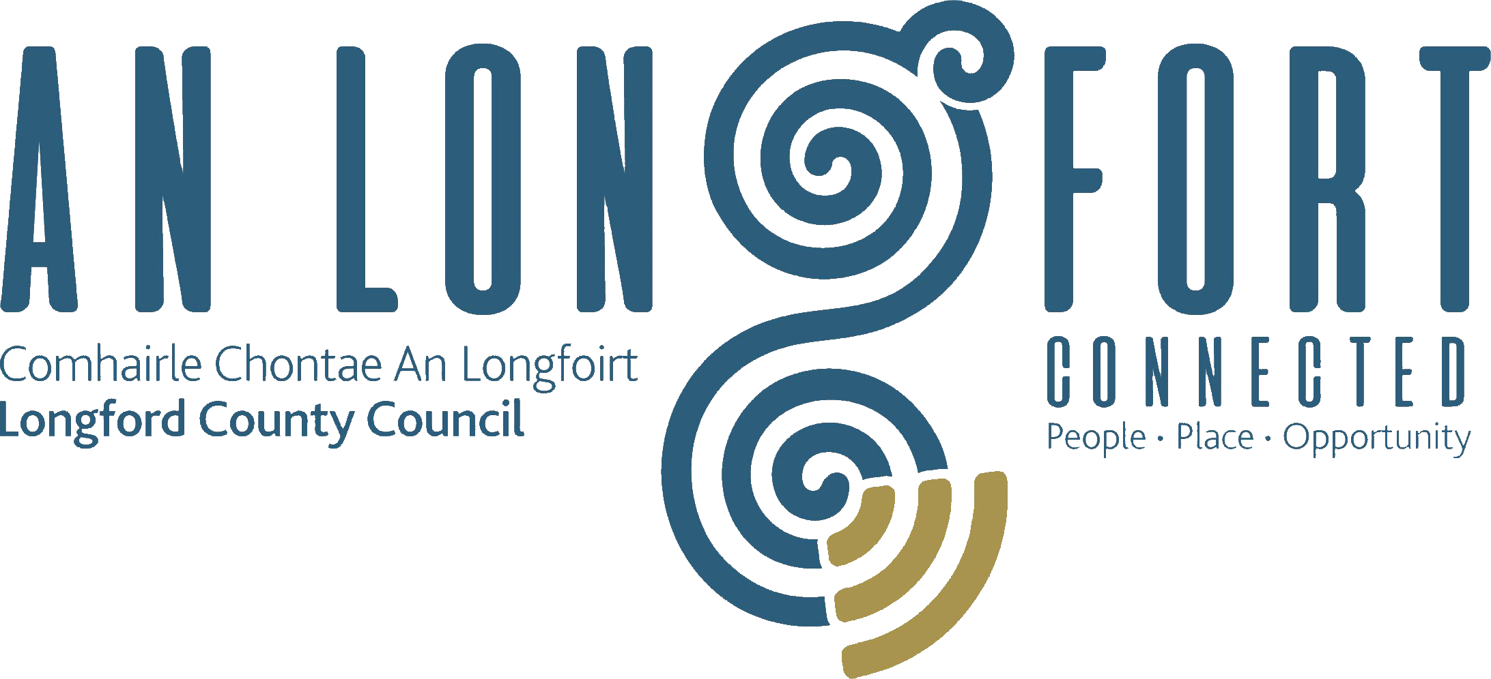

**PLACEMAKING STRATEGIC POLICY COMMITTEE**

**Minutes of Placemaking Strategic Policy Committee Meeting**

**held in the Council Chamber and via Microsoft Teams**

**on 04 December 2023 at 2pm**

**PRESIDING**: Councillor Paul Ross

**PRESENT**: Councillor PJ Reilly and Colm Murray, Cllr Gerard Farrell, Matt Farrell, Breda Murphy,

**APOLOGIES**: Vincent Fay

**IN ATTENDANCE:**  Ms. Barbara Heslin, Director of Services

Mr. Michael Nevin, A/Director of Services

Mr. Ciaran Murphy, Senior Executive Officer

Mr. David Barden, Administrative Officer

Ms. Maria Hall, Hub Planning consultant

**MEETINGS**

**ADMINISTRATOR**: Mr Gerard Dennigan

**ADOPTION OF MINUTES**

On the proposal of Cllr PJ Reilly seconded by Matt Farrell it was unanimously agreed to adopt the minutes of the Placemaking Strategic Policy Committee Meeting held on the 11 September 2023, as circulated.

**MATTERS ARISING FROM MINUTES**

None.

**DECLARATION OF INTERESTS**

None.

**CONSIDERATION OF DRAFT LOCAL ECONOMIC AND COMMUNITY PLAN (LECP) –**

Chairperson, Cllr Paul Ross introduced Maria Hall from Hub Planning consultant. Maria is appointed for the development of the Local Economic Community Plan (LECP), 2023-2029.

Maria provided a comprehensive update to members on progress and presented the updated version of the draft LECP and Implementation Plan document.

The members discussed the vision, goals, objectives, actions and proposed recommendations.

Acting Director of Services Michael Nevin complemented Maria and the team in LCC for the development of the plan. Michael provided the meeting with an update on projects submitted under the concept papers under the Just Transition Fund.

On the proposal of Councillor PJ Reilly and seconded by Cllr Paul Ross the members agreed to approve the draft LECP and Implementation Plan and move it forward to the December meeting of Longford County Council for consideration.

**DRAFT BYELAW-PARKS, PLAYGROUNDS AND OPEN SPACES 2024**

Director of Service Barbara Heslin updated the members on the Draft Byelaws-Parks, Playgrounds and Open Spaces 2024.

The purpose of the Byelaws is to ensure that parks, open spaces and all recreational playing grounds and their facilities are used to the maximum extent, in safety and comfort and for the protection of parks, open spaces and recreational playing grounds which are provided as a public amenity and for respect and consideration for park users to ensure as much enjoyment as is possible of these amenities.

The Byelaws contain the following:

1. Parks, Playgrounds and Open Spaces Byelaws 2024
2. Citation
3. Commencement and Duration
4. Interpretation
5. Opening and Closing Times
6. Prohibited Acts Governed by these Byelaws
7. Licences
8. Refusal of Permission
9. Enforcement
10. Offences
11. Fixed Payment Notice
12. Appealing a Fixed Payment Notice
13. Freedom of Information
14. Data Protection

Barbara informed the members the Byelaws have been reviewed by Gearty solicitors and are now ready for Public Consultation.

On the proposal of Cllr Paul Ross and seconded by Cllr PJ Reilly the members unanimously agreed for the Draft Byelaws-Parks, Playgrounds and Open Spaces 2024 to go to Public Consultation

**COMMUNITY GRANT SUPPORT SCHEME 2024**

Director of Services Barbara Heslin provided the members with an update which included:

* Overview of the Community Grant Support Scheme 2024
* All applicants must be a member of the PPN.
* No dual funding between Municipal Districts and County Wide Fund.
* All grants issued are to be published on the LCC website
* Information sessions for employees and communities to be scheduled.
* Update on the Climate Action fund.

On the proposal of Councillor Colm Murray and seconded by Councillor Paul Ross the members unanimously agreed that applications for the Community Grant Support Scheme 2024 be brought to the February 2024 meetings of the Municipal District and communities to be notified in March 2024.

**PLAYGROUND PROGRAMME**

David Barden provided the members with a comprehensive presentation on the Playground Programme. The presentation included the following:

* Playground locations throughout County Longford
* Funding methods
* Clár funding and how it operates
* Play and Recreation Capital Funding
* Update on Newtownforbes and Lanesboro playground 2022/2023
* Additional Sensory and Inclusive equipment upgrades
* Longford County Council Funding
* Role of the Local Authority
* Projects 2023
* McEoin Park-MUGA
* Priorities

On conclusion of the presentation David responded to question raised by the members. The members unanimously acknowledged the ongoing work to date by David and the Community team and thanked him for the comprehensive presentation.

**PROPOSED AMENDMENT TO THE OCCUPATION OF VACANT COMMERCIAL PREMISES INCENTIVE SCHEME**

Acting Director of Services Michael Nevin provided the members with an update on the Proposed amendment to the Occupation of Vacant Commercial Premises Incentive Scheme.

It was agreed that the current scheme due to expire on 31st December 2023 would expire in its current form but that a revised scheme for a period of 1 year to 31st December 2024 would replace it. The revised scheme would amend the eligibility criteria that exists under the current scheme to make the following applications only eligible for consideration. Three items were considered by the SPC Members.

As per the existing scheme the new scheme would only apply to those buildings that have been vacant for a period of 6 months.

On the proposal of Councillor Paul Ross and seconded by Cllr Colm Murray the members agreed to approve the proposed and move the item forward to the December meeting of Longford County Council for consideration.

**CONFIRMATION OF DATES FOR 2024 MEETINGS**

On the proposal of Councillor Paul Ross and Seconded by Councillor Colm Murray the following meeting dates were unanimously agreed by the members.

* 29 January 2024
* 15 April 2024
* 15 July 2024
* 14 October 2024

This concluded the business of the meeting.

**Confirmed and adopted at Strategic Policy Committee Meeting held on the 29 January 2023.**

**Signed: _______________**

**Gerard Dennigan**

**A/Meetings Administrator**

**Signed: _______________**

**Chairperson.**