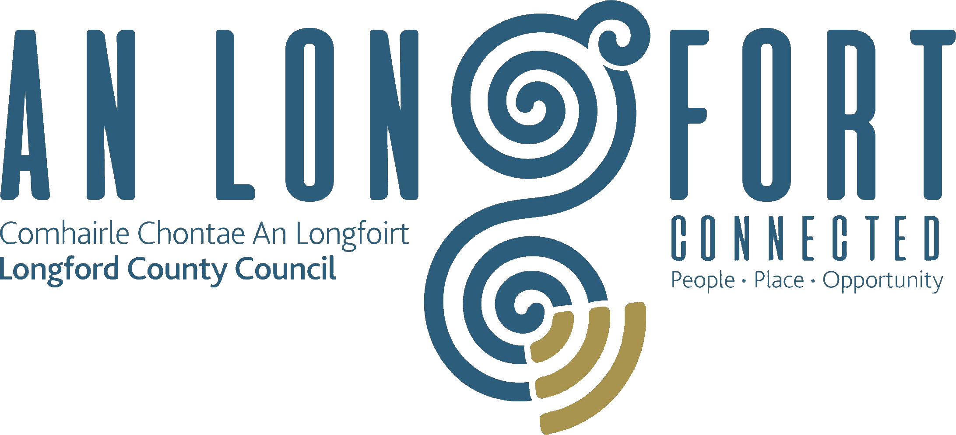

PLACEMAKING
STRATEGIC POLICY COMMITTEE

Minutes of Placemaking Strategic Policy Committee Meeting
held via Microsoft Teams on 31 January 2021 3pm

PRESIDING: Councillor Gerard Farrell Chairperson.

PRESENT: Councillors – Colm Murray, Martin Monaghan, PJ Reilly and Paul Ross,
Matt Farrell, Breda Murphy and Niamh Donlon.

APOLOGIES : Louise Lovett and Vincent Fay.

IN ATTENDANCE: Ms. Barbara Heslin, Director of Services.
Mr. Michael Nevin, Head of Local Enterprise.
Mr. Ciaran Murphy, Senior Executive Officer.
Ms. Mary Carleton Reynolds, County Librarian.

MEETINGS
ADMINISTRATOR: Ann Marie Mc Keon

ADOPTION OF MINUTES.

On the proposal of Councillor Colm Murray seconded by Matt Farrell, it was unanimously agreed to adopt Minutes of Placemaking Strategic Policy Committee Meeting held on the 18 October 2021 as circulated.

MATTERS ARISING FROM MINUTES.

None.

DECLARATION OF INTERESTS.

None.

LOCAL ECONOMIC AND COMMUNITY PLANS (LECP) GUIDELINES 2021.
The members noted that a link to Local Economic and Community Plans (LECP) Guidelines 2021, presentations and a recording of the LECP Introductory Event hosted by the Department of Rural and Community Development (DRCD) in conjunction with the Department of Housing, Local Government and Heritage (DHLGH) on 9 December 2021, had been circulated with the meeting agenda.
Ciaran Murphy explained to the members that the Local Economic and Community Plan (LECP) sets out, for a six-year period, the objectives and actions needed to promote and support the economic development and the local and community development of the relevant local authority area, both by itself directly and in partnership with other economic and community development stakeholders.
The DRCD and the DHLGH worked together to develop the Guidelines in order to enable and support integrated planning for both community and economic elements of the plan.
The economic elements of the LECP will be developed by the local authority/SPC for Economic Development and Enterprise while the Local Community Development Committee (LCDC) develop the community elements of the LECP. Following completion of the process outlined in the legislation, regarding both economic and community elements, an integrated plan will be presented to the full Council for approval as a reserved function.
The Guidelines recommend that each Local Authority establish an Advisory Steering Group to assist in the preparation, drafting, adoption, implementation and monitoring of the LECP. The Advisory Steering Group will focus on practical arrangements for the smooth preparation of an integrated Plan, from determining its scope through to final adoption. In addition, the group should have a role in supporting the Implementation Plan process to ensure that these plans are integrated and in line with the High-Level Goals and Sustainable Objectives outlined in the framework LECP.
The members approved the following recommended structure for Longford – 10 persons
- 2 members of the LCDC; (Chair Cllr Colm Murray and PPN rep. Grace Kearney who have been already nominated by the LCDC)

- The Chief Officer of the LCDC

- The Director of Service supporting the SPC for Economic Development and Enterprise

- The Local Enterprise Officer

- 2 members of the SPC for Economic Development and Enterprise (Place-making SPC)- one Councillor and one external nominee

- 1 Nominee from each of the following sectors

- Business Sector
- Agriculture Sector
- Education Sector (third level -AIT)

On the proposal of Councillor PJ Reilly, seconded by Councillor Gerard Farrell the members unanimously agreed that elected member Councillor Martin Monaghan be nominated to the steering group.
On the proposal of Breda Murphy, seconded by Councillor Martin Monaghan the members unanimously agreed that Sectoral Representative Niamh Donlon be nominated to the steering group.
On the proposal of Councillor Colm Murray, seconded by Councillor Martin Monaghan the members unanimously agreed that a nominee be sought from the following sectors – Business, Agriculture and Education Sector.
CREATIVE IRELAND PROGRAMME.
Mary Carleton Reynolds briefed the members on the Creative Ireland Programme
- Inspired by success of Ireland 2016 Centenary.
- Partnership between Creative Ireland in Department of Tourism, Culture, Arts Gaeltacht Sports & media and 31 local authorities.
- Values: Collaboration, Communication, Community, Participation, Inclusivity and Empowerment
- Each local authority developed a 5-year Culture and Creativity Strategy 2018-2022.
- Funding for programmes comes jointly from DRCD & DTCAGSM

Progress to date:
- Interim review carried out in 2020 showed that Creative Communities has substantially enhanced the reach of LA’s, increased our visibility and created great opportunities for communities.
- Its success is largely attributed to the way it has been delivered through a cross cutting Culture & Creativity Team & a designated CI Coordinator.
- Our programme has been targeted to meet local needs, to harness & nurture the creativity in our own communities & to demonstrate the value of creativity in supporting wellbeing, social cohesion & economic success.
- Funding for 2022
- Summer and Winter 2021 Live and Local Programmes
- 2022 Live and Local Programme – February to June
- Faoin Speir programme
- Creative Communities Economic Action Fund
- Open call for 2022 funding – applications close on 14 February.

The members welcomed the presentation and acknowledge the great success of this programme and made particular reference to the Summer and Winter Live and Local Programmes.

LEO PLAN 2022
Michael Nevin outlined the performance metrics for 2021 and 2022 to the members and progressed to highlight the Strategic Priorities for the Local Enterprise Office 2022 under the following headings:
- Entrepreneurship
- Competitiveness and Digitalisation
- Green/Sustainability
- Remote Working/Innovation Hubs
- Innovation
- Exporting/Internationalisation
- Networks and Clustering
- REDF Projects
- Just Transition/Territorial Plan
- Management Development Capability
- National LEO Programmes
- Local Enterprise Week
- National Ploughing Championship
- National Women’s Enterprise
- Student Enterprise
- National Enterprise Awards
- Ireland Best Young Entrepreneur
- Food Academy
- Microfinance Ireland

Michael outlined the challenge of getting investment into the county and the identification of landbanks for future development.

The work of the LEO office was fully recognised by the members and the support provided by them to businesses was acknowledged. The team were thanked for their proactive approach taken to supporting businesses in the county.
The Members agreed the LEO plan and priorities for 2022.
COMMUNITY GRANT SUPPORT SCHEME 2022
Ciaran Murphy gave an update to the members on the Community Activities Fund and confirmed that the Department of Rural & Community Development had provided €9m nationally with €264,769 allocated to Longford LCDC to administer and Longford Local Community Development Committee (LCDC) inviting online applications for grants towards running costs, to carry out necessary repairs & improvements to their facilities or to purchase equipment under the Community Activities Fund (CAF).
A Technical Support Information Session for Community Groups was held via Microsoft (MS) Teams on Monday 24 January and this was well attended, feedback was positive and a recording is available online.

- The Closing date for receipt of online application forms and uploaded supporting documentation is no later than 4pm on Wednesday 16 February 2022.
- Applications will be assessed by the LCDC Evaluation Committee at the end of February 2022.
- LCDC will consider and decide on applications in early March 2022.
- In order to avoid confusion for community groups and possible duplication of applications the CPG agreed to delay the launch of the Council’s Community Support Grant Scheme until mid-March 2022.
- The CGSS will have a closing date of the end of April 2022, to enable decisions at meetings of the Municipal Districts in May 2022.
Ciaran replied to the questions raised by the members and Barbara emphasied that the Community Activities Fund now covered operating costs and this showed the important change in approach by the government.

PLAYGROUND DEVELOPMENT AND REFURBISHMENT PLAN 2022.
Deferred to April Meeting.
DATE OF NEXT MEETINGS.
The dates for the meetings in 2022 were noted by the members.

This concluded the business of the meeting.

Ann Marie Mc Keon
Signed: _______________
Ann Marie Mc Keon
Meetings Administrator.

Confirmed and adopted at Strategic Policy Committee Meeting held on the
25 April 2022.

Gerard Farrell
Signed: _______________
Chairperson.

