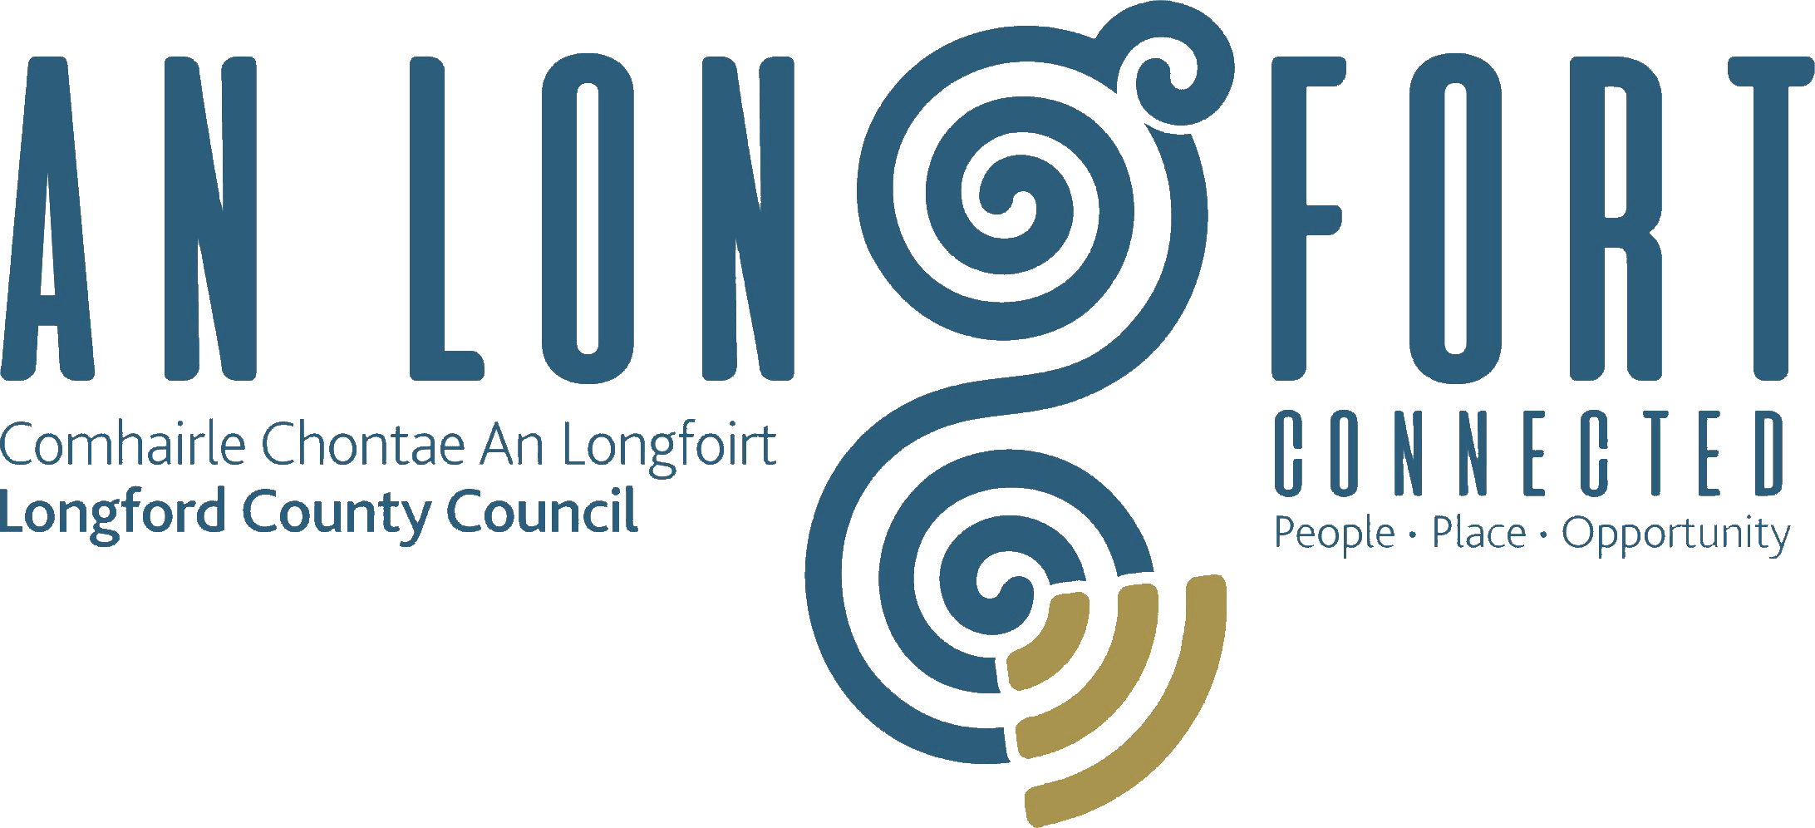

PLACEMAKING
STRATEGIC POLICY COMMITTEE

Minutes of Placemaking Strategic Policy Committee Meeting
held via Microsoft Teams on 19th July 2021 3pm

PRESIDING: Councillor Gerard Farrell Chairperson.

PRESENT: Councillors – Colm Murray, PJ Reilly, Martin Monaghan and Paul Ross, Louise Lovett, and Matt Farrell.

APOLOGIES : Niamh Donlon

IN ATTENDANCE: Ms. Barbara Heslin, Director of Services
Ms. Nora O’Farrell, Senior Executive Officer
Ms. Mary Reynolds, County Librarian
Ms. Dympna Reilly, Tourism Officer
Mr. Terry Rooney, Senior Executive Officer
Mr. Frank Horne, Senior Staff Officer.
Ms. Christine Collins, Broadband Officer.
Mr. Fergus Kennedy, Arts Officer.

MEETINGS
ADMINISTRATOR: Claire McNabola (Acting)

ADOPTION OF MINUTES.

On the proposal of Councillor PJ Reilly seconded by Councillor Martin Monaghan, it was unanimously agreed to adopt Minutes of Placemaking Strategic Policy Committee Meeting held on the 22nd April, as circulated.

On the proposal of Councillor Martin Monaghan seconded by Councillor PJ Reilly, it was unanimously agreed to adopt Minutes of the Joint Meeting of Placemaking Strategic Policy Committee Meeting and the Strategic Infrastructure Strategic Policy Committee held on the 22nd April, as circulated.

MATTERS ARISING FROM MINUTES.

None.

DECLARATION OF INTERESTS.

None.

LONGFORD COUNTY COUNCIL LIBRARY DEVELOPMENT PLAN 2021-2025.
Mary Reynolds provided an update on the Longford County Council Library Development Plan 2021-2025. Mary replied to queries raised by the members. Topic’s discussed were:

- Public Statement of Library Service
- Values of the Library Service
- The Key Strategic Plans that influenced the Library Development Plan
- An overview of the Profile of Longford Libraries including members registered, visits rentals, budget, events, footprint etc
- Social & Economic Impact of Longford Libraries
- Social & Cultural Inclusion in the Libraries
- Ambitions set out for the future
- How these ambitions will be achieved

Mary Reynolds, County Librarian highlighted the importance of our Libraries in our Local Community. She emphasised the importance of the wide range of services they provide. Mary also highlighted all the external organisations that the Library Services collaborate and engage with to enable provide such brilliant services.
The Members complemented Mary on the work of the Libraries and welcomed the focus on upgrade of facilities. They also highlighted the need to promote the excellent work carried and Longford’s statistics which demonstrate the level of engagement with and use of the library services.

LONGFORD CONNECTED COMMUNITIES – UPDATE – PRESENTATION BY CHRISTINE COLLINS.
Ms. Christine Collins gave a detailed update on the recently launched BCP around Co. Longford and replied to queries raised.
BCPs are public locations which have been selected to receive free high-speed broadband connectivity in this the first year of the National Broadband Plan (NBP). The BCP will provide high speed broadband access to communities that don't have it (amber area of the NBP), in advance of homes and businesses receiving future-proofed broadband directly to their door. Christine highlighted the importance of the BCP points in making Longford a more attractive place to live and work.
- BCP Points now located at – Mullinalaghta Community Centre, Moyne Latin School, Abbeyshrule Airfield, Colmcille GAA, Ballymore Shamrocks GAA, Corlea Trackway Visitor Centre, Carrickedmond GAA, Moydow Community Centre and for educational purposed only at Bunlahy National School and Fermoyle National School.
- How to book a desk, a training facility or a co working space
- Moydow selected as a pilot for the National booking system

The Members thanked Christine for her comprehensive presentation and welcomed the spread of BCPs throughout the county. They highlighted the importance of highspeed broadband in Placemaking.

TOURISM STRATEGY UPDATE.
Ms Dympna Reilly updated the Committee on the Tourism Strategy. She also replied to queries raised.
- Review of the vision and the objective of the strategy
- The Strategy aims to achieve this through the fulfilment of the following key objectives
- Developing Tourism Infrastructure
- Delivery of Visitor centric experiences
- Development of a Longford Tourism Brand
- Generating greater awareness of Longford as a tourism destination

Priorities are:

- Continue to market the Longford Tourism brand and generate greater awareness of County Longford as a Tourism destination.
- Continue to support the development of tourism products to increase County Longford’s attractiveness and to deliver high quality visitor experiences.
- Continue to communicate with our key target audiences through the various media, both on-line and off-line with emphasis on our new website www.longford.ie
- The Tourism strategy is committed to the key project areas A number of them to become Flagship Attractions that have the potential to transform tourism in County Longford
- Support the Center Parcs Development and the future planned expansion
- Establish the Maria Edgeworth Literary Trail
- Build a Tourism Accommodation product
- Build a Calendar of Tourism Events
- Promote Irelands Hidden Heartlands
- Progress the Mid Shannon Wilderness Park
- Open a visitor interpretive centre at Granard Motte
- Competition of the Royal Canal Greenway
- Map of the Rebel & Literary Trails
The Members complemented the work of the Tourism Office and the progress being made on the delivery of the Tourism Strategy. They asked that the Tourism Office make contact with the operators of Newcastle House regarding their future plans. Barbara explained that Longford County Council was aware of media reports regarding possible future investment and associated planning application. Matt Farrell also informed the meeting of the National Youth Championship which is to be held in Longford Golf Club in July.

ARTS OFFICE FRAMEWORK AND SUMMER OUTDOOR PERFORMANCE.

Fergus Kennedy provided the Committee with an overview on the following:
Summer Programme of Events
Longford County Council has received grant funding of 143,000 euro from the Department of Tourism Arts Culture Sports and the Gaeltacht to engage local artists, musicians, and crew to deliver live performances for the period from now to 30 September 2021. All of the events will take place at Nursing Homes, Family Resource centres, Community centres, GAA grounds, parks etc in towns and villages around the county and will be run with the support and cooperation of local communities and gardai in each area.
This summer programme of events is being coordinated by Longford County Council Arts Office with the support of local Events Manager Shane Crossan and his company Republic of Culture.
Barbara complemented the engagement and support of local communities in helping to deliver a very ambitious programme. She thanked Shane and the entire Local Authority team for their support in developing, delivering, and promoting the programme.

Call for Expressions of interest for the position of Project Manager Longford Culture Night 2021
Longford County Arts Office seeks expressions of interest from suitably qualified persons for the temporary position of Project Manager Longford Culture Night which will be held on Friday September 17th, 2021. Closing date Monday 9th August.

Proposed Framework Agreement
Discussions over the preferred content of our proposed Framework Agreement with the Arts Council has been ongoing between Fergus Kennedy and Sinead O’Reilly for some time. A draft framework has now been developed.

The Arts Officer advised that the next step is for discussions between Longford County Council Senior Management and Arts Council Senior Executives with a view to agreeing a final draft and agreements between the respective parties around arrangements for executing the Agreement.

The partnership agreement will last for 5 years and will change the funding arrangements currently in place. The Strategic Action Areas are:
- Promotion of creative arts including the use of digital tools and technology
- Place based arts development
- Enhancing skills of artists and creatives
- Evaluation of participation

The Members agreed the draft outline of the Framework.

It was agreed that all the presentations from the meeting will be circulated to the Members.

Members were encouraged to contact the Meetings Administrator with Agenda items for the next meeting in October.

NEXT MEETING

18th October 2021.

This concluded the business of the meeting.

Claire McNabola
Signed: _______________
Claire McNabola
A/Meetings Administrator.

Confirmed and adopted at Strategic Policy Committee Meeting held on the
18th October 2021.

Gerard Farrell
Signed: _______________
Chairperson.

