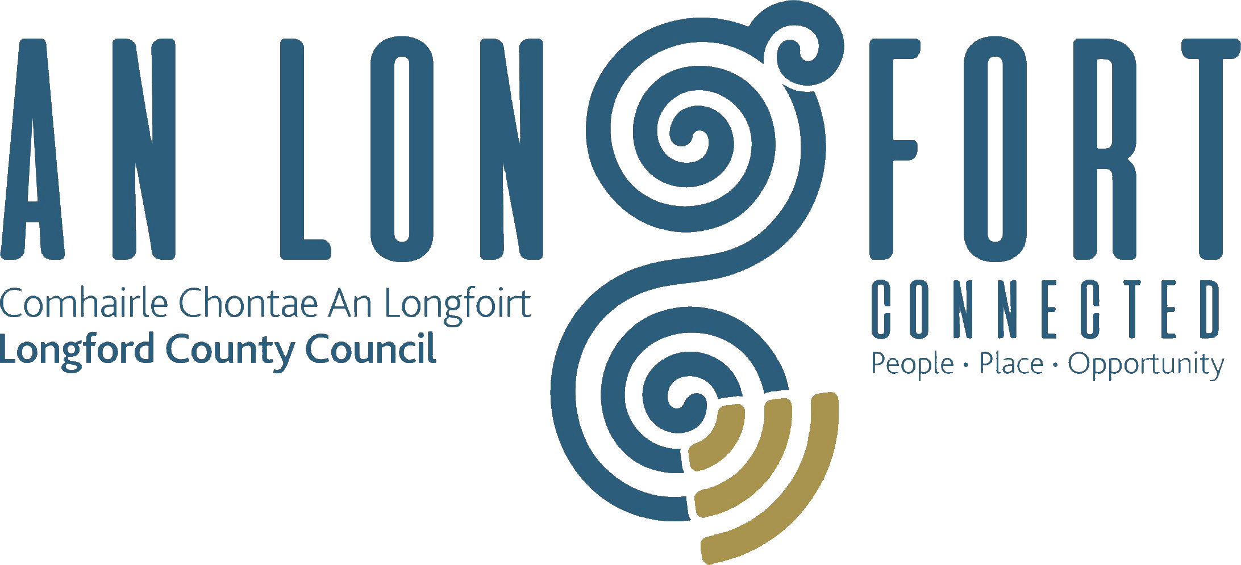

PLACEMAKING
STRATEGIC POLICY COMMITTEE

Minutes of Placemaking Strategic Policy Committee Meeting
held via Microsoft Teams on 18th October 2021 3pm

PRESIDING: Councillor Gerard Farrell Chairperson.

PRESENT: Councillors – Colm Murray, Martin Monaghan and Paul Ross,
Louise Lovett, Matt Farrell, Vincent Fay and Niamh Donlon.

APOLOGIES : PJ Reilly.

IN ATTENDANCE: Ms. Barbara Heslin, Director of Services.
Mr. Michael Nevin, Head of Local Enterprise.
Mr. Ciaran Murphy, Senior Executive Officer.

MEETINGS
ADMINISTRATOR: Ann Marie Mc Keon

ADOPTION OF MINUTES.

On the proposal of Louise Lovett seconded by Matt Farrell, it was unanimously agreed to adopt Minutes of Placemaking Strategic Policy Committee Meeting held on the 19th July 2021 as circulated.

MATTERS ARISING FROM MINUTES.

None.

DECLARATION OF INTERESTS.

None.

THE HEALTHY AGE FRIENDLY HOMES PROGRAMME
Mary Carey introduced herself as County Longford Local Coordinator, Mary briefed the members on the programme.

Sláintecare is the ten-year Programme to transform our health and social care services. It is the roadmap for building a world-class health and social care service for Irish people. The Sláintecare vision is to achieve a universal single-tier health and social care system where everyone has equal access to services based on need, and not ability to pay.

Age Friendly Ireland / Local Government, an appointed shared service function of local government hosted by Meath County Council, brings together, supports and provides technical guidance to the 31 Local Authority led, multi-agency Age Friendly City & County Programmes across Ireland delivering the goals and objectives of the World Health Organisations Age Friendly Global Framework:

- Demographic Change: The Challenge
- Objectives
- Phase 1 Areas
- Evaluation
- Participant Assessment
- Associated Duties
- Brochure
- Referral Form

What is the role of the Local Healthy Age Friendly Homes Coordinator
- Work in partnership with stakeholders and existing service providers
- Manage a caseload of Referrals
- Assess each older person’s individual needs
- Coordinate and facilitate a plan of supports and sign post them to services
- Identify any gaps in services | Highlight Models of good practice

The members welcomed the presentation and requested that a copy be circulated to them. They noted how the elderly don’t always request help and how important it is to have the appropriate facilities available for them. Mary would make her details available for anyone who would like to follow up with any further questions or required assistance.

COMMUNITY SAFETY PARTNERSHIP.
Janine Barley Coordinator for the Community Safety Partnership welcomed the opportunity to address the members.
- One of three pilot schemes
- 30 members, statutory & non-statutory interests,
- including elected representatives, state agencies, PPN representatives and other local interest groups.
- Independent Chair- appointed by Department of Justice - Ms Martina Moloney
- Partnership approach and action focused:
- working together to collate issues and develop solutions and create action
- Quarterly meetings of full Partnership
- Working groups to drive operational work
- Working closely with other bodies and committees
- Building on what’s working, rather than duplicating what’s already being done

Objectives:
- Prioritise issues identified by the community as safety concerns
- Improve multi-agency collaboration in the area
- Increase community confidence in service providers

Progress update:
- Partnership members have been appointed
- Coordinator commenced
- First meeting of the Partnership- 20th September 2021
- Planning for consultation phase has commenced including consideration of engagement & communication strategy
- Ongoing evaluation of the 3 pilot sites arranged by Department of Justice

Next Step
- Interactive workshop for LCSP members – to agree vision/mission and to identify themes to guide the public consultation process
- Finalise and action the awareness campaign and communication strategy to inform the public of the project and consultation
- Public Information and Consultation period - November- end January
- Have your say - SPC will be invited to make a submission.
- Any queries, suggestions or observations welcomed – submit through Coordinator

The members requested that a copy of the presentation together with information on the membership and Terms of Reference be circulated to them. The welcomed the presentation and noted that it would be interesting to see how the pilot scheme progressed in terms of numbers, resources and funding.

MIDLANDS REGIONAL ENTERPRISE PLAN TO 2024.
Michael Nevin briefed the members on the Midlands Regional Enterprise Plan (MREP)
- Oversee the MREP at a strategic level.
- Oversee the formation of working groups to drive implementation of actions.
- Provide a forum for the Working Groups to report to.
- Nominate and secure Objective Leads to support delivery of the Strategic Objectives.
- Explore and propagate new ideas and opportunities for collaborative projects, and funding.
- Provide a forum for the sharing of updates and information by members on key enterprise development initiatives
- Oversee, contribute to, and sign off (through the Chair) on mid-term MREP Progress Report
- Climate Action
- Smart Specialisation and Digitisation
- Placemaking

Strategic Objective 1
Climate Action - Transition to a zero - carbon economy
- Action 1.1: The Midlands Regional Transition Team will work to develop transformative projects with the support of Project Ireland 2040 funding streams and the European Just Transition Fund, including the provision of Technical Sectoral Advisors/ Mentors within enterprise agencies and LEOs to guide emerging ‘low carbon’ focused projects across the region
- Action 1.2: Develop a framework for Local Authorities to realise economic opportunities from the low carbon transition and empowering communities to embrace Social Enterprise and Community Gain, in partnership with the Eastern & Midlands Climate Action Regional Office (CARO) and the County & City Managers Association (CCMA) and other regional / national agencies and the Department of Enterprise, Trade & Employment. Develop and implement Local Authority Climate Action Plans, addressing both adaptation and mitigation measures, including the development and designation of decarbonisation zones, building upon lessons learned from the various elements in Portlaoise, as the national low carbon demonstration town, including The Cube
- Action 1.3: Regional ETBs will develop a National Pilot on Sustainability and a Rural Centre of Excellence within the Midland Region

Strategic Objective 2
Build on achievements to date in sectors in which the region has a competitive advantage through Smart Specialisation and wider adoption of digitalisation within business, leveraging the new Technological University of the Shannon
- Action 2.1: Work with the Technological University of the Shannon: Midlands Midwest to capitalise and realise business, industry, and skills opportunities presented by TU status to further support the development of the region, including the growth and expansion of Empower Eco, and the development of the Midlands Technology Campus
- Action 2.2: Deliver on the actions within Midlands Advanced Manufacturing Action Plan, to position the region as an advanced manufacturing centre of excellence through defined actions across enabling themes of Education, Training & Skills; Research & Innovation; Support Infrastructure & Networks; and Strengthening the Manufacturing base
- Action 2.3: Develop a Smart Connected Technologies Cluster to leverage identified and established regional competencies in telecoms and supporting areas including augmented reality, data analytics etc.

ADVANCED MANUFACTURING ACTION PLAN.
Michael Nevin briefed the members on the action plan:

The vision for the region is that by 2030, the Midlands Region is known internationally as a Centre of Excellence in Advanced Manufacturing and as an ideal location for manufacturing companies (both indigenous and FDI) to establish and grow their business and exports.

This will be achieved through:
- the growing numbers in the region of leading global manufacturing industries (both FDI and indigenous MNCs) and a dynamic indigenous manufacturing sector;
- shared ambition amongst the region’s manufacturing base for business excellence, international competitiveness, and a willingness to share knowledge with other companies in the region for mutual business advantage, and to pool their manufacturing in order to exploit market opportunities;
- a coordinated and collaborative region-wide ecosystem of business networks, research centres, education and training facilities and government agency actions and supports, which is interconnected with the wider national support ecosystem.

Members of the Action Plan Steering group and the wider working group
- Agencies (EI, IDA, LEO), Midlands Regional Skills Forum, Regional Enterprise Development Office;
- Midlands industry – Abbott Diagnostics, Grant Engineering, Greenfield Global, Mergon;
- Support system – TUS – Midlands Midwest, Engenuity network, CIPD, Cobotics Skillnet, IMR;
- A wider sample of Midlands manufacturing companies reflecting sectoral mix and geographical location

In addressing issues, the action plan seeks to build on the advantages which the Midlands has and to lay the pathway to achieve the vision for the Midlands as a manufacturing centre of excellence.

The action plan is structured around the following enabling themes:
- Theme 1. Education, Training & Skills
- Theme 2. Research & Innovation
- Theme 3. Support infrastructure & networks
- Theme 4. Strengthening the manufacturing industry base - FDI and Indigenous Sector
The successful implementation of the action plan will draw on supports available both at regional and local level and also where appropriate across the wider national infrastructure.

The members welcomed both of Michael presentations and noted the need to identify projects and the huge potential available and 2030 is not that far away.

Louise Lovett asked if projects already in the pipeline had potential could they be considered if they can scale up and Michael replied yes. The members mentioned Just Transition and the impact of the loss of Bord Na Mona jobs.

The members requested a copy of the plan.

LONGFORD COUNTY COUNCIL LIBRARY DEVELOPMENT PLAN 2021-2025.
Barbara Heslin, Director of Services reminded the members of the key elements of the Plan which was considered in detail at the last meeting. No additional comments were received from the Committee and no changes are proposed to the draft.
On the proposal of Councillor Martin Monaghan seconded by Louise Lovett, the members unanimously agreed to forward the Longford County Council Library Development Plan 2021-2025 to the full Council for adoption.

DATE OF NEXT MEETINGS.
The dates for the meetings in 2022 were noted by the members.
This concluded the business of the meeting.

Signed: _______________
Ann Marie Mc Keon
Meetings Administrator.

Confirmed and adopted at Strategic Policy Committee Meeting held on the
31st January 2022.

Signed: _______________
Chairperson.

