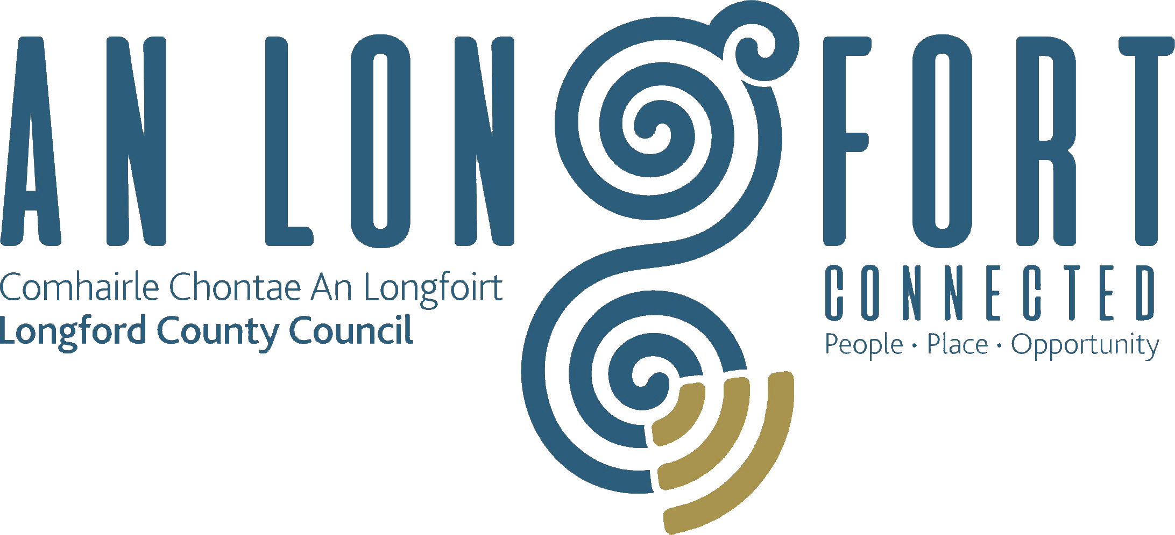

STRATEGIC INFRASTRUCTURE
STRATEGIC POLICY COMMITTEE

Minutes of Strategic Infrastructure Strategic Policy Committee Meeting
held in Longford Rugby Club Demesne,
Longford on Monday, 20th July 2020 at 3.00 p.m.

PRESIDING: Councillor Turlough McGovern, Chairperson.

PRESENT: Councillors - Paraic Brady, Colm Murray, Pat O’Toole and Gerry Warnock.
Ms. Fiona Fenelon and Stephanie Igoe.

APOLOGIES Maria Keelty, Damien O’Reilly, Tess Murphy
Mr. David Tubridy, Senior Engineer,

IN ATTENDANCE: Mr. John Brannigan, Director of Services.

MEETINGS
ADMINISTRATOR: Anne Lee.

ADOPTION OF MINUTES.

On the proposal of Councillor G. Warnock seconded by Councillor T. McGovern, it was unanimously agreed to adopt Minutes of Strategic Infrastructure Strategic Policy Committee meeting held on the 3rd February 2020, as circulated.

MATTERS ARISING.

None.
DECLARATION OF INTERESTS.

None.

AFFORDABLE HOUSING SCHEME and SERVICED SITE INITIATIVE.
J. Brannigan briefed the members regarding Affordable Housing Schemes and Serviced Site Initiatives.
With regard to Affordable Housing Scheme, John suggested that the Council should prepare a draft Scheme for submission to the Department requesting that Longford be included in a pilot scheme.
The members discussed various aspects of the proposed Scheme, including Income Thresholds and Clawback arrangements.
John stated that he is meeting with officials from the Department on the 22nd July and he will raise this issue at that meeting.

NEXT MEETING.

22nd October 2020.

This concluded the business of the meeting.
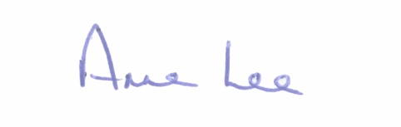

Signed: _______________
Anne Lee,
Meetings Administrator.

Confirmed and adopted at Strategic Policy Committee Meeting held on the
22nd October 2020.

Signed: _______________
Chairperson.

