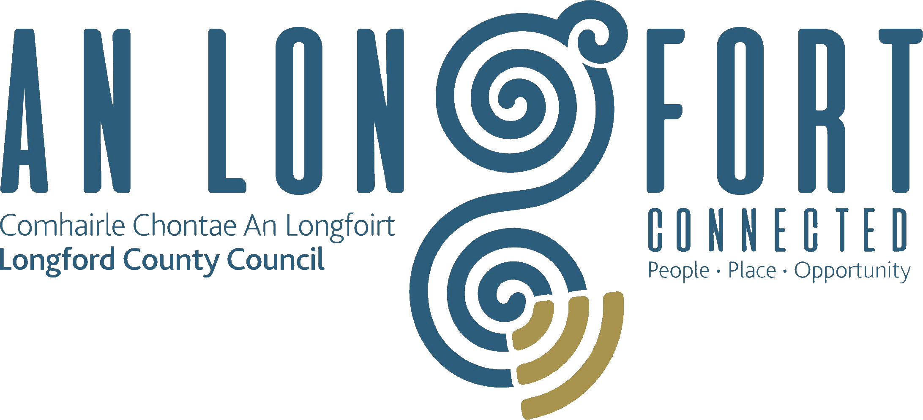

STRATEGIC INFRASTRUCTURE
STRATEGIC POLICY COMMITTEE

Minutes of Strategic Infrastructure Strategic Policy Committee Meeting
held in the Council Chamber, Aras an Chontae,
Great Water Street, Longford on Monday, 3rd February 2020 at 3.00 p.m.

PRESIDING: Councillor Paraic Brady, Chairperson.

PRESENT: Councillors - Turlough McGovern and Gerry Warnock
Ms. Fiona Fenelon, Maria Keelty and Mr. Damien O’Reilly.

APOLOGIES Councillors – Colm Murray, Pat O’Toole.

IN ATTENDANCE: Mr. John Brannigan, Director of Services.
Mr. Tom Murtagh, Senior Engineer.
Mr. David Tubridy, Senior Engineer.
Ms. Ann Marie McKeon, Administrative Officer.

MEETINGS
ADMINISTRATOR: Anne Lee.

INTRODUCTION.

Councillor Brady welcomed the members to the inaugural meeting of the Strategic Infrastructure Strategic Policy Committee. Councillor Brady confirmed that there are still two outstanding members to be appointed to the Committee - Tess Murphy and
Stephanie Igoe – approval to be ratified at the March meeting of the Council.

The members present introduced themselves.
DECLARATION OF INTERESTS.
None.

STANDING ORDERS

On the proposal of Councillor G. Warnock seconded by Councillor T. McGovern, it was agreed to adopt the Standing Orders, as circulated.

WORK PROGRAMME

John Brannigan stated that the Strategic Infrastructure Strategic Policy Committee will focus attention on the development of policy in the following areas which, when considered and agreed by the SPC, will be forwarded to the County Council for approval -

- Graveyard Survey.
- Pollinator Framework.
- Affordable Housing.
- Serviced Site Initiative.
- Reverse Vending Machines.
- Winter Maintenance Programme.
- “Adopt a Road” Scheme.
- Speed Ramps.

John outlined, in detail, the key areas in each heading.

It was agreed that the following items be included on the Agenda for the next SPC meeting -

- Affordable Housing.
- Serviced Site Initiative.
Councillor Warnock provided a summary regarding Notices of Motions which he has submitted to Longford County Council regarding these issues and stated that he will forward the Notices of Motions to the SPC members.

Waste Bye-Laws.

Following a query from Maria Keelty regarding recycling bins, J. Brannigan gave a summary of the current Waste Bye-Laws.

NEXT MEETING.

5th May 2020.

This concluded the business of the meeting.
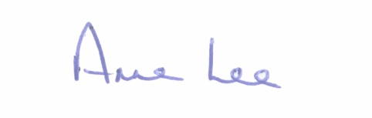

Signed: _______________
Anne Lee,
Meetings Administrator.

Confirmed and adopted at Strategic Policy Committee Meeting held on the
20th July 2020.

Signed: _______________
Chairperson.

