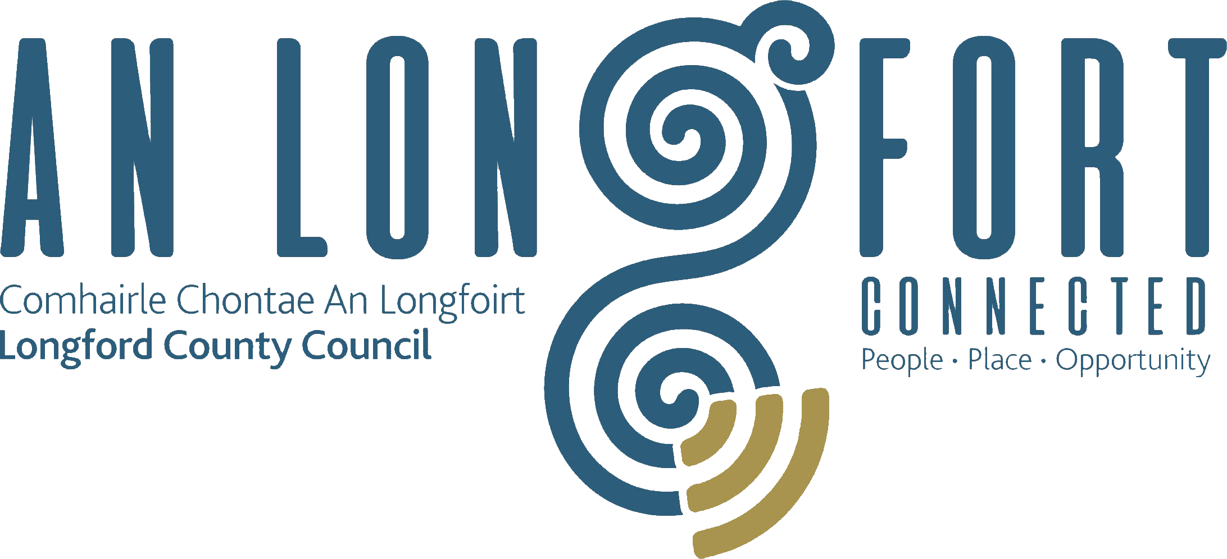

**STRATEGIC INFRASTRUCTURE**

**STRATEGIC POLICY COMMITTEE**

**Minutes of Strategic Infrastructure Strategic Policy Committee Meeting**

**held via Microsoft Teams**

**on Thursday, 29th July 2021 at 2pm**

**PRESIDING**: Councillor Turlough McGovern, Chairperson.

**PRESENT**: Councillors - Colm Murray, Paraic Brady, Pat O’Toole and Gerry Warnock.

Ms. Fiona Fenelon, Maria Keelty and Tess Murphy.

**APOLOGY:** Stephanie Igoe, Damien O’Reilly

**IN ATTENDANCE:**  Mr. John Brannigan, Director of Services.

Mr. David Tubridy, Senior Engineer.

Mr. Con Diffley, Senior Executive Engineer.

Mr. Liam Kiernan, Assistant Engineer.

Ms. Martina Mc Grath, Administrative Officer.

**MEETINGS**

**ADMINISTRATOR**: Ann Marie Mc Keon.

**ADOPTION OF MINUTES.**

On the proposal of Councillor Pat O’Toole seconded by Councillor Gerry Warnock, it was unanimously agreed to adopt Minutes of Strategic Infrastructure Strategic Policy Committee meeting held on the 22nd April, as circulated.

On the proposal of Councillor Pat O’Toole seconded by Councillor Gerry Warnock, it was unanimously agreed to adopt Minutes of the Joint Placemaking & Strategic Infrastructure Strategic Policy Committee meeting held on the 22nd April, as circulated.

**MATTERS ARISING.**

None.

**DECLARATION OF INTERESTS.**

None.

**TRAFFIC CALMING AND SPEED RAMPS**

Senior Engineer David Tubridy introduced himself and the roads staff to the members of the committee and outlined in brief the current traffic calming policy in Longford.

Liam Kiernan Assistant Engineer gave a presentation to the meeting on the national guidance and outlining an updated policy document based on the current national guidance.

The members welcomed the presentation and asked the following questions which Liam and Con responded to: -

* Audio box at St Mel’s Cathedral Junction
* Policy for existing ramps which have degraded
* Signage within estates for speeding
* Criteria for speed ramps
* Traffic calming on local road 11031 in Ballymahon
* Rural speed limits
* Request to circulate presentation
* Villages where excessive speed – cushions
* Children at play signs

The policy document was put before the members for adoption.

On the proposal of Councillor Padraig Brady and seconded by Councillor Pat O’Toole it was unanimously agreed by the members to forward the policy to the full council for approval.

County Development Plan

Tess Murphy requested that when appropriate an update on the housing strategy role in the Draft County Development Plan be provided to the members.

Ballinamuck Cemetery

Tess looked for an update on repairs to the cemetery at Ballinamuck and the meetings administrator informed Tess that she had passed her query to the environment section.

**NEXT MEETING.**

21st October 2021.

This concluded the business of the meeting.

Ann Marie Mc Keon

**Signed: _______________**

**Ann Marie Mc Keon**

**Meetings Administrator.**

**Confirmed and adopted at Strategic Infrastructure Strategic Policy Committee Meeting held on the 21st October 2021.**

Turlough Mc Govern

**Signed: _______________**

**Chairperson.**