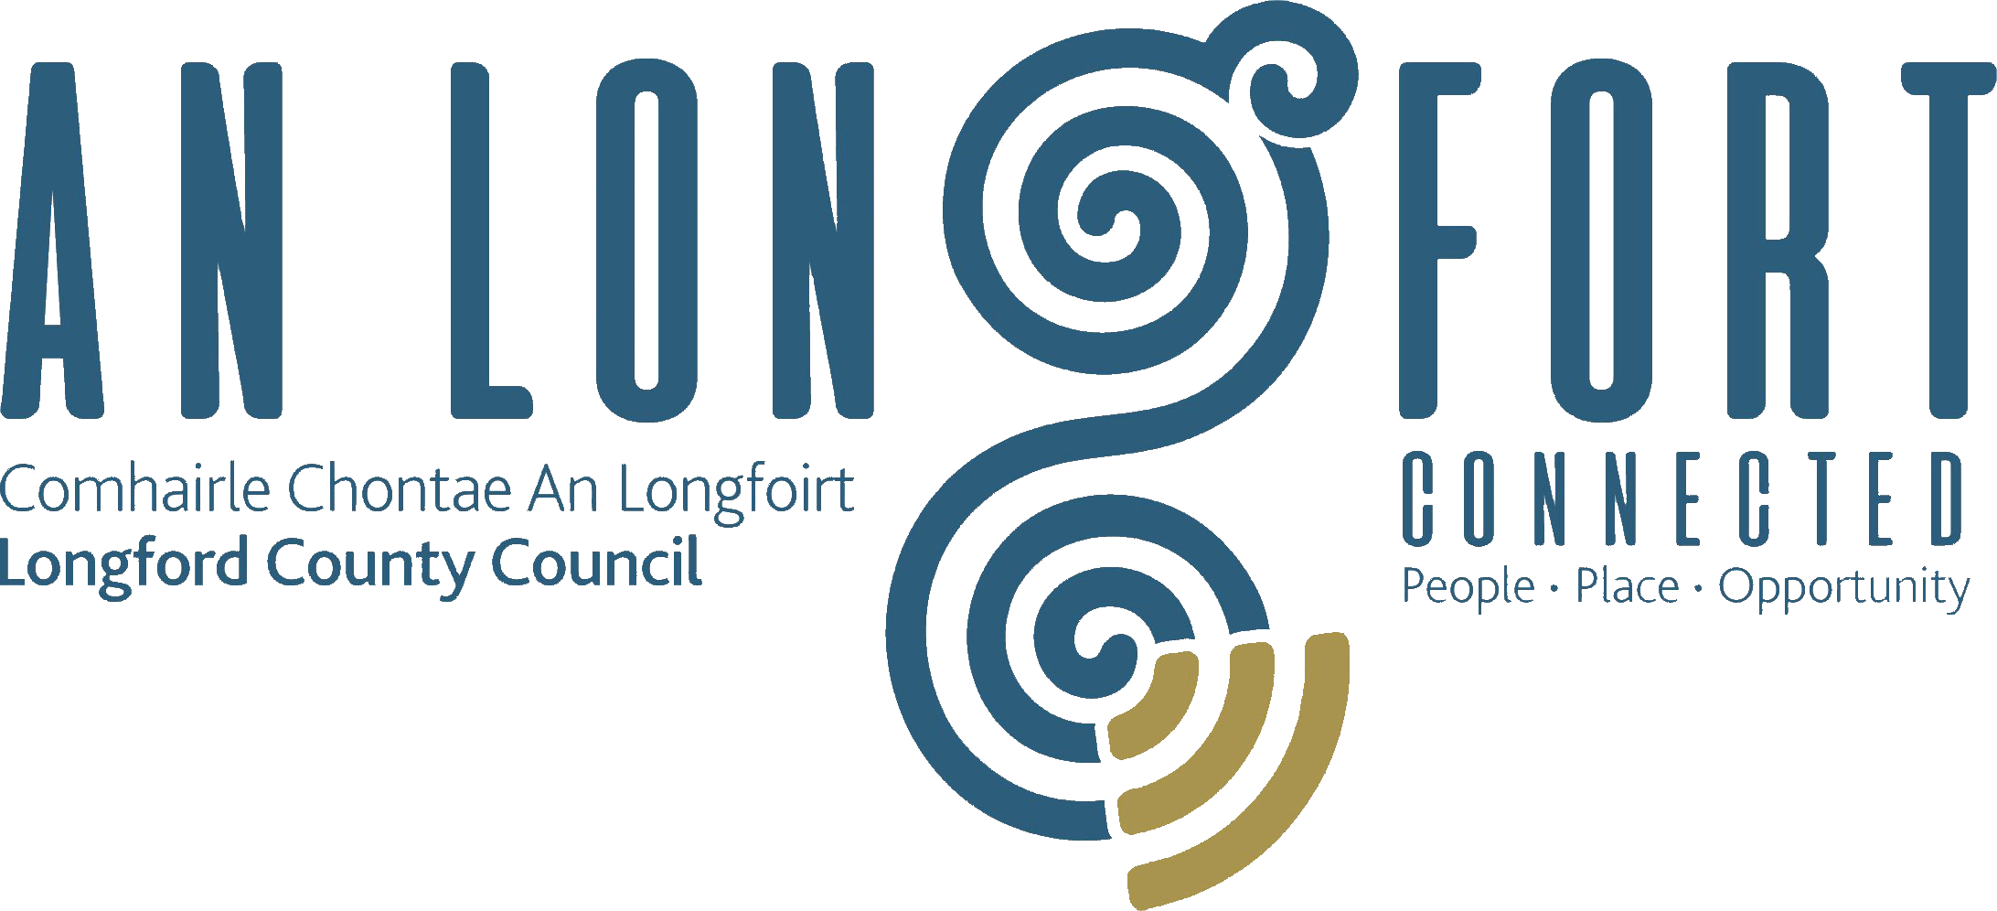

**STRATEGIC INFRASTRUCTURE**

**STRATEGIC POLICY COMMITTEE**

**Minutes of Strategic Infrastructure Strategic Policy Committee Meeting**

**held via Microsoft Teams**

**on Thursday, 20 October 2022 at 3pm**

**PRESIDING**: Councillor Colm Murray, Chairperson

**PRESENT**: Councillors – Turlough Mc Govern, Pat O’Toole and Gerry Warnock

Ms. Fiona Fenelon, Maria Keelty, Tess Murphy and Stephanie Igoe

**IN ATTENDANCE:**  Ms. Samantha Healy, Director of Services

Ms. Ann Marie Blessington Administrative Officer

Mr. Brian Kelly, Senior Executive Engineer

**APOLOGIES:** Councillor – Paraic Brady

Damien O’Reilly

**MEETINGS**

**ADMINISTRATOR**: Ann Marie Mc Keon

**ADOPTION OF MINUTES**

On the proposal of Councillor Pat O’Toole and seconded by Tess Murphy, it was unanimously agreed to adopt Minutes of Strategic Infrastructure Strategic Policy Committee meeting held on the 21 July 2022 as circulated.

**MATTERS ARISING**

Ms. Tess Murphy acknowledged receipt of the update on Tuaith, Granard, however, Tess required further information which she would confirm in an email to the Meetings Administrator for Director of Services, John Brannigan to reply to.

Director of Services, Samantha Healy confirmed that there would be no discussion on individual cases at this meeting and explained that the roles of the Strategic Policy Committee (SPC) is in assisting and advising the Council in relation to functions of a strategic statutory nature. The SPC system is intended to give councillors and relevant sectoral interests an opportunity for full involvement in the policy-making process from the early stages, when policy options are more fluid, it is not intended for individual projects.

The members unanimously agreed that that the administrative officer from Housing Capital would attend the SPC meetings going forward.

**DECLARATION OF INTERESTS**

None.

**SUPPLEMENTARY INTERNAL GUIDANCE POLICY ON PRIVATE HOUSING**

**GRANTS – as circulated**

The members welcomed the guidance policy on private housing grants and recognised that there is a number of grant options available to private homeowners who require essential works to be carried out in their home to allow them to continue to live there with greater comfort, security and safety. These grant options usually consist of adaptation grants for older people and people with a disability.

Director of Services, Samantha Healy outlined to the members that this policy is intended to

be an internal guidance and informative supplement to the Administrative Guidelines for

Local Authorities issued by the Department of Housing, Local Government & Heritage, dated

January 2021. These Guidelines have been issued in respect of each grant type and they

provide comprehensive details on the description of each grant, qualifying works, financial

thresholds, etc.

**AFFORDABLE HOUSING SCHEME**

Director of Services, Samantha Healy confirmed that Longford does not qualify for an Affordable Housing Scheme as the modelling is based on a county average in terms of housing affordability. However, the Housing capital team are actively engaging with the Department of Housing on this matter, specifically with regards affordability in Longford Town.

**REGENERATION UPDATE ON CYCLE LANES**

Senior Executive Engineer in Active Travel, Brian Kelly gave a presentation to the members on Active Travel in County Longford as follows:

* What is active travel
* “travelling with purpose using one’s own energy” (Department of Transport 2022)
* Walking, Cycling, Wheelchair users, non-motorised scooters
* Commute to and from work/school, travelling to shops etc.
* Recreational or leisure trips not considered Active travel
* Benefits of active travel
* Physical activity
* Create Modal shift in society towards non-motorised transport
* Reduce dependence on cars and numbers of cars on our roads
* Give people an attractive and safe option to leave the car at home on daily commutes
* Nurture an Active Travel culture amongst the school going generations
* Greater pedestrian and cyclist priority on our roads
* €1.8 billion Nationally over five years
* €2.4 million allocation to Longford Co. Council in 2022
* 14 project allocations in Longford (comprising 22 individual projects)
* National Transport Authority (NTA) are the funding and approving body.
* Funding within 50km/hr zones
* Funding outside 50km/hr zones by TII (Transport infrastructure Ireland)
* Focused on larger towns and urban areas
* Recreational or leisure only routes not funded
* A total of 22 individual projects currently under active travel in Longford

The members thanked Brian for the presentation and Brian responded to questions on safety routes to schools, funding available and new applications.

**CONSIDERATION OF DATES FOR THE 2023 MEETINGS**

On the proposal of Councillor Gerry Warnock, seconded by Councillor Pat O’Toole, the members unanimously agreed the dates of the 2023 meetings as circulated.

This concluded the business of the meeting.

**Signed: _______________**

**Ann Marie Mc Keon**

**Meetings Administrator.**

**Confirmed and adopted at Strategic Infrastructure Strategic Policy Committee Meeting held on the 2 February 2023.**

**Signed: _______________**

**Chairperson.**